
Hengyi Industries Sdn Bhd
恒逸实业（文莱）有限公司

HYBN-T4-16-0001-2018-1

On-site Disposal Plan of Utilities Dept.

公用工程部现场处置预案

Issued Date：March 2018 颁布日期：2018年3月

Contents

目录
Contents目录 II
1 General总则 1
2 Emergency Organization and Responsibilities应急组织与职责 2
4 Emergency Response Procedure应急响应程序 9
5 Emergency Disposal of Emergencies突发事件应急处置 11
6 Attachments附录 151

1 General

总则

1.1 Preparation purpose

编制目的

This Plan is hereby formulated in order to effectively and orderly perform the emergency response capability of the Utilities Dept. to cope with risks and accidents, avoid or minimize the losses caused by accidents and ensure the safety of employees’ lives and corporate property.
为高效有序的做好公用工程部应对风险和事故的应急处置能力，避免或最大程度地减轻事故造成的损失，保障员工生命和企业财产安全，特制定本预案。

1.2 Preparation basis

编制依据

This emergency plan is hereby formulated in accordance with relevant laws and regulations including Production Safety Law of the People’s Republic of China, Emergency Response Law of the People’s Republic of China, Regulations on the Safety Management of Hazardous Chemicals, Law of the People's Republic of China on Protecting against and Mitigating Earthquake Disasters, Regulations on Preparedness for and Response to Emergent Public Health Hazards and Guidelines for Enterprises to Develop Emergency Response Plan for Work Place Accidents GB/T29639-2013 and in combination with the actual situation of the Company.
根据《中华人民共和国安全生产法》、《中华人民共和国突发事件应对法》、《危险化学品安全管理条例》、《中华人民共和国防震减灾法》、《突发公共卫生事件应急条例》、《生产经营单位生产安全事故应急预案编制导则》GB/T29639-2013等相关法律法规并结合公司实际，特制定本应急预案。

1.3 Scope of application

适用范围

This Plan is applicable to the on-site emergency disposal and emergency rescue work for emergencies such as accident disasters in the Utilities Dept.
本预案适用公用工程部事故灾难等突发事件的现场应急处置和应急救援工作。

2 Emergency Organization and Responsibilities

应急组织与职责

2.1 Emergency organization

应急组织机构

Commander-in-chief: Utilities department manager
总指挥：公用工程部经理
Members: deputy process manager, deputy equipment manager, process engineer, equipment engineer, HSE engineer, team leader, indoor operator and outdoor operator
成 员：工艺副经理、设备副经理、工艺工程师，设备工程师、HSE工程师、班长、内操、外操
Operation department manager
Process engineer
HSE engineer
Deputy process manager
Deputy equipment manager
Equipment engineer

Team leader
Indoor operator
Outdoor operator

运行部经理
工艺工程师
HSE工程师
工艺副经理
设备副经理
设备工程师

班长
内操
外操

2.2 Responsibilities

职责

2.2.1 Responsibilities of the Manager

经理职责

Comprehensively command an emergency rescue. Arrive at the site of accident in the shortest time upon the receipt of the report. Command the process technicians, equipment administrators, safety officers and post holders to take effective actions quickly as per the accident emergency plan. After the end of accident disposal, command department staff to resume production. Cooperate with the fire department, security department and first aid department to dispose the accident and rescue personnel. Report the accident condition to the emergency office and leaders of the Company.
全面指挥突发事件应急救援工作。接到报告后，以最短的时间赶到事故现场，指挥工艺、设备、安全专业人员和岗位人员按照事故应急预案，迅速采取有效行动。事故处理结束后，指挥部门人员进行恢复生产工作。协同消防、保卫、急救等部门处理事故和人员救护。负责向公司应急办公室和公司领导汇报事故情况。

2.2.2 Responsibilities of the deputy process manager

工艺副经理职责

Assist the manager to command field emergency rescue and exercise the power of the commander-in-chief when the manager is absent. Know the production process condition at the accident state and quickly prepare a process disposal plan, a safety plan and a pollution prevention plan; command the post holder to conduct process disposal and take effective measures to prevent accident expansion; and prepare a process plan of production recovery and organize production recovery.
配合经理指挥现场应急救援工作，在经理不在时行使总指挥职权。负责了解清楚事故状态时岗位的生产工艺状况，迅速制定工艺处理方案、安全方案和防污染方案；负责指挥岗位人员进行工艺方面的处理，采取有效措施防止事故扩大；负责制定恢复生产的工艺方案并组织恢复生产。

2.2.3 Responsibilities of the deputy equipment manager

设备副经理职责

Assist the manager to command field emergency rescue and exercise the power of the commander-in-chief when the manager and the deputy process manager are absent. know the equipment condition at the accident state and report the equipment damage condition in the accident to the manager; prepare a repair plan of equipment and facilities; coordinate and provide emergency equipment and supplies; organize repair of equipment and facilities; command the maintenance personnel to process and repair equipment; undertake responsibilities of the shift supervisor for maintenance of equipment and facilities and production recovery after accident disposal; report to relevant leaders and organize field personnel to conduct disposal in advance.
配合经理指挥现场应急救援工作，在经理和工艺副经理不在时行使总指挥职权。负责了解清楚事故状态时的设备状况，向经理汇报事故中设备损坏情况；负责制定设备、设施抢修方案；负责应急设备、物资的协调、保障工作；负责组织设备、设施的抢修；负责指挥检修人员进行设备处理和抢险；负责事故处理后，设备、设施维修恢复生产值长的职责：汇报有关领导，组织现场人员进行先期处置。

2.2.4 Responsibilities of the process engineer

工艺工程师职责

Know the production process condition in case of an accident of the unit under his/her charge and assist the deputy process manager to prepare a process disposal plan, a safety plan and a pollution prevention plan of the unit under his/her charge; command the post holder to conduct process disposal as per the instruction of the commander-in-chief, and take effective measures to prevent accident expansion; prepare a process plan of production recovery of the unit under his/her charge and organize production recovery.
负责了解所负责单元事故时岗位的生产工艺状况，配合工艺副经理制定所负责单元的工艺处理方案、安全方案和防污染方案，根据总指挥的安排指挥岗位人员进行工艺上的处理，采取有效措施防止事故扩大；负责制定所负责单元恢复生产的工艺方案并组织恢复生产。

2.2.5 Responsibilities of the equipment engineer

设备工程师职责

Be responsible for knowing the equipment condition at the accident state of the unit under his/her charge; report the equipment damage condition in the accident of the unit under his/her charge to the deputy equipment manager and the commander-in-chief; prepare a repair plan of equipment and facilities of the unit under his/her charge; be responsible for assisting the deputy equipment manager to coordinate and provide emergency equipment and supplies; organize repair of damaged equipment and facilities of the unit under his/her charge; and be responsible for maintenance of equipment and facilities and production recovery after accident disposal of the unit under his/her charge.
负责了解所负责单元清楚事故状态时的设备状况，负责向设备副经理及总指挥汇报所负责单元事故中的设备损坏情况，负责制定所负责单元的设备、设施抢修方案；负责配合设备副经理进行应急设备、物资的协调、保障工作；组织所负责单元损坏设备、设施的抢修；负责所管辖单元事故处理后，设备、设施维修恢复生产。

2.2.6 Responsibilities of the HSE engineer

HSE工程师职责

Direct to set a warning area and prevent irrelevant personnel and vehicles from entering the accident site; command field fire control and first aid and be responsible for assisting the firefighter to put out a fire and rescue the wounded; provide emergency supplies such as fire fighting equipment and gas protection equipment; be responsible for implementing pollution prevention measures; and participate in accident survey and analysis and monitor implementation of preventive measures.
负责指导设立警戒区，阻止无关人员和车辆进入事故现场；负责指导现场消防和医疗急救工作，负责协助消防人员灭火和抢救伤员；负责各种消防、气防设备等应急物资的保障；负责落实防污染措施；参与进行事故调查分析，监督防范措施落实情况。

2.2.7 Responsibilities of the team leader

班长职责

Be responsible for knowing the accident site condition and report to relevant leaders; perform responsibilities of the commander-in-chief on command of field emergency before the commander-in-chief arrives; command team/group members to conduct preliminary accident disposal as per the emergency plan; organize implementation of process disposal measures and accident control measures; and organize implementation of production recovery measures.
负责了解事故现场状况并汇报有关领导；负责在总指挥到来前行使总指挥职责指挥现场应急；负责指挥班组成员按应急预案进行事故的初期处理；负责组织落实工艺处理措施和事故控制措施；；负责组织落实恢复生产措施。

2.2.8 Responsibilities of the indoor operator

内操职责

Report any abnormity timely. Be responsible for implementing the process disposal measures in and after the accident and command the outdoor operator to adjust the process to prevent accident expansion.
发现异常情况，及时汇报；负责落实事故中和事故后的工艺处理措施，指挥外操做工艺调整，控制事故扩大。

2.2.9 Responsibilities of the outdoor operator

外操职责

Report any abnormity found; be responsible for field warning and evacuation; guide the fire fighting truck; implement field process disposal measures in and after the accident; implement field pollution prevention measures.
发现异常情况负责汇报；负责现场警戒和疏散；负责引领消防车辆；负责落实事故中和事故后现场工艺处理措施；负责落实现场的防污染措施。

3 Accident Risk Analysis

事故风险分析

3.1 Fire and explosion accidents

火灾爆炸事故

All units of the Utilities Dept. are in the class A fire prevention area except the water supply station. The oil gas escaping into the circulating water of the circulating water equipment, the compressor lubricating oil stored in the air separation/compression unit, and the oil gas and other combustible gases released from the sewage of the unit in the sewage treatment plant are quite easy to trigger fire and explosion accidents when exposed to open flame in daily maintenance and repair work.
公用工程部各装置除供水站外均属于一级防火区域。循环水装置循环水中窜入的油气，空分空压装置存储的压缩机润滑油，污水处理场装置污水中释放出的油气及其他可燃气体，在日常检维修作业中接触明火，极易引发火灾爆炸事故。

3.2 Poisoning accident due to H₂S leakage

H₂S泄漏中毒事故

The incoming water from the upstream of the unit in the sewage treatment plant is of diverse quality, so in the sewage tank farm, oil-water separator, floatation tank, A/O pool, sludge dewatering unit, caustic sludge treatment unit, waste gas treatment unit, high-concentration waste liquid tank and all the sewage wells within its sewage area may the hydrogen sulfide and other poisonous and harmful gases overflow. The space in the sludge dewatering room is relatively closed, where there is a risk of the concentration of hydrogen sulfide exceeding standard; the hydrogen sulfide overflow may occur in the trench and inspection well within all sewage closed structures, which is likely to cause hydrogen sulfide poisoning accident;
污水处理场装置上游来水水质多样，因此在污水罐区、油水分离器、气浮池、A/O池、污泥脱水、碱渣处理单元、废气处理单元、高浓度废液罐及其污水区域内所有下水井内均有硫化氢及其他有毒有害气体溢出可能。污泥脱水间内空间相对密闭，存在硫化氢气体浓度超标风险；各污水密闭构筑物内地沟、窨井内存在硫化氢气体溢出可能，易造成硫化氢中毒事故发生；

3.3 Leakage and burns accident of and by acid, alkali and sodium hypochlorite

酸、碱、次氯酸钠泄漏、灼伤事故

The circulating water field, the sewage treatment plant and the lake water utilization equipment all use and store a large amount of acid, alkali and sodium hypochlorite which are highly corrosive, so it is very easy to cause accidents such as burns of personnel in case of any leakage in the production process.
循环水场、污水处理场、湖水利用装置均使用和储存大量酸碱及次氯酸钠，由于酸碱及次氯酸钠具有强烈的腐蚀性，在生产过程中如发生泄漏，极易造成人员灼伤等事故发生。

3.4 Electric shock accident

触电事故

Electric transformer and distribution facilities and electrical equipment in the electric room and electrical equipment and electrical lines in production and office spaces are likely to cause electric shock accidents to personnel during the course of installation, use and maintenance due to insulation aging or damage, no installation of electric leakage protection devices, poor protective earthing, exposed terminal blocks, wiring errors, chaotic lines, connection and pull of temporary lines without permission, hot-line work by operators in violation of regulations, etc.
电气间的变配电设施、电气设备及生产、办公场所的用电设备和电气线路，在安装、使用、维修过程中，由于绝缘老化或损坏、未安装漏电保护装置、保护接地不良、接线端子裸露、接线错误、线路混乱、私接乱拉临时线、操作人员违规带电操作等原因，易造成人员触电事故的发生。

3.5 Leakage accident of a large amount of cryogenic material

大量深冷物质泄漏事故

When a large amount of cryogenic material leaks from the air separation/compression unit, there will be plenty of suffocating vapor clouds on the site of accident, which will diffuse with the wind and thus may give rise to casualty accidents such as frostbite and suffocation.

当空分空压装置发生深冷物质发生大量泄漏时，事故现场会形成大量的窒息性蒸汽云，并随风扩散，可能导致人员冻伤、人员窒息等伤亡事故。

3.6 Leakage accident of gas cylinder

气瓶泄漏事故

After the leakage due to overpressure damage of gas cylinder or valve breakage in the air separation/compression unit, there will be plenty of suffocating, combustible and explosive gases on the site, which will diffuse with the wind and thus may give rise to accidents such as suffocation, fire or explosion.
空分空压装置气瓶超压破损或阀门破裂发生泄漏后，现场会形成大量窒息性、易燃易爆性气体，并随风扩散，可能导致人员窒息，火灾或爆炸等事故发生。

3.7 Environmental accidents

环保事故

The upstream production equipment fluctuates sharply; COD, sulfide, ammonia nitrogen, oil, volatile phenol, pH value, etc. in the drainage of the production equipment exceed the standard; the sewage treatment system gets impacted; and the effluent is not up to standard. The biochemical system is impacted, causing the exterior drainage index to exceed the standard, which is likely to cause a company-level environmental accident. Loud noise will generate at the plant of air separation unit and air compressor, the vent nozzle in molecular sieve switching, the vent nozzles of the compressor and the back-end system and when the air separation system starts or trips, which is easy to cause noise pollution to the surrounding environment.
上游生产装置发生大幅波动、生产装置排水中COD、硫化物、氨氮、油、挥发酚、pH值等超标，污水处理系统受到冲击，出水不达标。生化系统受到冲击，造成外排水指标超标，易造成公司级环保事故。空分装置空压机厂房，分子筛切换时放空口，压缩机及后端系统各放空口，空分系统启动或跳车时，均会产生较大噪音，易对周围环境造成噪声污染。

3.8 Natural disaster

自然灾害

When natural disasters such as earthquakes, floods, typhoons, lightning and hurricanes occur, the process system may be damaged or stop abnormally, resulting in derivative accidents including leakage, fire and explosion.
当发生地震、洪水、台风、雷电、飓风等自然灾害时，可能造成工艺系统损坏或工艺系统非正常停止，导致泄漏、火灾、爆炸等衍生事故发生。

4 Emergency Response Procedure

应急响应程序

The first accident finder
Central control operators
Leaders of operation department
On-duty team leader
Responsibilities
Quickly report to the central control room.
Take measures to control the situation under the condition of ensuring the safety of himself and others.
1. Record the details of the report after receiving the report. Report the team leader and take immediate measures to control the situation.
2. When the DCS system and the flammable and toxic gas alarm give an alarm or abnormal images appear on the industrial television screen, notify the employees of the position to go to the alarm site for inspection and disposal.
1. Immediately act as the on-site commander and initiate the emergency response procedure.
2. Immediately report the alarm to the Company's fire fighting and gas protection center, report to the dispatcher of the Company, and report to the on-duty personnel of the operation department and relevant leaders.
3. Organize emergency response personnel of the team to deal with the emergency.
1. Replace the team leader to be the on-site commander and set up an emergency response leading group of the operation department.
2. Confirm whether the emergency measures being taken at the site are reasonable and effective.
3. Be responsible for coordinating the external forces to participate in emergency rescue.
4. Be responsible for taking measures to ensure the safety of other production equipment in the area.
5. Be responsible for the termination of the emergency procedures at the operation department level.
Personnel
When the DCS system and the flammable and toxic gas alarm give an alarm or abnormal images appear on the industrial television screen, or the site is abnormal.

发现事件第一人
中控操作人员
运行部领导
当班班长
职 责
迅速向中控室报告。
在确保自身和他人安全的情况下，采取措施控制事态。
1.接到报告后记录报告的详细内容。报告班长，并立即采取措施控制事态。
2.当DCS系统、可燃有毒气体报警仪报警或工业电视屏幕出现异常画面时，通知所属岗位职工到报警现场检查处置。
1.立即成为现场指挥员，启动应急响应程序。
2.立即向公司消气防中心报警，向公司调度报告，向运行部值人员班和相关领导报告。
3.组织本班应急响应人员进行应急处理。
1.接替班长成为现场指挥员，成立运行部应急处理领导小组。
2.并确认现场正在进行的应急措施是否合理有效。
3.负责协调外部力量参与应急抢险。
4.负责采取措施确保区域内其他生产装置的安全。
5.负责运行部级应急程序的终止。
人 员
当DCS系统、可燃有毒气体报警仪报警或工业电视屏幕出现异常画面时、现场异常

Attention:
注意事项：
1. If the situation is urgent, the one involved can directly give an alarm to the Company’s dispatcher.
发现事态紧急，当事人可直接向公司调度报警。
2. Take personnel rescue as the first principle, organize the personnel on the site to evacuate and inform the evacuation direction through the emergency broadcast.
以救人为第一原则，组织现场人员进行疏散撤离，通过应急广播告知疏散方向。
3. Personnel participating in the emergency disposal on the site must wear compliance personal labor protection articles.
现场参与应急处置人员，必须穿戴合规的个人劳动保护用品。

5 Emergency Disposal of Emergencies

突发事件应急处置

5.1 Emergency disposal of emergencies in water treatment

水处理突发事件应急处置

5.1.1 Emergency disposal scheme for interruption of cooling water of the blower for sewage treatment

污水处理鼓风机冷却水中断应急处置方案
Steps  步骤 | Disposal  处 置 | Person in charge  负责人
Discover the abnormity  发现异常 | During the routing inspection, in case of any increased bearing temperature of the blower in the sewage treatment plant, quickly report it to the team leader by interphone who shall then ask the outdoor operator to make an on-site confirmation.  巡检发现污水处理场鼓风机轴承温度升高，迅速用对讲机报告班长，班长要求外操现场确认。 | The first accident finder  发现事件第一人
Confirm and report  确认、报告 | 1、[B]—Arrange the outdoor operator to confirm on site, and confirm that it is caused by the interruption of cooling water after the inspection.  [B]—安排外操人员至现场确认，检查后确认因冷却水中断引起。  2、[W]—Report to the team leader: it was found that the cooling water of the blower in the sewage treatment plant was interrupted, and the bearing temperature of the blower was continuously increased.  [W]—向班长报告：发现污水处理场鼓风机冷却水中断，监测鼓风机轴承温度持续升高。 | Team leader and outdoor operator  班长、外操
Give an alarm  报警 | [B]—The team leader shall report to the process engineer and the equipment engineer in the area.  [B]—班长向区域工艺工程师、设备工程师汇报。  If the cooling water cannot be recovered within 2 hours after the blower is stopped, the process engineer shall report to the professional leader of the department.  停鼓风机后，如2小时内仍无法恢复冷却水，工艺工程师汇报部专业领导。 | Team leader  班长
Initiate the emergency procedure  应急程序启动 | 1、[B]—The emergency rescue shall be carried out under command of the team leader who shall ask the outdoor operator to continuously monitor the actual temperature of the site with a thermodetector.  [B]—由班长指挥开展应急抢险，要求外操使用测温仪对现场实际温度进行连续监测。  2、[N]—Conduct DCS monitoring and cooperate with the outdoor operator in DCS operation.  [N]—做好DCS监控，配合外操做好DCS操作。 | Team leader and indoor operator  班长、内操
Event handling  事件处理 | 1、[W]—Monitor the actual temperature of the site with a thermodetector and compare it with the DCS data.  [W]—用测温仪监测现场实际温度，与DCS数据进行比对。  2、[W]—Check the cause of interruption of the circulating cooling water. If only the cooling water of a single blower is interrupted, immediately switch to the emergency blower for operation and stop the blower with the cooling water interrupted.  [W]—检查循环冷却水中断原因。若仅为单台鼓风机的冷却水中断，则应立即切换至备用鼓风机运行，停运冷却水中断的鼓风机。  3、[B]—If all cooling water of the blowers is interrupted, immediately check the flow path of the circulating cooling water pipeline in the sewage plant to determine whether it is caused by misclosing of the valve. If the internal pipeline of the unit is unblocked, immediately contact the dispatching center to check the external water supply pipeline to confirm the water passing. At the same time, the indoor operator shall pay attention to observing the temperature rise of the blower bearing. If the cooling water supply is not restored in time, the blower shall be stopped before reaching the upper temperature limit.  [B]—若鼓风机冷却水全部中断，则立即检查循环冷却水管路在污水场内的流程，以判断是否被误关阀门引起。若装置内部管路畅通，则立即联系调度中心检查外部供水管路，确认通水。同时内操注意观察鼓风机轴承温升情况，如未能及时恢复冷却水供应，则应在到达温度上限前，停运鼓风机。  4、[B]—If the flow path of the circulating water in the sewage plant is normal and the I circulating water field is operating normally, the blower shall be arranged to be stopped immediately to stop the water out of the regulating tank. At the same time, arrange a thorough investigation for the cause of the interruption of the circulating water to restore the cooling water as soon as possible. Return to operation after the cooling water is restored, and the starting load of the biochemical pool shall be determined according to the outage time of the blower. [B]—若污水场内循环水流程均正常，Ⅰ循环水场运行也正常，则立即安排停运鼓风机，停调节罐出水。同时安排对循环水中断原因进行彻底排查，以便尽快恢复冷却水。待冷却水恢复后重新投入运行，生化池启动负荷根据风机停运时间确定。 | Team leader and outdoor operator  班长、外操
Termination of emergency plan  应急预案终止 | [B]—The on-site cooling water of the blower is restored, and the blower can be put back into normal operation, so the emergency shall be terminated.  [B]—现场鼓风机冷却水恢复，鼓风机重新投入运行正常运行，应急终止。 | Team leader  班长
Diagram of the state after the disposal for interruption accident of cooling water of the blower
鼓风机冷却水中断事故处置后状态简图
Sign annotation: [W]—outdoor operator, [N]—indoor operator, [B]—team leader, [N/W]—indoor operator/outdoor operator
符号注释：[W]——外操，[N]——内操，[B]——班长，[N/W]——内操/外操

5.1.2 Emergency disposal scheme for power failure in the whole sewage treatment plant

污水处理全场停电应急处置方案

Steps  步骤 | Disposal  处 置 | Person in charge  负责人
Discover the abnormity  发现异常 | 1、[W]—The outdoor operator finds the outage of XX equipment in routing inspection on the site.  [W]—外操现场巡检，发现XX设备停运。  2、[N]—The indoor operator finds the outage of some or all equipment when monitoring the operation panel.  [N]—内操监盘发现部分设备或全部设备停运。  3、[W]—The finder shall quickly report to the team leader by interphone who shall then ask the outdoor operator to make an on-site confirmation.  [W]—发现人迅速用对讲机报告班长，班长要求外操现场确认。 | The first abnormity finder  发现异常第一人
Confirm at site and report  现场确认、报告 | 1、[B/W]—The team leader and the outdoor operator shall go to the site for confirmation.  [B/W]—班长、外操至现场确认。  2、[W]—Report to the master control room: confirm that all equipment in the sewage treatment unit is out of power.  [W]—向主控室报告：确认污水处理装置各设备均已停电。 | Team leader and outdoor operator  班长、外操
Give an alarm  报警 | [B]—The team leader shall immediately report to the regional process engineer, the equipment engineer, the leader in charge and the Company’s dispatching room and ask the electrical professional to make a timely inspection and handling.  [B]—班长立即向区域工艺工程师、设备工程师、主管领导及公司调度室汇报，要求电气专业人员抓紧排查处理。 | Team leader  班长
Initiate the emergency procedure  应急程序启动 | 1、 [W]—The outdoor operator shall immediately close the outlet valve of the regulating tank, the A/O outlet valve, the outlet valve of the secondary sedimentation tank, the return sludge pump and the outlet valve of the excess sludge emptying pump. If there is any sump oil recovery operation, stop the oil receiving immediately and close the oil receiving valve. If any tank or pool is in the process of dewatering or dehydration, immediately close the valve. Close the outlet valve of the caustic sludge pump behind the caustic sludge tank.  [W]—外操立即关闭调节罐出水阀门、A/O出水阀门、二沉池出水阀门、污泥回流泵和剩余污泥排放泵出口阀门。如有污油回收操作中，应立即停止收油，关闭收油阀门。如有罐、池在进行退水或脱水作业，应立即关闭阀门。关闭碱渣罐后碱渣泵出口阀门。  2、 [W]—The outdoor operator shall go to the site to shut down all the equipment and check all equipment on the site for any abnormality. Check the status of the valve of the sewage regulating tank for the outside sewage entering the sewage plant. If the pneumatic valve is closed, manually open the bypass valve to prevent the outside sewage from pressure accumulation for a long time.  [W]—外操至现场将所有设备均打至停运状态，并检查现场各设备有无异常。检查外来污水进污水场污水调节罐阀门的状态，如气动阀处于关闭状态，则应手动打开旁路阀门，防止外来污水长时间憋压。  3、 [N]—The indoor operator shall remove all the equipment interlocking.  [N]—内操将所有设备联锁切除。  4、 [N]—Contact the dispatching room and ask the dispatcher to inform all the units to reduce sewage discharge due to power failure of the sewage system.  [N]—联系调度室，要求调度通知各装置因污水系统停电，各装置需减少污水排放。  5、 [N]—Supervise and urge the electrical professional to restore power as soon as possible.  [N]—督促电气专业尽快恢复供电。 | Team leader, indoor operator and outdoor operator  班长、内操和外操
Adjust the procedure  流程调整 | 1、[W]—After power restoration in the sewage treatment system, the blower of the biochemical pool shall be put into operation first.  [W]—当污水处理系统恢复供电后，先投运生化池鼓风机。  2、[B/W]—The starting load of the biochemical pool shall be determined according to the outage time of the blower: after DO of the biochemical pool returns to normal state, open the DAF outlet valve and put the outlet pump of the sewage regulating tank into operation, and then open the outlet valve of the A/O tank and the outlet valve of the secondary sedimentation tank to put related pumps into operation one by one so as to get through the whole flow of sewage treatment. Put the return sludge pump and the excess sludge emptying pump into operation. And then gradually restore the remaining operations.  [B/W]—生化池启动负荷视风机停运时间确定：待生化池DO恢复到正常状态后，打开DAF出水阀门、投运污水调节罐出水泵，再打开A/O池出水阀门、二沉池出水阀门，逐个投运相关泵，打通污水处理全流程。投运污泥回流和剩余污泥排放泵。再逐步恢复其余操作。  3、[W]—If the centrifugal dehydrator is abnormally stopped at the time of shutdown, it is necessary to manually discharge the mud inside the revolving drum before re-running, and then flush it to be up to standard before putting it into automatic operation.  [W]—若停运时离心脱水机为非正常停机，重新运行前需手动操作将转鼓内部泥排出，并进行冲洗合格后，再投入自动运行。  4、[N]—After all equipment on the site has been put into normal operation, the equipment shall be put into interlocking.  [N]—现场各设备均已正常投运后，将设备投入联锁。 | Team leader, indoor operator and outdoor operator  班长、内操和外操
Termination of emergency plan  应急预案终止 | [B]—With power restoration of the sewage treatment system, normal test run of all the equipment and unobstructed sewage flow, the emergency shall be terminated.  [B]—污水处理系统电力恢复，各设备试运转正常，污水流程通畅，应急终止。 | Team leader  班长
Attention  注 意 | 1、After the sewage unit is powered off, the indoor operator shall contact the electrical maintenance staff for trouble shooting immediately.  污水装置停电后，内操应第一时间联系电气维修人员排除故障。  2、When the sewage plant is out of power, there shall be no spilling in pools, wells and tanks in principle. The principle after the power restoration is to put the blower of the biochemical pool into operation first for oxygen supply. The above bold and blackened parts are the key steps in handling this emergency.  污水场停电时，原则上要做到不冒池、井、罐。在恢复供电后的原则是先投运生化池的鼓风机供氧。以上加粗加黑部分是处置本应急的关键步骤。  3、All equipment on the site shall be turned to the stop position to prevent self-starting after power transmission, causing harm to personnel and equipment.  现场各设备需打至停止位置，防止送电后自启动，对人员、设备造成危害。  4、The starting point for the influent load recovery of the sewage biochemical pool shall be determined according to how long the aeration stops.  污水生化池的进水负荷恢复起点，需根据曝气停止时间的长短来决定。  5、First discharge the mud accumulated in the centrifugal machine out of the revolving drum and flush it to be up to standard before putting it into operation.  离心机内存泥需先排出转鼓外，并冲洗合格后，再行投运。
Sign annotation is as follows: [W]—outdoor operator, [N]—indoor operator, [B]—team leader
符号注释如下：[W]——外操，[N]——内操，[B]——班长

5.1.3 Emergency disposal scheme for power failure of Ⅰ circulating water field

Ⅰ循环水场停电应急处置方案

Steps  步骤 | Disposal  处 置 | Person in charge  负责人
Discover the abnormity  发现异常 | 1、[N]-It was found that the pressure and flow rate of the circulating water supply dropped rapidly when monitoring the operation panel.  [N]-监盘发现循环水供水压力、流量迅速下降。  2、[W]—The outdoor operator checks on the site and confirms that the pump has been stopped.  [W]—外操现场查看，确认机泵已停运。  3、[W]—The finder shall quickly report to the team leader by interphone who shall then ask the outdoor operator to make an on-site confirmation for the reason.  [W]—发现人迅速用对讲机报告班长，班长要求外操现场确认原因。 | The first abnormity finder  发现异常第一人
Confirm at site and report  现场确认、报告 | 1、[B/W]—The team leader and the outdoor operator shall go to the site for confirmation.  1、[B/W]—班长、外操现场确认。  2、[W]—Report to the master control room: confirm that the I circulating water field is out of power, and all the pumps and blowers have been stopped.  2、[W]—向主控室报告：确认Ⅰ循环水场停电，所有机泵、风机停止运行。 | Team leader and the first abnormity finder  班长、  发现异常第一人
Give an alarm  报警 | [B]—Report to the dispatcher and the process engineer: the I circulating water field is out of power, and all the water pumps, blowers and dosing units have been stopped, with no water supply; and get information about the reason of power failure and the recovery time needed. Ask the dispatcher to inform to all operation departments.  [B]—向调度、工艺工程师汇报：Ⅰ循环水场停电所有水泵、风机、加药装置停运已无法供水；并了解停电原因及需恢复时间。要求调度通知到各运行部。 | Team leader  班长
Initiate the emergency procedure  应急程序启动 | 1、[N]—Monitor the pressure of the existing water supply and return water and the liquid level in the suction tank.  [N]—监控现有供水、回水压力、吸水池液位。  2、[N/W]—The indoor operator shall contact the outdoor operator of the sewage plant to cut out the reused sewage and discharge it together with the saline sewage, and contact the outdoor operator of the circulating water field to close the water replenishment valve of the circulating water field (the water replenishment valve for reused sewage and production water supply) and close the blow-down valve of circulating water. Close the main inlet valve of the side filter.  [N/W]—内操联系污水场外操将回用污水切出去与含盐污水一起排放，联系循环水场外操关闭循环水场补水阀门（回用污水和生产给水补水阀门），关闭循环水排污阀。关闭旁滤器进水总阀。  3、[W]—The outdoor operator shall turn the operating column switches of all the running pumps and blowers to the stop state; close the outlet valve of the pump; check the process and prepare for starting after the power restoration.  [W]—外操将所有运行机泵、风机操作柱开关打到停止状态；关闭泵出口阀门；检查流程，做好电力恢复后启动准备。  4、[W]—The outdoor operator shall close the monitoring on the main steam valve of the heat exchanger.  [W]—外操关闭监测换热器蒸汽总阀。 | Team leader, indoor operator and outdoor operator  班长、内操和外操
Adjust the procedure  流程调整 | 1、[B/W/N]—After power restoration of the I circulating water field, start the water pump one by one according to the starting steps until the water supply pressure and flow rate are restored. Restore the water replenishment process.  [B/W/N]—当Ⅰ循环水场恢复供电后，按开工步骤逐个启动水泵直至恢复供水压力及流量。恢复补水流程。  2、[W]—Start the blower of the cooling tower to adjust the water supply temperature.  [W]—启动冷却水塔风机，调节供水温度。  3、[W]—Start the dosing unit to restore dosing, and confirm the backwash procedure of the side filter to resume to put into operation. Resume monitoring on the operation of the heat exchanger.  [W]—启动加药装置恢复加药，旁滤器确认反洗程序，重新投运。恢复监测换热器运行。 | Team leader, indoor operator and outdoor operator  班长、内操和外操
Attention  注 意 | 1、After the power failure, pay close attention to the pressure in main pipe network of the supply and return water, and the liquid levels in the tank at the tower bottom and the suction tank. Cut off the water replenishment when necessary to prevent overflow.  停电后，密切关注供、回水主管网压力，塔底水池及吸水池液位。必要时切断补水，防止溢流。  2、Turn the operating column switch of the running pump to the stop state immediately.  第一时间将运行时的机泵操作柱开关打到停止状态。  3、Check and close the pipeline valve of the dosing system.  检查关闭加药系统管线阀门。
Termination of emergency plan  应急预案的终止 | [B]—The power of I circulating water field is restored, and the system is started to restore normal water supply. The team leader shall report to the dispatcher, engineers and the department head that the abnormal situation has been removed. The emergency shall be terminated.  [B]—Ⅰ循环水场电力恢复，系统开启恢复正常供水。班长汇报调度、工程师及部门领导，异常情况解除。应急终止。
Sign annotation: [W]—outdoor operator, [N]—indoor operator, [B]—team leader
符号注释：[W]--外操，[N]--内操，[B]--班长

5.1.4 Emergency disposal scheme for power failure of Ⅱ circulating water field

Ⅱ循环水场停电应急处置方案

Steps  步骤 | Disposal  处 置 | Person in charge  负责人
Discover the abnormity  发现异常 | 1、[N]-It was found that the pressure and flow rate of the circulating water supply dropped rapidly when monitoring the operation panel.  [N]-监盘发现循环水供水压力、流量迅速下降。  2、[W]—The outdoor operator checks on the site and confirms that the pump has been stopped.  [W]—外操现场查看，确认机泵已停运。  3、[W]—The finder shall quickly report to the team leader by interphone who shall then ask the outdoor operator to make an on-site confirmation for the reason.  [W]—发现人迅速用对讲机报告班长，班长要求外操现场确认原因。 | The first abnormity finder  发现异常第一人
Confirm at site and report  现场确认、报告 | 1、[B/W]—The team leader and the outdoor operator shall go to the site for confirmation.  [B/W]—班长、外操现场确认。  2、[W]—Report to the master control room: confirm that the Ⅱ circulating water field is out of power, and all the pumps and blowers have been stopped.  [W]—向主控室报告：确认Ⅱ循环水场停电，所有机泵、风机停止运行。 | Team leader and the first abnormity finder  班长、  发现异常第一人
Give an alarm  报警 | [B]—Report to the dispatcher and the process engineer: the Ⅱ circulating water field is out of power, and all the water pumps, blowers and dosing units have been stopped, with no water supply; and get information about the reason of power failure and the recovery time needed. Ask the dispatcher to inform to all operation departments.  [B]—向调度、工艺工程师汇报：Ⅱ循环水场停电所有水泵、风机、加药装置停运已无法供水；并了解停电原因及需恢复时间。要求调度通知到各运行部。 | Team leader  班长
Initiate the emergency procedure  应急程序启动 | 1、[N]—Monitor the pressure of the existing water supply and return water and the liquid level in the suction tank.  [N]—监控现有供水、回水压力、吸水池液位。  2、[N/W]—The indoor operator shall contact the outdoor operator of the sewage plant to cut out the reused sewage and discharge it together with the saline sewage, and contact the outdoor operator of the circulating water field to close the water replenishment valve of the circulating water field (the water replenishment valve for reused sewage and production water supply) and close the blow-down valve of circulating water. Close the main inlet valve of the side filter.  [N/W]—内操联系污水场外操将回用污水切出去与含盐污水一起排放，联系循环水场外操关闭循环水场补水阀门（回用污水和生产给水补水阀门），关闭循环水排污阀。关闭旁滤器进水总阀。  3、[W]—The outdoor operator shall turn the operating column switches of all the running pumps and blowers to the stop state; close the outlet valve of the pump; check the process and prepare for starting after the power restoration.  [W]—外操将所有运行机泵、风机操作柱开关打到停止状态；关闭泵出口阀门；检查流程，做好电力恢复后启动准备。  4、[W]—The outdoor operator shall close the monitoring on the main steam valve of the heat exchanger.  [W]—外操关闭监测换热器蒸汽总阀。 | Team leader, indoor operator and outdoor operator  班长、内操和外操
Adjust the procedure  流程调整 | 1、[B/W/N]—After power restoration of the Ⅱ circulating water field, start the water pump one by one according to the starting steps until the water supply pressure and flow rate are restored. Restore the water replenishment process.  [B/W/N]—当Ⅱ循环水场恢复供电后，按开工步骤逐个启动水泵直至恢复供水压力及流量。恢复补水流程。  2、[W]—Start the blower of the cooling tower to adjust the water supply temperature.  [W]—启动冷却水塔风机，调节供水温度。  3、[W]—Start the dosing unit to restore dosing, and confirm the backwash procedure of the side filter to resume to put into operation. Resume monitoring on the operation of the heat exchanger.  [W]—启动加药装置恢复加药，旁滤器确认反洗程序，重新投运。恢复监测换热器运行。 | Team leader, indoor operator and outdoor operator  班长、内操和外操
Attention  注 意 | 1、After the power failure, pay close attention to the pressure in main pipe network of the supply and return water, and the liquid levels in the tank at the tower bottom and the suction tank. Cut off the water replenishment when necessary to prevent overflow.  停电后，密切关注供、回水主管网压力，塔底水池及吸水池液位。必要时切断补水，防止溢流。  2、Turn the operating column switch of the running pump to the stop state immediately.  第一时间将运行时的机泵操作柱开关打到停止状态。  3、Check and close the pipeline valve of the dosing system.  检查关闭加药系统管线阀门。
Termination of emergency plan  应急预案的终止 | [B]—The power of II circulating water field is restored, and the system is started to restore normal water supply. The team leader shall report to the dispatcher, engineers and the department head that the abnormal situation has been removed. The emergency shall be terminated.  [B]—Ⅱ循环水场电力恢复，系统开启恢复正常供水。班长汇报调度、工程师及部门领导，异常情况解除。应急终止。
Sign annotation: [W]—outdoor operator, [N]—indoor operator, [B]—team leader
符号注释：[W]--外操，[N]--内操，[B]--班长

5.1.5 Emergency disposal scheme for power failure of refrigeration station in the main plant

主厂区制冷站停电应急处置方案

Steps  步骤 | Disposal  处 置 | Person in charge  负责人
Discover the abnormity  发现异常 | 1、Find the refrigeration station in the main plant was out of service and give an alarm.  发现主厂区制冷站停运并报警。  2、The finder shall quickly report to the team leader who shall then ask the outdoor operator to make an on-site confirmation.  发现人迅速报告班长，班长要求外操现场确认。 | The first abnormity finder  发现异常第一人
Confirm at site and report  现场确认、报告 | 1、The team leader and the outdoor operator on the post shall go to the site for confirmation.  班长、岗位外操现场确认。  2、Report to the master control room: confirm that the refrigeration station in the main plant was out of power and all the pumps were stopped.  向主控室报告：确认主厂区制冷站停电，所有机泵停运。 | Team leader and the first abnormity finder  班长、  发现异常第一人
Give an alarm  报警 | Report to the dispatcher and the process engineer: the refrigeration station in the main plant was out of power, and get information about the reason of power failure and the recovery time needed. Ask the dispatcher to inform all operation departments of that the chilled water in the main plant was out of service.  向调度、工艺工程师报告：主厂区制冷站停电，了解停电原因及需恢复时间。要求调度通知各运行部主厂区冷冻水停运。 | Team leader  班长
Initiate the emergency procedure  应急程序启动 | 1、Power failure for a short time (within 30 minutes):  短时间停电（30分钟以内）：  1）[N/W]—According to the interlocking alarm signal, confirm that all the refrigerating machines in the main plant did really trip; monitor the temperature change of the refrigeration station, and confirm that the hot water regulating valves of all the refrigerating machines are closed in place on the site, and close the front and rear hand valves (to prevent leakage inside the regulating valve).  [N/W]—根据报警联信号，确认主厂区制冷机全部跳车；监控制冷站温度变化，确认所有制冷机的热水调节阀现场关闭到位，同时关闭其前后手阀（防止调节阀内漏）。  2）[B]—Inform the indoor operator and the outdoor operator to monitor the temperature change of the refrigeration station, and confirm the situation of all the units after tripping on the site; upon the restoration of power, immediately notify the outdoor operator to restart the refrigerating unit.  [B]—通知内操、外操监控制冷站温度变化，现场确认所有机组跳车后的情况；一旦停电恢复，马上通知外操重启制冷机组。  3）[W]—After the power restoration, cancel the alarm of PLC panel on the site, start the chilled water pump, reset the refrigerating machine, and start the refrigerating unit one by one; carefully check the refrigerating machine after the restart and adjust the load to the state before tripping.  [W]—电力恢复后，消除现场PLC面板报警，开启冷冻水泵，并对制冷机复位，逐台启动制冷机组；对重启后的制冷机仔细检查，将负荷调整到跳车前的状态。  2、Power failure for a long time (over 30 minutes):  长时间停电（30分钟以上）：  1）[W/N]—confirm that the hot water regulating valves of all the refrigerating machines are closed in place on the site, and close the front and rear hand valves (to prevent leakage inside the regulating valve). Carry out a careful routing inspection on the running condition of the refrigeration station and prepare for the power restoration.  [W/N]—确认所有制冷机的热水调节阀现场关闭到位，同时关闭其前后手阀（防止调节阀内漏）。对制冷站的运行情况仔细巡检，为电力恢复做好准备。  2）[B]—Report the situation that the power cannot be restored for a long time to the process engineer, pay attention to the power restoration time and timely inform the outdoor operator to restart the refrigerating unit.  [B]—将长时间电力无法恢复的情况汇报到工艺工程师，关注来电时间，及时通知外操重启制冷机组。  3）[N]The indoor operator shall closely monitor the situation after the complete tripping of the refrigerating machine.  [N]内操密切监控制冷机全部停车后的情况。 | Team leader, indoor operator and outdoor operator  班长、内操和外操
Adjust the procedure  流程调整 | 1、After the power restoration, cancel the alarm of PLC panel on the site, start the chilled water pump, reset the refrigerating machine, and start the refrigerating unit one by one.  1、电力恢复后，消除现场PLC面板报警，开启冷冻水泵，并对制冷机复位，逐台启动制冷机组。  2、After successful start of the refrigerating unit, adjust the inlet flow rate of the cold water pump and the opening of the hot water regulating valve, and restore the temperature and flow rate of the chilled water to the state before the tripping.  2、制冷机组启动成功后，调节冷水泵进水流量和热水调节阀开度，将冷冻水温度和流量恢复至跳停前的状态。 | Team leader, indoor operator and outdoor operator  班长、内操和外操
Termination of emergency plan  应急预案的终止 | [W]—After the power restoration, start the chilled water pump, and restart the refrigerating unit.  [W]—电力恢复后，开启冷冻水泵，重启制冷机组。  [B]—The team leader shall report to the dispatcher that the abnormal situation has been removed.  [B]—班长汇报调度，异常情况解除。 | Team leader and outdoor operator  班长、外操
Attention  注 意 | 1、After the tripping of the refrigerating machine, be sure to close the hot water valve in time to prevent evaporation for a long time and lithium bromide concentration to produce crystals.  制冷机跳停后一定要及时关闭热水阀门，以防长时间蒸发，溴化锂浓缩产生结晶。  2、After the power restoration, be sure to start the cold water pump first prior to restarting the refrigerating machine. The hot water valve can be opened only after the cooling water passes the evaporator, to prevent the too low temperature inside the evaporator from freezing off the heat exchange copper tube inside.  来电后重启制冷机前一定要先将冷水泵启动，给蒸发器通上冷却水后才能打开热水阀门，以防蒸发器内温度太低冻坏里面的换热铜管。
Sign annotation is as follows: [W]—outdoor operator, [N]—indoor operator, [B]—team leader
符号注释如下：[W]——外操，[N]——内操，[B]——班长

5.1.6 Emergency disposal scheme for power failure in hot water station

热水站停电应急处置方案

Steps  步骤 | Disposal  处 置 | Person in charge  负责人
Discover the abnormity  发现异常 | 1、The indoor operator finds that the hot water pumps (5601-P-101A/B/C/D) are all out of service in when monitoring the operation panel.  内操监盘发现热水泵（5601-P-101A/B/C/D）全部停运。  2、The finder shall quickly report to the team leader by interphone who shall then ask the outdoor operator to make an on-site confirmation.  发现人迅速用对讲机报告班长，班长要求外操现场确认。 | The first abnormity finder  发现异常第一人
Confirm at site and report  现场确认、报告 | 1、The team leader and the outdoor operator on the post shall go to the site for confirmation.  班长、岗位外操现场确认。  2、Report to the master control room: confirm that the hot water station was out of power and all the pumps were stopped.  向主控室报告：确认热水站停电，所有机泵停运。 | Team leader and the first abnormity finder  班长、  发现异常第一人
Give an alarm  报警 | Report to the general dispatcher and the process engineer: the hot water station is out of power and the hot water has been cut off; and get information from the dispatcher about the reason of power failure and the recovery time needed.  向总调、工艺工程师报告：热水站停电，热水停止供应；并向调度了解停电原因及需恢复的时间。 | Team leader  班长
Initiate the emergency procedure  应急程序启动 | 1）[N]—The indoor operator shall, according to the DCS state, confirm that the hot water station is out of power and all the pumps cannot be started.  [N]—内操人员根据DCS状态，确认热水站停电，所有机泵无法启动。  2）[B/W]—Contact the dispatcher and ask him/her to inform the hot water user of the outage of the hot water station and carry out the relevant emergency disposal; notify the outdoor operator to strengthen the routing inspection on the on-site operation after the power failure; the indoor operator shall pay attention to the changes of liquid level and pressure in the hot water buffer tank (5601-D-101) after the hot water pump is stopped and keep a watchful eye on the recovery of power at the same time to fully prepare for system restoration. Contact the dispatcher to turn down or turn off the hot water valve.  [B/W]—联系调度，要求调度通知热水用户热水站停运，做好相关应急处置；通知外操加强对停电后现场运行情况的巡检；内操关注热水泵停运后热水缓冲罐（5601-D-101）的液位和压力变化，同时关注停电恢复情况，为系统恢复做好充分准备。联系调度，关小或关闭热水阀。  3）[W]—Close the outlet hand valves of all the stopped hot water pumps, strengthen the routing inspection on the site, and prepare for the recovery of the hot water system after the power restoration.  [W]—关闭所有停运热水泵的出口手阀，加强对现场的巡检，为来电后热水系统的恢复做好准备。 | Team leader, indoor operator and outdoor operator  班长、内操和外操
Adjust the procedure  流程调整 | 1、After power restoration in the hot water station, start a hot water pump to establish a hot water circulation.  在热水站恢复供电后，启动一台热水泵，建立热水循环。  2、Put the 1.0 Mpa steam of the steam heater (5601-E-101) into use to heat the system hot water to a temperature of 110 °C. Contact the dispatcher to ask all hot water user units to prepare for use of hot water, and to restore all the systems.  投用蒸汽加热器（5601-E-101）的1.0Mpa蒸汽将系统热水温度加热到110℃。联系调度，要求所有热水用户单元，做好热水投用准备，对各系统进行恢复。  3、Adjust the number of starting of the hot water pumps according to the consumption of hot water and restore the flow rate, pressure and temperature of the hot water to the state before the interruption of hot water.  根据热水的用量，调整热水泵启动台数，将热水的流量、压力、温度恢复到热水中断前的状态。  4、After the aromatics complex returns to normal and the temperature of the returned hot water exceeds 110℃, the steam of the heater shall be gradually turned down to stop it.  待芳烃联合装置恢复正常，回来的热水温度超过110℃，逐渐关小加热器的蒸汽，对其停运。  5、Adjust the parameters of the hot water station to return to normal working conditions.  调整热水站的各参数，恢复到正常工况。 | Team leader, indoor operator and outdoor operator  班长、内操和外操
Termination of emergency plan  应急预案的终止 | [W] —After the power returns to normal, cooperate with the indoor operator to restore the hot water system to the normal state.  [W] —在停电恢复正常后，配合内操恢复热水系统到正常状态。  [B] —The team leader shall report to the dispatcher that the abnormal situation has been removed and the hot water station has resumed normal production.  [B] —班长汇报调度，异常情况解除，热水站已经恢复正常生产。 | Team leader and outdoor operator  班长、外操
Attention  注 意 | 1、After the interruption of hot water, the system temperature will drop rapidly, so the routing inspection for escaping, spilling, dripping and leakage shall be strengthened on the site.  在热水中断后，系统温度快速下降，现场要加强跑冒滴漏的巡察。  2、Before the use of the heater steam, open the low-point condensate guiding outlet to drain off the system’s condensate, and slightly open the steam valve to heat the pipeline and close it only when what spill from the condensate guiding outlet are all the steam, and pay attention to drain off the noncondensable gas inside the heater at the same time.  在投用加热器蒸汽前，要打开低点导凝将系统的凝液排尽，微开蒸汽阀门对管线进行暧管，直到导凝口冒出全为蒸汽后方可关闭，同时注意排尽加热器内的不凝气。
Sign annotation is as follows: [W]—outdoor operator, [N]—indoor operator, [B]—team leader, [N/W]—indoor operator/outdoor operator
符号注释如下：[W]——外操，[N]——内操，[B]——班长，[N/W]——内操/外操

5.1.7 Emergency disposal scheme for power failure in feed water and pressure pump station

给水加压泵站停电应急处置方案

Steps.  步骤 | Disposal  处 置 | Person in charge  负责人
Discover the abnormity  发现异常 | 1、It was found that the external supply flow of the production water showed to be zero and the pressure on the site continued to decrease.  发现生产水外供流量显示为零，现场压力持续降低。  2、It was found that the external supply flow of the living water showed to be zero and the pressure on the site continued to decrease.  发现生活水外供流量显示为零，现场压力持续降低。  3、The pressure in the fire-prevention pipe network suddenly dropped and then quickly recovered in a short time.  消防水管网压力突然降低，短时间内快速回升。 | The first abnormity finder  发现异常第一人
Confirm at site and report  现场确认、报告 | 1、[B/W]—The team leader and the outdoor operator shall go to the site for confirmation.  [B/W]—班长、外操至现场确认。  2、[W]—Report to the master control room: confirm that the production water, living water and pressure maintenance pumps in the feed water and pressure pump station have been out of service and the pumps on the site have been out of power.  [W]—向主控室报告：确认给水加压站内生产水、生活水、稳压泵均已停运，现场各机泵停电。 | Team leader and outdoor operator  班长、外操
Give an alarm  报警 | [B/N]—The team leader/indoor operator shall report to the dispatcher and ask him/her to coordinate to restore power supply as soon as possible and to notify all production water and living water users of the stopped water supply due to power failure of the pump; and ask him/her to inform the fire brigade. Then report the power failure to the process engineer and the head of the department.  [B/N]—班长/内操向调度汇报，要求调度尽快协调恢复供电，并要求调度通知所有生产水、生活水用水单位，因机泵断电已停止供水；并要求其告知消防队。再向工艺工程师、部主管领导汇报停电情况。 | Team leader/indoor operator  班长/内操
Initiate the emergency procedure  应急程序启动 | 1、[W]—After the power failure, one of the diesel fire pumps will start in an interlocking manner, and the outdoor operator should go to the site to confirm the running condition of the diesel pump after startup.  [W]—停电后其中一台柴油消防水泵会联锁启动，外操应到现场确认柴油泵启动后的运行情况。  2、[B]—In case of any running rainwater pump in the rain water system, immediately arrange the indoor operator to stop the rainwater pump to prevent the pump from burning out without cooling water, and switch all the rainwater pumps to the manual control state (remove the interlock). The team leader shall immediately inform all the posts in the department to check the use points of production water supply and switch or stop the running pump that requires cooling water for cooling.  [B]—雨水系统若有雨水泵正在运行，立即安排内操将雨水泵停运防止无冷却水烧坏机泵，并将各雨水泵切换到手动控制状态（切除联锁）。班长立即通知部内所有岗位，检查生产给水使用点，对需要冷却水冷却的在运行机泵予以切换或停运。  3、[W]—Turn the production water pump and the living water pump all to the stop position to prevent the interlock from self-starting and injuring people after the power transmission.  [W]—将生产水泵、生活水泵全部打至停止位置，防止送电后联锁自启动伤人。  4、[N]—The indoor operator shall pay close attention to the liquid levels of all production and living water tanks, contact the personnel on the chemical water post in the power station to inform them of the power failure of the feed water and pressure pump station, and consider to turn down the water replenishment valve of the tank according to the production water tank and the liquid level; if it is at the alarm level without interlocking action, immediately arrange the field outdoor operator to manually close the water replenishment valve.  [N]—内操人员密切注意各生产、生活水罐液位，联系电站化水岗位人员，告知其给水加压泵站停电情况，并按生产水罐和液位情况，考虑关小罐补水阀；若已处于报警液位而未联锁动作，立即安排现场外操将补水阀门手动关闭。 | Team leader, indoor operator, outdoor operator  班长、内操、外操
Adjust the procedure  流程调整 | After the power restoration  恢复供电后  1、[W]—Stop the diesel fire pump and use the interlock of the pressure regulating fire pump.  [W]—停运柴油消防泵，投用消防稳压泵联锁。  2、[W/N]—Restart the production water pump and the living water pump to operate and use the interlock. The indoor operator shall report to the dispatcher: the power supply on the site of the feed water and pressure station has been restored. All units shall check for the smooth running condition of the production water and the living water.  [W/N]—将生产水泵、生活水泵重新启动运行并投用联锁。内操通知调度：给水加压站现场供电恢复，请各装置检查生产水、生活水通畅情况。  3、[N]—The indoor operator shall monitor the pressure and flow changes in the production water and living water supply lines.  [N]—内操监控生产水、生活水供水管线压力、流量变化情况。  4、[W/N]—The outdoor operator shall open the manual water replenishment valve of the production water and living water tanks, and the indoor operator shall monitor the liquid level of each water tank to confirm that the liquid level interlock is used normally.  [W/N]—外操将生产水、生活水罐补水手动阀门打开，内操监控各水罐液位，确认液位联锁投用正常。  5、[B]—The team leader shall inform the outdoor operator to check for the smooth running condition of the cooling water of the rainwater pump, and the rainwater pump can be started to drain the rainwater after confirmation of the smooth running. Gradually restore the equipment operation of other water consuming points in the department.  [B]—班长通知外操检查雨水泵冷却水通畅情况，确认通畅后可启动雨水泵外排雨水。逐步恢复部内其它用水点的设备运行。 | Team leader, indoor operator, outdoor operator  班长、内操、外操
Termination of emergency plan  应急预案终止 | [B]—The power of the feed water and pressure station has been restored and all equipment has been put back into operation and running stably. The emergency shall be terminated.  [B]—给水加压站供电恢复，各设备重新投入运行，运行稳定。应急终止。 | Team leader  班长
Attention  注 意 | 1、After the power failure, contact the electrician for troubleshooting and handling immediately to restore the power supply in time. After the power restoration, resume the operation of the pressure maintenance pumps of fire fighting system first.  断电后，第一时间联系电气人员排查处理，及时恢复供电。恢复供电后，首先应恢复消防系统稳压泵运行。  2、The pump put into automatic operation shall be switched to stop on the site, and the diesel fire pump shall be confirmed to start normally to ensure the pressure and water supply of the fire-fighting pipe network of the whole plant.  现场需将投入自动的机泵切至停止，并需确认柴油消防泵启动正常，保证全厂消防管网的压力以及供水。  3、If there is any production water cooling equipment in each water consuming point, it shall be shut down in time or cooled by other temporary water sources to prevent equipment damage.  各用水点若有生产水冷却设备，需及时停运或改为临时其它水源冷却，防止设备损坏。
Sign annotation is as follows:
符号注释如下：
[W]—outdoor operator, [N]—indoor operator, [B]—team leader, [N/W]—indoor operator/outdoor operator
[W]——外操，[N]——内操，[B]——班长，[N/W]——内操/外操

5.1.8 Emergency disposal scheme for interruption of instrument air for sewage treatment

污水处理仪表风中断应急处置方案

Steps  步骤 | Disposal  处 置 | Person in charge  负责人
Discover the abnormity  发现异常 | 1、The outdoor operator finds that the pressure in the instrument air pipeline continuously decreased in routing inspection on the site.  外操现场巡检，发现仪表风管线压力持续下降。  2、The indoor operator finds when monitoring the operation panel that : 1）the pneumatic valve of XX equipment is not operating. 2）The value on the flow meter of instrument air in the sewage plant drops abnormally.  内操监盘发现：1）XX设备气动阀未动作。2）污水场仪表风流量计数值异常下降。  3、The finder shall quickly report to the team leader who shall then ask the outdoor operator to make an on-site confirmation.  发现人迅速报告班长，班长要求外操现场确认。 | The first abnormity finder  发现异常第一人
Confirm at site and report  现场确认、报告 | 1、The team leader and the outdoor operator on the post shall go to the site for confirmation.  班长、岗位外操现场确认。  2、The outdoor operator shall report to the master control room: confirm that the instrument air of the unit in the sewage plant is interrupted.  外操向主控室报告：确认污水场装置仪表风中断。 | Team leader and the first abnormity finder  班长、  发现异常第一人
Give an alarm  报警 | [B]—Report to the process engineer: the instrument air of the unit in the sewage treatment plant is interrupted, and the cause is being identified.  [B]—向工艺工程师报告：污水处理场装置仪表风中断，正自查原因。 | Team leader  班长
Initiate the emergency procedure  应急程序启动 | 1、[N/W]—The pneumatic valve of the waste gas treatment unit cannot be used. The team/group shall stop the waste gas treatment unit and the waste gas discharge fan; the indoor operator shall strengthen monitoring on the liquid level, and the outdoor operator shall strengthen the routing inspection to check the switching state of the on-site valves under each pneumatic valve accident.  ［N/W］—废气处理单元气动阀无法使用，班组停运废气处理单元，停运废气排放风机；内操加强液位监控，外操加强巡检查看各气动阀事故下现场阀门开关状态。  2、[N/W]—The pneumatic valve of the caustic sludge treatment unit cannot be used. The team/group shall stop the caustic sludge treatment unit and the corresponding pumps; the indoor operator shall strengthen monitoring on the liquid level, and the outdoor operator shall strengthen the routing inspection to check the switching state of the on-site valves under each pneumatic valve accident.  ［N/W］—碱渣处理单元气动阀无法使用，班组将停运碱渣处理单元，停运相应机泵；内操加强液位监控，外操加强巡检查看各气动阀事故下现场阀门开关状态。  3、[W]—The oily wastewater homogenizing and regulating tank and the saline wastewater homogenizing and regulating tank will not be able to drain the sludge temporarily. If the sludge is being drained, the sludge lift pump shall be stopped.  ［W］—含油均质调节罐、含盐均质调节罐将暂时无法排油泥，如若正在排泥中则停运油泥提升泵。  4、[W]—The flow rate control valve downstream the pump discharges of the oily wastewater homogenizing and regulating tank and the saline wastewater homogenizing and regulating tank cannot be used for the time being, and the dual-loop valve shall be opened to adjust the flow.  ［W］—含油均质调节罐、含盐均质调节罐出泵后流量调节阀暂时无法使用，开启复线阀调节流量大小。  5、[N]During the instrument air failure, the pneumatic valves of the oily and saline wastewater homogenizing and regulating tanks shall be fully opened, the pneumatic valve into the accident tank shall be fully closed. The indoor operator shall strengthen to patrol the monitor screen to keep a watchful eye on the COD and temperature of the incoming water as well as the liquid level in the homogenizing and regulating tank.  ［N］停仪表风期间，含油、盐均质调节罐气动阀全开，进事故罐气动阀门全关，内操加强巡屏，关注来水COD、温度及均质调节罐液位。 | Team leader  班长
Adjust the procedure  流程调整 | After the restoration of normal supply of the instrument air for the sewage plant  污水场仪表风恢复正常供应后  1、[N/W]—Resume the normal operation of the waste gas unit according to the starting steps. The flow rate control valve shall be put into use after the pump discharge the oily wastewater homogenizing and regulating tank and the saline wastewater homogenizing and regulating tank. Contact the instrument operator to check for the condition of the on-site pneumatic valve.  ［N/W］—按开工步骤恢复废气单元正常运行。含油均质调节罐、含盐均质调节罐出泵后投用流量调节阀。联系仪表人员对现场气动阀状态进行良好性检查。  2、[W]—Resume the sludge discharge operation of the oily wastewater homogenizing and regulating tank and the saline wastewater homogenizing and regulating tank.  ［W］—恢复含油均质调节罐、含盐均质调节罐排油泥作业。  3、[N/W]—Resume the operation of the caustic sludge treatment unit.  ［N/W］—恢复碱渣处理单元运行。 | Indoor operator, outdoor operator  内操、外操
Termination of emergency plan  应急预案终止 | [B]—The instrument air in the sewage plant has returned to normal, and all equipment has been put into normal operation. The emergency shall be terminated.  [B]—污水场仪表风恢复正常，各设备已正常投运，应急终止。 | Team leader  班长
Attention  注 意 | If the instrument air in the sewage plant stopped for a long time, the indoor operator shall strengthen to patrol the monitor screen, and the outdoor operator shall improve the quality of the on-site routing inspection and confirm the position of each pneumatic valve under the accident state to prevent the occurrence of the pool or tank spilling.  污水场仪表风长时间停运，内操要加强巡屏，外操加强现场巡检质量，确认各气动阀事故状态下位置，以防出现冒池、冒罐现象。
Sign annotation is as follows: [W]—outdoor operator, [N]—indoor operator, [B]—team leader, [N/W]—indoor/outdoor operator
符号注释如下：［W］—外操，［N］—内操，［B］—班长，［N/W］—内外操

5.1.9 Emergency disposal scheme for interruption of instrument air in I and II circulating water fields

Ⅰ、Ⅱ循循环水场仪表风中断应急处置方案

Steps  步骤 | Disposal  处 置 | Person in charge  负责人
Discover the abnormity  发现异常 | 1、[N]-The indoor operator finds when monitoring the operation panel that:  [N]-内操监盘发现：  The side filtration unit is abnormal, and all the pneumatic on-off valves do not operate.  旁滤单元异常，各气开阀未动作。  2、[W]-The outdoor operator finds in the on-site routing inspection that the pressure in the main line of the plant instrument air drops.  [W]-外操现场巡检，发现工厂仪表风主管线压力降低。  3、The finder shall report to the team leader who shall then ask the outdoor operator to make an on-site confirmation.  发现人报告班长，班长要求外操现场确认。 | The first abnormity finder  发现异常第一人
Confirm at site and report  现场确认、报告 | 1、[B/W]—The team leader and the outdoor operator on the post shall go to the site for confirmation.  [B/W]—班长、岗位外操到现场确认。  2、[W]—The outdoor operator shall report to the master control room: confirm that the instrument air in I and II circulating water fields is interrupted.  [W]—外操向主控室报告：确认Ⅰ、Ⅱ循环水场仪表风中断。 | Team leader and the first abnormity finder  班长、  发现异常第一人
Give an alarm  报警 | [B]—Report to the process engineer: the instrument air in I and II circulating water fields is interrupted.  [B]—向工艺工程师报告：Ⅰ、Ⅱ循循环水场仪表风中断。 | Team leader  班长
Initiate the emergency procedure  应急程序启动 | 1、[N]—The indoor operator shall contact the outdoor operator to close the inlet valve of the side filtration unit.  [N]—内操人员联系外操关闭旁滤单元进水阀。  2、[N/W]—The indoor operator and the outdoor operator shall pay attention to the pressure recovery of the instrument air and prepare for the production recovery.  [N/W]—内操、外操关注仪表风的压力恢复情况，做好生产恢复准备。 | Indoor operator, outdoor operator  内操、外操
Adjust the procedure  流程调整 | 1、[B/W/N]—After the restoration of normal supply of the instrument air in I circulating water field, restore the side filtration unit to normal operation according to the starting steps and detect the effluent quality.  [B/W/N]—Ⅰ循循环水场仪表风恢复正常供应后，按开工步骤恢复旁滤单元至正常运行并检测出水水质。  2、[B/W/N]—After the restoration of normal supply of the instrument air in II circulating water field, restore the side filtration unit to normal operation according to the starting steps and detect the effluent quality.  [B/W/N]—Ⅱ循循环水场仪表风恢复正常供应后，按开工步骤恢复旁滤单元至正常运行并检测出水水质。 | Team leader, indoor operator and outdoor operator  班长、内操和外操
Termination of emergency plan  应急预案的终止 | [B]—The production of the side filtration units in I and II circulating water stations returns to normal, and the side filtration system has been put into normal operation with abnormalities eliminated. The team leader shall report to the dispatcher, engineers and the department head that the abnormal situation has been removed. The emergency shall be terminated.  [B]—Ⅰ、Ⅱ循循环水站旁滤单元生产恢复正常，旁滤系统投用正常运行异常排除。班长汇报调度、工程师及部门领导，异常情况解除。应急终止。
Attention
注 意
Sign annotation is as follows: [W]—outdoor operator, [N]—indoor operator, [B]—team leader, [N/W]—indoor/outdoor operator
符号注释如下：［W］—外操，［N］—内操，［B］—班长，［N/W］—内外

5.1.10 Emergency disposal scheme for interruption of instrument air in hot water station

热水站仪表风中断应急处置方案

Steps  步骤 | Disposal  处 置 | Person in charge  负责人
Discover the abnormity  发现异常 | 1、The indoor operator finds when monitoring the operation panel that all regulating valves and switching valves in the hot water station are abnormal.  内操监盘发现热水站所有调节阀、开关阀异常。  2、The finder shall quickly report to the team leader who shall then ask the outdoor operator to make an on-site confirmation.  发现人迅速报告班长，班长要求外操现场确认。 | The first abnormity finder  发现异常第一人
Confirm at site and report  现场确认、报告 | 1、The team leader and the outdoor operator on the post shall go to the site for confirmation.  班长、岗位外操现场确认。  2、The outdoor operator shall report to the master control room: confirm that the instrument air in the hot water station is interrupted.  外操向主控室报告：确认热水站仪表风中断。 | Team leader and the first abnormity finder  班长、  发现异常第一人
Give an alarm  报警 | Report to the process engineer: the instrument air in the hot water station is interrupted, and the cause is being identified; the bypass operation has been switched.  向工艺工程师报告：热水站仪表风中断，正在查找原因；已经切换旁路运行。 | Team leader  班长
Initiate the emergency procedure  应急程序启动 | 1）[N]—The indoor operator confirms that the pressure of instrument air in the hot water station continues to drop to zero, and all the control valves (LV10101, UV10101, PV10102A, PV10102B, PV10104, TV10202 and LV10301) that were fail-closed (FC) have been closed. Check the liquid level and pressure of the hot water buffer tank and the flow rate and pressure changes of the hot water pipe network. Contact the site to make manual adjustment with the bypass hand valve of the regulating valve (the system can not automatically adjust at this moment) to control the system parameters within normal limits to maintain the normal supply of hot water.  [N]—内操人员确认热水站仪表风压力持续下降直到为零，所有故障关的控制阀（LV10101、UV10101、PV10102A、PV10102B、PV10104、TV10202、LV10301）均已关闭。检查热水缓冲罐的液位、压力和热水管网的流量、压力变化情况，联系现场用调节阀旁路手阀（此时系统已无法自动调节）手动进行调节，将系统参数控制在正常范围内，以维持热水的正常供给。  2）[B]—Contact dispatcher to inform the hot water user units to pay attention to the hot water usage (the hot water flow will fluctuate under manual adjustment); notify the outdoor operator to quickly rush to the scene and manually adjust the parameters of the system according to the requirements of the indoor operator, to maintain the normal operation of the hot water; notify the indoor operator to keep a watchful eye on the liquid level and pressure of the hot water buffer tank (5601-D-101) and the flow rate and pressure of hot water pipe network to control them within normal limits.  [B]—联系调度通知热水用户单元关注热水使用情况（热水流量手动调节会有波动）；通知外操迅速到达现场，按内操要求手动调节系统的参数，以维持热水正常运行；通知内操关注热水缓冲罐（5601-D-101）的液位、压力和热水管网的流量、压力，将其控制在正常范围内。  3）[W]—According to the requirements of the indoor operator, adjust the liquid level and pressure of the hot water buffer tank and the flow rate and pressure of the hot water pipe network by the on-site bypass hand valve to maintain the normal operation of the hot water system.  [W]—按内操的要求，通过现场旁路手阀调节热水缓冲罐的液位、压力和热水管网的流量、压力，维持热水系统的正常运行。 | Team leader, indoor operator and outdoor operator  班长、内操和外操
Adjust the procedure  流程调整 | 1、After the instrument air in the hot water station returns to normal, all the regulating valves that are fail-closed (FC) shall be restored one by one, and the bypass hand valve shall be closed after the restoration.  在热水站仪表风恢复正常后，对所有处于故障关的调节阀逐个进行恢复，并在恢复后关闭旁路手阀。  2、Manually adjust all parameters of the system to the normal indicators, and then put all the regulating valves into automatic control mode.  手动调节系统所有参数到正常指标，然后将各调节阀的控制模式投入自动。 | Team leader, indoor operator and outdoor operator  班长、内操和外操
Termination of emergency plan  应急预案的终止 | [W] —After the instrument air in the hot water station returns to normal, cooperate with the indoor operator to restore the system to the normal state.  [W]—在热水站仪表风恢复正常后，配合内操将系统恢复到正常状态。  [B]—The team leader shall report to the dispatcher that the abnormal situation has been removed.  [B]—班长汇报调度，异常情况解除。 | Team leader and outdoor operator  班长、外操
Attention  注 意 | 1、After the instrument air is interrupted, all the regulating valves in the hot water station will be closed in a short time. In order to ensure the normal hot water, the system must be adjusted to a stable state in the shortest time through its bypass hand valve.  仪表风中断后，热水站所有调节阀会在很短的时间内关闭，为确保热水正常，必须在最短的时间内通过其旁路手阀将系统调整到稳定状态。  2、When the regulating valve is restored after the instrument air is normal, in order to reduce system fluctuation, the bypass hand valve shall be closed at the same time of opening the regulating valve.  在仪表风正常后恢复调节阀时，为减小系统波动，应边打开调节阀的同时边关闭旁路手阀。  3、Due to the fact that the UV10101 is in the fail-closed (FC) position, the high-level interlock of the hot water buffer tank 5601-D-101 does not work, so close attention shall be paid to its liquid level to prevent full liquid and overpressure.  因UV10101处于故障关的位置，热水缓冲罐5601-D-101的高液位联锁不起作用，应密切关注其液位，防止满液和超压。
Sign annotation is as follows: [W]—outdoor operator, [N]—indoor operator, [B]—team leader, [N/W]—indoor operator/outdoor operator
符号注释如下：[W]——外操，[N]——内操，[B]——班长，[N/W]——内操

5.1.11 Emergency disposal scheme for leakage (injury) of sodium hypochlorite storage tank

次氯酸钠储罐泄漏（伤人）应急处置方案

Steps  步骤 | Disposal  处 置 | Person in charge  负责人
Discover the abnormity  发现异常 | 1、The outdoor operator finds in the routing inspection that the sodium hypochlorite storage tank (pipeline) in the dosing room leaks, and there is a large amount of sodium hypochlorite liquid on the ground. Someone was injured and poisoned by sodium hypochlorite.  外操巡检发现加药间次氯酸钠贮罐（管线）泄漏，地面有大量次氯酸钠液体。有人被次氯酸钠伤害、中毒。  2、The indoor operator finds that the liquid level in the sodium hypochlorite storage tank drops abnormally.  内操发现次氯酸钠贮罐液位下降异常。  3、The finder shall quickly report to the team leader who shall then ask the outdoor operator to make an on-site confirmation.  发现人迅速报告班长，班长要求外操现场确认。 | The first leak finder  发现泄漏第一人
Confirm at site and report  现场确认、报告 | 1、The outdoor operator shall wear acid-base protective clothing, protective mask and air breathing apparatus to the site for confirmation.  外操穿戴酸碱防护服、防护面罩、空气呼吸器到现场确认。  2、Report to the team leader: it was found that the tank body (flange, liquid level meter and ×× valve) of the sodium hypochlorite storage tank (pipeline) leaked, and there was a large amount of sodium hypochlorite liquid on the ground. × people were found burned or poisoned on the site.  向班长报告：发现次氯酸钠贮罐（管线）罐体（法兰、液位计、××阀）泄漏，地面有大量次氯酸钠液体，现场发现×人灼伤或中毒。 | Team leader, the first leak finder  班长、  发现泄漏第一人
Give an alarm  报警 | 1、[B/N]—In the following order: report to the Company’s first aid department (when someone is seriously injured), safety engineer and department head: the tank body (flange, liquid level meter and ×× valve) of sodium hypochlorite storage tank (pipeline) in dosing room of *** field of the Utilities Dept. leaks, and there is a large amount of sodium hypochlorite liquid on the ground, with relatively strong pungent smell. × people were found to have been poisoned to the ground or someone burned, in the injury condition of ×××, who are already in rescue.  ［B/N］—按以下顺序：报公司急救（有人受伤严重时）、安全工程师和部门领导：公用工程部***场加药间次氯酸钠贮罐（管线）罐体（法兰、液位计、××阀）泄漏，地面有大量次氯酸钠液体，有较强烈刺激性气味，发现×人中毒倒地或者有人灼伤，伤势×××，已经在救援中。  Note: if there is no person suffering from burn, poisoning, no evacuation requirement or greater impact, it is not necessary to report to the first aid department and the general dispatcher, but to the safety engineer and the equipment engineer.  注：如无人员灼伤、中毒、无疏散要求及无更大影响时，不必向急救、总调汇报，但应向安全工程师、设备工程师汇报。 | Team leader  班长
Cut off Leaking sources  切断泄漏源 | 1、[N/W]—If it is the outlet line of the dosing pump that leaks, contact the indoor operator to stop the corresponding pumps, and the outdoor operator shall wear a protective mask, acid and alkali resistant gloves, acid and alkali resistant clothing, etc., to the site to close the inlet and outlet valves of the pump, and thoroughly drain the outlet section of the pump through draining or unscrewing the pressure gauge. Open the ventilator in the dosing room for forced ventilation.  ［N/W］—如果为投加泵出口管线泄漏，则联系内操停运相应机泵，外操佩戴防护面罩、防酸碱手套、穿防酸碱服等到现场将泵进出口阀关闭，并通过导淋或拧开压力表对泵出口段进行排净。打开加药间的通风机进行强制通风。  2、[W]—If it is a leakage behind the root valve of the tank body, the outdoor operator shall immediately wear a protective mask, acid and alkali resistant gloves, acid and alkali resistant clothing, mask, etc. to stop the pump at the site, close the root valve of the tank and thoroughly drain it.  ［W］—如果为罐体根部阀后泄漏，则外操立即佩戴防护面罩、戴防酸碱手套、穿防酸碱服、面罩等到现场将泵停运，关闭罐根部阀并排净。  3、[W]—If it is the tank body that leaks, the pump shall continue to run (stop the pump when the liquid level is lower than the minimum liquid level required for the liquid level operation), and contact the maintenance personnel to wear protective masks, acid and alkali resistant gloves and acid and alkali resistant overalls, etc. to stop the leak at the site. If the leak cannot be stopped, open the emptying valve of the tank to empty the liquid level below the leakage point.  ［W］—如果为罐体泄漏，则机泵继续运行（当液位低于液位运行要求最低液位时停运机泵），联系检修人员佩戴防护面罩、戴防酸碱手套、穿防酸碱工作服等到现场进行堵漏，如无法堵漏，则打开罐放空阀将液位放空至泄漏点以下。 | Outdoor operator  外操  Indoor operator  内操
Initiate the emergency procedure  应急程序启动 | [B]—Notify personnel on other posts for reinforcement as needed. Conduct emergency rescue under the direction of the team leader and ask irrelevant personnel and constructors to stop operation immediately and leave the site (repeat for several times).  ［B］—按需通知其它岗位人员增援，由班长指挥开展应急抢险，要求无关人员及施工人员立即停止作业、离开现场（重复数遍）。 | Team leader  班长
Personnel rescue  人员抢救 | 1、Skin contact: take off the contaminated clothing, and wash with plenty of flowing water.  皮肤接触：脱去污染的衣着，用大量流动清水冲洗。  2、Eye contact: hold the skin of eyelid, wash with flowing water (the water pressure should not be too high) or normal saline and seek medical treatment as soon as possible.  眼睛接触：提起眼睑，用流动清水（水压不宜太大）或生理盐水冲洗，尽快就医。  3、Inhalation: quickly remove the sufferer from the scene to a place with fresh air, and keep the respiratory tract open. Give oxygen in case of dyspnea. Give artificial respiration immediately in case of respiratory arrest, and seek medical treatment.  吸入：迅速脱离现场至空气新鲜处，保持呼吸道通畅。如呼吸困难，给输氧。如呼吸停止，立即进行人工呼吸，就医。 | Outdoor operator and team leader  外操、班长
Alert  警戒 | [W]—Delimit the alert area, and set up an alert rope or arrange specially-assigned person for guardianship.  ［W］—划定警戒范围，设置警戒绳或安排专人监护。 | Outdoor operator  外操
Receive the rescue force  接应救援 | [W]—Confirm that the road is unobstructed for receiving the emergency ambulance and external emergency reinforcement force.  ［W］—确认道路通畅，接应急救车辆及外部应急增援力量。 | Outdoor operator  外操
Environmental protection  环境保护 | [W]—The residual sodium hypochlorite on the ground shall be flushed with plenty of clean water.  ［W］—地面残余次氯酸钠用大量清水冲洗。 | Outdoor operator  外操
Maintenance disposal  检修处置 | [B]—After cutting off the process and confirming that the pressure relief is completed at the leak which has been effectively isolated and the conditions are met, organize maintenance personnel to enter the site for disposal.  ［B］—切断流程并确认泄漏处泄压完毕和有效隔离、具备条件后，组织检修人员进入现场处置。 | Team leader  班长
Termination of emergency plan  应急预案终止 | [B]—The leakage of the sodium hypochlorite tank has been handled to be normal; the liquid level has been replenished to the normal level; and all the equipment has been put back into operation. The emergency shall be terminated.  ［B］—次氯酸钠罐泄漏已处理正常，液位已补充至正常液位，各设备重新投入运行，应急终止。 | Team leader  班长
Attention  注 意 | 1、Wear protective masks (use air breathing apparatus when necessary), acid-base protective clothing and acid and alkali resistant gloves when entering the sodium hypochlorite area.  进入次氯酸钠区域穿戴防护面罩（必要时使用空气呼吸器）、酸碱防护服、防酸碱手套。  2、Evacuate personnel (irrelevant personnel in the dosing room) to the emergency assembly point at the uptake as per the wind indicator, and count the number of personnel.  人员疏散（加药间内无关人员疏散即可）应根据风向标指示，撤离至上风口的紧急集合点，并清点人数。  3、 During evacuation of construction personnel, check and shut off the on-site fire source and switch off the temporary power supply.  施工人员疏散时，应检查关闭现场的用火火源，切断临时用电电源。  4、In the process of on-site rescue, the self-safety protection of the operators shall be ensured first before the rescue of the poisoned person.  在现场抢险过程中，首先应做好自身安全防护再将中毒人救出。
Sign annotation is as follows: [W]—outdoor operator, [N]—indoor operator, [B]—team leader, [N/W]—indoor/outdoor operator
符号注释如下：［W］—外操，［N］—内操，［B］—班长，［N/W］—内外操

5.1.12 Emergency disposal scheme for leakage (injury) of sodium hydroxide storage tank in the sewage treatment plant

污水处理场氢氧化钠储罐泄漏（伤人）应急处置方案

Steps  步骤 | Disposal  处 置 | Person in charge  负责人
Discover the abnormity  发现异常 | 1、The outdoor operator finds in the routing inspection that the sodium hydroxide storage tank (pipeline) leaks, and there is a large amount of alkali on the ground.  外操巡检发现氢氧化钠储罐（管线）泄漏，地面有大量碱。  2、The indoor operator finds that the liquid level in the alkali tank drops abnormally.  内操发现碱罐液位下降异常。  3、The finder shall quickly report to the team leader who shall then ask the outdoor operator to make an on-site confirmation.  发现人迅速报告班长，班长要求外操现场确认。 | The first leak finder  发现泄漏第一人
Confirm at site and report  现场确认、报告 | 1、The outdoor operator shall wear acid-base labour protection articles to make a confirmation at the site.  外操穿戴酸碱防护劳保到现场确认。  2、Report to the team leader: it was found that the tank body (flange, liquid level meter and ×× valve) of the sodium hydroxide storage tank (pipeline) leaked, and there was a large amount of alkali on the ground. × people were found burned on the site.  向班长报告：发现氢氧化钠储罐（管线）罐体（法兰、液位计、××阀）泄漏，地面有大量碱，现场发现×人灼伤。 | Team leader, the first leak finder  班长、  发现泄漏第一人
Give an alarm  报警 | 1、[B]—Give an alarm to the Company’s first aid department (as needed): the tank body (flange, liquid level meter and ×× valve) of alkali storage tank (pipeline) in *** dosing room of the Utilities Dept. leaks. Someone was found burned, in the injury condition of ×××. Alarm reporter ×××, contact number ××. And the rescue is already underway.  [B]—向公司急救报警（按需）：公用工程部***加药间碱储罐（管线）罐体（法兰、液位计、××阀）泄漏，发现有人灼伤，伤势×××，报警人×××，联系电话××，已经在救援中。  2、Report to the safety engineer and the department head: the tank body (flange, liquid level meter and ×× valve) of the *** sodium hydroxide storage tank (pipeline) leaked, and there was a large amount of alkali on the ground. × people were burned.  [B]—向安全工程师、部领导报告：***氢氧化钠储罐（管线）罐体（法兰、液位计、××阀）泄漏，地面有大量碱，有×人灼伤。  Note: if there is no person suffering from burn, no evacuation requirement or impact on the system, it is not necessary to report to the general dispatcher and the first aid department.  注：如无人员灼伤、疏散要求及影响系统，不必向总调、急救汇报。 | Team leader  班长
Cut off Leaking sources  切断泄漏源 | 1、[W]—If it is the outlet line of the sodium hydroxide that leaks, contact the indoor operator to stop the corresponding pumps, and the outdoor operator shall wear an acid and alkali resistant mask, acid and alkali resistant rubber gloves, acid and alkali resistant overalls, etc., to the site to close the inlet and outlet valves of the pump, and thoroughly drain the outlet section of the pump through draining or unscrewing the pressure gauge. In the drainage, flush with fresh water at the same time.  ［W］—如果为氢氧化钠出口管线泄漏，则联系内操停运相应机泵，外操佩戴防酸碱面罩、戴防酸碱橡胶手套、穿防酸碱工作服等到现场将泵进出口阀关闭，并通过导淋或拧开压力表对泵出口段进行排净。排放时，应同时用新鲜水冲洗。  2、[W]—If it is a leakage behind the root valve of the tank body, the outdoor operator shall immediately wear a acid and alkali resistant mask, rubber gloves, acid and alkali resistant overalls, etc. to stop the pump at the site, close the root valve of the tank and thoroughly drain it.  ［W］—如果为罐体根部阀后泄漏，则外操立即佩戴防酸碱面罩、戴橡胶手套、穿防酸碱工作服等到现场将泵停运，关闭罐根部阀并排净。  3、[W]—If it is the tank body that leaks, the pump shall continue to run (stop the pump when the liquid level is lower than the minimum liquid level required for the liquid level operation), and contact the maintenance personnel to wear acid and alkali resistant masks, rubber gloves, acid and alkali resistant overalls, etc. to stop the leak at the site. If the leak cannot be stopped, open the emptying valve of the tank to empty the liquid level below the leakage point.  ［W］—如为罐体泄漏，则机泵继续运行（当液位低于液位运行要求最低液位时停运机泵），联系检修人员佩戴防酸碱面罩、戴橡胶手套、穿防酸碱工作服等到现场进行堵漏，如无法堵漏，则打开罐放空阀将液位放空至泄漏点以下。  4、[N]—The indoor operator shall pay close attention to the changes in the pH value of the biochemical pool, and reduce the amount when necessary.  ［N］—内操密切关注生化池pH值变化情况，必要时减量处理。 | Outdoor operator  外操  Indoor operator  内操
Initiate the emergency procedure  应急程序启动 | [B]—Notify personnel on other posts for reinforcement (no need for reinforcement from other posts in principle in case of no casualties): *** sodium hydroxide storage tank (pipeline) is leaking. According to the actual needs, conduct emergency rescue under the direction of the team leader and ask irrelevant personnel and constructors to stop operation immediately and leave the site (repeat for three times).  ［B］—通知其他岗位人员增援（无人员伤亡时，原则上无须其它岗位增援）：***氢氧化钠储罐（管线）正在泄漏，根据实际需要,由班长指挥开展应急抢险，要求无关人员及施工人员立即停止作业、离开现场（重复3遍）。 | Team leader  班长
Personnel rescue  人员抢救 | 1、Skin contact with the alkali liquor—immediately take off the contaminated clothing, wipe it off with a dry cleaning cloth before flushing it with plenty of running water for at least 15 minutes, and seek medical treatment as soon as possible.  皮肤接触碱液——立即脱去被污染的衣物，用干燥抹布擦拭干净之后，用大量的流动清水冲洗至少15分钟，并尽快就医治疗。  2、Eye contact with the alkali liquor—immediately hold the skin of eyelid, flush it with plenty of running water for at least 15 minutes, and seek medical treatment as soon as possible.  眼睛接触碱液——立即提起眼睑，用大量的流动清水冲洗至少15分钟，并尽快就医治疗。 | Outdoor operator and team leader  外操、班长
Alert  警戒 | [W]—Delimit the alert area, and set up an alert rope or arrange specially-assigned person for guardianship.  ［W］—划定警戒范围，设置警戒绳或安排专人监护。 | Outdoor operator and team leader  外操、班长
Receive the rescue force  接应救援 | [W]—Confirm that the road is unobstructed for receiving the emergency ambulance and external emergency reinforcement force (as needed).  ［W］—确认道路通畅，接应急救车辆及外部应急增援力量（按需）。 | Outdoor operator and team leader  外操、班长
Environmental protection  环境保护 | [W]—The residual alkali on the ground shall be flushed with clean water.  ［W］—地面残余碱用清水冲洗。 | Outdoor operator  外操
Maintenance disposal  检修处置 | [B]—Effectively cut off the medium and vent it. After the conditions are met, organize maintenance personnel to enter the site for disposal.  ［B］—有效切断介质并放空，具备条件后，组织检修人员进入现场处置。 | Team leader  班长
Termination of emergency plan  应急预案终止 | [B]—The leakage of the sodium hydroxide storage tank has been handled; the liquid level has been replenished to the normal level; and all the equipment has been put back into operation. The emergency shall be terminated.  ［B］—氢氧化钠储罐泄漏已处理，液位已补加至正常液位，各设备重新投入运行，应急终止。 | Team leader  班长
Attention  注 意 | 1、Wear protective masks, acid-base protective clothing and acid and alkali resistant gloves when entering the acid-base area.  进入酸碱区域穿戴防护面罩、酸碱防护服、防酸碱手套。  2、Evacuate personnel in the dosing room and count the number of personnel.  疏散加药间内人员，并清点人数。  3、During evacuation of construction personnel, check and shut off the on-site fire source and switch off the temporary power supply.  施工人员疏散时，应检查关闭现场的用火火源，切断临时用电电源。  4、In the process of on-site rescue, the self-safety protection of the operators shall be ensured first before the rescue of the injured person.  在现场抢险过程中，首先应做好自身安全防护，再将受伤人员救出。
Sign annotation is as follows: [W]—outdoor operator, [N]—indoor operator, [B]—team leader, [N/W]—indoor/outdoor operator
符号注释如下：［W］—外操，［N］—内操，［B］—班长，［N/W］—内外操

5.1.13 Emergency disposal scheme for leakage (injury) of concentrated sulfuric acid storage tank in the sewage treatment plant

污水处理场浓硫酸储罐泄漏（伤人）应急处置方案

Steps  步骤 | Disposal  处 置 | Person in charge  负责人
Discover the abnormity  发现异常 | 1、The outdoor operator finds in the routing inspection that the concentrated sulfuric acid leaks and there is a large amount of sulfuric acid on the ground.  外操巡检发现浓硫酸泄漏，地面有大量硫酸。  2、The finder shall quickly report to the team leader by interphone.  发现人迅速用对讲机报告班长。 | The first leak finder  发现泄漏第一人
Confirm at site and report  现场确认、报告 | 1、The outdoor operator shall wear acid-base labour protection articles, protective glasses, mask, etc. to make a confirmation at the site.  外操穿戴酸碱防护劳保、防护眼镜、面罩等到现场确认。  2、Report to the team leader: it was found that the tank body (flange, liquid level meter and ×× valve) of the ×× storage tank (pipeline) leaked, and there was a large amount of sulfuric acid on the ground. × people were found burned on the site.  向班长报告：发现××贮罐（管线）罐体（法兰、液位计、××阀）泄漏，地面有大量硫酸，现场发现×人灼伤。 | Team leader, the first leak finder  班长、  发现泄漏第一人
Give an alarm  报警 | 1、[B]— Report for first aid to the Company: the tank body (flange, liquid level meter and ×× valve) of the concentrated sulfuric acid storage tank (pipeline) in the sewage treatment plant of the Utilities Dept. leaked, and there was a large amount of sulfuric acid on the ground. × people were burned. Alarm reporter ×××, contact number ×××. There is no need to report for the first aid in case of a small amount of leakage and no injury.  [B]— 向公司报急救：公用工程部污水处理场浓硫酸储罐（管线）罐体（法兰、液位计、××阀）泄漏，地面有大量硫酸，有×人灼伤，报警人×××，联系电话×××。如少量泄漏，且无人员受伤，则无须报急救。  2、[B]— Report to the general dispatcher, the safety engineer and the department head: the tank body (flange, liquid level meter and ×× valve) of the concentrated sulfuric acid storage tank (pipeline) in the sewage plant leaked, and there was a large amount of sulfuric acid on the ground. Some/no people were burned. And there was no fire on the site. There is no need to report to the general dispatcher in case of a small amount of leakage and no person injured or other equipment damaged.  [B]— 向总调、安全工程师、部领导报告：污水场浓硫酸储罐（管线）罐体（法兰、液位计、××阀）泄漏，地面有大量硫酸，有/无人灼伤，现场没有着火。如少量泄漏，且无人员受伤和无其它设备受损，则无须报总调。 | Team leader  班长
Cut off Leaking sources  切断泄漏源 | 1、[N/W]— If it is not a leakage in the proper of the tank, immediately stop the sulfuric acid pump and the caustic sludge lift pump, close the valve in front of the leakage point, and stop the caustic sludge lift pump for neutralization and dilution and the effluent discharge pump in due time according to the liquid level.  ［N/W］— 如果不是罐本体泄漏，立即停运硫酸泵、碱渣提升泵，关闭泄漏点前面的阀门，根据液位适时停运中和稀释碱渣提升泵、出水外排泵。  2、[W]—If it is a leakage in the proper of the concentrated sulfuric acid storage tank (including the pipeline in front of the outlet valve), the liquid level in the sulfuric acid tank shall be emptied below the leakage point, and the emptying direction (collected in another vessel or pit) shall be determined according to the location of the leakage point.  ［W］—如果是浓硫酸储罐本体（包括出口阀前的管线）发生泄漏，将硫酸罐内液位放空至泄漏点以下，视泄漏点位置决定放空去向（另行容器收集或地坑）。  Note: in the above operation, the full set of acid and alkali resistant safety products must be put on.  注意：以上操作时，必须佩带防酸碱的全副安全用品。 | Indoor operator, outdoor operator  内操、外操
Initiate the emergency procedure  应急程序启动 | [B]—The team leader may notify personnel on other posts for reinforcement as needed (in case of casualties) and direct to conduct emergency rescue and ask irrelevant personnel and constructors to stop operation immediately and leave the site (repeat for several times).  [B]—班长可按需通知其它岗位人员增援（如有人员伤亡时），由班长指挥开展应急抢险，要求无关人员及施工人员立即停止作业、离开现场（重复数遍）。 | Team leader  班长
Personnel rescue  人员抢救 | 1、Skin contact with the concentrated sulfuric acid—immediately leave the leaking area and take off the contaminated clothing, wipe it off with a dry cleaning cloth before flushing it with plenty of running water for at least 15 minutes, and seek medical treatment as soon as possible.  皮肤接触浓硫酸：立即离开泄漏区域，立即脱去污染的衣着，用干燥抹布擦拭干净之后，再用大量流动清水冲洗至少15分钟，尽快就医。  2、Eye contact with the concentrated sulfuric acid—immediately hold the skin of eyelid, thoroughly flush it with plenty of running water for at least 15 minutes, and seek medical treatment as soon as possible.  眼睛接触浓硫酸：立即提起眼睑，用大量流动清水彻底冲洗至少15分钟，尽快就医。  3、Inhalation of concentrated sulfuric acid: Quickly remove the sufferer from the scene to a place with fresh air. Keep the respiratory tract open. Give oxygen in case of dyspnea. Give artificial respiration immediately in case of respiratory arrest, and seek medical treatment as soon as possible.  吸入浓硫酸： 迅速脱离现场至空气新鲜处。保持呼吸道通畅。如呼吸困难，给输氧。如呼吸停止，立即进行人工呼吸，尽快就医。 | Outdoor operator and team leader  外操、班长
Alert  警戒 | [W]—After the alarm reporting, delimit the alert area, set up an alert rope or arrange specially-assigned person for guardianship, and immediately clear the alert area of irrelevant personnel.  ［W］—在报警后即划定警戒范围，设置警戒绳或安排专人监护，并立即清退警戒范围内的无关人员。 | Outdoor operator and team leader  外操、班长
Receive the rescue force  接应救援 | [W]—Confirm that the road is unobstructed for receiving the emergency ambulance and external emergency reinforcement force.  ［W］—确认道路通畅，接应急救车辆及外部应急增援力量。 | Outdoor operator and team leader  外操、班长
Environmental protection  环境保护 | [W]—The residual acid on the underground circle dyke shall be neutralized with a solid alkali and discharged to the sewage plant for treatment after the pH is up to standard.  ［W］—地下围堤残余酸，用固体碱中和，pH合格后排至污水场处理。 | Outdoor operator  外操
Maintenance disposal  检修处置 | [B]—After the conditions are met, organize maintenance personnel to enter the site for disposal.  [B]—具备条件后，组织检修人员进入现场处置。 | Team leader  班长
Adjust the procedure  流程调整 | After the completion of the maintenance, start to feed the concentrated sulfuric acid storage tank to the normal liquid level, and put the caustic sludge system into use.  检修完毕，启动将浓硫酸储罐内进料到正常液位，碱渣系统投用。 | Outdoor operator  外操
Termination of emergency plan  应急预案终止 | [B]—The leakage maintenance of the concentrated sulfuric acid storage tank has been completed, and all the equipment has been put back into operation. The emergency shall be terminated.  [B]—浓硫酸储罐泄漏检修完毕，各设备重新投入运行，应急终止。 | Team leader  班长
Attention  注 意 | 1、Wear acid-base protective clothing, acid and alkali resistant gloves and protective mask when entering the acid-base area.  进入酸碱区域穿戴酸碱防护服、防酸碱手套、防护面罩。  2、There is no need to evacuate personnel in areas not affected by the leakage of concentrated sulfuric acid, but the alert shall be strengthened to prevent irrelevant personnel from entering the leaking area.  不受浓硫酸泄漏影响的范围，无须疏散人员，但应加强警戒，防止无关人员进入泄漏区域。  3、During evacuation of construction personnel, check and shut off the on-site fire source and switch off the temporary power supply.  施工人员疏散时，应检查关闭现场的用火火源，切断临时用电电源。  4、In the process of on-site rescue, the self-safety protection of the operators shall be ensured first before the rescue of the victims.  在现场抢险过程中，首先应做好自身安全防护再将受害人救出。  5、The solid alkali shall be used for neutralization, and the liquid alkali is prohibited to use, to prevent the concentrated sulfuric acid from too much heat release and thus causing splash.  中和用固体碱，禁止用液体碱，防止浓硫酸大量放热引起飞溅。
Sign annotation is as follows: [W]—outdoor operator, [N]—indoor operator, [B]—team leader, [N/W]—indoor/outdoor operator
符号注释如下：［W］--外操，［N］--内操，［B］--班长，［N/W］--内外操

5.1.14 Emergency disposal for leakage of sewage caustic sludge in the Utilities Dept.

公用工程部污水碱渣泄漏应急处置

Steps  步骤 | Disposal  处 置 | Person in charge  负责人
Discover the abnormity  发现异常 | 1、The outdoor operator finds in the routing inspection that the caustic sludge homogenizing tank (pipeline) leaks, and there is a large amount of caustic sludge on the ground, with severe foul odour on the site.  外操巡检发现碱渣均质罐（管线）泄漏，地面有大量碱渣，现场恶臭气味严重。  2、The indoor operator finds that the liquid level in the waste alkali storage tank drops at abnormal speed.  内操发现废碱贮罐液位下降速度异常。  3、The finder shall quickly report to the team leader who shall then ask the outdoor operator to make an on-site confirmation.  发现人迅速报告班长，班长要求外操现场确认。 | The first leak finder  发现泄漏第一人
Confirm at site and report  现场确认、报告 | 1、[B/W]—The outdoor operator shall wear the acid and alkali resistant labour protection articles to make a confirmation at the site (if it is the caustic sludge leakage, it can be smelled from a distance).  [B/W]—外操穿戴防酸碱劳保到现场确认（碱渣泄漏，从气味上远远就可以闻到）。  2、[W]—Report to the indoor operator: it was found that the tank body (flange, liquid level meter and ×× valve) of the caustic sludge homogenizing tank (pipeline) leaked, and there was a large amount of waste alkali on the ground. × people were found burned on the site.  [W]—向内操报告：发现碱渣均质罐（管线）罐体（法兰、液位计、××阀）泄漏，地面有大量废碱，现场发现×人灼伤。 | Team leader and outdoor operator  班长、外操  The first leak finder  发现泄漏第一人
Give an alarm  报警 | 1、[B/N]—Give an alarm to the first aid department of the Company (in case of any injury): the tank body (flange, liquid level meter and ×× valve) of the caustic sludge homogenizing tank (pipeline) of the utilities leaked, and there was a large amount of caustic sludge on the ground. × people were burned. Alarm reporter ×××, contact number ××× (no need to report to the first aid department in case of no injury).  [B/N]—向公司急救报警（如有人员受伤时）：公用工程碱渣（管线）均质罐体（法兰、液位计、××阀）泄漏，地面有大量碱渣，有×人灼伤，报警人×××，联系电话×××（如无人员受伤，无须报急救）。  2、[B/N]—Report to the safety engineer, the equipment engineer and the department head: the tank body (flange, liquid level meter and ×× valve) of the caustic sludge homogenizing tank (pipeline) leaked, and there was a large amount of caustic sludge on the ground. Some/no people were burned.  [B/N]—向安全工程师、设备工程师及部门领导报告：碱渣均质罐（管线）罐体（法兰、液位计、××阀）泄漏，地面有大量碱渣，有/无人灼伤。 | Team leader and indoor operator  班长、内操
Cut off Leaking sources  切断泄漏源 | 1、[B/N/W]—If it is a leakage in the pipeline in front of the inlet valve for the entry of the caustic sludge into the caustic sludge homogenizing and regulating tank, contact the dispatcher and the relevant departments, and ask to immediately stop the discharge of caustic sludge, cut off the valve of the discharge source and the inlet valve of the caustic sludge tank, conduct water flushing from caustic sludge discharge device at the farthest end to the receiving tank of the unit in the sewage plant (or purge with compressed air, but no steam purging is allowed to prevent caustic embrittlement), and deliver it for maintenance after being flushed thoroughly; if it is a leakage in the pipeline behind the inlet valve for the entry of the caustic sludge into the caustic sludge homogenizing and regulating tank, switch to another caustic sludge tank, and then pour the caustic sludge in the tank into the another tank. At the same time, continue to treat the caustic sludge in the tank until maintenance conditions are met.  [B/N/W]—如果为碱渣进碱渣均质调节罐入口阀前管线泄漏，则联系调度及相关部门，要求立即停止碱渣排放，切断排放源头的阀和碱渣罐入口阀，由最远端的碱渣排放装置向污水场装置接收罐进行水冲洗（或压缩空气吹扫，但不得使用蒸汽吹扫，防止碱脆），冲洗干净后交付检修；如果为碱渣进碱渣均质调节罐入口阀后管线泄漏，则切换进另外一台碱渣罐，再将该罐内碱渣倒去另外一台罐。同时继续处理该台罐内的碱渣，直到具备检修条件。  2、[B/N]—If it is a leakage in the pipeline in front of the outlet valve of the caustic sludge homogenizing tank, pour the caustic sludge in the tank into another tank. At the same time, continue to treat the caustic sludge in the tank until maintenance conditions are met.  [B/N]—如果为碱渣均质罐出口阀前管线泄漏，将该罐内碱渣倒去另外一台罐。同时继续处理该台罐内的碱渣，直到具备检修条件。  3、[W]—If it is a leakage behind the root valve of the tank body, the outdoor operator shall immediately wear acid and alkali resistant gloves, acid and alkali resistant overalls, mask, etc. to stop the pump at the site, close the root valve of the tank and thoroughly drain the residual caustic sludge inside the outlet line, and deliver it for maintenance.  [W]—如果为罐体根部阀后泄漏，则外操立即戴防酸碱手套、穿防酸碱工作服、面罩等到现场将泵停运，关闭罐根部阀，并排净出口管线内残存碱渣，交付检修。  4、[B/W]—If it is a leakage of the tank body, pour the caustic sludge in the leaking tank into another caustic sludge tank. Under the condition that the liquid level of another caustic sludge tank permits, lower the liquid level of the leaking tank as much as possible below the leakage point and then stop the stirring pump, contact the maintenance personnel to wear air breathing apparatus, acid and alkali resistant gloves and acid and alkali resistant overalls, etc. to stop the leak at the site (no direct hot work is allowed).  [B/W]—如为罐体泄漏，则将泄漏罐内的碱渣倒去另外一台碱渣罐，在另外一台碱渣罐液位允许的情况下，尽可能降低泄漏罐的液位至泄漏点以下后停搅拌泵，联系检修人员佩戴空气呼吸器、戴防酸碱手套、穿防酸碱工作服等到现场进行堵漏（不允许直接动火）。  When the tank body needs to be repaired for the leakage by hot work, it is necessary to completely empty and replace the inside of the tank until the conditions for hot work are reached.  罐体需动火补漏时，需对罐内进行彻底放空、置换，直到达到动火条件。 | Outdoor operator  外操  Indoor operator  内操
Initiate the emergency procedure  应急程序启动 | [B/W]—The team leader shall determine whether personnel on other posts are needed for reinforcement according to the actual situation on site, and direct to conduct emergency rescue, determine the alert area depending on the situation, and arrange irrelevant personnel in the alert area to stop operation immediately and leave the site (repeat for several times).  [B/W]—班长根据现场实际情况决定是否需其它岗位人员增援。由班长指挥开展应急抢险，视情况确定警戒范围，并安排警戒范围内的无关人员立即停止作业、离开现场（重复数遍）。  Arrange the emptying and pressure relief work of the leakage point after completing the isolation of the caustic sludge leakage point according to the location of the leakage point, and contact the maintenance personnel to carry out maintenance work as per the procedure at the same time.  根据泄漏点位置，在完成碱渣泄漏点的隔离后，安排泄漏点的放空和泄压工作，同时按程序联系检修人员开展检修工作。 | Team leader and outdoor operator  班长、外操
Personnel rescue  人员抢救 | 1、[B/W]—Skin contact with the caustic sludge —immediately take off the contaminated clothing, flush it with plenty of running water for at least 15 minutes, and seek medical treatment as soon as possible.  [B/W]—皮肤接触碱渣——立即脱去被污染的衣物，用大量的流动清水冲洗至少15分钟，并尽快就医治疗。  2、[B/W]—Eye contact with the caustic sludge —immediately hold the skin of eyelid, flush it with plenty of running water for at least 15 minutes, and seek medical treatment as soon as possible.  [B/W]—眼睛接触碱渣——立即提起眼睑，用大量的流动清水冲洗至少15分钟，并尽快就医治疗。 | Outdoor operator and team leader  外操、班长
Alert  警戒 | [B/W]—After the alarm reporting, delimit the alert area, set up an alert rope or arrange specially-assigned person for guardianship, and immediately clear the alert area of irrelevant personnel. The guardian shall stand in the upwind direction.  [B/W]—在报警后即划定警戒范围，设置警戒绳或安排专人监护，并立即清退警戒范围内的无关人员。监护人应注意站上风向。 | Outdoor operator and team leader  外操、班长
Receive the rescue force  接应救援 | [B/W]—Confirm that the road is unobstructed for receiving the emergency ambulance and external emergency reinforcement force.  [B/W]—确认道路通畅，接应急救车辆及外部应急增援力量。 | Outdoor operator and team leader  外操、班长
Environmental protection  环境保护 | 1、[B/W]—Check and confirm that the cofferdam in the caustic sludge area is in good condition. In case of any damage, seal it with sandbags and try to control the leaking caustic sludge from diffusion. For caustic sludge that can be recovered, a submersible pump shall be set to recover it to another caustic sludge tank not leaking. Pay attention to filtering out impurities.  [B/W]—检查确认碱渣区域围堰完好，若有破损，用沙袋封堵，尽量控制泄漏碱渣不扩散。对能够回收的碱渣，应设置潜水泵进行回收去另外一个未泄漏的碱渣罐。注意过滤杂质。  2、[W]—The residual caustic sludge that cannot be recovered shall be flushed with the clean water or the reused sewage in the sewage plant and discharged to the sewage lifting tank through the floor drain to be lifted into the wastewater homogenizing and regulating tank.  [W]—无法回收的残余碱渣用清水或污水场内的回用污水冲洗，通过地漏排至污水提升池，提升进污水均质调节罐。 | Outdoor operator  外操
Maintenance disposal  检修处置 | [B]—After the maintenance conditions (the process has been cut off; the liquid level has dropped, etc.) are met, organize maintenance personnel to enter the leak scene for disposal.  [B]—具备检修条件后（流程切断、液位下降等），组织检修人员进入泄漏现场处置。 | Team leader  班长
Adjust the procedure  流程调整 | [B]—After the completion of the maintenance, determine whether the caustic sludge tank shall continue to be put into normal use depending on the situation.  [B]—检修完毕，视情况决定碱渣罐是否继续投入正常使用。 | Team leader  班长
Attention  注 意 | 1、Wear acid-base protective clothing, acid and alkali resistant gloves and protective mask when entering the area.  进入区域穿戴酸碱防护服、防酸碱手套、防护面罩。  2、Evacuate personnel to the emergency assembly point at the uptake as per the wind indicator, and count the number of personnel.  人员疏散应根据风向标指示，撤离至上风口的紧急集合点，并清点人数。  3、During evacuation of construction personnel, check and shut off the on-site fire source and switch off the temporary power supply.  施工人员疏散时，应检查关闭现场的用火火源，切断临时用电电源。  4、In the process of on-site rescue, the self-safety protection of the operators shall be ensured first before the rescue of the victims.  在现场抢险过程中，首先应做好自身安全防护再将受害人救出。  5、The recovery of the leaked caustic sludge and the treatment of caustic sludge unable to be recovered shall be completed as soon as possible to prevent the expansion of the situation caused by the rainfall.  对泄漏碱渣的回收和无法回收碱渣的处理要尽快完成，防止降雨造成事态的扩大。
Termination of emergency plan  应急预案的终止 | [B]—When the leak stops, and the leakage point is handled or provided with relevant maintenance arrangements; the caustic sludge and waste liquid on the ground has been recovered and washed out, and the waste liquid has been recovered, with no situation expansion occurring due to the rainfall; and the caustic sludge treatment unit has returned to normal operation, the on-duty team leader shall announce the termination of the emergency.  [B]—当泄漏停止、泄漏点得到处理或相关检修安排，地面碱渣废液得到回收和冲洗干净，废液得以回收，不会因降雨造成事态扩大。碱渣处理单元恢复正常运行。由当班班长宣布应急终止。
Sign annotation is as follows: [W]—outdoor operator, [N]—indoor operator, [B]—team leader, [N/W]—indoor operator/outdoor operator
符号注释如下：[W]——外操，[N]——内操，[B]——班长，[N/W]——内操/外操

5.1.15 Emergency disposal for low pressure of production water supply in the feed water and pressure station of the Utilities Dept.

公用工程部给水加压站生产水供水压力低应急处置

Steps  步骤 | Disposal  处 置 | Person in charge  负责人
Discover the abnormity  发现异常 | 1、The outdoor operator finds in the on-site routing inspection that the outlet pressure of XX production water feeding pump is low.  外操现场巡检，发现XX生产水给水泵出口压力低。  2、The indoor operator finds that:  内操发现：  1）The pressure in the production water supply pipe network is low and the value on the flow meter drops abnormally;  生产给水管网压力低、流量计数值异常下降；  2）During the dispensing of the dosing system, there is no change in the liquid level of the dispensing tank (no water injection);  加药系统配药期间，配药槽液位无变化（无水注入）；  3、Other operation departments and the dispatcher reflect the low production water pressure over the phone.  其他运行部、调度电话反映生产水压力低。  4、The finder shall quickly report to the team leader by interphone who shall then ask the outdoor operator to make an on-site confirmation.  发现人迅速用对讲机报告班长，班长要求外操现场确认。 | The first abnormity finder  发现异常第一人
Confirm at site and report  现场确认、报告 | 1、[B/W]—The team leader and the outdoor operator shall go to the site for confirmation.  [B/W]—班长、外操现场确认。  2、[W]—Report to the master control room: confirm that the pressure in the production water supply pipe network is low.  [W]—向主控室报告：确认生产给水管网压力低。 | Team leader and the first abnormity finder  班长、  发现异常第一人
Give an alarm  报警 | [B/N]—Report to the dispatcher and the process engineer: the pressure in the production water pipe network is low. The internal troubleshooting has been carried out and the dispatcher shall conduct an external troubleshooting.  [B/N]—向调度、工艺工程师报告：生产水管网压力低。已开展内部排查，并要求调度进行外部排查。 | Team leader  班长
Initiate the emergency procedure  应急程序启动 | 1、[B/W]—Confirm the reason of the low pressure at the site and the recovery time needed. The team/group shall arrange an external pipe network team to immediately conduct an on-site inspection for whether there is any burst of the production water supply pipeline.  [B/W]—现场确认压力低原因及需恢复时间。班组安排外网班立即进行现场检查，是否有生产给水管线爆管情况发生。  2、[W]—Close the outlet of the running pump to the tank return valve.  [W]—关闭运行泵出口至罐回流阀门。  3、[W]—Open more production water pumps to increase the amount of water supplied to the production water pipe network.  [W]—增开生产水泵，增加往生产水管网的供水量。  4、[N]—The indoor operator shall pay close attention to the pressure change. If the pressure does not recover significantly after the above measures have been taken, and no pipe network burst has been detected, contact the dispatcher immediately to ask him/her to continue to find out the reason.  [N]—内操密切关注压力变化，如以上措施采取后，压力无明显回升，且未检查到有管网爆管情况，则应立即联系调度，要求继续查找原因。  5、[N]—The indoor operator shall pay close attention to the pressure change until the pressure in the production water pipe network returns to normal.  [N]—内操密切关注压力变化直到生产水管网压力恢复至正常状态。 | Team leader, outdoor operator and indoor operator  班长、外操和内操
Attention  注 意 | Start the pump as per the normal pump starting steps and attentions, and adjust the return flow according to the actual situation until the pressure in the pipe network returns to normal and stable. If the on-site pump and the technological process are confirmed to be normal but not meet the normal pressure requirements after the emergency procedure is initiated, contact the dispatcher and relevant leaders in a timely manner to explain the situation and continue to find out the reason.  按正常启泵步骤和注意事项启泵，根据实际情况调整回流量，直到管网压力恢复正常并平稳。应急程序启动后若确认现场泵和工艺流程均正常但还未达到正常压力要求，及时跟调度和相关领导联系说明情况并继续查找原因。
Termination of emergency plan  应急预案的终止 | [B]—When the low pressure problem has been eliminated and the pressure and working conditions of the production water supply pipe network have returned to normal, the on-duty team leader shall announce the termination of the emergency and inform it to the dispatcher.  [B]—当低压问题消除，生产给水管网压力及工况恢复正常，由当班班长宣布，应急终止，并告知调度。
Sign annotation is as follows: [W]—outdoor operator, [N]—indoor operator, [B]—team leader, [N/W]—indoor operator/outdoor operator
符号注释如下：[W]——外操，[N]——内操，[B]——班长，[N/W]——内操/外操

5.1.16 Emergency disposal for low pressure of water supply in the fire pump station of the Utilities Dept.

公用工程部消防水泵站供水压力低应急处置

Steps  步骤 | Disposal  处 置 | Person in charge  负责人
Discover the abnormity  发现异常 | 1、The indoor operator finds that the pressure in the fire-prevention pipe network is low when monitoring the operation panel.  内操监盘发现消防水管网压力低。  2、The outdoor operator finds in the on-site routing inspection that the pressure in the fire-prevention pipe network is low.  外操现场巡检，发现消防水管网压力低。  3、The finder shall quickly report to the team leader by interphone who shall then ask the outdoor operator to make an on-site confirmation.  发现人迅速用对讲机报告班长，班长要求外操现场确认。 | The first abnormity finder  发现异常第一人
Confirm at site and report  现场确认、报告 | 1、[B/W]—The team leader and the outdoor operator on the post shall go to the site for confirmation.  [B/W]—班长、岗位外操现场确认。  2、[W]—Report to the master control room: confirm that the pressure of the fire water supply is low.  [W]—向主控室报告：确认消防水供水压力低。 | Team leader and the first abnormity finder  班长、  发现异常第一人
Give an alarm  报警 | [B/N]—Report to the dispatcher, the fire brigade and the process engineer: the fire water pressure is low, there may be abnormal water using or pipe network failure, and the pipe network and the abnormal water using shall be checked.  [B/N]—向调度、消防队、工艺工程师报告：消防水压力低，可能有异常用水或管网故障，要求查管网和异常用水。 | Team leader  班长
Initiate the emergency procedure  应急程序启动 | 1、[B/W]—Confirm the reason of the low pressure at the site and the recovery time needed: arrange personnel of the external pipe network team to immediately conduct an on-site inspection for whether any fire hydrant has been opened to misuse the fire water or whether there is any burst of the fire-fighting pipe. Arrange an outdoor operator for emergency observation and disposal at the fire pump station until the pressure returns to normal.  [B/W]—现场确认压力低原因及需恢复时间：安排外网班人员立即现场检查是否有消防栓被打开乱用消防水或有消防管爆管情况。安排一名外操到消防泵站应急蹲点，直到压力恢复正常。  2、[B/W/SE]—Control the existing misuse of fire hydrant and close the fire hydrant; in case of any burst of fire-fighting pipe network, the team leader shall immediately report to the fire brigade. The water system safety engineer shall inform the location of the pipe network to be overhauled over the phone, and the process engineer shall arrange to isolate the pipe burst section; the safety engineer shall submit a written application for the maintenance of the pipeline and the cutting of part of the fire-fighting pipe network, and carry out maintenance on the burst pipeline after obtaining the approval.  [B/W/SE]—对存在的消防栓乱用情况进行控制，关闭消防栓；如存在消防管网爆管问题，应由班长立即报告消防队。由水系统安全工程师电话告知需检修的管网位置，工艺工程师安排对爆管段进行隔离；安全工程师提出书面维修管道和切断部分消防管网的申请，在获得批准后，再对爆管管线进行维修。  3、[N]—The indoor operator shall pay close attention to the pressure change until the pressure in the fire-prevention pipe network returns to normal.  [N]—内操密切关注压力变化，直到消防水管网压力恢复至正常状态。 | Team leader, indoor operator and outdoor operator  班长、内操和外操
Attention  注 意 | After receiving instructions, the personnel of the external pipe network team shall immediately go to the site to inspect the fire-fighting pipe network without delay.  外网班人员在接到指令后，应立即去现场检查消防管网，不得拖延。  For the problem of burst of the fire-fighting pipe network, the isolation and maintenance scheme shall be formulated according to the location of the pipe burst, which shall be countersigned and reported for the record by the fire brigade.  对于消防管网爆管的问题，按爆管位置制定隔离、检修方案，并须经消防队会签报备。
Termination of emergency plan  应急预案的终止 | [B]—When the problem has been eliminated and the pressure and working conditions of the fire water have returned to normal, the on-duty team leader shall announce the termination of the emergency and report it to the dispatcher.  [B]—当问题消除，消防水压力及工况恢复正常后，由当班班长宣布，应急终止，并向调度报告。
Sign annotation is as follows: [W]—outdoor operator, [N]—indoor operator, [B]—team leader, [N/W]—indoor operator/outdoor operator, [SE]—safety engineer
符号注释如下：[W]——外操，[N]——内操，[B]——班长，[N/W]——内操/外操，[SE]——安全工程师

5.1.17 Emergency disposal for poisoning or suffocation due to exceeding poisonous and harmful gas in sewage treatment of the Utilities Dept.

公用工程部污水处理有毒有害气体超标中毒或窒息应急处置

Steps  步骤 | Disposal  处 置 | Person in charge  负责人
Discover the abnormity  发现异常 | 1、In the routing inspection by the outdoor operator, the portable gas detection alarm gives an alarm or the smell of rotten eggs is smelt, or someone is found fainted, in the injury condition of ×××.  外操巡检时，便携式气体检测报警仪报警或闻到臭鸡蛋气味，或发现有人昏倒，伤势×××。  2、The finder shall quickly evacuate from the site and force people around it to leave the site.  发现人迅速撤离现场，并强制要求周围人员撤离现场。  3、Report to the team leader by interphone who shall then ask the outdoor operator to make an on-site reconfirmation.  用对讲机报告班长，班长要求外操现场再次确认。 | The first leak finder  发现泄漏第一人
Confirm at site and report  现场确认、报告 | 1、[B/W]—The outdoor operator must wear an air breathing apparatus and take a gas detection alarm to make a confirmation at the site.  [B/W]—外操必须佩戴空气呼吸器、携带气体检测报警仪到现场确认。  2、[W]—Report to the team leader: it was found that the hydrogen sulfide or other poisonous and harmful gases leaked in ××× area, and × people fainted, in the injury condition of ×××. Alarm reporter ×××.  [W]—向班长报告：发现×××区域有硫化氢或其它有毒有害气体泄漏，发现×人昏倒，伤势×××，报警人×××。 | Team leader, the first leak finder  班长、  发现泄漏第一人
Give an alarm  报警 | 1、[B/N]—Give an alarm to the first aid department and the Company’s gas protection department: there is a hydrogen sulfide leakage in the ××× area of water treatment of the Utilities Dept., × people have been found fainted, in the injury condition of ×××. Alarm reporter ×××, contact number ××. And the rescue is already underway. Ask for immediate medical rescue and gas protection support.  [B/N]—向急救和公司气防报警：公用工程部水处理×××区域有硫化氢泄漏，发现×人昏倒，伤势×××，报警人×××，联系电话××，已经在救援中。要求立即医疗救援和气防支援。  2、[B/N]—Report to the safety engineer, the dispatcher and relevant leaders of the department: there is a hydrogen sulfide leakage in the ××× area of water treatment of the Utilities Dept., × people have been found fainted, in the injury condition of ×××. Alarm reporter ×××, contact number ×××. And the alarm has been reported for gas protection and first aid.  [B/N]—向部门安全工程师、调度和部门相关领导报告：公用工程部水处理×××区域有硫化氢泄漏，发现×人昏倒，伤势×××，报警人×××，联系电话×××，已经报气防警和急救。  If there is no person suffering from poisoning, no evacuation requirement or impact on the system, it is not necessary to report for the first aid.  如无人员中毒、疏散要求及影响系统，不必报急救。 | Team leader  班长
Cut off Leaking sources  切断泄漏源 | [B/W]—The outdoor operator shall immediately wear an air breathing apparatus to enter the area where the poisonous and harmful gas leaks to the extent of exceeding the standard to find out Leaking sources and cut it off.  [B/W]—外操迅速佩戴好空气呼吸器，进入有毒有害气体泄漏超标区域查找泄漏源头并切断。 | Team leader and outdoor operator  班长、外操
Initiate the emergency procedure  应急程序启动 | [B/W]—Initiate the emergency plan: in case of any person suffering from poisoning, the team leader shall notify personnel on other posts for reinforcement: the hydrogen sulfide in ××× area leaks, × people have been found fainted, in the injury condition of ×××. With two people left on the post of the outdoor operators, organize the rest of personnel to carry out the rescue of the poisoned person under the premise of having the air breathing apparatus put on, set the warning line and the alert area, and force and direct the construction operators around it to immediately evacuate towards the upwind (repeat for three times).  [B/W]—启动应急预案：如有人员中毒，班长通知其它岗位人员增援：×××区域硫化氢泄漏，发现×人昏倒，伤势×××。外操岗位留守2人，组织其余人员在佩戴好空气呼吸器的前提下，开展中毒人员抢救，设置警戒线和警戒区域，强制要求并指挥周围的施工作业人员立即向上风向撤离（重复三遍） | Team leader and outdoor operator  班长、外操
Personnel rescue  人员抢救 | 1、[B/W]—After wearing an air breathing apparatus and entering the site to confirm the concentration of hydrogen sulfide and casualties, the outdoor operator shall immediately transfer and rescue the poisoned personnel to a place with fresh and circulating air first, and conduct first aid so as to seek medical treatment as soon as possible, and report to the team leader and the indoor operator at the same time.  [B/W]—外操在佩戴好空气呼吸器，进入现场确认硫化氢浓度和人员伤亡情况时，应第一时间先展开转移、抢救中毒人员至空气新鲜流通处，并施行急救，使尽快就医治疗。同时向班长和内操汇报。  2、[B/W]—If the poisoned person’s breathing and heartbeat stop, immediately perform the closed cardiac massage (if it is hydrogen sulfide poisoning, no artificial respiration is allowed), and continue to conduct the first aid until the professional medical ambulancemen arrive.  [B/W]—中毒人员呼吸心跳停止时，立即进行胸外心脏按压术（如硫化氢中毒，不得进行人工呼吸），并持续进行急救，直到专业医疗救护人员到达。 | Team leader and outdoor operator  班长、外操
Personnel evacuation  人员疏散 | [B/W]—Quickly force the personnel unrelated to the rescue (including the construction personnel) to evacuate towards the upwind, and cordon off.  [B/W]—迅速强制要求与抢险无关的人员（含施工人员）向上风向撤离，拉好警戒。 | Outdoor operator and team leader  外操、班长
Alert  警 戒 | [B/W]—Delimit the alert area, set up an alert rope or arrange specially-assigned person for guardianship, and prevent the entry of irrelevant vehicles and personnel. The alert personnel shall observe the wind indicator at any time to judge the changes of wind direction and wind force, adjust the scope of the alert area when necessary, and inform the relevant personnel of the adjustment.  [B/W]—划定警戒范围，设置警戒绳并安排专人监护，阻止无关车辆、人员进入。警戒人员要随时观察风向标，以判断风向和风力的变化，必要时调整警戒区域范围，并将调整情况通知给相关人员。 | Outdoor operator and team leader  外操、班长
Receive the rescue force  接应救援 | [B/W]—Confirm that the fire fighting access is unobstructed and send specially-assigned person to receive the gas protection vehicle and ambulance and external emergency reinforcement force at the intersection.  [B/W]—确认消防通道通畅，专人到路口接应气防、救护车等车辆及外部应急增援力量。 | Outdoor operator and team leader  外操、班长
Attention  注 意 | 1、After the discovery of any poisoning, the first priority is to rescue the poisoned personnel with all the strength on the premise of self-protection.  发现有人员中毒后，第一要务是在做好自身防护的前提下，先全力抢救中毒人员。  2、Any person entering the leak alert area must wear an air breathing apparatus. No blind rescue is allowed. No air breathing apparatus shall be removed without confirmation that the personnel has evacuated from the toxic area.  任何进入泄漏警戒区域人员，必须佩戴好空气呼吸器。不得盲目施救。未确认已经撤离有毒区域，不得摘除空气呼吸器。  3、Evacuate personnel to the emergency assembly point at the uptake as per the wind indicator, and count the number of personnel.  人员疏散应根据风向标指示，撤离至上风口的紧急集合点，并清点人数。  4、During evacuation of construction personnel, check and shut off the on-site fire source and switch off the temporary power supply.  施工人员疏散时，应检查关闭现场的用火火源，切断临时用电电源。  5、Arrange personnel to go to the site for inspection and confirmation and make a written record every 4 hours after the alarm.  报警后每隔4小时，安排人员去现场检测确认并做好书面记录。  6、The safety engineer shall replace the team leader to conduct the on-site command after arriving at the site.  安全工程师到达现场后，接替班长进行现场指挥。
Termination of emergency plan  应急预案的终止 | [B]—If the hydrogen sulfide concentration in the area is detected to be less than 10 ppm for 12 consecutive hours and confirmed by the safety engineer on the site, the safety engineer shall announce the termination of the emergency and inform the area to return to normal. The team leader shall report to the dispatcher and relevant personnel of the department.  [B]—如果连续12小时检测该区域硫化氢浓度低于10ppm，并经安全工程师现场确认后，由安全工程师宣布应急终止，并通知该区域恢复正常。班长报告调度、部相关人员。
Sign annotation is as follows: [W]—outdoor operator, [N]—indoor operator, [B]—team leader, [N/W]—indoor operator/outdoor operator
符号注释如下：[W]——外操，[N]——内操，[B]——班长，[N/W]——内操/外操

5.1.18 Emergency disposal scheme for electric shock of personnel

人员触电应急处置方案

Steps  步骤 | Disposal  处 置 | Person in charge  负责人
Discover the abnormity  发现异常 | [W]—The electric shock of personnel found in routing inspection shall be quickly reported to the team leader over the phone.  [W]—巡检发现人员有人员触电情况发生时，迅速电话报告班长。 | Outdoor operator  外操
Confirm and report  确认、报告 | [W]—Report to the team leader: it was found that × people on the post of ×× got an electric shock at the location of ××.  [W]—向班长报告：发现××岗位××位置有×人有触电情况发生。 | Outdoor operator and the first electric shock finder  外操、  发现触电第一人
Give an alarm  报警 | [B/N]—The team leader shall report to the Company’s first aid department, the safety engineer, the leader in charge and the dispatcher: × people on the post of ×× of the Utilities Dept. got an electric shock at the location of ××. The indoor operator shall immediately contact the electrician to participate in the power disconnection work at the site.  [B/N]—班长向公司急救、安全工程师、主管领导及调度汇报：公用工程部××岗位××位置有×人有触电情况发生。内操立即联系电气人员到现场参与电源脱离工作。 | Team leader  班长
Emergency procedure initiation and handling  应急程序启动  及处理 | When an electric shock occurs, the most important thing is to immediately disconnect the person got the electric shock from the power supply. It is absolutely prohibited for rescuers to directly contact the person got the electric shock with bare hands to prevent the occurrence of secondary accidents.  触电发生时，最关键是使触电人员立即与电源脱离。绝对禁止施救人员直接用裸手接触触电人员，防止二次事故发生。  1、Methods for power disconnection:  脱离电源方法：  ①[W]—Use a dry insulated wooden stick, bamboo pole, cloth bag, etc. to remove the power from the person got the electric shock first or pull the one away from the power. After disconnection from the power, immediately transfer the person got the electric shock to an uncharged area.  [W]—用干燥的绝缘木棒、竹竿、布袋等特将电源先从触电者身上拨离或者将触电者拨离电源。脱离电源后，立即将触电人员转移到未带电区域。  ②[W]—The electrician shall immediately cut off the power.  [W]—电气人员立即切断电源。  ③[W]—Cut off the power cord with an insulating tool (or electrician's pliers with insulated handle, an axe with wooden handle and a hoe) when necessary.  [W]—必要时可用绝缘工具（或带有绝缘柄的电工钳、木柄斧头以及锄头）切断电源线。  2、[B/W]—The specially-assigned person shall wait at the intersection and direct the ambulance to quickly rush to the site of accident.  [B/W]—专人在交叉路口处等候，指引救护车迅速赶到事故现场。  3、[B/W]—The specially-assigned person shall perform alert at the site of accident and strictly prohibit the entry of irrelevant personnel into the dangerous zone.  [B/W]—专人在事故现场警戒，严禁无关人员进入危险区域。 | Team leader and outdoor operator  班长、外操
Personnel rescue  人员抢救 | 1、[B/W]—If the person got an electric shock is conscious, he/her should lie flat on his/her back on the spot and be observed closely. Do not let him/her stand or walk about for the time being.  [B/W]—触电伤员如神志清醒者，应使其就地仰面平躺，严密观察，暂时不要使其站立或走动。  2、[B/W]—If the person got an electric shock is unconscious, he/her should lie flat on his/her back on the spot and keep the respiratory tract unblocked. Call the injured or pat his/her shoulder for 5 seconds to judge whether he/she has lost consciousness. It is forbidden to shake the injured person's head to call him/her.  [B/W]—触电伤员如神志不清者，应就地仰面平躺，且确保气道畅通，并用5秒时间呼叫伤员或轻拍其肩部，以判断伤员是否意识丧失，禁止摇动伤员头部呼叫伤员。  3、[B/W]—The injured person who falls after the electric shock should lie flat on his/her back on the spot and keep the spine in a straight state, which should not be bent. If transfer is required, a hard template shall be used to keep the injured lie flat on his/her back so that the injured person's body is in a straight state and avoid spinal injury.  [B/W]—触电后又摔伤的伤员，应就地仰面平躺，保持脊柱在伸直状态，不得弯曲，如需搬运，应用硬模板保持仰面平躺，使伤员身体处于平直状态，避免脊椎受伤。  4、[B/W]—If the person got an electric shock has lost consciousness, take rescue measures such as closed cardiac massage and artificial respiration respectively according to the breathing and heartbeat, and send him/her to the hospital for treatment as soon as possible.  [B/W]—触电伤员如意识丧失，根据呼吸和心跳情况，分别采取胸外按压、人工呼吸等抢救措施，并尽快送往医院救治。 | Team leader and outdoor operator  班长、外操
Alert  警戒 | [W]—After the alarm reporting, delimit the alert area, set up an alert rope or arrange specially-assigned person for guardianship. If it is a high-voltage electric shock, extend the alert area over 10m away from the site of accident and immediately clear the alert area of irrelevant personnel.  [W]—在报警后即划定警戒范围，设置警戒绳或安排专人监护，若高压触电，警戒范围应扩大到出事地点10m以外，并立即清退警戒范围内的无关人员。 | Outdoor operator  外操
Receive the rescue force  接应救援 | [W]—Confirm that the road is unobstructed and appoint personnel to receive the emergency ambulance and external emergency reinforcement force.  [W]—确认道路通畅，指定人员进行接应急救车辆及外部应急增援力量。 | Outdoor operator  外操
Termination of emergency response  应急终止 | 1、The persons got an electric shock have been rescued by professional medical staff or sent to the hospital.  触电人员已经得到专业医护人员救护或送往医院。  2、After the electrical professional has tested the site, it is confirmed that the power has been cut off and the alert can be removed.  电气专业人员对现场检测后，确认电源已经切断，警戒已经可以撤除。  After at least the above two conditions are met, the on-site safety engineer shall announce the termination of the emergency. The team leader shall report to the dispatcher and relevant personnel.  具备至少以上两个条件后，由现场安全工程师宣布应急终止。班长汇报调度和相关人员。
Attention  注 意 | ①The rescuer shall not directly touch the skin and the damp clothing of the person got an electric shock before the insulating measures are taken.  未采取绝缘措施前，救护人不得直接触及触电者的皮肤和潮湿的衣服。  ②It is strictly forbidden for the rescuer to push, pull and touch the person got an electric shock directly by hand. The rescuer shall not use metal or other objects with poor insulating properties (such as wet wooden sticks, cloth belts, etc.) as rescue tools.  严禁救护人员直接用手推、拉和触摸触电者，救护人不得采用金属或其他绝缘性能差的物体（如潮湿的木棒、布带等）作为救护工具。  ③In the process of pulling the person got an electric shock out of the power supply, the rescuer should operate with one hand, which is safer for the him/her.  在拉拽触电者脱离电源的过程中，救护人宜用单手操作，这样对救护人比较安全。  ④When the person got an electric shock is at a high position, measures shall be taken to prevent him/her from falling to the ground and hurting himself/herself (the secondary damage by electric shock) after disconnection from the power supply.  当触电者位于高位时，应采取措施预防触电者在脱离电源后，坠地摔伤（电击二次伤害）。  ⑤If the electric shock accident occurs at night, consider the temporary lighting issue after the power is cut off to facilitate the rescue.  夜间发生触电事故时，应考虑切断电源后的临时照明问题，以利于救护。
Sign annotation: [W]—outdoor operator, [N]—indoor operator, [B]—team leader, [N/W]—indoor operator/outdoor operator
符号注释：[W]——外操，[N]——内操，[B]——班长，[N/W]——内操

5.1.19 Emergency disposal scheme for drowning of personnel

人员溺水应急处置方案

Steps  步骤 | Disposal  处 置 | Person in charge  负责人
Discover the abnormity  发现异常 | [W]—The drowning of personnel found in routing inspection shall be quickly reported to the team leader over the phone.  [W]—巡检发现人员有溺水情况发生时，迅速电话报告班长。 | Outdoor operator  外操
Confirm and report  确认、报告 | [W]—Report to the team leader: it was found that × people on the post of ×× got a drowning at the location of ××.  [W]—向班长报告：发现××岗位××位置有×人溺水。 | Outdoor operator and the first drowning finder  外操、  发现溺水第一人
Give an alarm  报警 | [B]—The team leader shall give an alarm to the Company’s first aid department, and report to the safety engineer, the leader in charge and the dispatcher at the same time: × people on the post of ×× of the Utilities Dept. got a drowning at the location of ××.  [B]—班长向公司急救报警，同时向安全工程师、主管领导及调度汇报：公用工程部××岗位××位置有×人有溺水情况发生。 | Team leader  班长
Emergency procedure initiation and handling  应急程序启动  及处理 | 1、[B]—The team leader shall immediately convene more than two rescuers to carry the water life saving appliances and rush to the site to conduct rescue.  [B]—班长应立即召集2名以上施救人员携带水上救生设施赶往现场实施救援。  2、[B]—Arrange personnel to wait at the intersection and direct the ambulance to quickly rush to the site of accident.  [B]—安排人员在交叉路口处等候，指引救护车迅速赶到事故现场。  3、[W]—As the case may be, stop the rotating equipment at the drowning site.  [W]—视情况，停运溺水地点的动设备。  4、[B/W]—If the drowned person is still able to move, throw the surrounding floating objects like lifebuoy, bamboo pole and planks to the him/her and drag him/her to the shore for rescue.  [B/W]—如溺水者仍能活动，则将周边的救生圈、竹竿、木板等漂浮物抛给溺水者，并将其拖至岸边救起。  5、[B/W]—If there is no rescue equipment or the drowned person has already been unable to move on his/her own, rescue personnel can be arranged to jump into the water for direct rescue (the rescuer must be familiar with water and know how to save people, carrying life saving appliances).  [B/W]—若没有救护器材或溺水者已经无法自主活动，可安排施救人员入水直接救护（施救者必须熟悉水性且懂得救人方法，携带救生设施）  6、[B/W]—At the time of approaching the drowned person, turn his/her hips back to the rescuer and then haul. Be careful to keep the drowned person's mouth and nose out of the water.  [B/W]—接近溺水者时要转动他的髋部，使其背向自己然后拖运。注意应让溺水者口鼻露出水面。 | Team leader and outdoor operator  班长、外操
Personnel rescue  人员抢救 | 1、[B/W]—After landing on shore, quickly clear the sludge, weeds and secretions out of the mouth and nose, keep the respiratory tract unblocked, and pull out the tongue to avoid blocking the respiratory tract.  [B/W]—上岸后，迅速清除口、鼻中的污泥、杂草及分泌物，保持呼吸道畅通，并拉出舌头，以避免堵塞呼吸道。  2、[B/W]—Hold the drowned person up and make him/her lie on his/her stomach against the shoulder of the rescuer, with the belly close to the shoulder of the rescuer and the head drooping, so that the water accumulated in the respiratory tract can naturally flow out. But do not delay the time for cardiopulmonary resuscitation due to water controlling.  [B/W]—将溺水者抱起，使其俯卧在救护者肩上，腹部紧贴救护者肩部，头部下垂，使呼吸道内积水自然流出，但不要因为控水而耽误心肺复苏时间。  3、[B/W]—Implement artificial respiration or closed cardiac massage according to the breathing and heartbeat conditions.  [B/W]—根据呼吸和心跳情况，进行人工呼吸或胸外挤压法。  4、[B/W]—The first aid shall not be stopped until the professional ambulancemen arrive and take over the rescue work.  [B/W]—不得停止急救，直到专业救护人员到达并接手救护工作。 | Team leader and outdoor operator  班长、外操
Alert  警戒 | [W]—After the alarm reporting, delimit the alert area, set up an alert rope or arrange specially-assigned person for guardianship, and control the crowd of onlookers from blocking the road.  [W]—在报警后即划定警戒范围，设置警戒绳或安排专人监护，控制围观人群，不得堵塞道路。 | Outdoor operator  外操
Receive the rescue force  接应救援 | [W]—Confirm that the road is unobstructed and appoint personnel to receive the emergency ambulance and external emergency reinforcement force.  [W]—确认道路通畅，指定人员进行接应急救车辆及外部应急增援力量。 | Outdoor operator  外操
Attention  注 意 | 1、 Stop the rotating equipment inside the structure in case of any drowned person found, to prevent secondary injury.  发现有溺水者需将构筑物内动设备停运，防止二次伤害。  2、 With poor ability in swimming, the rescuer is not allowed to blindly jump into the water for rescue.  若救援人员水性不佳，切不可盲目进入水中救援。  3、 After landing on shore, the personnel shall quickly open the respiratory tract of the drowned person. If there is no spontaneous respiration, they should immediately give a cardiopulmonary resuscitation until there is a spontaneous respiration or the professional rescue team arrives.  人员上岸后迅速打通气道，无自主呼吸时需立即进行心肺复苏，直至有自主呼吸或专业救援队伍赶到为止。
Sign annotation: [W]—outdoor operator, [N]—indoor operator, [B]—team leader, [N/W]—indoor operator/outdoor operator
符号注释：[W]——外操，[N]——内操，[B]——班长，[N/W]——内操/外操

5.1.20 Emergency disposal plan for interruption of replenishment of fire water in water supply and fire fighting pressure pump station

给水及消防加压泵站消防水补水中断应急处置预案

Steps  步骤 | Disposal  处 置 | Person in charge  负责人
Discover the abnormity  发现异常 | 1、It was found that the water replenishment flow rate from the production water supply to the fire fighting production water tank was zero.  发现生产给水至消防生产水罐补水流量显示为零。  2、It was found that the liquid level of the fire fighting production water tank was dropping continuously.  发现消防生产水罐液位持续下降。 | The first abnormity finder  发现异常第一人
Confirm at site and report  现场确认、报告 | 1、[B/W]—The team leader and the outdoor operator on the post shall go to the site for confirmation.  [B/W]—班长、岗位外操至现场确认。  2、[W]—Report to the master control room: confirm that the replenishment of fire water in feed water and pressure station has been interrupted.  [W]—向主控室报告：确认给水加压站内消防水补水已中断。 | Team leader and outdoor operator  班长、外操
Give an alarm  报警 | [B]—The team leader shall report to the process engineer, the leader in charge and the dispatcher. If the liquid level continues to drop to where the water replenishment valve of the water tank will open automatically, it shall also be reported to the fire brigade.  [B]—班长向工艺工程师、主管领导汇、调度汇报。如液位持续降低至水罐补水阀自动开启液位时，还应向消防队报告。 | Team leader  班长
Initiate the emergency procedure  应急程序启动 | 1、[N]—Contact the dispatcher and ask it to coordinate with the seawater desalination facilities of the power plant to restore the water supply to the fire fighting production water tank as soon as possible, and coordinate with all the operation units to minimize the consumption of production water without affecting normal production.  [N]—联系调度，要求其协调电站海淡设施为消防生产水罐尽快恢复供水，并协调各运行装置在不影响正常生产的情况下尽量减少生产水的消耗。  2、[W/N]—Check whether the valves for water replenishment in the pressure station are unobstructed, and the pneumatic valve for water replenishment shall be in normal condition. Open the bypass valve to confirm whether there is water replenished into the tank. If there is still no water replenished in, continue to confirm the upstream pipelines. The indoor operator shall contact the seawater desalination unit to know the situation of water produced by seawater desalination and water supply to the fire fighting water tanks.  [W/N]—检查加压站内补水各阀门是否通畅，补水气动阀应处于正常。将旁路阀门打开确认是否有水补入罐内，若仍无水补入则继续对上游管线进行确认。内操联系海水淡化装置，了解海淡产水及供水到消防水罐情况。  3、[B/W]—The team leader and the outdoor operator shall conduct a patrol along the fire water replenishment line to confirm whether there is any leakage in the pipeline; in case of any leak which causes the interruption of water supply, immediately contact the maintenance personnel for repair on site.  [B/W]—班长、外操对消防水补水沿线进行巡查确认管线有无泄漏；若有泄漏造成供水中断则立即联系维保人员现场抢修。  4、[B/W]—Confirm that all valves along the water replenishment line are opened, and open the valve immediately if it is closed.  [B/W]—补水沿线确认各阀门均处于开启状态，若有关闭阀门则立即打开。  5、[B/W]—Put all the water produced by the lake water treatment unit into the fire fighting water tank.  [B/W]—将湖水处理单元的产水全部切入消防水罐。  6、[N]—When the liquid level drops to 11.5m, give an early warning to the dispatcher that the production water system is going to be stopped in an interlocking manner (the interlocking value is 11.2m, estimated to be 0.5 hour), ask to coordinate with the fire brigade and decide whether to use the fire reserve water as soon as possible.  [N]—液位降至11.5m时，向调度发出生产水系统即将联锁停运的预警（联锁值11.2m，预计0.5小时），要求协调消防队，尽快决定是否动用消防储备水。 | Team leader, indoor operator, outdoor operator  班长、内操、外操
Adjust the procedure  流程调整 | 1、[W]—After the restoration of water supply for replenishment of the fire water, close the bypass valve for replenishment, and open the front and rear hand valves of the pneumatic valve to the maximum, so as to quickly replenish the liquid level of the production fire fighting water tank.  [W]—当消防水补水恢复供水后，将补水旁路阀门关闭，并将气动阀前后手阀开至最大，使生产消防水罐液位快速补充。  2、[N]—When the liquid level is replenished above 11.2m, put the level interlock of the production water pump back into the system control.  [N]—当液位补至11.2m以上后，将生产水泵液位联锁重新投入系统控制。  3、[B]—The team leader shall inform the dispatcher that the on-site fire water replenishment has returned to normal, the liquid level has been replenished to the normal operating level, and all the operation units can resume normal water use.  [B]—班长通知调度，现场消防水补水已恢复正常，液位已补充至正常运行液位，各运行装置可恢复正常用水。 | Team leader, indoor operator, outdoor operator  班长、内操、外操
Termination of emergency plan  应急预案终止 | [B]—The feed water and pressure station restores the supply of fire water replenishment; the liquid level of the fire fighting production water tank has been controlled at the normal operating level; and fire and production water supply is normal. The emergency shall be terminated.  [B]—给水加压站消防水补水恢复供给，消防生产水罐液位已控制在正常运行液位运行，消防及生产供水正常。应急终止。 | Team leader  班长
Attention  注 意 | 1、In the event of interruption of water replenishment, send personnel for troubleshooting and handling immediately to restore the water replenishment as soon as possible.  补水中断第一时间需派人员排查处理，尽快恢复补水。  2、Check the pipelines and valves along the water replenishment to ensure the unobstructed and leak-free pipeline.  检查各补水沿线管路及阀门情况，确保管线通畅无泄漏。
Sign annotation is as follows: [W]—outdoor operator, [N]—indoor operator, [B]—team leader, [N/W]—indoor operator/outdoor operator
符号注释如下：[W]——外操，[N]——内操，[B]——班长，[N/W]——内操/外操

5.1.21 Emergency disposal plan for interruption of production water supply in feed water and pressure station

给水加压站生产水供水中断应急处置预案

Steps  步骤 | Disposal  处 置 | Person in charge  负责人
Discover the abnormity  发现异常 | 1、It was found that the external supply flow of the production water showed to be zero and the pressure of pipe network on the site continued to decrease.  发现生产水外供流量显示为零，现场管网压力持续降低。 | The first abnormity finder  发现异常第一人
Confirm at site and report  现场确认、报告 | 1、[B/W]—The team leader and the outdoor operator shall go to the site for confirmation.  [B/W]—班长、外操至现场确认。  2、[W]—Report to the master control room: confirm that there is no flow in the external supply pipeline of the production water in the feed water and pressure station; the pressure is continuously dropping; and the production water pump is out of service.  [W]—向主控室报告：确认给水加压站内生产水外供管线无流量，压力持续下降中，生产水泵处于停运状态。 | Team leader and outdoor operator  班长、外操
Give an alarm  报警 | [B]—The team leader shall report to the process engineer, the leader in charge and the Company’s dispatching room. Inform the dispatcher that the production water supply is temporarily interrupted, which is under investigation, and let all the operation units pay attention to it.  [B]—班长向工艺工程师、主管领导及公司调度室汇报。告知调度生产水供水暂时中断正在排查，请各运行装置注意。 | Team leader  班长
Initiate the emergency procedure  应急程序启动 | 1、[B]—The team leader shall inform the outdoor operator to temporarily shut down the rainwater pump if it is running, to prevent the device from burning out without cooling water. Inform the sewage plant and the circulating water field of the interruption of the production water supply, and ask them to pay attention to check the production water supply cooling equipment and stop it when necessary.  [B]—班长通知外操若有雨水泵正在运行，暂时停运，防止无冷却水将设备烧坏。通知污水场和循环水场，生产给水中断，注意检查生产给水冷却的设备，必要时停机。  2、[N/W]—Go to the site to check whether the liquid level of the production water tank is above the pump-starting level and the DCS contrast level is correct to check the reason for pump stopping at the low liquid level.  [N/W]—至现场查看生产水罐液位是否处于启泵液位以上，并且DCS对照液位无误，以排查低液位停泵的原因。  3、[W]—If the liquid level is met, the outdoor operator shall restart the production water pump on the site.  [W]—如液位满足，外操现场重新启动生产水泵。  4、[W]—If the production water pump cannot be started, immediately open the reserve pump process to start the reserve pump for the water supply.  [W]—若生产水泵无法启动，立即打通备用水泵流程，启动备用水泵运行供水。 | Team leader, indoor operator, outdoor operator  班长、内操、外操
Adjust the procedure  流程调整 | 1、[W]—After the pump switching or maintenance, the pump has resumed to supply at normal quantity, and the flow rate and pressure of the water main have returned to normal.  [W]—经切泵或经维保维修后水泵已正常上量，供水总管流量及压力已恢复正常。  2、[B]—After the outdoor operator has been informed to confirm that the rainwater pump cooling water has been unblocked, the rainwater pump can be started to drain the rainwater.  [B]—通知外操确认雨水泵冷却水已通畅后，可启动雨水泵外排雨水。  3、[N]—The indoor operator monitors the pressure and flow rate of the production water supply line to have been restored and error free from those contrasted on the site.  [N]—内操监控生产水供水管线压力、流量已恢复，并与现场对照无误。  4、[N]—Inform the dispatcher that the external supply of the production water on the site of the feed water and pressure station has been restored, and all the units shall be required to check for the unobstructed production water.  [N]—通知调度人员，给水加压站现场生产水已恢复外供，请各装置检查生产水通畅情况。 | Team leader, indoor operator, outdoor operator  班长、内操、外操
Termination of emergency plan  应急预案终止 | [B]—The production water supply of the feed water and pressure station is restored; the flow rate and pressure of the water supply network return to normal; and the operation is stable. The emergency shall be terminated.  [B]—给水加压站生产水供给恢复，给水管网流量、压力恢复正常，运行稳定。应急终止。 | Team leader  班长
Attention  注 意 | 1、In the event of interruption of water supply, arrange operating personnel for troubleshooting at the site immediately to restore the water supply as soon as possible.  供水中断第一时间安排操作人员至现场排查，尽快恢复供水。  2、Pay attention to inform the dispatcher of the unit or equipment that uses the production water in each unit to avoid equipment damage due to the suspension of production water.  注意通知调度各装置使用生产水的单元或设备，避免因生产水暂停而造成设备损坏。
Sign annotation is as follows: [W]—outdoor operator, [N]—indoor operator, [B]—team leader, [N/W]—indoor operator/outdoor operator
符号注释如下：[W]——外操，[N]——内操，[B]——班长，[N/W]——内操/外操

5.1.22 Emergency disposal for fire in the sump oil dehydration tank farm (intermediate tank of sump oil) of the sewage treatment plant

污水处理场污油脱水罐区（污油中间罐）着火应急处置

Steps  步骤 | Disposal  处 置 | Person in charge  负责人
Discover the abnormity  发现异常 | 1、The on-site routing inspection personnel found that the sump oil dehydration tank farm (the intermediate tank containing the sump oil) caught fire at the location of ×××.  现场巡检人员发现污油脱水罐区（含污油中间罐）着火，着火位置×××。  2、The indoor operator finds when monitoring the operation panel that the temperature of the sump oil dehydration tank rises sharply.  内操监盘发现：发现污油脱水罐温度大幅上升。 | Routing inspection personnel for outdoor operation and indoor operator  外操巡检人员、内操
Confirm at site and report  现场确认、报告 | 1、The finder shall quickly report to the team leader who shall then ask the outdoor operator to go to the site for confirmation immediately.  发现人迅速报告班长。班长要求外操立即现场确认。  2、[W]—Report to the master control room: it was found that the sump oil dehydration tank farm (intermediate tank of sump oil) caught fire at the location of ×××, and × people have been confirmed to be injured and dead on the site.  ［W］—向主控室报告：发现污油脱水罐区（污油中间罐）着火，着火位置×××，现场确认×人伤亡。 | Team leader and the first fire finder  班长、  发现着火第一人
Cut off Leaking sources and conduct fire extinguishment operations  切断泄漏源及灭火操作 | 1、[W]—Stop draining the sump oil into the sump oil dehydration tank farm (intermediate tank of sump oil) on fire. Cut off the process of entering the slop tank. If possible, start the sump pump to empty the tank, i.e. pour the sump oil in the tank on fire to another slop tank as much as possible to help put out the fire.  ［W］—停止向着火的污油脱水罐区（污油中间罐）内继续排入污油。切断该污油罐进罐流程。若有可能，启动污油泵倒罐，将着火罐内污油尽可能倒去另外一个污油罐，以助灭火。  2、[W]—In case that the fire is not on the proper of the oil tank and the fire spreads rapidly, cool the oil tank with fire water, but do not inject water into the tank, to prevent the oil level from rising or even overflowing, intensifying the fire.  ［W］—非油罐本体着火，火势蔓延迅速，用消防水冷却油罐，但勿向罐内注水，防止油位上升甚至溢出，导至火势加剧。 | Team leader, indoor operator, outdoor operator  班长、内操、外操
Give an alarm  报警 | 1、[N]—Give a fire alarm: the sump oil dehydration tank in the sewage treatment plant of the Utilities Dept. is on fire, and × people have been injured and dead on the site. Alarm reporter ×××, contact number ×××. Report to the first aid department at the same time in case of any casualties.  ［N］—报火警：公用工程部污水处理场污油脱水罐着火，现场有×人员伤亡，报警人×××，联系电话×××。如有人员伤亡，应同时报急救。  2、[B]—Report to the dispatcher, the safety engineer and the department head: the sump oil dehydration tank in the sewage treatment plant is on fire, and ** people have been injured and dead on the site. The sump oil system is undergoing a medium removal and control, and the fire alarm been reported.  ［B］—向调度、安全工程师、部领导报告：污水处理场污油脱水罐着火，现场**人员伤亡,污油系统正进行介质切除和控制，已经报火警。 | Team leader  班长
Initiate the emergency procedure  应急程序启动 | The team leader shall notify the other posts as needed: the sump oil dehydration tank farm is on fire, except the personnel necessary to maintain the production in all areas, the other personnel shall immediately assemble in front of the outdoor operation room of the sewage treatment plant according to the actual needs, and the team leader shall direct to conduct the emergency rescue and ask irrelevant personnel and constructors to stop operation immediately and evacuate towards the upwind (repeat for several times).  根据需要，由班长通知其它岗位：污油脱水罐区着火，各区域除维持生产所必须人员外，其他人员根据实际需要立即到污水处理场外操室前集合,由班长指挥开展应急抢险，要求无关人员及施工人员立即停止作业、向上风向撤离（重复数遍）。 | Team leader  班长
Personnel rescue  人员抢救 | 1、[B/W]—Transfer the injured and conduct first aid.  ［B/W］—转移受伤人员，并施行急救。  2、[B/W]—Continue the on-site first aid until the professional ambulancemen arrive.  ［B/W］—持续进行现场急救，直到专业救护人员到达。 | Team leader and outdoor operator  班长、外操
Personnel evacuation  人员疏散 | [B/W]—Organize evacuation of personnel unrelated to rescue at site (including construction personnel).  ［B/W］—组织现场与抢险无关的人员（含施工人员）撤离。 | Outdoor operator and team leader  外操、班长
Alert  警戒 | [B/W]—Delimit the alert area, and set up an alert rope or arrange specially-assigned person for guardianship. The alert area shall be large enough to prevent the slop tank from exploding and injuring people.  ［B/W］—划定警戒范围，设置警戒绳或安排专人监护。警戒范围要足够大，防止污油罐爆炸伤人。 | Outdoor operator and team leader  外操、班长
Receive the rescue force  接应救援 | [B/W]—Confirm that the fire fighting access is unobstructed and send specially-assigned person to receive the fire fighting truck, gas protection vehicle, environmental monitoring vehicle and external emergency reinforcement force.  ［B/W］—确认消防通道通畅，专人接应消防、气防、环境监测等车辆及外部应急增援力量。  [B/W]—Provide firefighters with on-site information such as the location of fire hydrants, and cooperate with the firefighters to put out the fire.  ［B/W］—为消防人员提供消防栓位置等现场信息，配合消防人员灭火。 | Outdoor operator and team leader  外操、班长
Environmental protection  环境保护 | 1、The foam water generated by fire fighting, the leaked sump oil, etc. shall be controlled within the fire dike of the slop tank. After the fire extinguishment, the foam water and the sump oil shall be introduced into the sewage system. No sump oil is allowed to be discharged into the rainwater system. Check and confirm that the rain rill is blocked for the sump oil with oil absorbent felt (when necessary).  消防产生的泡沫水、泄漏的污油等均控制在污油罐防火堤内，在灭火结束后，将泡沫水和污油引入污水系统。不得将污油排入雨水系统。检查确认雨水沟、（必要时）用吸油毡封堵污油。  2、The leaked sump oil shall be recycled to the slop tank as possible. The unrecyclable sump oil can be flushed into the sewage tank and lifted to the saline wastewater homogenizing and regulating tank for oil separation.  泄漏污油尽可能回收到污油罐。无法回收的污油，可冲洗排入污水池，提升至含盐污水均质调节罐进行隔油处置。 | Team leader and outdoor operator  班长、外操
Maintenance disposal  检修处置 | After the fire is put out and the on-site sump oil, foam water, etc. have all been cleaned out, the maintenance personnel shall be organized to enter the site for disposal.  灭火结束，现场污油、泡沫水等均清理干净后，组织检修人员进入现场处置。 | Team leader  班长
Termination of emergency plan  应急预案终止 | [B]—The fire on the slop tank has been put out, and the injured have been provided with proper safety rescue. The emergency shall be terminated.  ［B］—污油罐火灾已经扑灭，受伤人员已做好安全救护，应急终止 | Team leader  班长
Attention  注 意 | 1、Evacuate personnel to the emergency assembly point at the uptake as per the wind indicator, and count the number of personnel.  人员疏散应根据风向标指示，撤离至上风口的紧急集合点，并清点人数。  2、During evacuation of construction personnel, check and shut off the on-site fire source and switch off the temporary power supply.  施工人员疏散时，应检查关闭现场的用火火源，切断临时用电电源。
Sign annotation is as follows: [W]—outdoor operator, [N]—indoor operator, [B]—team leader, [N/W]—indoor/outdoor operator
符号注释如下：［W］—外操，［N］—内操，［B］—班长，［N/W］—内外操

5.1.23 Emergency disposal scheme for rainwater system pollution

雨水系统污染应急处置方案

Steps  步骤 | Disposal  处 置 | Person in charge  负责人
Discover the abnormity  发现异常 | 1、 The oil slick was found on the surface of the rainwater open channel or in the inflow of the rainwater monitoring pool.  发现雨水明渠中表面有浮油或雨水监控池进水有浮油。  2、 The inflow was found to have a color on the surface and have an unusual odor. Immediately report to the team leader.  发现来水表面带有颜色、有异常气味。立即报告班长。 | The first accident finder  发现事件第一人
Confirm and report  确认、报告 | 1、[B]—Arrange the outdoor operators to make a confirmation at the site and check the rain rill along the road to find out the source of the pollution.  [B]—安排外操人员至现场确认，并对沿路雨水沟进行检查，查找污染源头。  2、[W]—Report to the team leader: the upstream incoming rainwater is abnormal, which has an unusual odor and has a color, with oil slick on the surface. The source of the pollution has been found/not found.  [W]—向班长报告：上游雨水来水异常，来水有异常气味且带有颜色，表面有浮油。污染源头已经找到/未找到。 | Team leader and outdoor operator  班长、外操
Give an alarm  报警 | [B]—The team leader shall report to the process engineer, the leader in charge, the HSE department and the dispatcher, and ask the HSE department to conduct an immediate troubleshooting to all the units to cut off the source of pollution as soon as possible.  [B]—班长向工艺工程师、主管领导、HSE部及调度汇报，要求HSE部对各装置立即进行排查，尽快切断污染源。 | Team leader  班长
Initiate the emergency procedure  应急程序启动 | 1、[W]—The team leader shall direct to carry out the emergency disposal, arrange the outdoor operator to immediately close the wall-mounted valves 1 and 2 to prevent the polluted rainwater from entering the rainwater monitoring pool, and open the wall-mounted valve 3 to receive the polluted rainwater into the accident pool.  [W]—由班长指挥开展应急处理，安排外操立即关闭壁板阀1、2阻止污染雨水进入雨水监控池内，打开壁板阀3接收污染雨水至事故池内。  2、[W]—If the rainwater is being discharged at this moment, temporarily stop it. Carry out sampling analysis on the polluted rainwater at the rainwater inlet and the rainwater in the rainwater monitoring pool respectively.  [W]—若此时雨水正在外排，则暂时停止外排。分别对雨水进口处污染雨水和雨水监控池内雨水进行取样分析。  3、[W]—Use a floating oil receiver to receive the oil slick entering the rainwater tank.  [W]—对进入雨水池内的浮油使用浮动收油器进行收油。  3、[B/W]—The personnel of the external pipe network team shall check along the polluted rain rill to the upstream step by step to find out the source of pollution.  [B/W]—外网班人员沿污染雨水沟至上游逐步排查，查找污染源头。  4、[W]—After finding the source of pollution, immediately close the wall-mounted valve from the rain rill at the downstream of the source to the rainwater main to prevent contamination of other clean rainwater. And carry out a sampling analysis on the rainwater from the source of pollution.  [W]—查找到污染源头后，立即将源头下游雨水沟至雨水总管处壁板阀关闭，防止污染其它清净雨水。并对污染源头雨水取样分析。  5、[B]—Immediately inform the HSE department of the location of the source of pollution by telephone, and ask it to immediately cut off the source of pollution.  [B]—立即电话通知HSE部污染源位置，要求立即切断污染源。 | Team leader and outdoor operator  班长、外操
Event handling  事件处理 | 1、[W]—After the source of pollution at the upstream has been cut off, carry out a sampling analysis on the polluted rainwater body to determine the direction of the polluted rainwater (which shall be recycled to a nearby sewage lifting tank in the unit area or discharged into the clean rainwater system). Continue to analyze the water quality changes, and open the wall-mounted valve to discharge it into the rainwater system after it is up to standard.  [W]—待上游污染源头已切断，对受污染的雨水水体进行采样分析，以决定改污染雨水的去向（就近回收去装置区的污水提升池或排入清净雨水系统）。继续分析水质变化，待合格后打开壁板阀排入雨水系统。  2、[B]—Continue to analyze the quality of water inflowing into the rainwater tank. After the water is up to standard, arrange the outdoor operator to close the wall-mounted valve 3, and then open the wall-mounted valves 1 and 2. The sewage in the accident rainwater corridor shall be lifted to the accident rainwater tank.  [B]—持续分析雨水池进水水质，待进水合格后，安排外操关闭壁板阀3，再打开壁板阀1、2。事故雨水廊道内的污水提升去事故雨水池。  3、[B]—Carry out a sampling analysis on the water stored in the accident pool, and determine the volume of water to be transferred to the sewage treatment according to the analysis results.  [B]—对事故池内存水进行取样分析，根据分析结果确定向污水处理转移水量。 | Team leader and outdoor operator  班长、外操
Termination of emergency plan  应急预案终止 | [B]—The source of pollution has been cut off; the rainwater inflow data has returned to normal; and the polluted rainwater has been under control and subsequent processing. The emergency shall be terminated. The team leader shall report to the process engineer, the leader in charge, the HSE department and the dispatcher.  [B]—污染源头已切断，雨水进水数据恢复正常，污染雨水已得到控制及后续处理，应急终止。班长向工艺工程师、主管领导、HSE部及调度汇报。 | Team leader  班长
Sign annotation: [W]—outdoor operator, [N]—indoor operator, [B]—team leader, [N/W]—indoor operator/outdoor operator
符号注释：[W]——外操，[N]——内操，[B]——班长，[N/W]——内操/外操

5.1.24 Emergency disposal scheme for rainstorm in rainwater system

雨水系统暴雨应急处置方案

Steps  步骤 | Disposal  处 置 | Person in charge  负责人
Discover the abnormity  发现异常 | In rainstorm weather, the liquid level of the rainwater tank rises quickly.  暴雨天气，雨水池液位上升较快。 | The first accident finder  发现事件第一人
Confirm and report  确认、报告 | [W]—Report to the team leader: The rain outside is heavy; the amount of rainfall collected in the rainwater tank is large; and the liquid level of the rainwater tank rises quickly.  [W]—向班长报告：外面雨势较大，汇集至雨水池的雨水量大，雨水池液位上涨较快。 | Team leader and outdoor operator  班长、外操
Give an alarm  报警 | [B]—The team leader shall communicate with the dispatcher and require all the units to divert wastewater from clean water. The rainwater could not enter the sewage system except the initial rainwater.  [B]—班长与调度沟通，要求各装置做好清污分流，除初期雨水外其余雨水不可进入污水系统内。 | Team leader  班长
Initiate the emergency procedure  应急程序启动 | 1、[W]—The team leader shall direct to conduct the emergency disposal, and arrange the personnel of the external pipe network team to strengthen the inspection on the whole plant area, especially in some relatively low-lying areas shall the dredging work be carried out. Clean debris on rainwater grilles on the road surface and in the rainwater channel, to ensure them to be unimpeded.  [W]—由班长指挥开展应急处理，安排外网班人员加强全厂区的检查，尤其是一些相对低洼地带，做好疏通工作。对路面雨水格栅、雨水渠道中雨水格栅等进行杂物清理，以保畅通。  2、[W]—Check whether the wall-mounted valves at the inlet of the rainwater monitoring pool are all open for storing the rainwater in the plant area.  [W]—检查雨水监控池进口壁板阀全部开启，收纳厂区雨水。  3、[N/W]—Carry out the DCS monitoring to monitor the change of the liquid level in the rainwater tank, and the outdoor operator shall check the supply of cooling water of the rainwater pump. The outdoor operator shall clean the debris on the grille at the inlet of the rainwater monitoring pool to ensure the unimpeded inflow grille. The difference between the water levels in front of and behind the grille shall not exceed 0.5m in principle.  [N/W]—做好DCS监控，监控雨水池液位变化情况，外操检查雨水泵冷却水供应情况。外操对雨水监控池进口格栅进行杂物的清理，确保进水格栅的畅通。格栅前、后的水位差，原则上不得大于0.5米。  4、[W/N]—After all the rainwater pumps are put into use, the outdoor operator shall pay attention to the operation of the rainwater pump, and the indoor operator shall pay attention to the change of the liquid level. In case of any failure of the rainwater pump, contact the maintenance personnel immediately for repair on site.  [W/N]—雨水泵全部投用后，外操应关注雨水泵运行情况，内操关注液位变化情况。如雨水泵有故障，须立即联系维修人员现场抢修。 | Team leader, indoor operator, outdoor operator  班长、内操、外操
Event handling  事件处理 | 1、[W]—During the process of rainfall, the external pipe network team shall conduct regular inspections on rainwater channels, wall-mounted valves, rainwater wells, etc. and clear debris to ensure them to be unimpeded.  [W]—降雨过程中，外网班要对雨水渠道、壁板阀、雨水井等进行经常性检查，清除杂物，以保畅通。  2、[B]—Report the current operation to the dispatcher and the department head as needed.  [B]—按需向调度及部门领导汇报当前运行情况。 | Team leader and outdoor operator  班长、外操
Termination of emergency plan  应急预案终止 | [B]—The rain has eased up; the liquid level of the rainwater tank has been controlled and continues to drop; and the danger has been eliminated. The emergency shall be terminated.  [B]—雨势减小，雨水池液位已得到控制，液位持续下降，险情已排除，应急终止。 | Team leader  班长
Sign annotation: [W]—outdoor operator, [N]—indoor operator, [B]—team leader, [N/W]—indoor operator/outdoor operator
符号注释：[W]——外操，[N]——内操，[B]——班长，[N/W]——内操/外操

5.1.25 Emergency disposal scheme for interruption of replenishment of circulating water

循环水补水中断应急处置方案

Steps  步骤 | Disposal  处 置 | Person in charge  负责人
Discover the abnormity  发现异常 | 1、It was found that the flow meter of the replenishment of the circulating water production water showed zero.  发现循环水生产水补水流量计显示为零。  2、It was found that the liquid level of the circulating water was continuously dropping.  发现循环水液位处于持续下降状态。  3、Quickly inform the team leader of the on-site situations.  迅速通知班长现场情况。 | The first abnormity finder  发现异常第一人
Confirm at site and report  现场确认、报告 | 1、[B/W]—The team leader and the outdoor operator shall go to the site for confirmation and patrol the water replenishment pipeline along the road.  [B/W]—班长、外操至现场确认，并对沿路补水管线巡查。  2、[W]—Report to the master control room: confirm that there is no water flowing out of the circulating water replenishment pipeline (or one of the lines).  [W]—向主控室报告：确认循环水补水管线（或其中某一路）无水流出。 | Team leader and outdoor operator  班长、外操
Give an alarm  报 警 | [B/N]—Report to the process engineer. The indoor operator shall contact the line interrupted for restoration of the water supply of as soon as possible.  [B/N]—向工艺工程师汇报。内操联系中断的一路尽快恢复供水。 | Team leader and indoor operator  班长、内操
Initiate the emergency procedure  应急程序启动 | 6、 [W]—The team leader shall arrange the outdoor operator to close all the sewage discharge in the pool at the bottom of the tower at the site.  [W]—班长安排外操至现场将塔底水池所有排污全部关闭。  7、 [W]—Reduce the handling capacity of the side filter and extend the backwash cycle.  [W]—旁流过滤器降低处理量，延长反洗周期。  8、 [B]—After the sewage discharge is closed, increase the sampling analysis of the suction tank, and reduce the amount of each dosage according to the analysis result, and inform the on-site responsible personnel of the pharmacy supplier of the on-site adjustment.  [B]—排污关闭后，增加吸水池取样分析，根据分析结果对各加药量进行减量调整，并通知药剂供应商现场负责人员现场调整情况。  9、 [B]—Inform the sewage treatment unit to increase the reuse water to the circulating water replenishment to the maximum flow.  [B]—通知污水处理装置加大回用水至循环水补水流量至最大。  10、 [N]—The indoor operator shall pay close attention to the changes in the liquid level of the suction tank and the water replenishment flow.  [N]—内操密切关注吸水池液位变化及补水流量变化情况。 | Team leader, indoor operator, outdoor operator  班长、内操、外操
Adjust the procedure  流程调整 | 1、[W]—After the production water replenishment is restored, turn up the production water replenishment valve to replenish the liquid level of the suction tank to the normal one.  [W]—当生产水补水恢复后，开大生产水补水阀门，将吸水池液位补至正常液位。  2、[W]—After the liquid level returns to normal, open the blowdown valve of the suction tank.  [W]—当液位恢复正常后，将吸水池排污阀打开。  3、[N/W]—Restore the side filter to normal conditions: to normal handling capacity and normal backwash cycle.  [N/W]—将旁流过滤器恢复到正常工况：恢复到正常处理量和正常反洗周期。  4、[N]—Inform the dispatcher that the production water replenishment has returned to normal; the liquid level of the suction tank is already the normal one; and the heat load of all the units can be restored to normal.  [N]—通知调度生产水补水恢复正常，现吸水池液位已处于正常液位，各装置热负荷可恢复正常。  5、[B]—After returning to normal, carry out sampling analysis on the suction tank, adjust each dosage according to all the indexes, and inform the on-site responsible person of the manufacturer.  [B]—恢复正常后对吸水池取样分析，根据各指标对各加药量进行调整，并通知厂家现场负责人。 | Team leader, indoor operator, outdoor operator  班长、内操、外操
Termination of emergency plan  应急预案终止 | [B]—The replenishment of the circulating water production water has been restored; the liquid level of the suction tank has been replenished to the normal one; and all the equipment has been put back into operation. The emergency shall be terminated.  [B]—循环水生产水补水已恢复，吸水池液位已补充至正常液位，各设备重新投入运行，应急终止。 | Team leader  班长
Attention  注 意 | 1、After the replenishment is interrupted, it is necessary to contact the feed water and pressure pump station and the sewage plant at the first time to restore the replenishment.  补水中断后需第一时间联系给水加压泵站和污水场，以恢复补水。  2、Manually intervene in the on-site sewage discharge and water-consuming equipment to save water and ensure the liquid level of the suction tank.  将现场排污及消耗水的设备手动干预，节约水源保证吸水池液位。  3、After the sewage discharge is closed, the concentration multiple will increase, so all the dosages shall be controlled to be within the scope of technic indexes.  排污关闭后浓缩倍数将有所上升，控制各加药量确保在工艺指标范围内。
Sign annotation is as follows: [W]—outdoor operator, [N]—indoor operator, [B]—team leader, [N/W]—indoor operator/outdoor operator
符号注释如下：[W]——外操，[N]——内操，[B]——班长，[N/W]——内操/外操

5.1.26 Emergency disposal scheme for tripping of one circulating water pump in the circulating water station

循环水站一台循环水泵跳车应急处置方案

Steps  步骤 | Disposal  处 置 | Person in charge  负责人
Discover the abnormity  发现异常 | 1、The indoor operator found when monitoring the operation panel that the signal of the circulating water pump was abnormal; the circulating water pump 5111-P-101×× tripped; and the pressure and flow rate of the circulating water supply/return water dropped.  内操监盘发现循环水泵信号异常，循环水泵5111-P-101××跳车，循环水供/回水压力、流量下降。  2、The outdoor operator checks on the site and confirms that the pump has tripped.  外操现场查看，确认泵已跳车。  3、The finder shall quickly report to the team leader who shall then ask the outdoor operator to make an on-site confirmation for the reason.  发现人迅速报告班长，班长要求外操现场确认原因。 | The first abnormity finder  发现异常第一人
Confirm at site and report  现场确认、报告 | 1、[B/W]—The team leader and the outdoor operator on the post shall go to the site for confirmation.  [B/W]—班长、岗位外操现场确认。  2、Report to the master control room: confirm that the circulating water pump 5111-P-101×× of the circulating water unit has tripped and pay attention to the pressure and flow of the water supply network.  向主控室报告：确认循环水装置循环水泵5111-P-101××跳车，注意供水管网压力流量。 | Team leader and the first abnormity finder  班长、  发现异常第一人
Give an alarm  报警 | [B]—Report to the dispatcher and the process engineer: the circulating water pump 5111-P-101×× of the circulating water unit has tripped; the pressure of the circulating water supply is fluctuating and the standby pump is ready to be started.  [B]—向调度、工艺工程师报告：循环水装置循环水泵5111-P-101××跳车；循环供水压力波动，已准备启动备用泵。 | Team leader  班长
Initiate the emergency procedure  应急程序启动 | 1、[B]—Inform the indoor and outdoor operators to be ready to start the standby circulating water pump, and check the process on site to prepare for the start.  [B]—通知内、外操准备开启备用循环水泵，现场检查好流程做好启动准备。  2、[N]—The indoor operator shall monitor the operation panel to monitor the pressure and flow of the existing supply and return water and the operating condition of other running pumps, and cooperate with the outdoor operator to start the standby circulating water pump.  [N]—内操人员监盘监控现有供、回水压力流量及其它运行机泵运行状态，配合外操开启备用循环水泵。  3、[W]—Start the standby circulating water pump, cooperate with the indoor operator to adjust the opening of the outlet valve, and restore the pressure and flow of the water supply.  [W]—启动备用循环水泵，配合内操调节出口阀门开度，恢复供水压力流量。 | Team leader, indoor operator and outdoor operator  班长、内操和外操
Adjust the procedure  流程调整 | 1、[W]—If the circulating water pump trips, immediately check the process for confirmation and then start the standby pump to restore the pressure and flow of the water supply.  [W]—循环水泵跳车，则立即检查流程确认后启动备用泵恢复供水压力及流量。  2、[W]—Put the operating column switch of the tripping circulating water pump 5111-P-101×× to the stop state.  [W]—将跳车循环水泵5111-P-101××操作柱开关打到停止状态  3、[B]—Immediately contact the electrical, equipment and maintenance related personnel to inspect the tripping pump.  [B]—立即联系电气、设备、维修相关人员对跳车机泵进行检查处理 | Team leader, indoor operator and outdoor operator  班长、内操和外操
Attention  注 意 | 1、After the circulating water pump 5111-P-101×× trips, the indoor operator shall pay close attention to the pressure and flow of the main supply and return water pipe network.  循环水泵5111-P-101××跳车后，内操密切关注供、回水主管网压力及流量  2、The outdoor operator shall immediately check whether the multi-function valve (check valve) at the outlet of the tripping circulating water pump is closed in place and whether there is any reverse phenomenon. If there is any reverse, the manually operated valve at the outlet shall be closed first; if there is no reverse, the standby circulating water pump shall be started first to restore the water supply before the manually operated valve at the outlet shall be closed.  外操第一时间检查跳车循环水泵出口多功能阀（止回阀）是否关闭到位、有无倒转现象，若有倒转则先关闭出口手动阀门；无倒转现象则先启备用循环水泵恢复供水后再关闭出口手动阀门。
Termination of emergency plan  应急预案的终止 | [B]—The standby pump of the circulating water station is running normally, and the pressure and flow of the pipe network have been restored. The team leader shall report to the dispatcher, the process engineer and the department head that the abnormal situation has been removed. The emergency shall be terminated.  [B]—循环水站备用泵运行正常，管网压力、流量已经恢复。班长汇报调度、工艺工程师及部门领导，异常情况解除。应急终止。
Sign annotation is as follows: [W]—outdoor operator, [N]—indoor operator, [B]—team leader, [N/W]—indoor operator/outdoor operator, [B/W]—team leader/outdoor operator
符号注释如下：[W]--外操，[N]--内操，[B]--班长，[N/W]--内操/外操，[B/W]--班长/外操

5.1.27 Emergency disposal scheme for tripping of all the circulating water pumps in the circulating water station

循环水站循环水泵全部跳车应急处置方案

Steps  步骤 | Disposal  处 置 | Person in charge  负责人
Discover the abnormity  发现异常 | 1、[N]-The indoor operator found when monitoring the operation panel that the signal of the circulating water pump in the circulating water station is abnormal and all the circulating water pumps were in the state of tripping, and the pressure and flow of the circulating water supply and return water dropped rapidly.  [N]-内操监盘发现循环水站循环水泵信号异常所有循环水泵处于跳车状态，循环水供、回水压力及流量迅速下降。  2、[W]—The outdoor operator checks on the site and confirms that all the circulating water pumps have tripped.  [W]—外操现场查看，确认所有循环水泵已跳车。  3、The finder shall quickly report to the team leader who shall then ask the outdoor operator to make an on-site confirmation for the reason.  发现人迅速报告班长，班长要求外操现场确认原因。 | The first abnormity finder  发现异常第一人
Confirm at site and report  现场确认、报告 | 1、[B/W]—The team leader and the outdoor operator on the post shall go to the site for confirmation.  [B/W]—班长、岗位外操现场确认。  2、[W] —Report to the master control room: confirm that all the circulating water pumps of the circulating water unit have tripped and pay attention to the pressure and flow of the water supply network.  [W] —向主控室报告：确认循环水装置循环水泵全部跳车，注意供水管网压力及流量。 | Team leader and the first abnormity finder  班长、  发现异常第一人
Give an alarm  报警 | [B] —Immediately report to the dispatcher and the process engineer: all the circulating water pumps of the circulating water unit have tripped; and the pressure of the circulating water supply drops rapidly and the water cannot be supplied.  [B] —立即向调度、工艺工程师报告：循环水装置循环水泵全部跳车；循环供水压力迅速下降，无法供水。 | Team leader  班长
Initiate the emergency procedure  应急程序启动 | 1）[N]—The indoor operator shall monitor the operation panel to monitor the pressure and flow of the existing supply and return water, and cooperate with the outdoor operator to check the status of the standby circulating water pumps one by one. If the standby pump also has no electricity, it can be judged to be an electrical cause. Contact the electrical professional immediately and ask to restore the power supply in the shortest time.  [N]—内操人员监盘监控现有供、回水压力及流量，配合外操逐台检查备用循环水泵状态。如备用泵也无电，则判断为电气原因。立即联系电气专业，并要求最短时间内恢复供电。  2）[B]—Inform the indoor and outdoor operators to jointly conduct the on-site pump inspection and DCS reset work, and prepare for restarting the pump.  [B]—通知内、外操共同做好现场机泵检查和DCS复位工作，做好重新启泵准备。  3）[W]—After restoration of the power supply, report to the dispatcher, start the circulating water pumps one by one according to the starting steps, and adjust the outlet pressure and flow rate to restore the normal water supply.  [W]—恢复供电后，汇报调度，按开工步骤逐台启动循环水泵，并调节出口压力及流量，恢复正常供水。 | Team leader, indoor operator and outdoor operator  班长、内操和外操
Adjust the procedure  流程调整 | 1、[W] —In case of tripping of all the running circulating water pumps, immediately check the process and prepare for the restart after the power restoration. After restart of the circulating water pump, check the pressure and flow rate of the water supply.  [W] —运行循环水泵全部跳车，则立即检查流程，做好恢复供电后的重新启动的准备。重新启动循环水泵后，检查供水压力及流量。  2、[B]—Immediately contact the electrical, equipment and maintenance related personnel to deal with the reason for tripping.  [B] —立即联系电气、设备、维修相关人员对跳车原因进行处理 | Team leader, indoor operator and outdoor operator  班长、内操和外操
Attention  注 意 | 2、After the circulating water pump trips, the indoor operator shall pay close attention to the pressure and flow of the main supply and return water pipe network, and immediately contact the electrical professional to check for the reason, in order to restore the power supply as soon as possible.  循环水泵跳车后内操密切关注供、回水主管网压力及流量，并立即联系电气专业人员前来检查原因，以求最快时间恢复供电。  2、The outdoor operator shall immediately check whether the pressure-difference valves at the outlet of all the tripping circulating water pumps are closed in place and whether there is any reverse phenomenon of the motor. If there is any reverse, the manually operated valve at the outlet shall be closed first; if there is no reverse, the circulating water pump shall be restarted after the power supply is restored.  外操第一时间检查所有跳车循环水泵出口压差调节阀是否关闭到位，电机有无倒转现象，若有倒转则先关闭出口手动阀门；无倒转现象，则等待恢复供电后，重新启动循环水泵。
Termination of emergency plan  应急预案的终止 | [B] —The system of the circulating water station has resumed normal water supply and the reason for the tripping has been found out. The team leader shall report to the dispatcher, the process engineer and the department head that the abnormal situation has been removed. The emergency shall be terminated.  [B] —循环水站系统恢复正常供水，跳车原因查明。班长汇报调度、工艺工程师及部门领导，异常情况解除。应急终止。
Sign annotation is as follows: [W]—outdoor operator, [N]—indoor operator, [B]—team leader, [N/W]—indoor operator/outdoor operator, [B/W]—team leader/outdoor operator
符号注释如下：[W]--外操，[N]--内操，[B]--班长，[N/W]--内操/外操，[B/W]--班长/外操

5.1.28 Emergency disposal plan for DCS blank screen of water treatment system

水处理系统DCS黑屏应急处置预案

Steps  步骤 | Disposal  处 置 | Person in charge  负责人
Discover the abnormity  发现异常 | [N]—There is a DCS blank screen, and the DCS operation station cannot operate, resulting that the data cannot be viewed.  [N]—DCS黑屏，DCS操作站无法操作，不能查看数据。 | Indoor operator  内操
Confirm at site and report  现场确认、报告 | 1、[B/W]—The team leader and the outdoor operator shall confirm the operating parameters of the main equipment respectively at the site of the sewage treatment plant, circulating water station, pressure pump station, hot water station, refrigeration station and rainwater station.  [B/W]—班长、外操分别至污水处理场、循环水站、加压泵站、热水站、制冷站、雨水站现场确认主要设备运行参数。  2、[W]—Report the situation related to the site to the master control room.  [W]—向主控室报告现场相关情况。 | Team leader and outdoor operator  班长、外操
Give an alarm  报警 | [B/N]—Report to the process engineer, the leader in charge and the dispatcher, and ask the instrument professionals to conduct prompt troubleshooting and handling.  [B/N]—向工艺工程师、主管领导及调度汇报，要求仪表专业人员抓紧排查处理。 | Team leader and indoor operator  班长、内操
Initiate the emergency procedure  应急程序启动 | 11、 [W]—The team leader shall arrange all the outdoor operators to the site of all areas and strengthen the on-site monitoring on the main equipment.  [W]—班长安排全体外操至各区域现场，加强对主要设备进行现场监控。  12、 [N]—Contact the instrument-related personnel immediately for emergency disposal.  [N]—立即联系仪表相关人员紧急处理。  13、 [B/N]—The indoor operator shall keep in touch with the on-site outdoor operator and report the relevant parameters in time; if there is no action when the parameters fluctuate to the interlocking value, the outdoor operator shall intervene and adjust in time to keep the equipment and process run stably.  [B/N]—内操与现场外操保持联系，及时汇报相关参数；参数波动至联锁值而未动作，外操应及时干预调整保持设备及工艺运行稳定。  14、 Contact the engineer of the Instrument Control Dept. for temporary DCS monitoring at the engineering station.  联系仪控部工程师，在工程师站上进行临时DCS监视。 | Team leader, indoor operator and outdoor operator  班长、内操和外操
Adjust the procedure  流程调整 | 1、[W/N]—After the DCS control screen is restored, the outdoor operator and the indoor operator shall compare the operating parameters of the equipment on the site with the DCS data one by one.  [W/N]—DCS控制画面恢复后，外操人员与内操人员就现场各设备运行参数与DCS数据进行逐一比对。  2、[N]—The indoor operator shall check whether all the system interlocking is used normally.  [N]—内操人员检查各系统联锁投用情况应正常。  3、[W]—The equipment, valves, etc. under manual intervention (if any) can be switched to the automatic operation and put into the interlock control again after the on-site process is confirm to be unaffected.  [W]—若有手动干预的设备及阀门等，现场流程确认无影响后可重新切至自动运行投入联锁控制。 | Indoor operator, outdoor operator  内操、外操
Termination of emergency plan  应急预案终止 | [B]—The DCS screen in the control room is normal; the data is transmitted accurately and the interlock is in place; and all the units on the site are restored. The emergency shall be terminated.  [B]—控制室内DCS画面正常，各数据传输准确联锁到位，现场各装置恢复，应急终止。 | Team leader  班长
Attention  注 意 | 1、After the DCS blank screen, contact the instrument maintenance personnel immediately for troubleshooting.  DCS黑屏后，应第一时间联系仪表维修人员排除故障。  2、The outdoor operator shall promptly go to the site of the main equipment of each unit, monitor the changes of various parameters, and give according handling based on the action of the on-site equipment.  外操应迅速至各装置主要设备处现场，监控各参数变化情况，并根据现场设备动作情况予以相应处理。  3、After the screen is restored, the parameters shall be compared and the on-site parameters shall be displayed accurately.  画面恢复后应对各参数进行比对，应准确显示现场参数。
Sign annotation is as follows: [W]—outdoor operator, [N]—indoor operator, [B]—team leader, [N/W]—indoor operator/outdoor operator
符号注释如下：[W]——外操，[N]——内操，[B]——班长，[N/W]——内操/外操

5.1.29 Emergency disposal scheme for tripping of refrigeration station in the main plant

主厂区制冷站跳车应急处置方案

Steps  步骤 | Disposal  处 置 | Person in charge  负责人
Discover the abnormity  发现异常 | 1、The indoor operator found when monitoring the operation panel that the refrigerating machine of the refrigeration station in the main plant gave an alarm of shutdown in an interlocking manner.  内操监盘发现主厂区制冷站制冷机联锁报警停车。  2、The finder shall quickly report to the team leader who shall then ask the outdoor operator to make an on-site confirmation.  发现人迅速报告班长，班长要求外操现场确认。 | The first abnormity finder  发现异常第一人
Confirm at site and report  现场确认、报告 | 1、The team leader and the outdoor operator on the post shall go to the site for confirmation and find out the reason for tripping.  班长、岗位外操现场确认并查找跳车原因。  2、Report to the master control room: confirm that the refrigerating machine in the main plant has tripped.  向主控室报告：确认主厂区制冷机跳车。 | Team leader and the first abnormity finder  班长、  发现异常第一人
Report  报告 | Report to the dispatcher, the instrument professional and the equipment engineer: the refrigerating machine in the main plant tripped.  向调度、仪表专业人员及设备工程师报告：主厂区制冷机跳车。 | Team leader  班长
Initiate the emergency procedure  应急程序启动 | Start the standby refrigerating machine  启动备用制冷机  1）[N]—The indoor operator shall confirm the interlocking tripping of the refrigerating machine in the main plant according to the interlocked shutdown alarm signal, and check the refrigerating machine tripping to shut down to confirm that the hot water regulating valve has been closed, and the chilled water and the circulating cooling water are kept flowing for cooling.  [N]—内操人员根据报警联锁停车信号，确认主厂区制冷机联锁跳车，并对跳停的制冷机检查，确认其热水调节阀已经关闭，冷冻水和循环冷却水保持流动进行降温。  2）[B]—Inform the indoor and outdoor operators to monitor the temperature change of the refrigeration station, confirm the tripping situation of the accident unit at the site, and find out the reason for the tripping.  [B]—通知内操、外操监控制冷站温度变化，现场确认事故机组跳车情况，并查找跳停原因。  3）[W]—The outdoor operator shall immediately start the standby refrigerating machine for operation to meet the needs of the chilled water user. Confirm that the hot water regulating valve of the refrigerating machine tripping to shut down is closed in place on the site, and close its hand valve (to prevent leakage inside the regulating valve). Conduct a careful routing inspection on the operation of the refrigeration station.  [W]—外操人员立即启动备用制冷机运行，以满足冷冻水用户的需求。确认跳停制冷机的热水调节阀现场关闭到位，同时关闭其手阀（防止调节阀内漏）。对制冷站的运行情况仔细巡检。 | Team leader, indoor operator and outdoor operator  班长、内操和外操
Adjust the procedure  流程调整 | 1、In the event of tripping of refrigeration station, start the standby refrigerating machine for operation immediately on the site.  制冷站跳车，现场立即启动备用制冷机运行，  2、After successful start of the standby refrigerating machine, adjust the inlet flow rate of the cold water pump and the opening of the hot water regulating valve, and restore the temperature and flow rate of the chilled water to the state before the tripping.  备用制冷机成功启动后，调节冷水泵进水流量和热水调节阀开度，将冷冻水温度和流量恢复至跳停前的状态。 | Team leader, indoor operator and outdoor operator  班长、内操和外操
Termination of emergency plan  应急预案的终止 | [B]—After the standby machine runs normally, the team leader shall report to the dispatcher that the abnormal situation has been removed.  [B]—备用机运行正常后，班长汇报调度，异常情况解除。 | Team leader and outdoor operator  班长、外操
Attention  注 意 | 1、After the tripping of the refrigerating machine, be sure to close the hot water valve in time to prevent evaporation for a long time and lithium bromide concentration to produce crystals.  制冷机跳停后一定要及时关闭热水阀门，以防长时间蒸发，溴化锂浓缩产生结晶。  2、Be sure to start the cold water pump first prior to restarting the standby refrigerating machine. The hot water valve can be opened only after the cooling water passes the evaporator, to prevent the too low temperature inside the evaporator from freezing off the heat exchange copper tube inside.  备用制冷机在启动前一定要先将冷水泵启动，给蒸发器通上冷却水后才能打开热水阀门，以防蒸发器内温度太低冻坏里面的换热铜管。  3、Quickly handle the accident unit and restore it to the standby state.  快速对事故机组进行处理，并将其恢复至备用状态。
Sign annotation is as follows: [W]—outdoor operator, [N]—indoor operator, [B]—team leader, [N/W]—indoor operator/outdoor operator
符号注释如下：[W]——外操，[N]——内操，[B]——班长，[N/W]——内操/外操

5.1.30 Emergency disposal scheme for interruption of hot water in hot water station

热水站热水中断应急处置方案

Steps  步骤 | Disposal  处 置 | Person in charge  负责人
Discover the abnormity  发现异常 | 1、The indoor operator found when monitoring the operation panel that there is an alarm of low flow (FT10102) and low pressure (PT10103) of hot water from the aromatics unit, which was further confirmed as the hot water interruption of the aromatics unit.  内操监盘发现来自芳烃装置的热水低流量（FT10102）和低压力（PT10103）报警，进一步确认为芳烃装置热水中断。  2、The finder shall quickly report to the team leader who shall then ask the outdoor operator to make an on-site confirmation.  发现人迅速报告班长，班长要求外操现场确认。 | The first abnormity finder  发现异常第一人
Confirm at site and report  现场确认、报告 | 1、The team leader and the outdoor operator on the post shall go to the site for confirmation.  班长、岗位外操现场确认。  2、Report to the master control room: confirm that the hot water in the hot water station is interrupted.  向主控室报告：确认热水站热水中断。 | Team leader and the first abnormity finder  班长、  发现异常第一人
Give an alarm  报警 | Report to the dispatcher and the process engineer: the hot water in the hot water station is interrupted.  向调度、工艺工程师报告：热水站热水中断。 | Team leader  班长
Initiate the emergency procedure  应急程序启动 | 1）[N]—The indoor operator shall confirm that the hot water from the aromatics unit is interrupted according to the alarm signal.  [N]—内操人员根据报警信号，确认来自芳烃装置的热水中断。  2）[B]—Contact the dispatcher to inform the hot water user unit of the outage of the hot water, and make relevant emergency disposal; notify the outdoor operator to stop the hot water pump (5601-P-101A/B/C/D), and strengthen the routing inspection on the on-site operation after the hot water interruption; notify the indoor operator to pay attention to the liquid level and pressure of the hot water buffer tank (5601-D-101), and control them within the normal range.  [B]—联系调度通知热水用户单元热水停运，做好相关应急处置；通知外操停运热水泵（5601-P-101A/B/C/D），加强对热水中断后现场运行情况的巡检；通知内操关注热水缓冲罐（5601-D-101）的液位和压力，将其控制在正常范围内。  3）[W]—Contact the indoor operator to stop the hot water pump and strengthen the routing inspection on the site; after the hot water supply of the aromatics unit is normal, put the hot water pump into use.  [W]—与内操联系停运热水泵，加强对现场的巡检；芳烃装置热水供应正常后投用热水泵。 | Team leader, indoor operator and outdoor operator  班长、内操和外操
Adjust the procedure  流程调整 | 1、After the inflow in the hot water pipeline of the aromatics unit is normal, start a hot water pump according to the starting steps, to establish a hot water circulation. Contact the dispatcher to inform all the hot water users to be ready for receiving the hot water.  在芳烃装置热水管线来水正常后，按开工步骤，启动一台热水泵，建立热水循环。联系调度，通知所有热水用户，做好热水接收。  2、If the hot water of the aromatics unit is lower than 110 °C, use the steam heater (5601-E-101) to heat the hot water to the temperature of 110 °C.  若芳烃装置热水低于110℃，投用蒸汽加热器（5601-E-101）将热水温度加热到110℃。  3、Adjust the number of starting of the hot water pumps according to the consumption of hot water and restore the flow rate, pressure and temperature of the hot water to the state before the interruption of hot water.  根据热水的用量，调整热水泵启动台数，将热水的流量、压力、温度恢复到热水中断前的状态。 | Team leader, indoor operator and outdoor operator  班长、内操和外操
Termination of emergency plan  应急预案的终止 | [W] —After the inflow in the hot water pipeline of the aromatics unit is normal, cooperate with the indoor operator to restore the system to the normal state.  [W]-在芳烃装置热水管线来水正常后，配合内操将系统恢复到正常状态。  [B]—The team leader shall report to the dispatcher and the process engineer that the abnormal situation has been removed.  [B]-班长汇报调度、工艺工程师，异常情况解除。 | Team leader and outdoor operator  班长、外操
Attention  注 意 | 1、After the interruption of hot water, the system temperature will drop rapidly, so the inspection for escaping, spilling, dripping and leakage shall be strengthened on the site.  在热水中断后，系统温度快速下降，现场要加强跑、冒、滴、漏的检查。
Sign annotation is as follows: [W]—outdoor operator, [N]—indoor operator, [B]—team leader, [N/W]—indoor operator/outdoor operator
符号注释如下：[W]——外操，[N]——内操，[B]——班长，[N/W]——内操/外操

5.2 Emergency disposal of emergencies of air separation/compression

空分空压突发事件应急处置

Principle: in the event of the air separation/compression system failure, the protection priority: ① instrument air; ② product nitrogen (2.5>0.85>0.7MPa); ③ plant air.
原则：空分空压系统故障时，保护优先级：①仪表风；②产品氮气（2.5＞0.85＞0.7MPa）；③工厂风。

5.2.1 Emergency disposal plan for tripping of one air compressor

一台空压机跳车应急处置预案
Steps  步骤 | Disposal  处 置 | Person in charge  负责人
Discover the abnormity  发现异常 | [N]—The indoor operator found when monitoring the operation panel that one air compressor tripped.  [N]—内操监盘发现一台空压机跳车。 | The first abnormity finder  发现异常第一人
Confirm and report  确认、报告 | [W]—The outdoor operator shall make an on-site confirmation and report to the team leader: confirm that one air compressor has tripped.  [W]—外操现场确认，向班长报告：确认一台空压机跳车。 | Team leader and the first abnormity finder  班长、  发现异常第一人
Give an alarm  报警 | [B]—Report to the dispatcher, the process engineer and the deputy manager: one air compressor has tripped, require the gas consuming unit to control the gas consumption, and report the estimated time required to return to normal.  [B]—向调度、工艺工程师、副经理报告：一台空压机跳车，要求用气装置控制用气量，汇报预计恢复到正常所需要的时间。 | Team leader  班长
Initiate the emergency procedure  应急程序启动 | 1）[N]—The air separation shall run by load reduction (reduced to about 80% as the case may be); the expansion amount of the pressure increased expander shall be reduced by controlling the guide vanes; the liquid nitrogen delivery valve HV00503 shall be closed, and the nitrogen delivery amount shall be reduced through HV00403/HV00404 (pay attention to the backup system supply to ensure the stable pressure of the nitrogen pipe network); DCS shall keep a watchful eye on the air compressor outlet pressure PI00110, and the instrument air pressure shall be controlled at 0.7MPa;  [N]—空分降负荷运行（视情况降至80％左右），通过控制导叶减少增压膨胀机膨胀量，关闭液氮送出阀HV00503，通过HV00403/HV00404减少氮气外送量（关注后备系统补供，确保氮气管网压力稳定），DCS关注空压机出口压力PI00110，仪表风压力控制在0.7MPa；  2）[W]—If it is charging, stop the liquid nitrogen charging pump and close the charging valve V00603 on the site to stop the liquid nitrogen delivery operation;  [W]—若正在充液，停止液氮充车泵并现场关闭充液阀V00603，停止液氮外送操作；  3）[B]—Inform the indoor and outdoor operators to cooperate to inspect the standby machine and prepare for putting into operation;  [B]—通知内外操配合检查备机，做好投运准备；  4）[W]—Start the standby air compressor and confirm that the operating indexes of the standby unit are normal.  [W]—启动备用空压机，确认备用机组各运行指标正常。  If the standby unit cannot be started normally:  如备用机组无法正常启动：  1）[B]—Immediately contact the mechanical, electrical and instrument control professionals for on-site disposal;  [B]—立即联系机械，电气，仪控专业人员现场进行处置；  2）[N]—Pay attention to the plant air pressure PI01001 and the instrument air pipe network pressure PI01004 to optimize the working condition of the air separation system;  [N]—关注工厂风压力PI01001和仪表风管网压力PI01004，优化空分系统工况；  3）[W]—Pay attention to the maintenance situation of the standby machine, start it immediately after the fault correcting, and return it to normal working condition.  [W]—关注备机检修情况，故障修复后立即启动，恢复至正常工况。 | Team leader, indoor operator and outdoor operator  班长、  内操和外操
Adjust the procedure  流程调整 | The standby unit starts and operates normally; the pressure and flow rate of the unit outlet main return to the original operating index; and the system is adjusted to the original load operation state.  备用机组启动运行正常，机组出口总管压力，流量恢复至原运行指标，系统调整至原负荷运行状态。 | Team leader, indoor operator and outdoor operator  班长、  内操和外操
Attention  注 意 | 1）If the instrument air pressure is low, adjust the plant air consumption to give priority to ensure the instrument air pressure;  若仪表风压力低，调节工厂风用量来优先保证仪表风压力；  2）If the nitrogen purity of the product is low, adjust the working condition of the air separation;  若产品氮气纯度低，调整空分工况；  3）If the pressure of the nitrogen pipe network is low, start the backup nitrogen system;  若氮气管网压力低，启动后备氮系统；  4）If the outlet pressure of the air compressor is low, adjust the nitrogen consumption of the air separation system product.  空压机出口压力低，调整空分系统产品氮气用量。
Diagram of process/facility system  工艺/设施系统简图 | 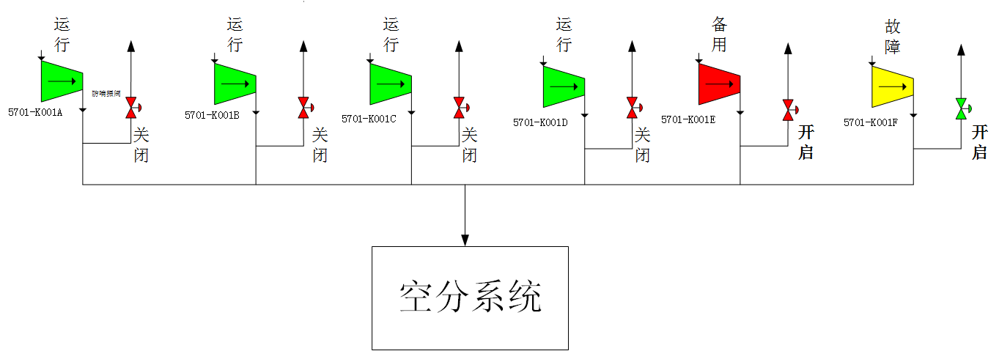  Operation  Malfunction  Operation  Open  Operation  Operation  Standby  Open  Close  Close  Close  Close  Air separation system  Anti-surge valve  Diagram of accident scene process (the above diagram) is attached.  附事故场景流程简图（上图）
Termination of emergency plan  应急预案终止 | The five air compressors have resumed normal operation; the unit has resumed the original load; and the dispatcher, the process engineer and the deputy manager have been reported that the abnormal situation has been removed. The team leader shall announce the termination of the emergency plan.  五台空压机恢复正常运行，装置恢复原有负荷，汇报调度、工艺工程师、副经理，异常情况解除，班长宣布应急预案终止。
Sign annotation is as follows:
符号注释如下：
[W]—outdoor operator, [N]—indoor operator, [B]—team leader, [N/W]—indoor operator/outdoor operator
[W]——外操，[N]——内操，[B]——班长，[N/W]——内操/外操

5.2.2 Emergency disposal plan for tripping of two/three/four air compressors

二/三/四台空压机跳车应急处置预案

Steps  步骤 | Disposal  处 置 | Person in charge  负责人
Discover the abnormity  发现异常 | [N]—It was found when monitoring the operation panel that two/three/four air compressors tripped.  [N]—监盘发现二/三/四台空压机跳车。 | The first abnormity finder  发现异常第一人
Confirm and report  确认、报告 | [W]—The outdoor operator shall make an on-site confirmation and report to the team leader: confirm that two/three/four air compressors have tripped.  [W]—外操现场确认，向班长报告：确认二/三/四台空压机跳车。 | Team leader and the first abnormity finder  班长、  发现异常第一人
Give an alarm  报警 | [B]—Report to the dispatcher, the process engineer and the deputy manager: two/three/four air compressors have tripped and the air separation has shut down in an interlocking manner. Require the dispatcher to notify all the nitrogen consuming departments to control the consumption, and inform the dispatcher of the estimated time required to return to normal.  [B]—向调度、工艺工程师、副经理报告：二/三/四台空压机跳车，空分联锁停车，要求调度通知所有用氮气单位控制用量，并告知调度预计恢复到正常所需要的时间。 | Team leader  班长
Initiate the emergency procedure  应急程序启动 | 1、[N]—DCS shall confirm that the external supply pressure PICAS00611A/B/C, temperature TIAS00604A/B/C and flow rate FI00601 of the backup low-pressure liquid nitrogen pump are normal, and that the pressure PICAS00707A/B/C, temperature TIAS00703A/B/C and flow rate FI00701 of the medium-pressure nitrogen pipe network are normal; pay attention to whether the instrument air pressure and the plant air pressure PI01001/PI01004 and the flow rate FI01001/FI01004 are normal; the air separation system shall have an emergency shutdown (close HV00503, HV00502, HV00403, HV00404 and PV00406, confirm that the HV00401A/B has been closed in an interlocking manner, and monitor the pure nitrogen tower pressure PI00403/PI00404; confirm that the sealing gas pressure of the pressure increased expander is normal; confirm that the sealing gas of the cold box is supplied normally; and confirm that the instrument air of the air separation system has been switched to the instrument air of the air compression system); if four compressors trip, operate PV01001B to turn down the delivery amount of the plant air to give priority to ensure that the instrument air pressure PI01001 and flow rate FI01001 are normal;  [N]—DCS确认后备低压液氮泵外供压力PICAS00611A/B/C、温度TIAS00604A/B/C、流量FI00601正常，确认中压氮管网压力PICAS00707A/B/C、温度TIAS00703A/B/C、流量FI00701正常；关注仪表风压力及工厂风压力PI01001/PI01004、流量FI01001/FI01004正常；空分系统做紧急停车处理（关闭HV00503、HV00502、HV00403、HV00404、PV00406，确认HV00401A/B联锁关闭，监控纯氮塔压力PI00403/PI00404；确认增压膨胀机密封气压力正常；确认冷箱密封气正常供应；确认空分系统仪表气已切换为空压系统仪表气）；若四台压缩机跳车，操作PV01001B关小工厂风外送量，优先保证仪表风压力PI01001、流量FI01001正常；  2、[W]—If the liquid filling is in progress, immediately stop the liquid nitrogen filling pump, and close the charging valve V00603 on the site to stop the liquid nitrogen delivery operation; confirm on the site that the water-bath type and air-temperature type vaporizers and the backup liquid nitrogen pump are running normally, without phenomenon of escaping, spilling, dripping and leakage;  [W]—若正在进行液体充装，立即停止液氮充装泵，并现场关闭充液阀V00603，停止液氮外送操作；现场确认水浴式、空温式汽化器、后备液氮泵正常运行，无跑、冒、滴、漏现象；  3、[B/N]—Contact electrical, instrument control and maintenance professionals to dispose the tripping unit on the site;  [B/N]—联系电气、仪控、维修专业人员现场处理跳车机组；  4、[N/W]—If two/three air compressors trip, restart the air compressor to confirm that the unit is running normally; if four air compressors trip, start the standby air compressor and adjust the plant air delivery amount FI01004 to return to normal;  [N/W]—若二/三台空压机跳车，重新启动空压机，确认机组运行正常；若四台空压机跳车，启动备用空压机，调整工厂风外送量FI01004恢复正常；  5、[N]—Restart the air separation system and return it to normal working condition.  [N]—重新启动空分系统，恢复至正常工况。 | Team leader, indoor operator and outdoor operator  班长、内操和外操
Adjust the procedure  流程调整 | After the air compressor is resumed to run, the air separation system shall be restarted. After it is normal, the qualified nitrogen shall be delivered to stop the backup nitrogen system.  恢复空压机运行后，重新启动空分系统，正常后外送合格氮气，停止后备氮系统。 | Team leader, indoor operator and outdoor operator  班长、内操和外操
Attention  注 意 | 1、If the pressure of instrument air and plant air pipe network is low, adjust the plant air consumption to give priority to ensure the instrument air pressure;  若仪表风、工厂风管网压力低，调节工厂风用量来优先保证仪表风压力；  2、If the pressure of the nitrogen pipe network is low, start the backup nitrogen system; if the air-temperature type vaporizer is severely frozen, conduct deicing on the site;  若氮气管网压力低，启动后备氮系统；若空温式汽化器结冰严重，现场除冰；  3、Monitor the liquid level drop rate in the vacuum storage tank of the medium-pressure liquid nitrogen. If the liquid level drops too fast, the backup medium-pressure liquid nitrogen pump shall be started to supply;  监控中压液氮真空贮槽的液位下降速率，如液位下降过快，需启动后备中压液氮泵予以供应；  4、Monitor the pressure and liquid level in the pure nitrogen tower, and the temperature difference between the hot and cold ends of the heat exchanger;  监控纯氮塔内压力和液位，换热器的冷热端温差；  5、The liquid level in the storage tank of the atmospheric-pressure liquid nitrogen shall be ≥6m, to avoid cavitation of the backup pump, damaging the equipment.  常压液氮贮槽液位≥6m，以免后备泵发生气蚀，损坏设备。
Diagram of process/facility system  工艺/设施系统简图 | 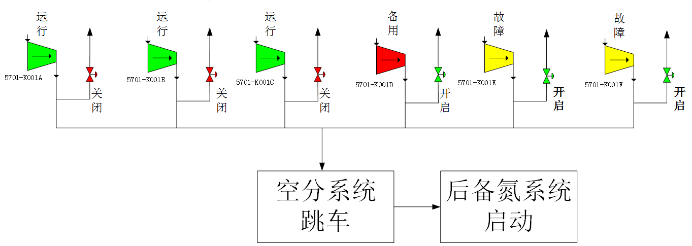  Tripping of air separation system  Start of backup nitrogen system  Close  Open  Open  Operation  Operation  Operation  Operation  Operation  Operation  Operation  Standby  Malfunction  Malfunction  Close  Close  Open  Fig. 1 Tripping of two compressors  图1 二台压缩机跳车  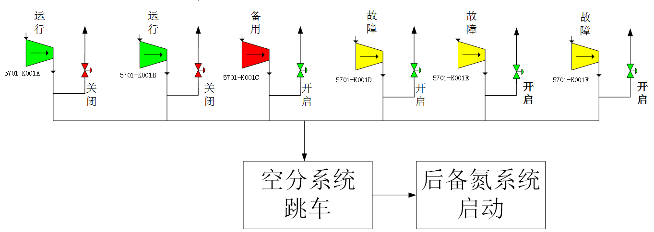  Standby  Operation  Operation  Open  Close  Tripping of air separation system  Start of backup nitrogen system  Close  Open  Open  Open  Malfunction  Malfunction  Malfunction  Fig. 2 Tripping of three compressors  图2 三台压缩机跳车  Operation  Malfunction  Open  Open  Open  Close  Tripping of air separation system  Start of backup nitrogen system  Air compression system  Standby  Malfunction  Malfunction  Malfunction  Open  Open  Open  Turn down  Instrument air valve  Plant air valve  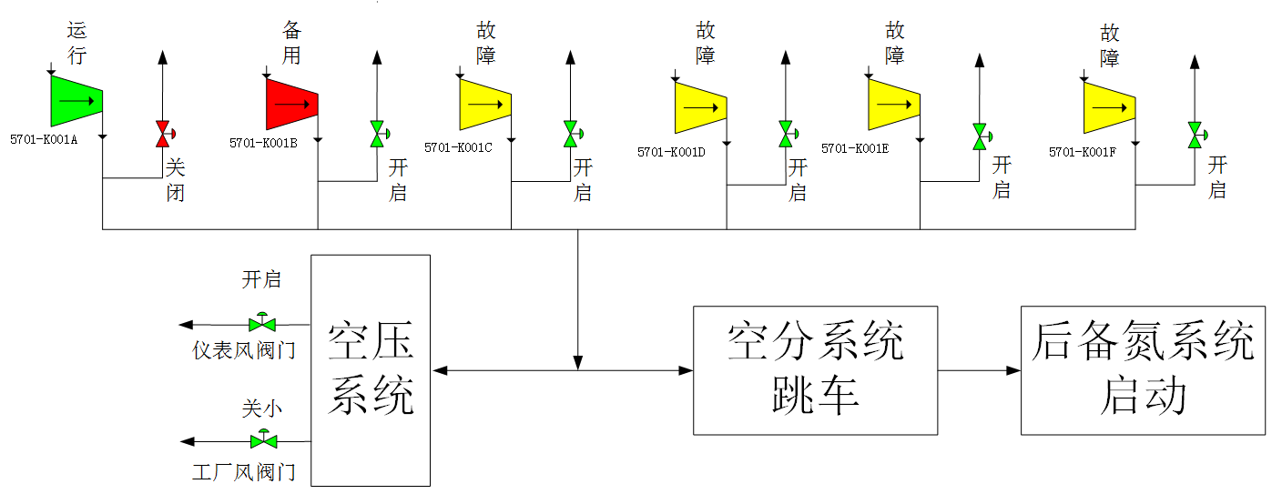  Fig. 3 Tripping of four compressors  图3 四台压缩机跳车  Diagram of accident scene process (the above diagram) is attached.  附事故场景流程简图（上图）
Termination of emergency plan  应急预案终止 | The five air compressors are in normal operation; the accident units have been disposed; the air separation system is running normally; the backup nitrogen system has been withdrawn; and the dispatcher, the process engineer and the deputy manager have been reported that the abnormal situation has been removed. The team leader shall announce the termination of the emergency plan.  五台空压机正常运行，事故机组得到处理，空分系统运行正常，后备氮系统退出，汇报调度、工艺工程师、副经理，异常情况解除，班长宣布应急预案终止。
Sign annotation is as follows:
符号注释如下：
[W]—outdoor operator, [N]—indoor operator, [B]—team leader, [N/W]—indoor operator/outdoor operator
[W]——外操，[N]——内操，[B]——班长，[N/W]——内操/外操

5.2.3 Emergency disposal plan for tripping of five air compressors

五台空压机跳车应急处置预案

Steps  步骤 | Disposal  处 置 | Person in charge  负责人
Discover the abnormity  发现异常 | [N]—It was found when monitoring the operation panel that five air compressors tripped.  [N]—监盘发现五台空压机跳车。 | The first abnormity finder  发现异常第一人
Confirm and report  确认、报告 | [W]—The outdoor operator shall make an on-site confirmation and report to the team leader: confirm that five air compressors have tripped.  [W]—外操现场确认，向班长报告：确认五台空压机跳车。 | Team leader  班长  The first abnormity finder  发现异常第一人
Give an alarm  报警 | [B]—Report to the dispatcher, the process engineer and the deputy manager: five air compressors have shut down, and report the reason for shutdown and the time required to return to normal.  [B]—向调度、工艺工程师、副经理报告：五台空压机停车，汇报停车原因及需恢复正常所需时间。 | Team leader  班长
Initiate the emergency procedure  应急程序启动 | 1、[N]—Confirm that the external supply pressure PICAS00707A/B/C and PICAS00611A/B/C and the flow rate FI00701/FI00601 of the backup medium and low pressure liquid nitrogen pumps are normal; the outlet temperatures TIAS00703A/B/C and TIAS00604A/B/C of the medium and low pressure water-bath type vaporizer are normal; pay attention to the pressure PI01002 of the instrument air accident tank and the pressure PI01001 of the instrument air pipe network, and close the external supply valve PV01001B to the plant air; the air separation system shall have an emergency shutdown (close HV00503, HV00502, HV00403, HV00404 and PV00406, confirm that HV00401A/B has been closed in an interlocking manner and monitor the pure nitrogen tower pressure PI00403/PI00404; confirm that the sealing gas pressure of the pressure increased expander is normal; confirm that the sealing gas of the cold box is supplied normally; and confirm that the instrument air of the air separation system has been switched to the instrument air of the air compression system);  1、[N]—确认后备中、低压液氮泵外供压力PICAS00707A/B/C、PICAS00611A/B/C、流量FI00701/FI00601正常；中低压水浴式汽化器出口温度TIAS00703A/B/C、TIAS00604A/B/C正常；关注仪表空气事故罐压力PI01002和仪表风管网压力PI01001，关闭去工厂风外供阀门PV01001B；空分系统做紧急停车处理（关闭HV00503、HV00502、HV00403、HV00404、PV00406，确认HV00401A/B联锁关闭，监控纯氮塔压力PI00403/PI00404；确认增压膨胀机密封气压力正常；确认冷箱密封气正常供应；确认空分系统仪表气已切换为空压系统仪表气）；  2、[W]—If the liquid filling is in progress, immediately stop the liquid nitrogen filling pump, and close the charging valve V00603 on the site to stop the liquid nitrogen delivery operation; confirm on the site that the water-bath type and air-temperature type vaporizers and the backup liquid nitrogen pump are running normally, without phenomenon of escaping, spilling, dripping and leakage;  [W]—若正在进行液体充装，立即停止液氮充装泵，并现场关闭充液阀V00603，停止液氮外送操作；现场确认水浴式、空温式汽化器、后备液氮泵正常运行，无跑、冒、滴、漏现象；  3、[N/W]—Start the standby air compressor and restore the external supply of the instrument air;  [N/W]—启动备用空压机，恢复仪表风外供；  4、[B]—Contact electrical, instrument control and maintenance professionals to dispose the tripping unit on the site; start the air compressor after it is normal, restart the air separation system, and return it to normal working condition.  [B]—联系电气、仪控、维修专业人员现场处理跳车机组；正常后启动空压机，重新启动空分系统，恢复至正常工况。 | Team leader  班长  Indoor operator and outdoor operator  内操和外操
Adjust the procedure  流程调整 | Resume the operation of the air compressor, resume the plant air delivery, and restart the air separation system. After it is normal, the qualified nitrogen shall be delivered to stop the backup nitrogen system.  恢复空压机运行，恢复工厂风外送，重新启动空分系统，正常后外送合格氮气，停止后备氮系统。 | Team leader  班长  Indoor operator and outdoor operator  内操和外操
Attention  注 意 | 1、Close the external supply of plant air to ensure the external supply pressure of instrument air;  关闭工厂风外供，保证仪表风外供压力；  2、Start the standby air compressor as soon as possible after starting the backup nitrogen system for instrument air supply;  启动后备氮系统后尽快启动备用空压机供仪表风；  3、If the air-bath type vaporizer is severely frozen, conduct deicing on the site;  若空浴式汽化器结冰严重，现场除冰；  4、Monitor the pressure and liquid level in the pure nitrogen tower, and the temperature difference between the hot and cold ends of the heat exchanger;  监控纯氮塔内压力和液位，换热器的冷热端温差；  5、The liquid level in the storage tank of the atmospheric-pressure liquid nitrogen shall be ≥6m, to avoid cavitation of the backup pump, damaging the equipment.  常压液氮储槽液位≥6m，以免后备泵发生气蚀，损坏设备。
Diagram of process/facility system  工艺/设施系统简图 | 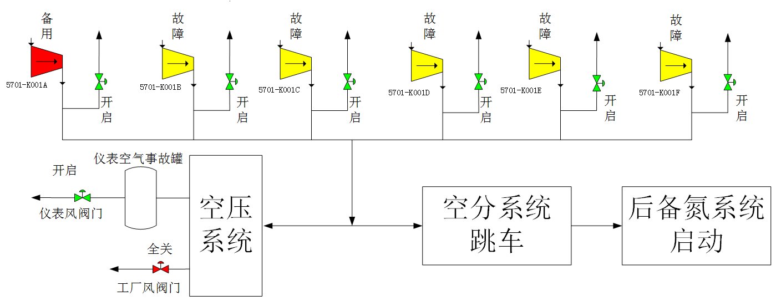  Standby  Open  Tripping of air separation system  Start of backup nitrogen system  Air compression system  Open  Fully close  Instrument air valve  Instrument air accident tank  Malfunction  Malfunction  Malfunction  Malfunction  Malfunction  Open  Open  Open  Open  Open  Plant air valve  Diagram of accident scene process (the above diagram) is attached.  附事故场景流程简图（上图）
Termination of emergency plan  应急预案终止 | The five air compressors are in normal operation; the accident units have been disposed; the delivery of the instrument air and the plant air have been resumed; the air separation system is running normally; the backup nitrogen system has been withdrawn; and the dispatcher, the process engineer and the deputy manager have been reported that the abnormal situation has been removed. The team leader shall announce the termination of the emergency plan.  五台空压机正常运行，事故机组得到处理，恢复仪表风和工厂风外送，空分系统运行正常，后备氮系统退出，汇报调度、工艺工程师、副经理，异常情况解除。班长宣布应急预案终止。
Sign annotation is as follows:
符号注释如下：
[W]—outdoor operator, [N]—indoor operator, [B]—team leader, [N/W]—indoor operator/outdoor operator
[W]——外操，[N]——内操，[B]——班长，[N/W]——内操/外操

5.2.4 Emergency disposal plan for power failure due to grid fault

电网故障停电应急处置预案

Steps  步骤 | Disposal  处 置 | Person in charge  负责人
Discover the abnormity  发现异常 | [N]—It was found when monitoring the operation panel that the air separation/compression systems stopped.  [N]—监盘发现空分空压系统停车。 | The first abnormity finder  发现异常第一人
Confirm and report  确认、报告 | [W]—The outdoor operator shall make an on-site confirmation and report to the team leader: confirm that the whole air separation/compression systems have stopped.  [W]—外操现场确认，向班长报告：确认空分空压全系统停车。 | Team leader and the first abnormity finder  班长、  发现异常第一人
Give an alarm  报警 | [B]—Report to the dispatcher, the process engineer and the deputy manager: the whole line of the air separation/compression has stopped due to power failure, and the dispatcher is required to control the total gas consumption of the whole plant to be ≤10000Nm³/h.  [B]—向调度、工艺工程师、副经理报告：空分空压因断电全线停车，要求调度控制全厂总用气量≤10000Nm³/h。 | Team leader  班长
Initiate the emergency procedure  应急程序启动 | 1、[N]—Confirm that the pipe network to supply the medium-pressure nitrogen 0.7MPa, 0.85MPa and 2.5MPa through the vacuum storage tank of liquid nitrogen is normal; pay attention to the pressure PI01002 of the instrument air accident tank and the pressure PI01001 of the instrument air pipe network, and close the external supply valve PV01001B to the plant air; the air separation system shall have an emergency shutdown (close HV00503, HV00502, HV00403, HV00404 and PV00406, confirm that HV00401A/B has been closed in an interlocking manner and monitor the pure nitrogen tower pressure PI00403/PI00404; confirm that the sealing gas pressure of the pressure increased expander is normal; confirm that the sealing gas of the cold box is supplied normally; and confirm that the instrument air of the air separation system has been switched to the instrument air of the air compression system);  [N]—确认中压氮气通过液氮真空贮槽供氮气0.7MPa、0.85MPa、2.5MPa管网正常；关注仪表空气事故罐压力PI01002和仪表风管网压力PI01001，关闭去工厂风外供阀门PV01001B；空分系统做紧急停车处理（关闭HV00503、HV00502、HV00403、HV00404、PV00406，确认HV00401A/B联锁关闭，监控纯氮塔压力PI00403/PI00404；确认增压膨胀机密封气压力正常；确认冷箱密封气正常供应；确认空分系统仪表气已切换为空压系统仪表气）；  2、[B]—Contact the electrical professional to check for the cause of the power failure, and start the backup nitrogen pump to supply nitrogen as soon as possible; start the air compressor to ensure the instrument air pressure; and restart the air compression/separation systems and return them to normal working condition;  [B]—联系电气专业人员排查停电原因，尽快启动后备氮泵供应氮气；启动空压机来保证仪表风压力；重新启动空压空分系统，恢复至正常工况；  3、[W]—If the liquid filling is in progress, and the liquid nitrogen filling pump has stopped due to the power failure, close the charging valve V00603 on the site to stop the liquid nitrogen delivery operation; confirm on the site that the water-bath type and air-temperature type vaporizers and the backup liquid nitrogen pump are running normally, without phenomenon of escaping, spilling, dripping and leakage.  [W]—若正在进行液体充装，液氮充装泵因停电已停止，现场关闭充液阀V00603，停止液氮外送操作；现场确认水浴式、空温式汽化器、后备液氮泵正常运行，无跑、冒、滴、漏现象。 | Team leader, indoor operator and outdoor operator  班长、内操和外操
Adjust the procedure  流程调整 | Resume the operation of the air compressor, restore the instrument air first, and restart the air separation system. After it is normal, the qualified nitrogen shall be delivered to stop the backup nitrogen system.  恢复空压机运行，先恢复仪表风，重新启动空分系统，正常后外送合格氮气，停止后备氮系统。 | Team leader, indoor operator and outdoor operator  班长、内操和外操
Attention  注 意 | 1、Close the plant air to ensure the instrument air pressure;  关闭工厂风，保证仪表风压力；  2、If the duration of power outage is too long and the pressure of the instrument air accident tank drops to 1.0 MPa, the early warning shall be given to the dispatcher again; the instrument air supply will be cut off;  若停电时间过长，仪表空气事故罐压力降至1.0MPa时，再次向调度预警；仪表风将断供；  3、If the air-temperature type vaporizer is severely frozen, conduct deicing on the site;  若空温式汽化器结冰严重，现场除冰；  4、Monitor the pressure and liquid level in the pure nitrogen tower, and the temperature difference between the hot and cold ends of the heat exchanger.  监控纯氮塔内压力和液位，换热器的冷热端温差。
Diagram of process/facility system  工艺/设施系统简图 | 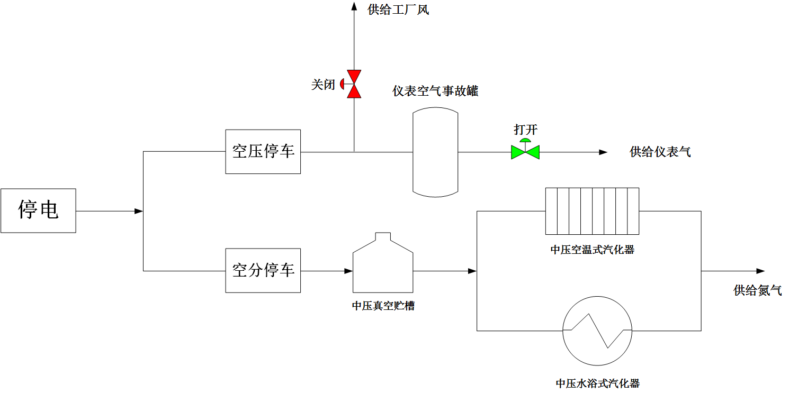Diagram of accident scene process (the above diagram) is attached.  Power failure  Shutdown of air compression  Shutdown of air separation  Close  Supply of plant air  Instrument air accident tank  Medium-pressure vacuum storage tank  Open  Supply of instrument air  Medium-pressure air-temperature type vaporizer  Medium-pressure water-bath type vaporizer  Supply of nitrogen  附事故场景流程简图（上图）
Termination of emergency plan  应急预案终止 | The electric power supply has returned to normal; the backup nitrogen system has been in normal supply; the air compressor has been restarted; the plant air delivery has been resumed; the air separation system is running normally; and the backup nitrogen system has been withdrawn. If the pressure in the instrument air accident tank is low, the instrument air supercharger shall be restarted to charge it. The dispatcher, the process engineer and the deputy manager have been reported that the abnormal situation has been removed. The team leader shall announce the termination of the emergency plan.  电力供应恢复正常，后备氮系统正常供应，空压机重新启动，恢复工厂风外送，空分系统运行正常，后备氮系统退出，如仪表空气事故罐压力低，则重新启动仪表空气增压机给其充压，汇报调度、工艺工程师、副经理，异常情况解除，班长宣布应急预案终止。
Sign annotation is as follows:
符号注释如下：
[W]—outdoor operator, [N]—indoor operator, [B]—team leader, [N/W]—indoor operator/outdoor operator
[W]——外操，[N]——内操，[B]——班长，[N/W]——内操/外操

5.2.5 Emergency disposal plan for interruption of circulating water for air separation/compression

空分空压循环水中断应急处置预案

Steps  步骤 | Disposal  处 置 | Person in charge  负责人
Discover the abnormity  发现异常 | [N]—The indoor operator found when monitoring the operation panel that the water pressure was alarmed to be low; the interstage intake air temperature of the air compressor was high; an interlock of five air compressors tripped; and the air separation system tripped in an interlocking manner.  [N]—内操监盘发现水压低报，空压机级间进气温度高，联锁五台空压机跳车，空分系统联锁跳车。 | The first abnormity finder  发现异常第一人
Confirm and report  确认、报告 | [W]—The outdoor operator shall make an on-site confirmation and report to the team leader: confirm that the whole air separation/compression systems have tripped.  [W]—外操现场确认，向班长报告：确认空分空压全系统跳车。 | Team leader and the first abnormity finder  班长、  发现异常第一人
Give an alarm  报警 | [B]—Report to the dispatcher, the process engineer and the deputy manager: the air separation/compression systems have tripped on the whole line due to interruption of the circulating water. Ask the dispatcher to control the gas consumption of the back system and report the estimated time required to return to normal.  [B]—向调度、工艺工程师、副经理报告：空分空压因循环水中断导致全线跳车。要求调度控制后系统用气量，汇报预计恢复到正常所需要的时间。 | Team leader  班长
Initiate the emergency procedure  应急程序启动 | 1、[N]—Confirm that the external supply pressure PICAS00707A/B/C and PICAS00611A/B/C and the flow rate FI00701/FI00601 of the backup medium and low pressure liquid nitrogen pumps are normal; the outlet temperatures TIAS00703A/B/C and TIAS00604A/B/C of the medium and low pressure water-bath type vaporizer are normal; pay attention to the pressure PI01002 of the instrument air accident tank and the pressure PI01001 of the instrument air pipe network, and close the external supply valve PV01001B to the plant air; the air separation system shall have an emergency shutdown (close HV00503, HV00502, HV00403, HV00404 and PV00406, confirm that HV00401A/B has been closed in an interlocking manner and monitor the pure nitrogen tower pressure PI00403/PI00404; confirm that the sealing gas pressure of the pressure increased expander is normal; confirm that the sealing gas of the cold box is supplied normally; and confirm that the instrument air of the air separation system has been switched to the instrument air of the air compression system);  [N]—确认后备中、低压液氮泵外供压力PICAS00707A/B/C、PICAS00611A/B/C、流量FI00701/FI00601正常；中低压水浴式汽化器出口温度TIAS00703A/B/C、TIAS00604A/B/C正常；关注仪表空气事故罐压力PI01002和仪表风管网压力PI01001，关闭去工厂风外供阀门PV01001B；空分系统做紧急停车处理（关闭HV00503、HV00502、HV00403、HV00404、PV00406，确认HV00401A/B联锁关闭，监控纯氮塔压力PI00403/PI00404；确认增压膨胀机密封气压力正常；确认冷箱密封气正常供应；确认空分系统仪表气已切换为空压系统仪表气）；  2、[W]—If the liquid filling is in progress, close the charging valve V00603 on the site to stop the liquid nitrogen delivery operation; confirm on the site that the water-bath type and air-temperature type vaporizers and the backup liquid nitrogen pump are running normally, without phenomenon of escaping, spilling, dripping and leakage;  [W]—若正在进行液体充装，现场关闭充液阀V00603，停止液氮外送操作；现场确认水浴式、空温式汽化器、后备液氮泵正常运行，无跑、冒、滴、漏现象；  3、[B]—Confirm whether the second circulating water pump is out of service first, and then contact the electrical, mechanical and instrument control professionals to check for the cause of interruption of the circulating water;  [B]—先确认二循水泵是否停运，然后联系电气、机械、仪控专业人员排查循环水中断原因；  4、[N/W]—Restore the circulating water supply and start the air compression system to ensure the instrument air supply;  [N/W]—恢复循环水供应，启动空压系统保证仪表气供应；  5、[N]—Restart the air separation system and return it to normal working condition.  [N]—重新启动空分系统，恢复至正常工况。 | Team leader, indoor operator and outdoor operator  班长、  内操和外操
Adjust the procedure  流程调整 | Resume the operation of the air compressor, resume the plant air delivery, and restart the air separation system. After it is normal, the qualified nitrogen shall be delivered to stop the backup nitrogen system.  恢复空压机运行，恢复工厂风外送，重新启动空分系统，正常后外送合格氮气，停止后备氮系统。 | Team leader, indoor operator and outdoor operator  班长、  内操和外操
Attention  注 意 | 1、Close the plant air to ensure the instrument air pressure;  关闭工厂风，保证仪表风压力；  2、If the air-bath type vaporizer is severely frozen, conduct deicing on the site;  若空浴式汽化器结冰严重，现场除冰；  3、Monitor the pressure and liquid level in the pure nitrogen tower, and the temperature difference between the hot and cold ends of the heat exchanger;  监控纯氮塔内压力和液位换热器的冷热端温差；  4、Before the circulating water is resupplied, the pipeline and equipment shall be vented at a high point.  循环水重新供应之前，对管线、设备进行高点排气。
Diagram of process/facility system  工艺/设施系统简图 | 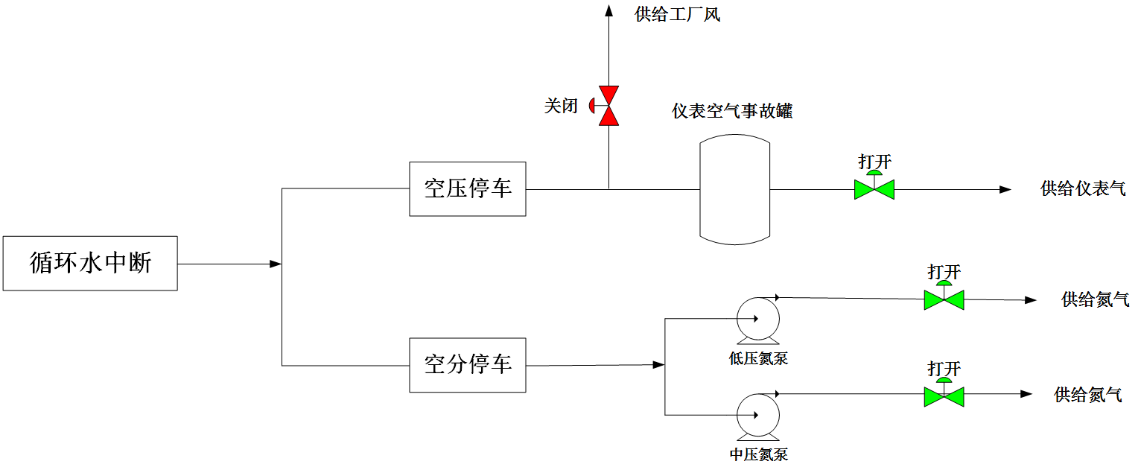  Shutdown of air compression  Shutdown of air separation  Close  Supply of plant air  Instrument air accident tank  Low-pressure nitrogen pump  Medium-pressure nitrogen pump  Open  Open  Open  Supply of instrument air  Supply of nitrogen  Supply of nitrogen  Interruption of circulating water  Diagram of accident scene process (the above diagram) is attached.  附事故场景流程简图（上图）
Termination of emergency plan  应急预案终止 | The five air compressors are in normal operation; the delivery of the instrument air and the plant air have been resumed; the air separation system is running normally; the backup nitrogen system has been withdrawn; and the dispatcher, the process engineer and the deputy manager have been reported that the abnormal situation has been removed. The team leader shall announce the termination of the emergency plan.  五台空压机正常运行，恢复仪表风和工厂风外送，空分系统运行正常，后备氮系统退出，汇报调度、工艺工程师、副经理异常情况解除。班长宣布应急预案终止。
Sign annotation is as follows:
符号注释如下：
[W]—outdoor operator, [N]—indoor operator, [B]—team leader, [N/W]—indoor operator/outdoor operator
[W]——外操，[N]——内操，[B]——班长，[N/W]——内操/外操

5.2.6 Emergency disposal plan for tripping of air separation unit

空分装置跳车应急处置预案
Steps  步骤 | Disposal  处 置 | Person in charge  负责人
Discover the abnormity  发现异常 | [N]—The indoor operator found when monitoring the operation panel that the air separation system tripped in an interlocking manner.  [N]—内操监盘发现空分系统联锁跳车。 | The first abnormity finder  发现异常第一人
Confirm and report  确认、报告 | [W]—The outdoor operator shall make an on-site confirmation and report to the team leader: confirm that the air separation system has tripped.  [W]—外操现场确认，向班长报告：确认空分系统跳车。 | Team leader and the first abnormity finder  班长、  发现异常第一人
Give an alarm  报警 | [B]—Report to the dispatcher, the process engineer and the deputy manager: the air separation system has tripped, require the dispatcher to control the nitrogen consumption of the whole plant, and report the estimated time required to return to normal.  [B]—向调度、工艺工程师、副经理报告：空分系统跳车，要求调度控制全厂氮气用量，汇报预计恢复到正常所需要的时间。 | Team leader  班长
Initiate the emergency procedure  应急程序启动 | 1、[N]—Confirm that the external supply pressure PICAS00611A/B/C, temperature TIAS00604A/B/C and flow rate FI00601 of the backup low-pressure liquid nitrogen pump are normal; confirm that the pressure PICAS00707A/B/C, temperature TIAS00703A/B/C and flow rate FI00701 of the medium-pressure nitrogen pipe network are normal; confirm that the main vent valve PV00110 of the compressor pipeline is normally opened for venting, and control the total outlet pressure to be normal to avoid overpressure; pay attention to whether the pressure PI00101 and flow rate FI01001 of the instrument air and the pressure PI01004 and flow rate FI01004 of the plant air are normal; the air separation system shall have an emergency shutdown (close HV00503, HV00502, HV00403, HV00404 and PV00406, confirm that the HV00401A/B has been closed in an interlocking manner, and monitor the pure nitrogen tower pressure PI00403/PI00404; confirm that the sealing gas pressure of the pressure increased expander is normal; confirm that the sealing gas of the cold box is supplied normally; and confirm that the instrument air of the air separation system has been switched to the instrument air of the air compression system);  [N]—确认后备低压液氮泵外供压力PICAS00611A/B/C、温度TIAS00604A/B/C、流量FI00601正常；确认中压氮管网压力PICAS00707A/B/C、温度TIAS00703A/B/C、流量FI00701正常；确认压缩机管线总放空阀PV00110正常打开放空，并控制总出口压力正常，避免出现超压现象；关注仪表风压力PI00101、仪表风流量FI01001及工厂风压力PI01004、工厂风流量FI01004正常；空分系统做紧急停车处理（关闭HV00503、HV00502、HV00403、HV00404、PV00406，确认HV00401A/B联锁关闭，监控纯氮塔压力PI00403/PI00404；确认增压膨胀机密封气压力正常；确认冷箱密封气正常供应；确认空分系统仪表气已切换为空压系统仪表气）；  2、[W]—If the liquid filling is in progress, and the liquid nitrogen filling pump has stopped due to the power failure, close the charging valve V00603 on the site to stop the liquid nitrogen delivery operation; confirm on the site that the water-bath type and air-temperature type vaporizers and the backup liquid nitrogen pump are running normally, without phenomenon of escaping, spilling, dripping and leakage;  [W]—若正在进行液体充装，液氮充装泵因停电已停止，现场关闭充液阀V00603，停止液氮外送操作；现场确认水浴式、空温式汽化器、后备液氮泵正常运行，无跑、冒、滴、漏现象；  3、[B]—Contact electrical, instrument control and maintenance professionals to confirm the reason for the tripping of the air separation system on the site;  [B]—联系电气、仪控、维修专业人员现场确认空分跳车原因；  4、[N]—Restart the air separation system and return it to normal working condition.  [N]—重新启动空分系统，恢复至正常工况。 | Team leader, indoor operator and outdoor operator  班长、内操和外操
Adjust the procedure  流程调整 | Restart the air separation system, resume the external supply of nitrogen after it is normal, and withdraw the backup system.  重新启动空分系统，正常后恢复外供氮气，退出后备系统。 | Team leader, indoor operator and outdoor operator  班长、内操和外操
Attention  注 意 | 1、Pay attention to the total outlet pressure regulation of the compressor, control the pressure of instrument air and plant air to be normal;  关注压缩机总出口压力调节，控制仪表风和工厂风压力正常；  2、If the air-bath type vaporizer is severely frozen, conduct deicing on the site;  若空浴式汽化器结冰严重，现场除冰；  3、Monitor the pressure and liquid level in the pure nitrogen tower, and the temperature difference between the hot and cold ends of the heat exchanger;  监控纯氮塔内压力和液位，换热器的冷热端温差；  4、The liquid level in the storage tank of the atmospheric-pressure liquid nitrogen shall be ≥6m, to avoid cavitation of the backup pump, damaging the equipment.  常压液氮储槽液位≥6m，以免后备泵发生气蚀，损坏设备。
Diagram of process/facility system  工艺/设施系统简图 | 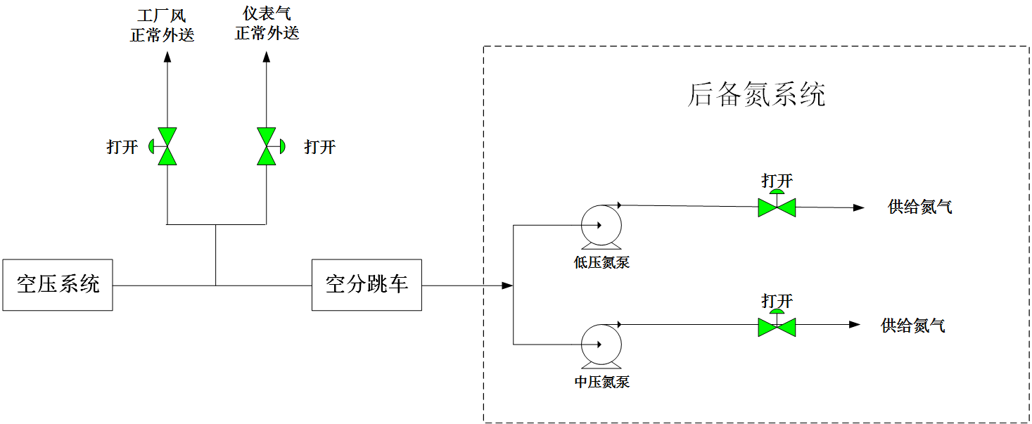  Air compression system  Tripping of air separation  Open  Low-pressure nitrogen pump  Medium-pressure nitrogen pump  Supply of nitrogen  Supply of nitrogen  Open  Open  Backup nitrogen system  Normal delivery of plant air  Normal delivery of instrument air  Open  Diagram of accident scene process (the above diagram) is attached.  附事故场景流程简图（上图）
Termination of emergency plan  应急预案终止 | The air separation system is running normally; the backup nitrogen system has been withdrawn; and the dispatcher, the process engineer and the deputy manager have been reported that the abnormal situation has been removed. The team leader shall announce the termination of the emergency plan.  空分系统运行正常，后备氮系统退出，汇报调度、工艺工程师、副经理，异常情况解除。班长宣布应急预案终止。
Sign annotation is as follows:
符号注释如下：
[W]—outdoor operator, [N]—indoor operator, [B]—team leader, [N/W]—indoor operator/outdoor operator
[W]——外操，[N]——内操，[B]——班长，[N/W]——内操/外操

5.2.7 Emergency disposal plan for UPS failure to supply power/malfunction after power failure of air separation/compression systems

空分空压断电后UPS不能供电/失效时应急处置预案

Steps  步骤 | Disposal  处 置 | Person in charge  负责人
Discover the abnormity  发现异常 | [N]—The indoor operator found when monitoring the operation panel that the operation station and the DCS were out of power, and all the computers got a blank screen.  [N]—内操监盘发现操作站、DCS断电，所有电脑黑屏。 | The first abnormity finder  发现异常第一人
Confirm and report  确认、报告 | [W]—Confirm on the site that the air separation/compression systems have stopped on the whole line.  [W]—现场确认空分空压系统全线停车。 | Team leader and the first abnormity finder  班长、  发现异常第一人
Give an alarm  报警 | [B]—Report to the dispatcher and the leader in charge: the whole air separation/compression systems have tripped, and ask the gas comsuming unit to reduce the gas consumption.  [B]—向调度、主管报告：空分空压全系统跳车，要求用气装置减少用气量。 | Team leader  班长
Initiate the emergency procedure  应急程序启动 | 1、[W]—Open the bypass hand valve V01027 at the outlet of the instrument air accident tank on the site for external supply of instrument air, close the manually operated valve V01007 to the plant air, and monitor the instrument air pressure through the on-site pressure gauge PG01001; confirm the medium-pressure vacuum liquid storage tank on the site→ water-bath type vaporizer/air-temperature type vaporizer→ medium/low pressure nitrogen to the pipe network; manually open the bypass liquid inlet valve V00739/V00742 of the vaporizer, monitor the pressure gauge PG00804 of the nitrogen storage tank D004 and the external nitrogen supply pressure on the site (the external nitrogen supply pressure shall be confirmed by contacting the nitrogen user), and manually open the steam valve V00785 of the water-bath type vaporizer to ensure the safe operation of the vaporizer;  [W]—现场打开仪表风事故罐出口旁路手阀V01027外供仪表风，关闭去工厂风手动阀V01007，通过现场压力表PG01001监控仪表风压力；现场确认中压真空液体贮槽→水浴式汽化器/空温式汽化器→中压/低压氮气去管网；手动开汽化器旁路进液阀V00739/V00742，现场监控氮气储罐D004压力表PG00804及外供氮气压力（外供氮气压力通过联系氮气用户来确认），手动开水浴式汽化器蒸汽阀门V00785保证汽化器安全运行；  2、[B]—Contact electrical and instrument control personnel to restore UPS and DCS power supply;  [B]—联系电气、仪控恢复UPS及DCS供电；  3、[N/W]—After the power returns to normal, start the backup medium and low pressure liquid nitrogen pumps to supply nitrogen; and start the air compressor to supply the instrument air;  [N/W]—电力恢复正常后启动后备中、低压液氮泵供氮气；启动空压机供仪表风；  4、[N/W]—Restart the air separation system and return it to normal working condition.  [N/W]—重新启动空分系统，恢复至正常工况。 | Team leader, indoor operator and outdoor operator  班长、内操和外操
Adjust the procedure  流程调整 | After the power supply of DCS is restored, start the air compressor, restart the air separation system, withdraw the backup nitrogen system, and report to the dispatcher that the abnormal situation has been removed. The team leader shall announce the termination of the emergency plan.  DCS恢复供电后启动空压机，重新启动空分系统，后备氮系统退出，汇报调度，异常情况解除。班长宣布应急预案终止。 | Team leader, indoor operator and outdoor operator  班长、内操和外操
Attention  注 意 | 1、It is strictly prohibited to stand around the outlet of the safety valve before the DCS returns to normal;  DCS恢复正常之前，严禁站在安全阀出口周围；  2、Take care to prevent frostbite in liquor drainage;  排液时注意防止冻伤；  3、Take care to prevent scald in manual operation of the steam valve;  手动操作蒸汽阀门时，注意防止烫伤；  4、Keep a watchful eye on whether the key pressure gauge and temperature gauge are normal on the site.  现场关注重点压力表、温度表正常。
Diagram of process/facility system  工艺/设施系统简图 | 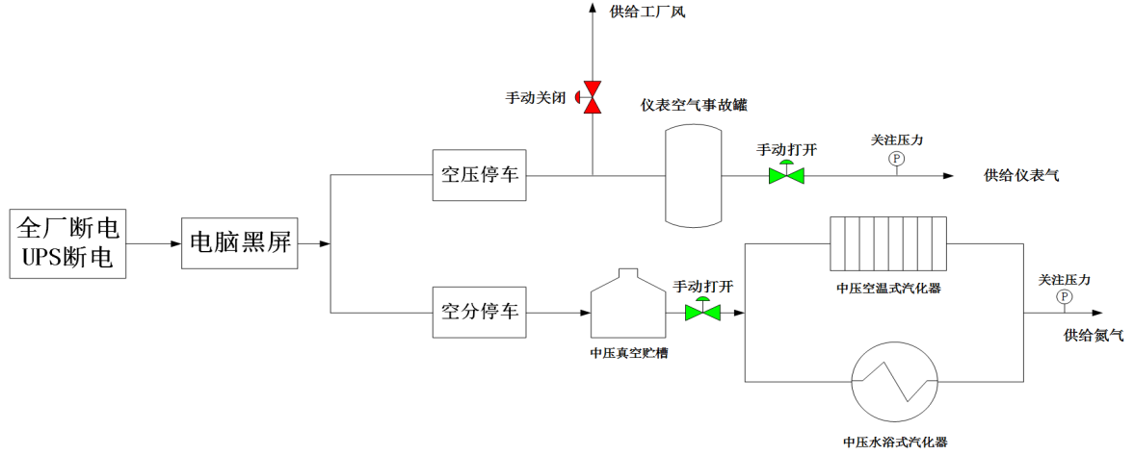  Power failure of the whole plant  UPS power failure  Shutdown of air compression  Shutdown of air separation  Manually close  Supply of plant air  Instrument air accident tank  Supply of instrument air  Supply of nitrogen  Blank screen of computer  Medium-pressure vacuum storage tank  Medium-pressure air-temperature type vaporizer  Medium-pressure water-bath type vaporizer  Manually open  Pay close attention to the pressure  Pay close attention to the pressure  Manually open  Diagram of accident scene process (the above diagram) is attached.  附事故场景流程简图（上图）
Termination of emergency plan  应急预案终止 | The power supply of DCS has been resumed; the air separation/compression systems have returned to normal; the external supply of instrument air, plant air and nitrogen has been normal; the backup nitrogen system has been withdrawn; and the dispatcher, the process engineer and the deputy manager have been reported that the abnormal situation has been removed. The team leader shall announce the termination of the emergency plan.  DCS恢复供电，空分空压系统恢复正常，正常外供仪表风、工厂风、氮气；后备氮系统退出，汇报调度、工艺工程师、副经理，异常情况解除。班长宣布应急预案终止。
Sign annotation is as follows:
符号注释如下：
[W]—outdoor operator, [N]—indoor operator, [B]—team leader, [N/W]—indoor operator/outdoor operator
[W]——外操，[N]——内操，[B]——班长，[N/W]——内操/外操

5.2.8 Emergency disposal plan for interruption of the instrument air

仪表风中断应急处置预案

Steps  步骤 | Disposal  处 置 | Person in charge  负责人
Discover the abnormity  发现异常 | [N]—The air compressor system has stopped for too long and cannot be recovered. The pressure of the instrument air accident tank is below the lower limit, and it is unable to continue to supply the instrument air.  [N]—空压系统停车时间过长且无法恢复，仪表风事故储罐压力低于下限，无法继续提供仪表风。 | The first abnormity finder  发现异常第一人
Confirm and report  确认、报告 | [W]—The outdoor operator shall make an on-site confirmation that the pressure of the instrument air accident tank is low.  [W]—外操现场确认仪表风事故储罐压力低低。 | Team leader and the first abnormity finder  班长、  发现异常第一人
Give an alarm  报警 | [B]—Report to the dispatcher, the process engineer and the deputy manager: the instrument air has been interrupted (the standby instrument air has been used up), which cannot be recovered in a short time.  [B]—向调度、工艺工程师、副经理报告：仪表风中断（备用仪表风已用完）且短时间无法恢复。 | Team leader  班长
Initiate the emergency procedure  应急程序启动 | 1、[W]—Confirm the medium-pressure vacuum liquid storage tank on the site→ water-bath type vaporizer/air-temperature type vaporizer→ medium/low pressure nitrogen to the pipe network; manually open the bypass liquid inlet valve V00739/V00742 of the vaporizer, monitor the pressure gauge and the external supply pressure on the site, and manually open the steam valve V00785 of the water-bath type vaporizer to ensure the safe operation of the vaporizer;  [W]—现场确认中压真空液体贮槽→水浴式汽化器/空温式汽化器→中压/低压氮气去管网；手动开汽化器旁路进液阀V00739/V00742，现场压力表监控外供压力，手动开水浴式汽化器蒸汽阀门V00785保证汽化器安全运行；  2、[B]—Contact the electrical, instrument control and mechanical engineers to deal with the abnormalities so that the air compressor meets the starting conditions;  [B]—联系电气、仪控、机械工程师处理异常，使空压机具备启动条件；  3、[N/W]—Start the temporary instrument air compressor to supply the instrument air to the air compressor, and restore operation of the air compression system to supply the instrument air for the whole system; and start the backup nitrogen pump for nitrogen supply;  [N/W]—启动临时仪表风压缩机给空压机供仪表风，恢复空压系统运行，为整个系统提供仪表风；启动后备氮泵供氮气；  4、[N/W]—Restart the air separation system and return it to normal working condition.  [N/W]—重新启动空分系统，恢复至正常工况。 | Team leader, indoor operator and outdoor operator  班长、内操和外操
Adjust the procedure  流程调整 | After the instrument air is restored, restart the air separation system, withdraw the backup nitrogen system, and report to the dispatcher that the abnormal situation has been removed.  仪表风恢复后重新启动空分系统，后备氮系统退出，汇报调度，异常情况解除。 | Team leader, indoor operator and outdoor operator  班长、内操和外操
Attention  注 意 | 1、Manually control the valves related to the pure nitrogen tower on the site to ensure the safety after the air separation system stops;  现场手动控制纯氮塔相关阀门，保证空分停车后安全；  2、Manually control the pressure inside the atmospheric storage tank of liquid nitrogen;  液氮常压贮槽手动控制内部压力；  3、Take care to prevent scald in manual operation of the steam valve;  手动操作蒸汽阀门时，注意防止烫伤；  4、Keep a watchful eye on whether the key pressure gauge and temperature gauge are normal on the site;  现场关注重点压力表、温度表正常；  5、Take care to prevent frostbite in liquor drainage.  排液时注意防止冻伤。
Diagram of process/facility system  工艺/设施系统简图 | 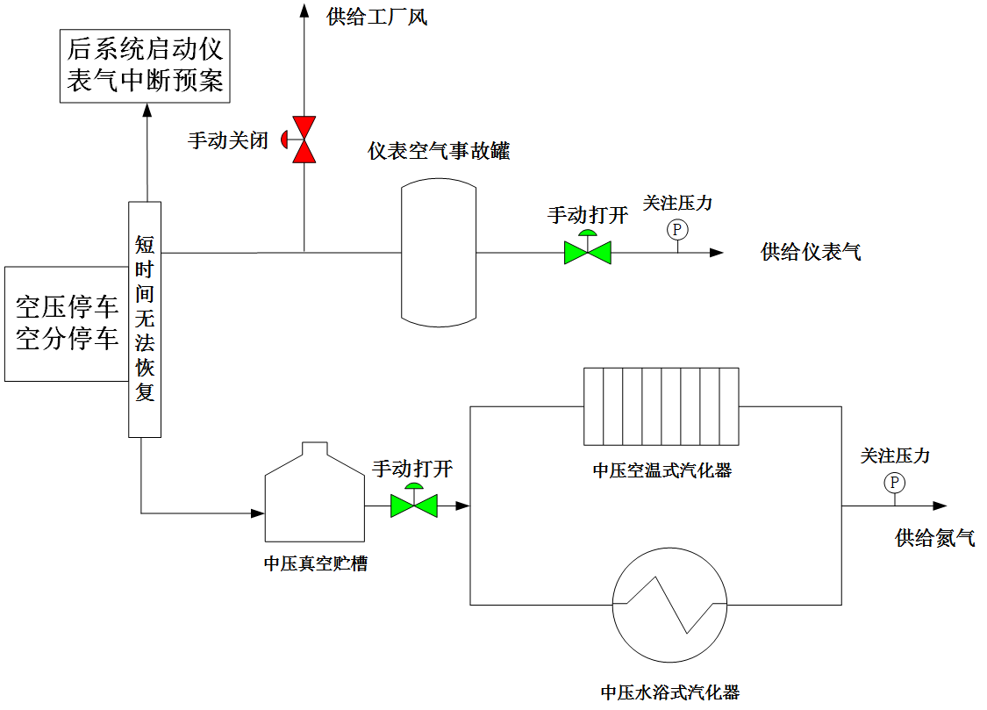  Initiate the plan for interruption of instrument air for the back system  Shutdown of air compression  Shutdown of air separation  Unable to be recovered in a short time  Supply of plant air  Manually close  Instrument air accident tank  Manually open  Pay close attention to the pressure  Supply of instrument air  Manually open  Medium-pressure vacuum storage tank  Medium-pressure air-temperature type vaporizer  Medium-pressure water-bath type vaporizer  Pay close attention to the pressure  Supply of nitrogen  Diagram of accident scene process (the above diagram) is attached.  附事故场景流程简图（上图）
Termination of emergency plan  应急预案终止 | The instrument air has returned to normal; the air separation/compression systems have returned to normal; the external supply of instrument air, plant air and nitrogen has been normal; the backup nitrogen system has been withdrawn; and the dispatcher, the process engineer and the deputy manager have been reported that the abnormal situation has been removed. The team leader shall announce the termination of the emergency plan.  仪表风恢复正常，空分空压系统恢复正常，正常外供仪表风，工厂风，氮气；后备氮系统退出，汇报调度、工艺工程师、副经理，异常情况解除。班长宣布应急预案终止。
Sign annotation is as follows:
符号注释如下：
[W]—outdoor operator, [N]—indoor operator, [B]—team leader, [N/W]—indoor operator/outdoor operator
[W]——外操，[N]——内操，[B]——班长，[N/W]——内操/外操

5.2.9 Emergency disposal plan for malfunction of sequencing valve of molecular sieve

分子筛程控阀故障应急处置预案

Steps  步骤 | Disposal  处 置 | Person in charge  负责人
Discover the abnormity  发现异常 | [N]—The indoor operator found when monitoring the operation panel that the programming controller timer gave a malfunction alarm and the programming controller was suspended.  [N]—内操监盘发现程控器计时器故障报警，程控器暂停。 | The first abnormity finder  发现异常第一人
Confirm and report  确认、报告 | [N]—The central control room shall confirm that the sequencing valve has got a malfunction, and the programming controller has been suspended.  [N]—中控室确认程控阀故障程控器暂停。 | Team leader and the first abnormity finder  班长、  发现异常第一人
Give an alarm  报警 | [B] —Report to the process engineer: the sequencing valve of the molecular sieve has got a malfunction, and the programming controller has given a suspension alarm.  —向工艺工程师报告：分子筛程控阀故障，程控器报警暂停。  If it cannot be recovered within 1 hour, report to the dispatcher and the deputy manager.  如1小时内无法恢复，向调度、副经理报告。 | Team leader  班长
Initiate the emergency procedure  应急程序启动 | 1、[N]—Contact the instrument control professional to confirm the cause of the malfunction of the sequencing valve and repair it;  [N]—联系仪控专业人员确认程控阀故障原因并修复；  2、[B]—Inform the indoor operator and the outdoor operator to monitor the disabled state of the molecular sieve and the malfunction condition of the on-site sequencing valve;  [B]—通知内操、外操监控分子筛停用状态及现场程控阀故障情况；  3、[N]—After the repair, the programming controller shall be put into normal use.  [N]—修复后程控器正常投用。  If the malfunction of sequencing valve of the molecular sieve cannot be troubleshooted:  当分子筛程控阀故障无法排除：  1、[N]—The indoor operator shall monitor the carbon dioxide monitoring instrument indicator AIA00203 at the outlet of the molecular sieve.  [N]—内操对分子筛出口二氧化碳分析仪指示AIA00203进行监控。  2、[B]—The team leader shall immediately notify the mechanical and instrument control personnel to deal with the failover valve.  [B]—班长立即通知机械、仪控人员对故障切换阀进行处理。  If the purification system cannot resume operation during the interlocked tripping, plan to stop the air separation system.  如果纯化系统联锁跳车时间内不能恢复运行，做好空分计划停车。 | Team leader, indoor operator and outdoor operator  班长、  内操和外操
Adjust the procedure  流程调整 | After the malfunctioning valve is restored, restart the programming controller, and report to the dispatcher that the abnormal situation has been removed.  故障阀门恢复后重新启动程控器，汇报调度，异常情况解除。 | Team leader, indoor operator and outdoor operator  班长、  内操和外操
Attention  注 意 | 1、Monitor the changes in carbon dioxide content at the outlet of the molecular sieve;  监控分子筛出口二氧化碳含量变化；  2、If the sequencing valve cannot be processed and the carbon dioxide exceeds the standard for a long time, the air separation system shall be stopped;  程控阀无法处理，长时间二氧化碳超标，空分系统停车处置；  3、Pay attention to safety and prevent mechanical injury on the site when repairing the valve that is fail-closed (FC) of the actuator.  修复执行机构故障关的阀门时现场注意安全，防止机械伤害。
Diagram of process/facility system  工艺/设施系统简图 | 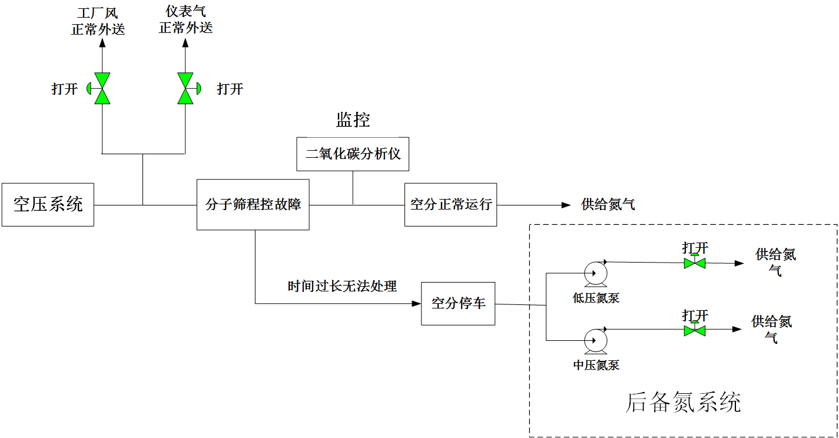Diagram of accident scene process (the above diagram) is attached.  Air compression system  Open  Monitoring  Backup nitrogen system  Supply of  nitrogen  Supply of  nitrogen  Supply of nitrogen  Open  Normal delivery of plant air  Normal delivery of instrument air  Program control malfunction of the molecular sieve  Carbon dioxide monitoring instrument  Normal operation of air separation  Shutdown of air separation  Unable to be processed for too long  Open  Open  Low-pressure nitrogen pump  Medium-pressure nitrogen pump  附事故场景流程简图（上图）
Termination of emergency plan  应急预案终止 | The malfunction of sequencing valve of the molecular sieve has been confirmed to be troubleshooted; the programming controller has been started for operation; the analysis index of carbon dioxide at the outlet has been monitored; the system is running smoothly; and the team leader has reported to the dispatcher, the process engineer and the deputy manager that the abnormal situation has been removed. The team leader shall announce the termination of the emergency plan.  确认分子筛程控阀故障排除，启动程控器运行，监控出口二氧化碳分析指标，系统运行平稳，班长汇报调度、工艺工程师、副经理，异常情况解除。班长宣布应急预案终止。
Sign annotation is as follows:
符号注释如下：
[W]—outdoor operator, [N]—indoor operator, [B]—team leader, [N/W]—indoor operator/outdoor operator
[W]——外操，[N]——内操，[B]——班长，[N/W]——内操/外操

5.2.10 Emergency disposal plan for tripping of the booster expansion turbine

增压透平膨胀机跳车应急处置预案
Steps  步骤 | Disposal  处 置 | Person in charge  负责人
Discover the abnormity  发现异常 | [N]—It was found when monitoring the operation panel that the pressure increased expander gave an interlocked tripping alarm; the return valve UV00362A/B was opened; the emergency shut-off valve HV00360A/B was closed; and the air separation system stopped in an interlocking manner.  [N]—监盘发现增压膨胀机报警联锁跳车，回流阀UV00362A/B打开，紧急切断阀HV00360A/B关闭，联锁空分停车。 | The first abnormity finder  发现异常第一人
Confirm and report  确认、报告 | [W]—Confirm on the site that the pressure increased expander has tripped and the air separation system has tripped, and confirm that the backup nitrogen system has started automatically in an interlocking manner.  [W]—现场确认增压膨胀机跳车，空分跳车，确认后备氮系统已联锁自启。 | Team leader and the first abnormity finder  班长、  发现异常第一人
Give an alarm  报警 | [B]—Report to the dispatcher, the process engineer and the deputy manager: the pressure increased expander has stopped and the air separation system has stopped, and report the reason for the stopping and the recovery time needed.  [B]—向调度、工艺工程师、副经理报告：增压膨胀机停车，空分停车，汇报停车原因及需恢复时间。 | Team leader  班长
Initiate the emergency procedure  应急程序启动 | 1、[N]—Confirm that the external supply pressure PICAS00611A/B/C, temperature TIAS00604A/B/C and flow rate FI00601 of the backup low-pressure liquid nitrogen pump are normal; confirm that the pressure PICAS00707A/B/C, temperature TIAS00703A/B/C and flow rate FI00701 of the medium-pressure nitrogen pipe network are normal; confirm that the main vent valve PV00110 of the compressor pipeline is normally opened for venting, and control the total outlet pressure to be normal to avoid overpressure; pay attention to whether the pressure PI00101 and flow rate FI01001 of the instrument air and the pressure PI01004 and flow rate FI01004 of the plant air are normal; the air separation system shall have an emergency shutdown (close HV00503, HV00502, HV00403, HV00404 and PV00406, confirm that the HV00401A/B has been closed in an interlocking manner, and monitor the pure nitrogen tower pressure PI00403/PI00404; confirm that the sealing gas pressure of the pressure increased expander is normal; confirm that the sealing gas of the cold box is supplied normally; and confirm that the instrument air of the air separation system has been switched to the instrument air of the air compression system);  [N]—确认后备低压液氮泵外供压力PICAS00611A/B/C、温度TIAS00604A/B/C、流量FI00601正常；确认中压氮管网压力PICAS00707A/B/C、温度TIAS00703A/B/C、流量FI00701正常；确认压缩机管线总放空阀PV00110正常打开放空，并控制总出口压力正常，避免出现超压现象；关注仪表风压力PI00101、仪表风流量FI01001及工厂风压力PI01004、工厂风流量FI01004正常；空分系统做紧急停车处理（关闭HV00503、HV00502、HV00403、HV00404、PV00406，确认HV00401A/B联锁关闭，监控纯氮塔压力PI00403/PI00404；确认增压膨胀机密封气压力正常；确认冷箱密封气正常供应；确认空分系统仪表风已切换为空压系统仪表风）；  2、[W]—If the liquid filling is in progress, close the charging valve V00603 on the site to stop the liquid nitrogen delivery operation; confirm on the site that the water-bath type and air-temperature type vaporizers and the backup liquid nitrogen pump are running normally, without phenomenon of escaping, spilling, dripping and leakage;  [W]—若正在进行液体充装，现场关闭充液阀V00603，停止液氮外送操作；现场确认水浴式、空温式汽化器、后备液氮泵正常运行，无跑、冒、滴、漏现象；  3、[N/W]—Restart the air separation system and return it to normal working condition;  [N/W]—重新启动空分系统，恢复至正常工况；  4、[B]—Contact electrical, instrument control and mechanical professionals to check for the cause of the tripping of the pressure increased expander on the site and repair it for standby application.  [B]—联系电气、仪控、机械专业人员现场检查增压膨胀机跳车原因，修复备用。 | Team leader, indoor operator and outdoor operator  班长、内操和外操
Adjust the procedure  流程调整 | Restart the air separation system, resume the external supply of nitrogen after it is normal, and withdraw the backup system.  重新启动空分系统，正常后恢复外供氮气，退出后备系统。 | Team leader, indoor operator and outdoor operator  班长、内操和外操
Attention  注 意 | 1、Pay attention to the total outlet pressure regulation of the compressor, control the pressure of instrument air and plant air to be normal;  关注压缩机总出口压力调节，控制仪表风和工厂风压力正常；  2、If the air-bath type vaporizer is severely frozen, conduct deicing on the site;  若空浴式汽化器结冰严重，现场除冰；  3、Monitor the pressure and liquid level in the pure nitrogen tower, and the temperature difference between the hot and cold ends of the heat exchanger;  监控纯氮塔内压力和液位，换热器的冷热端温差；  4、The liquid level in the storage tank of the atmospheric-pressure liquid nitrogen shall be ≥6m, to avoid cavitation of the backup pump, damaging the equipment;  常压液氮储槽液位≥6m，以免后备泵发生气蚀，损坏设备；  5、Warm the malfunctioning pressure increased expander.  对故障增压膨胀机加温。
Diagram of process/facility system  工艺/设施系统简图 | 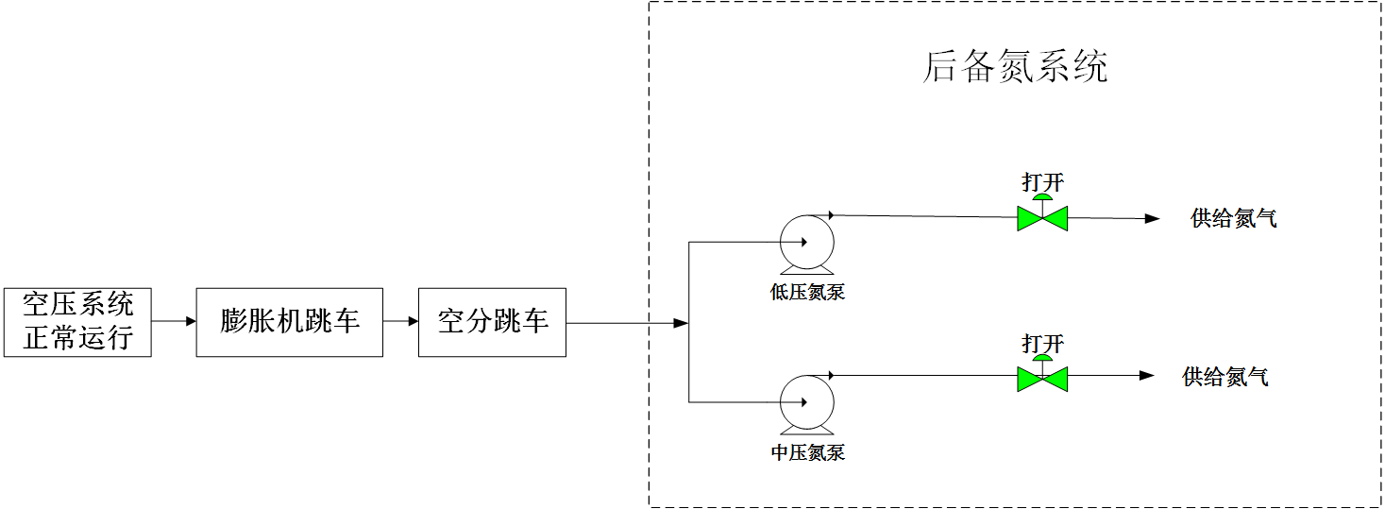  Normal operation of air compression system  Tripping of the expansion machine  Tripping of air separation  Backup nitrogen system  Low-pressure nitrogen pump  Medium-pressure nitrogen pump  Open  Open  Supply of nitrogen  Supply of nitrogen  Diagram of accident process (the above diagram) is attached  附事故流程简图（上图）
Termination of emergency plan  应急预案终止 | The air separation system returns to normal, and the external nitrogen supply is normal; the malfunctioning pressure increased expander has been restored to normal standby after the warming up and cause searching; the dispatcher, the process engineer and the deputy manager have been reported that the air separation/compression systems have returned to normal and the abnormal situation has been removed. The team leader shall announce the termination of the emergency plan.  空分系统恢复正常，正常外供氮气；对故障增压膨胀机进行加温、查找原因后恢复正常备用；汇报调度、工艺工程师、副经理空分空压恢复正常，异常情况解除。班长宣布应急预案终止。
Sign annotation is as follows:
符号注释如下：
[W]—outdoor operator, [N]—indoor operator, [B]—team leader, [N/W]—indoor operator/outdoor operator
[W]——外操，[N]——内操，[B]——班长，[N/W]——内操/外操

5.2.11 Emergency disposal plan for electric-dazzling of the power grid

电网晃电应急处置预案

Steps  步骤 | Disposal  处 置 | Person in charge  负责人
Discover the abnormity  发现异常 | [N]—It was found when monitoring the operation panel that the air separation/compression systems stopped.  [N]—监盘发现空分空压系统停车。 | The first abnormity finder  发现异常第一人
Confirm and report  确认、报告 | [W]—The outdoor operator shall make an on-site confirmation and report to the team leader: confirm that the whole air separation/compression systems have tripped.  [W]—外操现场确认，向班长报告：确认空分空压全系统跳车。 | Team leader and the first abnormity finder  班长、  发现异常第一人
Give an alarm  报警 | [B]—Report to the dispatcher, the process engineer and the deputy manager: the air separation/compression systems have stopped due to electric-dazzling.  [B]—向调度、工艺工程师、副经理报告：空分空压因晃电停车。 | Team leader  班长
Initiate the emergency procedure  应急程序启动 | 1、[N]—After the power grid returned to normal, confirm that the external supply pressure PICAS00611A/B/C, temperature TIAS00703A/B/C and flow rate FI00701 of the backup low pressure liquid nitrogen pump are normal; the pressure PICAS00707A/B/C, temperature TIAS00703A/B/C and flow rate FI00701 of the medium pressure nitrogen pipe network are normal; pay attention to the pressure PI01002 of the instrument air accident tank and the pressure PI01001 of the instrument air pipe network, and close the external supply valve PV01001B to the plant air; the air separation system shall have an emergency shutdown (close HV00503, HV00502, HV00403, HV00404 and PV00406, confirm that HV00401A/B has been closed in an interlocking manner and monitor the pure nitrogen tower pressure PI00403/PI00404; confirm that the sealing gas pressure of the pressure increased expander is normal; confirm that the sealing gas of the cold box is supplied normally; and confirm that the instrument air of the air separation system has been switched to the instrument air of the air compression system);  [N]—电网恢复正常后，确认后备低压液氮泵外供压力PICAS00611A/B/C、温度TIAS00604A/B/C、流量FI00601正常；确认中压氮管网压力PICAS00707A/B/C、温度TIAS00703A/B/C、流量FI00701正常；关注仪表空气事故罐压力PI01002和仪表风管网压力PI01001，关闭去工厂风外供阀门PV01001B；空分系统做紧急停车处理（关闭HV00503、HV00502、HV00403、HV00404、PV00406，确认HV00401A/B联锁关闭，监控纯氮塔压力PI00403/PI00404；确认增压膨胀机密封气压力正常；确认冷箱密封气正常供应；确认空分系统仪表风已切换为空压系统仪表风）；  2、[W]—If the liquid filling is in progress, and the liquid nitrogen filling pump has stopped due to the power failure, close the charging valve V00603 on the site to stop the liquid nitrogen delivery operation; confirm on the site that the water-bath type and air-temperature type vaporizers and the backup liquid nitrogen pump are running normally, without phenomenon of escaping, spilling, dripping and leakage;  2、[W]—若正在进行液体充装，液氮充装泵因停电已停止，现场关闭充液阀V00603，停止液氮外送操作；现场确认水浴式、空温式汽化器、后备液氮泵正常运行，无跑、冒、滴、漏现象；  3、[B]—Contact electrical professional to check for the cause of electric-dazzling, and start the air compressor to supply the instrument air pressure.  [B]—联系电气专业人员排查晃电原因，启动空压机供仪表风压力；  4、[N/W]—Restart the air compression/separation systems and return them to normal working condition.  [N/W]—重新启动空压空分系统，恢复至正常工况。 | Team leader, indoor operator and outdoor operator  班长、内操和外操
Adjust the procedure  流程调整 | Resume the operation of the air compressor, resume the plant air delivery, and restart the air separation system. After it is normal, the qualified nitrogen shall be delivered to stop the backup nitrogen system.  恢复空压机运行，恢复工厂风外送，重新启动空分系统，正常后外送合格氮气，停止后备氮系统。 | Team leader, indoor operator and outdoor operator  班长、内操和外操
Attention  注 意 | 1、Close the plant air to ensure the instrument air pressure;  关闭工厂风，保证仪表风压力；  2、If the air-bath type vaporizer is severely frozen, conduct deicing on the site;  若空浴式汽化器结冰严重，现场除冰；  3、Monitor the pressure and liquid level in the pure nitrogen tower, and the temperature difference between the hot and cold ends of the heat exchanger;  监控纯氮塔内压力和液位，换热器的冷热端温差；
Diagram of process/facility system  工艺/设施系统简图 | 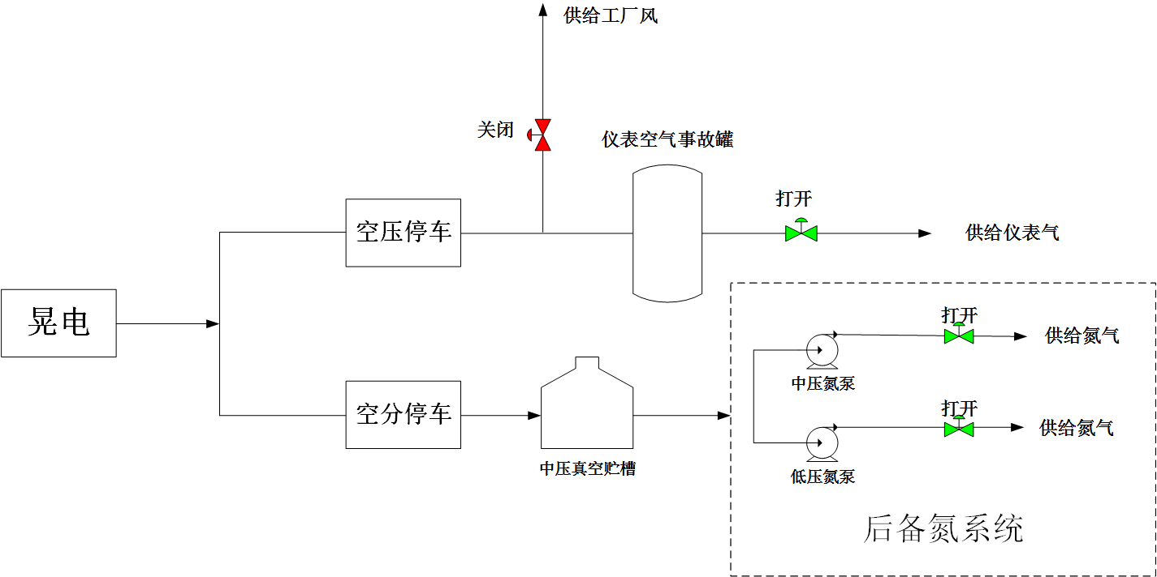  Backup nitrogen system  Low-pressure nitrogen pump  Medium-pressure nitrogen pump  Open  Open  Supply  of nitrogen  Supply  of nitrogen  Open  Close  Electric-dazzling  Shutdown of air compression  Shutdown of air separation  Supply of instrument air  Supply of plant air  Instrument air accident tank  Medium-pressure vacuum storage tank  Diagram of accident scene process (the above diagram) is attached  附事故场景流程简图（上图）
Termination of emergency plan  应急预案终止 | The electric power supply has returned to normal; the backup nitrogen supply has been normal; the air compressor has been started; the plant air delivery has been resumed; the air separation system is running normally; the backup nitrogen system has been withdrawn; and the dispatcher, the process engineer and the deputy manager have been reported that the abnormal situation has been removed. The team leader shall announce the termination of the emergency plan.  电力供应恢复正常，后备氮正常供应，空压机启动，恢复工厂风外送，空分系统运行正常，后备氮系统退出，汇报调度、工艺工程师、副经理，异常情况解除。班长宣布应急预案终止。
Sign annotation is as follows:
符号注释如下：
[W]—outdoor operator, [N]—indoor operator, [B]—team leader, [N/W]—indoor operator/outdoor operator
[W]——外操，[N]——内操，[B]——班长，[N/W]——内操/外操

5.2.12 Emergency disposal plan for leakage of liquid nitrogen vessel

液氮罐泄漏应急处置预案

Steps  步骤 | Disposal  处 置 | Person in charge  负责人
Discover the abnormity  发现异常 | [W]—It was found in the on-site routing inspection that the liquid nitrogen vessel leaked and the white fog permeated in the scene.  [W]—现场巡检发现液氮罐泄漏，现场白雾弥漫。 | The first abnormity finder  发现异常第一人
Confirm and report  确认、报告 | [W]—Two persons shall fully wear the labour protection articles and be equipped with the air breathing apparatus and portable oxygen analyzer to confirm the leakage position on the liquid nitrogen vessel from the windward to the site to determine the alert area and report to the team leader.  [W]—两人穿戴劳保齐全并配戴空气呼吸器、便携式氧分析仪从上风处至现场确认液氮罐泄漏部位，确定警戒范围，向班长报告。 | Team leader and the first abnormity finder  班长、  发现异常第一人
Give an alarm  报警 | [B] —Report to the dispatcher, the process engineer, the safety engineer, the equipment engineer and the deputy manager: the liquid nitrogen vessel leaks. And report the cause of leakage;  [B]—向调度、工艺工程师、安全工程师、设备工程师、副经理报告：液氮罐泄漏，汇报泄漏原因；  [B]—Give a gas protection alarm.  [B]—报气防警。 | Team leader  班长
Initiate the emergency procedure  应急程序启动 | 1、[B/W]—Direct the on-site operation personnel and other personnel nearby to immediately evacuate towards the direction of the uptake, set up a warning line, and block the intersection;  [B/W]—指挥现场作业及周边其他人员立即向上风口方向撤离，设置警戒线，封锁路口；  2、[N/W]—Close the charging valve HV00503 for liquid nitrogen to the storage tank, confirm the leakage of the liquid nitrogen vessel and the evacuation of the on-site personnel through monitoring; stop the liquid nitrogen filling tank truck, confirm the specific part of the leak on the site, cut off the source of liquid nitrogen, and let the liquid to evaporate naturally.  [N/W]—关闭液氮至储槽充液阀门HV00503，通过监控确认液氮罐泄漏情况及现场人员撤离情况；停止液氮充槽车，现场确认泄漏具体部位，切断液氮来源，待液体自然蒸发。  The accident liquid nitrogen vessel leaks at very large leakage amount, which cannot be disposed  事故液氮罐泄漏量非常大且无法处置  1、[B]—Contact the dispatcher to notify the personnel of other units in the downwind direction to take measures to prevent nitrogen suffocation, and be ready to evacuate at any time;  [B]—联系调度通知下风向其他装置人员做好防氮气窒息措施，随时准备撤离；  2、[N]—Fully open the pressure regulating valve on the top of the storage tank, report the dispatcher to prepare for stopping and evacuating the air separation system at any time, and perform safety disposal work for the follow-up equipment.  [N]—全开贮槽顶部调压阀，报告调度空分随时做好停车撤离准备，后续装置做好安全处置工作。 | Team leader, indoor operator and outdoor operator  班长、内操和外操
Adjust the procedure  流程调整 | The liquid nitrogen on the site has been naturally evaporated; the alert has been cancelled; the leakage point of the liquid nitrogen has been disposed; and the liquid nitrogen storage tank shall be restored to normal use.  现场液氮自然蒸发完毕，警戒撤销，液氮泄漏点得到处理，液氮储槽恢复正常使用。 | Team leader, indoor operator and outdoor operator  班长、内操和外操
Attention  注 意 | 1、For leakage at the leakage point of the low-pressure liquid nitrogen vessel, stop the liquid nitrogen delivery, cut off the medium, and eliminate the leakage on the site;  针对低压液氮罐泄漏点泄漏情况，停止液氮外送，切断介质，现场消漏；  2、If the leakage point cannot be disposed temporarily, follow the command of the gas protection personnel to safely dispose the leakage;  漏点暂时无法处理，听从气防人员指挥，安全处置漏情；  3、Prevent people from nitrogen suffocation and frostbite;  防止人员氮气窒息、冻伤；
Termination of emergency plan  应急预案终止 | The liquid nitrogen storage tank has been disposed for the leakage point and returned to normal; and the dispatcher, the process engineer, the safety engineer, the equipment engineer and the deputy manager have been reported that it has returned to normal and the abnormal situation has been removed. The team leader shall announce the termination of the emergency plan.  液氮储槽泄漏点得到处理，恢复正常；汇报调度、工艺工程师、安全工程师、设备工程师、副经理恢复正常，异常情况解除。班长宣布应急预案终止。
Sign annotation is as follows:
符号注释如下：
[W]—outdoor operator, [N]—indoor operator, [B]—team leader, [N/W]—indoor operator/outdoor operator
[W]——外操，[N]——内操，[B]——班长，[N/W]——内操/外操

5.2.13 Emergency disposal plan for nitrogen leakage

氮气泄漏应急处置预案

Steps  步骤 | Disposal  处 置 | Person in charge  负责人
Discover the abnormity  发现异常 | [W]—The portable oxygen analyzer gives an alarm in the on-site routing inspection to confirm the nitrogen leak.  [W]—现场巡检便携式氧分析仪报警，确认氮气泄漏。 | The first abnormity finder  发现异常第一人
Confirm and report  确认、报告 | [W]—Confirm the leakage position of the nitrogen pipeline on the site.  [W]—现场确认氮气管线泄漏部位。 | Team leader and the first abnormity finder  班长、  发现异常第一人
Give an alarm  报警 | [B]—Report to the dispatcher, the process engineer and the equipment engineer: the nitrogen pipeline leaks at the site of air separation.  [B]—向调度、工艺工程师、设备工程师报告：空分现场氮气管线泄漏。 | Team leader  班长
Initiate the emergency procedure  应急程序启动 | 1、[N]—Confirm the pressure change trend of the leakage pipeline, and carry out energy isolation and backup nitrogen supplementation for the leaking nitrogen pipeline;  [N]—确认泄漏管线压力变化趋势，对泄漏氮气管线能源隔离和后备氮气补充工作；  2、[W]—Carry a portable oxygen analyzer and ask the operation personnel to immediately evacuate from the site and count the number of personnel, and cordon off;  [W]—携带便携式氧分析仪，要求作业人员立即撤离现场并清点人数，拉警戒线；  3、[B]—Contact the professional to eliminate the leakage on the site;  [B]—联系专业人员现场消漏；  4、[W]—After the leakage elimination is completed, resume the pipeline gas supply and withdraw the standby nitrogen system;  [W]—消漏完成后，恢复管线供气，退出备用氮系统； | Team leader, indoor operator and outdoor operator  班长、内操和外操
Adjust the procedure  流程调整 | The leakage elimination is completed and the gas supply shall be resumed.  消漏完成，恢复供气。 | Team leader, indoor operator and outdoor operator  班长、内操和外操
Attention  注 意 | 1、Prevent nitrogen suffocation and falling from high altitude;  防止氮气窒息，防止高空坠落；  2、Pay attention to the nitrogen supply pressure, purity and flow rate;  注意供应氮气压力、纯度、流量；  3、Pay attention to the wind direction in personnel evacuation;  疏散人员时注意风向；  4、If the on-site environmental oxygen analyzer gives an alarm, all personnel shall be prohibited from entering.  如现场环境氧分析仪发生报警，禁止所有人员进入。
Termination of emergency plan  应急预案终止 | The leakage elimination has been completed; the gas supply has been resumed; and the dispatcher, the process engineer and the equipment engineer have been reported that the abnormal situation has been removed. The team leader shall announce the termination of the emergency plan.  消漏完成，恢复供气，汇报调度、工艺工程师、设备工程师，异常情况解除。班长宣布应急预案终止。
Sign annotation: [W]—outdoor operator, [N]—indoor operator, [B]—team leader, [N/W]—indoor operator/outdoor operator
符号注释：[W]——外操，[N]——内操，[B]——班长，[N/W]——内操/外操

6 Attachments

附录

6.1 Address book for emergency disposal

应急处置联络通讯录

6.1.1 Frequently used work number

常用工作联系电话

S/N  序号 | Contact addresses  联系地点 | Telephone number  电话号码
1 | Fire alarm  火 警
2 | First aid center  急 救
3 | Traffic accident  交通事故
4 | Telephone number of the Company’s general dispatcher  公司总调电话

6.1.2 List of contact numbers of management personnel and team leaders

管理人员及班长联系电话一览表

Member  成员 | Name  姓名 | Title  职务 | Mobile phone  电话 | IP phone  IP电话 | Remarks  备注
Commander-in-chief  总指挥 | She Hongmei  佘红梅 | Department leader  部长 | 13995302806 | 3152
Deputy commander-in-chief  副总指挥 | Ying Tangjin  应唐进 | Deputy department leader  副部长 | 13506848166 | 3606
Safety guarantee group  安全保障组 | Zhang Haoran  张浩然  Li Wenqiang  李文强 | Safety engineer  安全工程师 | 13909517500  13895670634 | 3609
Equipment disposal group  设备处置组 | Shi Shuigen  施水根  Liang Jinbao  梁金豹  Ning Zexian  宁泽贤 | Deputy department leader  副部长  Chief equipment engineer  设备主任工程师  Equipment Engineer  设备工程师 | 13567438224  13519585044  18312961005 | 3608  3153
Process disposal group  工艺处置组 | Wen Jiancheng  温建成  Wang Liang  王 亮  Ma Yue  马 跃 | Deputy department leader  副部长  Process Engineer  工艺工程师  Process Engineer  工艺工程师 | 13709598781  13895305381  18368475429
On-site emergency group  现场应急组 | Wu Yuanyi  吴圆意 | Team leader  班长 | 13157308536
On-site emergency group  现场应急组 | Zhao Liangliang  赵亮亮 | Team leader  班长 | 17330276504
On-site emergency group  现场应急组 | Yu Yi  余 毅 | Team leader  班长 | 18700099958
On-site emergency group  现场应急组 | Chen Daixing  陈代兴 | Team leader  班长 | 15923145622
On-site emergency group  现场应急组 | Deng Kun  邓 昆 | Team leader  班长 | 18792568606
On-site emergency group  现场应急组 | Wang Ying  王 莹 | Team leader  班长 | 15825385210
On-site emergency group  现场应急组 | Yu Yapeng  于亚鹏 | Team leader  班长 | 13347031551
On-site emergency group  现场应急组 | Zhang Yunbo  张云波 | Team leader  班长 | 18603436779

6.2 Hazard information and emergency disposal principles of key hazardous chemicals involved in the accident

事故所涉及的重点监管危险化学品危害信息、应急处置原则

Name  名称 | Chemical activity  化学活性 | Toxicity  毒性 | First aid  急救 | Leakage disposal  泄漏处理 | Fire technology  消防技术 | Others  其他
Hydrochloric acid  盐酸 | It can react with some active metal powder to release hydrogen, and produce highly toxic hydrogen cyanide gas in the presence of cyanide. It reacts with the base and gives off a lot of heat. And it is highly corrosive.  能与一些活性金属粉末发生反应, 放出氢气。遇氰化物能产生剧毒的氰化氢气体。与碱发生中合反应，并放出大量的热。具有较强的腐蚀性。 | Exposure to its vapor or smog can cause acute poisoning, triggering eye conjunctivitis, burning sensation in the nasal and oral mucosas, epistaxis, gingiva bleeding, tracheitis, etc. Taking by mistake can cause burns in the digestive tract and ulceration, which may cause gastric perforation, peritonitis, etc. Eye and skin contact can cause burns. Chronic effects: long-term exposure will cause chronic rhinitis, chronic bronchitis, dental erosion and skin lesion.  接触其蒸气或烟雾，可引起急性中毒，出现眼结膜炎，鼻及口腔粘膜有烧灼感，鼻衄、齿龈出血，气管炎等。误服可引起消化道灼伤、溃疡形成，有可能引起胃穿孔、腹膜炎等。眼和皮肤接触可致灼伤。慢性影响：长期接触，引起慢性鼻炎、慢性支气管炎、牙齿酸蚀症及皮肤损害。 | In the event of an accident, immediately adopt the following procedure for treatment, and contact the doctor at the same time to describe the type of the accident, the scope of the injury and the symptoms.  如果发生了事故，立即采用下面的程序处理，同时与医生联系，叙述事故的类型，受伤范围和症状。  Skin contact: take off contaminated clothing immediately, wash with a large amount of flowing water for at least 15 minutes. Seek medical treatment.  皮肤接触： 立即脱去污染的衣着，用大量流动清水冲洗至少15 分钟。就医。  Eye contact: hold the skin of eyelid immediately, thoroughly wash with a large amount of flowing water or physiological saline for at least 15 minutes. Seek medical treatment.  眼睛接触： 立即提起眼睑，用大量流动清水或生理盐水彻底冲洗至少15 分钟。就医。  Inhalation: quickly remove the sufferer from the scene to a place with fresh air. Keep the respiratory tract open. Give oxygen in case of dyspnea. Give artificial respiration immediately in case of respiratory arrest, and seek medical treatment.  吸入： 迅速脱离现场至空气新鲜处。保持呼吸道通畅。如呼吸困难，给输氧。如呼吸停止，立即进行人工呼吸，就医。  Ingestion: gargle with water, drink milk or egg white. Seek medical treatment.  食入： 用水漱口，给饮牛奶或蛋清。就医。 | Personnel shall be quickly evacuated from the leakage contaminated area to safety areas, and then the leakage contaminated area shall be isolated, and its access shall be strictly prohibited. It is suggested that emergency treatment personnel wear self-contained positive pressure respirators and acid and alkali-resistant work clothing. Direct exposure to leakage is strictly prohibited. Leaking sources shall be cut off as possible. Small amount of leakage: the leakage can be mixed with sand, dry lime or soda ash, or washed with a large amount of water, and the diluted washing water shall be discharged into the wastewater system. Large amount of leakage: cofferdam shall be constructed or holes shall be dug for receiving large amount of leakage. Then the leakage shall be transferred to tank cars or special collectors by pumps for recovery or transported to waste treatment fields for treatment.  迅速撤离泄漏污染区人员至安全区，并进行隔离，严格限制出入。建议应急处理人员戴自给正压式呼吸器，穿防酸碱工作服。不要直接接触泄漏物。尽可能切断泄漏源。小量泄漏：用砂土、干燥石灰或苏打灰混合。也可以用大量水冲洗，洗水稀释后放入废水系统。大量泄漏：构筑围堤或挖坑收容。用泵转移至槽车或专用收集器内，回收或运至废物处理场所处置。 | Neutralize with alkaline substance such as sodium bicarbonate, sodium carbonate and hydrated lime. It can also be put out by a large amount of water.  用碱性物质如碳酸氢钠、碳酸钠、消石灰等中和。也可用大量水扑救
Sulfuric acid  硫酸 | It releases a lot of heat and even gives rise to boiling and splashing in water. It reacts vigorously with inflammables (e.g. benzene) and combustibles (e.g. sugar and cellulose), and even results in combustion, reacts violently with calcium carbide, perchlorate, fulminate, nitrate, picrate, metal powder, etc., resulting in explosion or combustion, and has strong corrosivity and water absorbability.  遇水大量放热，可发生沸溅。与易燃物（如苯）和可燃物（如糖、纤维素等）接触会发生剧烈反应，甚至引起燃烧。遇电石、高氯酸盐、雷酸盐、硝酸盐、苦味酸盐、金属粉末等猛烈反应，发生爆炸或燃烧。有强烈的腐蚀性和吸水性。 | Sulfuric acid has strong irritant and corrosive effects on skin and mucous membrane. Its vapor or mist can cause conjunctivitis, chemosis, opacitas corneae and even blindness, irritation to respiratory tract, and dyspnea and pulmonary edema in severe cases; and high-concentration sulfuric acid can cause laryngospasm or glottis edema, and even asphyxia and death. After oral application, burns in the digestive tract will occur, resulting in ulceration, and possible gastric perforation, peritonitis, renal impairment, shock, etc. in severe cases. Erythema develops in those with skin slightly burned, and ulcer develops in those with skin severely burned; the scar contracts after healing, but still affects skin function. When sulfuric acid splashes into eyes, burns, even corneal perforation, panophthalmitis and blindness will occur.  对皮肤、粘膜等组织有强烈的刺激和腐蚀作用。蒸气或雾可引起结膜炎、结膜水肿、角膜混浊，以致失明，引起呼吸道刺激，重者发生呼吸困难和肺水肿；高浓度引起喉痉挛或声门水肿而窒息死亡。口服后引起消化道烧伤以致溃疡形成，严重者可能有胃穿孔，腹膜炎；肾损害、休克等。皮肤灼伤轻者出现红斑，重者形成溃疡，愈后斑痕收缩影响功能。溅入眼内可造成灼伤，甚至角膜穿孔、全眼炎以至失明。  Chronic effects: dental erosion, chronic bronchitis, emphysema and pneumosclerosis.  慢性影响：牙齿酸蚀症、慢性支气管炎、肺气肿和肺硬化。 | Skin contact: take off contaminated clothing immediately, wash with a large amount of flowing water for 20-30 minutes. Seek medical treatment in case of discomfort.  皮肤接触：立即脱去污染的衣着，用大量流动清水冲洗20～30 分钟。如有不适感，就医。  Eye contact: hold the skin of eyelid immediately, thoroughly wash with a large amount of flowing water or normal saline for 10-15 minutes. Seek medical treatment in case of discomfort.  眼睛接触：立即提起眼睑，用大量流动清水或生理盐水彻底冲洗10～15 分钟。如有不适感，就医。  Inhalation: quickly remove the sufferer from the scene to a place with fresh air. Keep the respiratory tract open. Give oxygen in case of dyspnea. Perform cardiopulmonary resuscitation immediately if breathing and heartbeat stop. Seek medical treatment.  吸入：迅速脱离现场至空气新鲜处。保持呼吸道通畅。如呼吸困难，给输氧。呼吸、心跳停止，立即进行心肺复苏术。就医。 | Personnel shall be quickly evacuated from the leakage contaminated area to safety areas, and then the leakage contaminated area shall be isolated, and its access shall be strictly prohibited. It is suggested that emergency treatment personnel wear self-contained positive pressure respirators and acid and alkali-resistant work clothing. Direct exposure to leakage is strictly prohibited.  迅速撤离泄漏污染区人员至安全区。并进行隔离，严格限制出人。建议  应急处理人员戴自给正压式呼吸器，穿防酸碱工作服。不要直接接触泄漏物。  Leaking sources shall be cut off as possible. Prevent it from flowing into sewer, flood discharge trench and other confined space. Small amount of leakage: the leakage can be mixed with sand, dry lime or soda ash, or washed with a large amount of water, and the diluted washing water shall be discharged into the wastewater system. Large amount of leakage: cofferdam shall be constructed or holes shall be dug for receiving large amount of leakage; then the leakage shall be transferred to tank cars or special collectors by pumps for recovery or transported to the waste treatment fields for treatment.  尽可能切断泄漏源。防止进入下水道、排洪沟等限制性空间。小量泄漏：用砂土、干燥石灰或苏打灰混合。也可以用大量水冲洗，洗水稀释后放人废水系统。大量泄漏：构筑围堤或挖坑收容；用泵转移至槽车或专用收集器内，回收或运至废物处理场所处置。 | The chemical is non-combustible. Select suitable fire extinguishing agent for extinguishment based on reasons for the fire. Attentions and measures for extinguishment: fire fighters must wear full-body acid and alkali-resistant fire fighting protective clothing and air breathing apparatus for extinguishment. Vessels shall be removed from the scene of a fire to open space. It shall cool vessels in the fireground by spraying water until the fire is extinguished. Impact of water flow against articles must be avoided to prevent sulfuric acid from generating lots of heat in water and splashing, burning the skin.  本品不燃。根据着火原因选择适当灭火剂灭火。灭火注意事项及措施：消防人员必须穿全身耐酸碱消防服、佩戴空气呼吸器灭火。尽可能将容器从火场移至空旷处。喷水保持火场容器冷却，直至灭火结束。避免水流冲击物品，以免遇水会放出大量热量发生喷溅而灼伤皮肤。
Sodium hydroxide  氢氧化钠 | The chemical is non-combustible, and may generate lots of heat in the presence of water and vapor and form corrosive solution. It may cause a neutralization reaction and release heat when contacted with acids. Sodium hydroxide is highly corrosive.  本品不会燃烧，遇水和水蒸气大量放热，形成腐蚀性溶液。与酸发生中和反应并放热。具有强腐蚀性。 | The chemical is strongly irritant and corrosive. Its dust or smog is irritant to eyes and respiratory tract, and corrosive to nasal septum, direct exposure to skin and eyes can cause burns; taking by mistake can result in burns in the digestive tract, mucosa erosion, haemorrhage and shock.  本品有强烈刺激和腐蚀性。粉尘或烟雾刺激眼和呼吸道，腐蚀鼻中隔；皮肤和眼直接接触可引起灼伤；误服可造成消化道灼伤，粘膜糜烂、出血和休克。  Handling methods: water spray and sand. The fire fighting equipment (including SCBA) cannot provide sufficient and effective protection. Immediately evacuate from the site, isolate the equipment, and thoroughly clean the personnel in case of accidental contact. If the substance or the contaminated fluid enters the waterway, inform the downstream users with potential water pollution, and inform the local health and fire officials, and the pollution control departments. Use the water spray to cool the exposed vessel beyond the safe explosion-proof distance.  处理方式：雾状水、砂土。消防器具(包括SCBA)不能提供足够有效的防护。若不小心接触，立即撤离现场，隔离器具，对人员彻底清污。如果该物质或被污染的流体进入水路，通知有潜在水体污染的下游用户，通知地方卫生、消防官员和污染控制部门。在安全防爆距离以外，使用雾状水冷却暴露的容器。 | Skin contact: wash immediately with water for at least 15 minutes. Seek medical treatment in case of burns. Take off and isolate the contaminated clothing and shoes. For a small amount of skin contact, avoid expanding the material spread area. Take care to keep the sufferer warm and keep quiet. Inhalation, ingestion or skin contact of the substance may cause a delayed reaction. Ensure that the medical personnel have knowledge about the personal protection related to the substance and pay attention to their own protection.  皮肤接触：立即用水冲洗至少15 分钟。若有灼伤，就医治疗。脱去并隔离被污染的衣服和鞋。对少量皮肤接触，避免将物质播散面积扩大。注意患者保暖并且保持安静。吸入、食入或皮肤接触该物质可引起迟发反应。确保医务人员了解该物质相关的个体防护知识，注意自身防护。  Eye contact: hold the skin of eyelid immediately, wash with flowing water or normal saline for at least 15 minutes, or with 3% boric acid solution.  眼睛接触：立即提起眼脸，用流动清水或生理盐水冲洗至少15 分钟。或用3%硼酸溶液冲洗。  Seek medical treatment.  就医。  Inhalation: remove the sufferer from the scene to a place with fresh air, and carry out artificial respiration if necessary. Seek medical treatment. Give oxygen in case of dyspnea. If the sufferer has ingested or inhaled the substance, the artificial respiration shall not be conducted mouth to mouth but with a one-way valve small air breathing apparatus or other suitable medical respirators.  吸入：脱离现场至空气新鲜处。必要时进行人工呼吸。就医。如果呼吸困难，给予吸氧。如果患者食入或吸入该物质不要用口对口进行人工呼吸，可用单向阀小型呼吸器或其他适当的医疗呼吸器。  Ingestion: Rinse the mouth immediately when the sufferer is conscious, and drink diluted vinegar or lemon juice, and Seek medical treatment.  食入：患者清醒时立即漱口，口服稀释的醋或柠檬汁，就医。 | Isolate the leakage contaminated area, and arrange warning signs around it. It is suggested that emergency treatment personnel wear gas masks and chemical protection clothing.  隔离泄漏污染区，周围设警告标志，建议应急处理人员戴好防毒面具，穿化  Do not directly contact the leakage, and collect it in a dry and clean vessel with cover through a clean shovel, then add some in a large amount of water, and make it neutral, and discharge it in sewage system.  学防护服。不要直接接触泄漏物，用洁清的铲子收集于干燥净洁有盖的容器  It is also allowed to wash with a large amount of water, and the diluted washing water shall be discharged into the wastewater system. If there is large amount of leakage, it shall be recycled and abandoned after harmless treatment.  中，以少量加入大量水中，调节至中性，再放入废水系统。也可以用大量水  冲洗，经稀释的洗水放入废水系统。如大量泄漏，收集回收或无害处理后废  弃。
Hypochlorous acid  次氯酸 | The chemical is non-combustible and corrosive, and can cause burns to human body, with sensitization. It will produce toxic and corrosive fumes by high thermal decomposition.  本品不燃，具腐蚀性，可致人体灼伤，具致敏性。受高热分解产生有毒的腐蚀性烟气。 | Workers who often touch the chemical with hands will sweat a lot on their palms, with nails becoming thinner, and will suffer from falling off their hair. The chemical has sensitization. The free chlorine released from this chemical may cause poisoning.  经常用手接触本品的工人，手掌大量出汗，指甲变薄，毛发脱落。本品有致敏作用。本品放出的游离氯有可能引起中毒。 | First aid: skin contact: take off the contaminated clothing, and wash with plenty of flowing water.  急救：皮肤接触：脱去污染的衣着，用大量流动清水冲洗。  Eye contact: hold the skin of eyelid, wash with flowing water or normal saline. Seek medical treatment.  眼睛接触：提起眼睑，用流动清水或生理盐水冲洗。就医。  Inhalation: quickly remove the sufferer from the scene to a place with fresh air. Keep the respiratory tract open. Give oxygen in case of dyspnea. Perform artificial respiration immediately in case of respiratory arrest. Seek medical treatment.  吸入：迅速脱离现场至空气新鲜处。保持呼吸道通畅。如呼吸困难，给输氧。如呼吸停止，立即进行人工呼吸。就医。  Ingestion: drink sufficient warm water and apply emetic method. Seek medical treatment.  食入：饮足量温水，催吐。就医。  Protective measures: in a high concentration environment, a chin style gas mask (half mask) shall be worn. Personnel must wear chemical safety protection glasses, anticorrosion work clothing, and rubber gloves. It is prohibited to smoke, eat and drink at the work site. Personnel shall have a shower and change clothing after work, and pay attention to personal hygiene.  防护措施：高浓度环境中，应该佩戴直接式防毒面具（半面罩）。戴化学安全防护眼镜。穿防腐工作服。戴橡胶手套。工作现场禁止吸烟、进食和饮水。工作完毕，淋浴更衣。注意个人清洁卫生。 | Leakage disposal: personnel shall be quickly evacuated from the leakage contaminated area to safety areas, and then the leakage contaminated area shall be isolated, and its access shall be strictly prohibited. It is suggested that emergency treatment personnel wear self-contained positive pressure respirators and acid and alkali-resistant work clothing. Direct exposure to leakage is strictly prohibited. Leaking sources shall be cut off as possible.  泄漏处理：迅速撤离泄漏污染区人员至安全区，并进行隔离，严格限制出入。建议应急处理人员戴自给正压式呼吸器，穿防酸碱工作服。不要直接接触泄漏物。尽可能切断泄漏源。  Small amount of leakage: small amount of leakage can be absorbed by sand, vermiculite or other inert materials.  小量泄漏：用砂土、蛭石或其它惰性材料吸收。  Large amount of leakage: cofferdam shall be constructed or holes shall be dug for receiving large amount of leakage. Foam shall be adopted to cover the leakage so as to reduce disasters caused by vapor. Then the leakage shall be transferred to tank cars or special collectors by pumps for recovery or transported to waste treatment fields for treatment.  大量泄漏：构筑围堤或挖坑收容。用泡沫覆盖，降低蒸气灾害。用泵转移至槽车或专用收集器内，回收或运至废物处理场所处置。 | 2）Cautions for storage and transportation  储运注意事项  Operation cautions: operate in an enclosed and well-ventilated environment. Operators must receive special training and comply with operation specification strictly. It is suggested that the operator wear the chin style gas mask (half mask), chemical safety protection glasses, anticorrosion work clothing and rubber gloves. Prevent vapor from leaking into air in the workplace. Avoid contact with the alkalies. Load and unload lightly to prevent damages of packaging and vessels. Provide leakage emergency treatment facilities. Empty vessels may have harmful residues.  操作注意事项：密闭操作，全面通风。操作人员必须经过专门培训，严格遵守操作规程。建议操作人员佩戴直接式防毒面具（半面罩），戴化学安全防护眼镜，穿防腐工作服，戴橡胶手套。防止蒸气泄漏到工作场所空气中。避免与碱类接触。搬运时要轻装轻卸，防止包装及容器损坏。配备泄漏应急处理设备。倒空的容器可能残留有害物。  Storage cautions: it shall be stored in a shady and cool and ventilated warehouse. Keep away from fire and heat source. Temperature in the warehouse shall not be more than 30℃. Store separately from alkalies and forbid to store in mixing. Storage area shall be provided with leakage emergency treatment equipment and applicable leakage material holding apparatus.  储存注意事项：储存于阴凉、通风的库房。远离火种、热源。库温不宜超过30℃。应与碱类分开存放，切忌混储。储区应备有泄漏应急处理设备和合适的收容材料。
Oxygen (O)  氧 | Colorless and odorless gas. Relative density (air=1) 1.43, relative density of fluid (water=1)1.14/－183℃. Melting point －218.8℃, boiling point －183.1℃. Critical temperature -118.4℃, critical pressure 5.08MPa. －164℃ saturation, vapor pressure 506.62℃. Being soluble in water and ethanol.  无色无臭气体。相对密度（空气=1）1.43，液体相对密度（水=1）1.14/－183℃。熔点－218.8℃，沸点－183.1℃。临界温度-118.4℃，临界压力5.08MPa。－164℃易饱和蒸气压506.62℃。溶于水、乙醇。 | Oxygen is a comburent. It is one of the basic elements for combustion and explosion of inflammables and combustibles, and can oxidize most active substances, which can form the explosive mixture with inflammables (e.g. acetylene and methane). Exposure of liquid oxygen to oils, grease, etc. will cause burning and explosion.  氧为助燃物。是易燃物、可燃物燃烧爆炸的基本要素之一，能氧化大多数活性物质。与易燃物（如乙炔、甲烷等）形成有爆炸性的混合物。液氧接触油品、油脂等会导致燃烧、爆炸。  In usual atmospheric pressure, when the concentration of oxygen exceeds 40%, oxygen poisoning may occur. In case of inhalation of 40-60% of oxygen, there will be a substernal discomfort sensation, a tussicula, and then chest distress, substernal burning sensation and dyspnea and intensified cough; and pulmonary edema and asphyxia in severe cases. When the concentration of inhaled oxygen is above 80%, there would be facial muscle twitching, paleness, dizziness, tachycardia, collapse, and then tonic convulsion throughout the body, coma, respiratory failure and death.  常压下，当氧的浓度超过40%时，有可能发生氧中毒，吸入40～60%的氧时，出现胸骨后不适感、轻咳，进而胸闷、胸骨后烧灼感和呼吸困难、咳嗽加剧；严重时可发生肺水肿、窒息。吸入的氧浓度在80%以上时，出现面部肌肉抽动、面色苍白、眩晕、心动过速、虚脱，继而全身强直性抽搐、昏迷、呼吸衰竭而死亡。 | Inhalation: immediately leave the scene, breathe fresh air in time, rest quietly, and seek medical treatment.  吸入：立即脱离现场，及时呼吸新鲜空气，安静休息，就医。  Skin contact: in the event of frostbite, rewarm with warm water (38-42 °C). Do not use hot water or radiant heat. Do not rub. Use antiepileptic drugs such as diazepam and phenobarbital sodium in case of convulsion.  皮肤接触：发生冻伤，用温水（38～42℃）复温，忌用热水或辐射热，不要揉搓。抽蓄时用抗癫痫药物，如安定、苯巴比妥钠等。 | Personnel shall be quickly evacuated from the leakage area to upwind places, and then the leakage area shall be isolated, and its access shall be strictly prohibited. It is suggested that emergency treatment personnel wear self-contained positive pressure respirators and general work clothing. Avoid contact with combustibles or inflammables. Leaking vessels can be reused after proper treatment, repair and inspection. The leakage contaminated area shall be ventilated properly to accelerate spread. If possible, send the exhaust fan for leaking gas to an open space or install a suitable nozzle to burn it. Leaking vessels can be reused after proper treatment, repair and inspection. All the equipment used in operation shall be earthed. Leaking sources shall be cut off as possible. All the ignition sources shall be removed. the waste gas shall be directly discharged into the atmosphere. Pay attention to the discharge rate and the oxygen concentration at the discharge site.  迅速撤离泄漏区人员至上风处，并进行隔离，严格限制出入。 建议应急处理人员戴自给正压式呼吸器，穿一般作业工作服。避免与可燃物或易燃物接触。漏气容器要妥善处理，修复、检验后再用。 合理通风，加速扩散。如有可能，将漏出气用排风机送至空旷地方或装设适当喷头烧掉。 漏气容器要妥善处理，修复、检验后再用。 作业时使用的所有设备应接地。 尽可能切断泄漏源。 消除所有点火源。废气直接排入大气，注意排放速度和排放场所的氧气浓度。 | If the leaking gas is on fire, it is strictly forbidden to extinguish the fire unless Leaking sources can be safely cut off. It is suggested that emergency treatment personnel wear self-contained positive pressure respirators and general work clothing. Leaking sources shall be cut off as possible. The leakage contaminated area shall be ventilated properly to accelerate spread. All the ignition sources shall be removed. According to the area which is affected by the gas diffusion, precautionary area shall be designated, and irrelevant persons shall be evacuated into safety areas from crosswind and upwind directions. The leaking gas is allowed to be discharged into the atmosphere, and the leakage area shall be isolated until the gas is totally dispersed. Keep the vessel cool with water to prevent it from exploding due to heating and rapidly intensifying the fire. Quickly cut off the gas source, spray it with water to protect the personnel who is cutting off the gas source, and then select suitable fire extinguishing agent for extinguishment based on reasons for the fire.  泄漏气体着火，严禁灭火，除非能安全切断漏源。 建议应急处理人员戴自给正压式呼吸器，穿一般工作服。 尽可能切断泄漏源。 合理通风，加速扩散。 消除所有点火源。 根据气体扩散的影响区域划定警戒区，无关人员从侧风、上风向撤离至安全区。 漏出气允许排入大气中，隔离泄漏区直至气体散尽。用水保持容器冷却，以防受热爆炸，急剧助长火势。迅速切断气源，用水喷淋保护切断气源的人员，然后根据着火原因选择适当灭火剂灭火。
Nitrogen  氮 | Colorless and odorless gas. Its boiling point is at -195.6℃, and melting point at -209.8℃, and its relative density (water=1) is 0.81, and relative density (air=1) 0.97.  无色无臭气体。沸点为-195.6℃，熔点为-209.8℃，相对密度（水=1）为0.81，相对密度（空气=1）为0.97。 | Pressure in the vessel increases at high temperature, resulting in possible risk of burst and explosion. Contact with liquid nitrogen can cause frostbite. Excessively high nitrogen content in the air will cause asphyxia due to hypoxia.  遇高热，容器内压增大，有开裂和爆炸的危险。接触液氮会引起冻伤。空气中氮气含量过高，会引起缺氧窒息。 | Quickly remove the sufferer from the scene to a place with fresh air. Keep the respiratory tract open. Give oxygen in case of dyspnea. In case of respiration and cardiac arrest, give artificial respiration and closed cardiac massage promptly. Seek medical treatment. Skin contact: in the event of frostbite, rewarm with warm water (38-42 °C). Do not use hot water or radiant heat. Do not rub. Use antiepileptic drugs such as diazepam and phenobarbital sodium in case of convulsion.  迅速脱离现场至空气新鲜处。保持呼吸道通畅。如呼吸困难，给输氧。呼吸心跳停止时，立即进行人工呼吸和胸外心脏按压术。就医。 皮肤接触：发生冻伤，用温水（38～42℃）复温，忌用热水或辐射热，不要揉搓。抽蓄时用抗癫痫药物，如安定、苯巴比妥钠等。 | Personnel shall be quickly evacuated from the leakage contaminated area to upwind places, and then the leakage contaminated area shall be isolated, and its access shall be strictly prohibited. It is suggested that emergency treatment personnel wear self-contained positive pressure respirators and general work clothing. Leaking sources shall be cut off as possible. The leakage contaminated area shall be ventilated properly to accelerate spread. Leaking vessels can be reused after proper treatment, repair and inspection. The waste gas shall be directly discharged into the atmosphere. Pay attention to the discharge rate and the concentration at the discharge site.  迅速撤离泄漏污染区人员至上风处，并进行隔离，严格限制出入。 建议应急处理人员戴自给正压式呼吸器，穿一般作业工作服。 尽可能切断泄漏源。 合理通风，加速扩散。 漏气容器要妥善处理，修复、检验后再用。废气直接排入大气，注意排放速度和排放场所的浓度。 | The chemical is non-combustible. It is suggested that emergency treatment personnel wear self-contained positive pressure respirators and anti-static clothing. The leakage contaminated area shall be ventilated properly to accelerate spread. The leaking gas is allowed to be discharged into the atmosphere, and the leakage area shall be isolated until the gas is totally dispersed.  本品不燃 。建议应急处理人员戴自给正压式呼吸器，穿防静电工作服。 合理通风，加速扩散。 漏出气允许排入大气中，隔离泄漏区直至气体散尽。
Hydrogen sulfide  硫化氢 | Colorless and odorous gas. Its boiling point is at -60.4℃, and melting point at -85.5℃, and its relative density (air=1) is 1.19, and its explosion limit is 4%-46% (volume).  无色有恶臭的气体。沸点为-60.4℃，熔点为-85.5℃，相对密度（空气=1）为1.19，爆炸极限为4%～46%（体积）。 | It is flammable, and capable of forming an explosive mixture in case of mixture with air and causing a combustion explosion in the event of high temperature or an open flame. Its contact with concentrated nitric acid, fuming nitric acid or other strong oxidants will give rise to a violent chemical reaction, causing explosion. The gas is heavier than the air, can spread to remote places in low areas, and can cause back-burn in the presence of an open flame.  易燃，与空气混合能形成爆炸性混合物，遇高热、明火能引起燃烧爆炸。与浓硝酸、发烟硝酸或其他强氧化剂接触发生剧烈化学反应，发生爆炸。气体比空气重，能在较低处扩散到相当远的地方，遇明火会引起回燃。  Hydrogen sulfide is a strong neurotoxic substance, and has a strong irritating effect on the mucous membranes. Inhalation of high concentrations of hydrogen sulfide in short term will cause lacrimation, ophthalmodynia, running nose, burning sensation in the throat, cough, chest distress, headache, hypodynamia, clouding of consciousness, etc. Some sufferers may have cardiac damages. The serious patient may suffer encephaledema and pulmonary edema. Extremely high concentration (above 1,000mg/m³) will cause sudden coma, respiration and cardiac arrest in a few seconds and cause rapid death.  硫化氢是强烈的神经毒物，对粘膜有强烈刺激作用。短期内吸入高浓度硫化氢后出现流泪、眼痛、流涕、咽喉部灼热感、咳嗽、胸闷、头痛、乏力、意识模糊等。部分患者会有心肌损害。重者可出现脑水肿、肺水肿。极高浓度（1000mg/m³以上）时可在数秒钟内突然昏迷，呼吸和心跳骤停，发生闪电型死亡。 | Inhalation: quickly remove the sufferer from the scene to a place with fresh air. Keep the respiratory tract open. Give oxygen in case of dyspnea, In case of respiration and cardiac arrest, give artificial respiration and closed cardiac massage promptly, and seek medical treatment.  吸入：迅速脱离现场至空气新鲜处。保持呼吸道通畅。如呼吸困难，给氧。呼吸心跳停止时，立即进行人工呼吸和胸外心脏按压术，就医。 | According to the area which is affected by the gas diffusion, precautionary area shall be designated, and irrelevant persons shall be evacuated into safety areas from crosswind and upwind directions. All the ignition sources shall be removed (it is forbidden to smoke nearby the leakage area, and all the open flames, sparks or flames shall be removed). All the equipment shall be earthed in the operation. The emergency treatment personnel shall wear the positive-pressure self-contained breathing apparatus, and wear fully enclosed chemical protective clothing in the event of leakage without fire. The leakage shall be stopped in safety situation. The leakage area shall be isolated until the gas is totally dispersed. Isolation and evacuation distance: as for small-scale leakage, initial isolation distance shall be 30m and downwind evacuation distances in the daytime and at nights are 100m and 100m, respectively; as for large-scale leakage, initial isolation distance shall be 600m and downwind evacuation distances in the daytime and at nights are 3,500m and 8,000m, respectively.  根据气体扩散的影响区域划定警戒区，无关人员从侧风、上风向撤离至安全区。消除所有点火源（泄漏区附近禁止吸烟、消除所有明火、火花或火焰）。作业时所有设备应接地。应急处理人员戴正压自给式空气呼吸器，泄漏、未着火时应穿全封闭防化服。在保证安全的情况下堵漏。隔离泄漏区直至气体散尽。 隔离与疏散距离：小量泄漏，初始隔离30m，下风向疏散白天100m、夜晚100m；大量泄漏，初始隔离600m，下风向疏散白天3500m、夜晚8000m。 | Air sources shall be cut off. If the air source cannot be cut off, it is not allowed to put out flame at the leaking point. It shall spray water to cool vessels and move them from fireground to open space as far as possible.  切断气源。若不能切断气源，则不允许熄灭泄漏处的火焰。喷水冷却容器，尽可能将容器从火场移至空旷处。  Fire extinguishing agents: water spray, foam, carbon dioxide and dry chemical powder.  灭火剂：雾状水、泡沫、二氧化碳、干粉。
Lithium bromide  溴化锂 | The chemical is non-combustible. Lithium compounds have significant damage to the kidneys. Acute poisoning caused by oral administration of it is mainly manifested in the gastrointestinal tract, heart, kidney and nervous system.  本品不燃。锂化合物对肾脏有明显的损害作用。口服引起的急性中毒，以胃肠道、心脏、肾脏和神经系统的表现为主。  Invasion ways: inhalation or ingestion.  侵入途径： 吸入、食入。 | [Toxicity] Oral toxicity to rats LD50:1800mg/kg; oral toxicity to mice LD50:1840mg/kg  【毒性】 大鼠经口LD50:1800mg/kg；小鼠经口LD50:1840mg/kg | [Inhalation]: quickly remove the sufferer from the scene to a place with fresh air. Keep the respiratory tract open. Give oxygen in case of dyspnea. Perform cardiopulmonary resuscitation immediately if breathing and heartbeat stop. Seek medical treatment.  【吸入】：迅速脱离现场至空气新鲜处。保持呼吸道通畅。如呼吸困难，给输氧。呼吸、心跳停止，立即进行心肺复苏术。就医。  [Eye contact]: separate the skin of eyelid immediately, thoroughly wash with flowing water or normal saline. Seek medical treatment.  【眼睛接触】：立即分开眼睑，用流动清水或生理盐水彻底冲洗。就医。  [Skin contact]: take off contaminated clothing immediately, and thoroughly wash with flowing water. Seek medical treatment.  【皮肤接触】：立即脱去污染的衣着，用流动清水彻底冲洗。就医。  [Ingestion]: Rinse the mouth, and apply emetic method by putting the finger to the retropharynx. Seek medical treatment.  【食入】：漱口，以手指探咽后部催吐。就医。  Give sodium chloride to antagonize the toxicity of lithium.  给予氯化钠拮抗锂的毒性。 | [Leakage emergency disposal] The leakage contaminated area shall be isolated, and its access shall be strictly prohibited. It is suggested that emergency treatment personnel wear dust mask and antitoxic clothing. Do not touch the cracked vessels and leakage before wearing proper protective clothing. Leaking sources shall be cut off as possible. The leakage shall be covered by plastic cloth to reduce dispersal. Do not allow water to enter the packaging vessel. Collect the leakage with a clean shovel to a clean, dry and loosely lided vessel which shall then be moved away from the leakage area.  【泄漏应急处置】 隔离泄漏污染区，限制出入。建议应急处理人员戴防尘口罩，穿防毒服。穿上适当的防护服前严禁接触破裂的容器和泄漏物。尽可能切断泄漏源。用塑料布覆盖泄漏物，减少飞散。勿使水进入包装容器内。用洁净的铲子收集泄漏物，至于干净、干燥、盖子较松的容器中，将容器移离泄漏区。 | [Fire fighting methods]: it shall spray water to cool vessels and move them from fireground to open space as far as possible. Firefighters must wear full-body fireproofing and antitoxic clothing and air breathing apparatus, and extinguish the fire in the upwind direction.  【灭火方法】 喷水冷却容器，尽可能将容器从火场移至空旷处。消防人员必须穿全身防火毒服，佩戴空气呼吸器，在上风向灭火。  The chemical is non-combustible. Select suitable fire extinguishing agent based on reasons for the fire.  本品不燃，根据火灾原因选择适当的灭火剂。
Sulfur dioxide  二氧化硫 | Non-combustible. At normal temperature, the moist sulfur dioxide reacts with hydrogen sulfide to precipitate sulfur. Under the conditions of presence of high temperature and catalyst, it can be reverted to hydrogen sulfide by hydrogen and reverted to sulfur by carbon monoxide. Strong oxidants can oxidize the sulfur dioxide to sulfur trioxide, and the oxygen can oxidize the sulfur dioxide to sulfur trioxide only in the presence of a catalyst. It is pyrophoric without combustion-supporting property. Liquid sulfur dioxide can dissolve organic compounds such as amines, ethers, alcohols, phenols, organic acids and aromatics, and most saturated hydrocarbons cannot be dissolved. It has a certain water solubility and reacts with water and water vapor to generate toxic and corrosive vapors.  不燃。 在常温下，潮湿的二氧化硫与硫化氢反应析出硫。在高温及催化剂存在的条件下，可被氢还原成为硫化氢，被一氧化碳还原成硫。强氧化剂可将二氧化硫氧化成三氧化硫，仅在催化剂存在时，氧气才能使二氧化硫氧化为三氧化硫。具有自燃性，无助燃性。液态二氧化硫能溶解如胺、醚、醇、苯酚、有机酸、芳香烃等有机化合物，多数饱和烃不能溶解。有一定的水溶性，与水及水蒸气作用生成有毒及腐蚀性蒸气。 | [Heath hazard] It is strongly irritant to eyes and respiratory mucosa and massive inhalation may lead to asphyxia due to pulmonary edema, laryngeal edema and spasm of vocal cords. Liquid sulfur dioxide may result in skin and eye burn and can immediately cause corneal opacity and superficial cell death when it sprays into eyes. In severe case, corneal scar will occur.  Occupational exposure limit: PC-TWA (permissible concentration-time weighted average) (mg/m³): 5; PC-STEL (permissible concentration-short term exposure limit) (mg/m³): 10.  【健康危害】 对眼及呼吸道粘膜有强烈的刺激作用，大量吸入可引起肺水肿、喉水肿、声带痉挛而致窒息。液体二氧化硫可引起皮肤及眼灼伤，溅入眼内可立即引起角膜浑浊，浅层细胞坏死。严重者角膜形成瘢痕。  职业接触限值：PC-TWA（时间加权平均容许浓度）（mg/m³）：5；PC-STEL（短时间接触容许浓度）（mg/m³）：10。 | [First aid measure] Inhalation: quickly remove the sufferer from the scene to a place with fresh air. Keep the respiratory tract open. Give oxygen in case of dyspnea, Perform artificial respiration immediately in case of respiratory arrest. Seek medical treatment.  【急救措施】 吸入：迅速脱离现场至空气新鲜处。保持呼吸道通畅。如呼吸困难，给氧。如呼吸停止，立即进行人工呼吸。就医。  Skin contact: take off contaminated clothing immediately, wash with a large amount of flowing water. Seek medical treatment.  皮肤接触：立即脱去污染的衣着，用大量流动清水冲洗。就医。  Eye contact: hold the skin of eyelid, wash with flowing water or normal saline. Seek medical treatment.  眼睛接触：提起眼睑，用流动清水或生理盐水冲洗。就医。 | [Leakage emergency disposal] According to the area which is affected by the gas, precautionary area shall be designated, and irrelevant persons shall be evacuated into safety areas from crosswind and upwind directions. It is suggested that emergency treatment personnel wear self-contained positive pressure respirators and fully enclosed chemical protective clothing. In case of leakage of LPG, it shall pay attention to frostbite prevention. It is forbidden to contact or cross leakage substance. Leaking sources shall be cut off as possible. Gas shall be prevented from diffusing through sewer, ventilation system and enclosed spaces. If it is possible to turn over vessels, it is important to enable gas to escape from vessels instead of liquid. Spray water shall be spouted to restrict vapor or change vaporous cloud flow direction and prevent water from contacting leakage. It is forbidden to directly flush leakage or leakage sources with water. The leakage area shall be isolated until the gas is totally dispersed. Isolation and evacuation distance: as for small-scale leakage, initial isolation distance shall be 60m and downwind evacuation distances in the daytime and at nights are 300m and 1,200m, respectively; as for large-scale leakage, initial isolation distance shall be 400m and downwind evacuation distances in the daytime and at nights are 2,100m and 5,700m, respectively.  【泄漏应急处置】 根据气体的影响区域划定警戒区，无关人员从侧风、上风向撤离至安全区。建议应急处理人员穿内置正压自给式空气呼吸器的全封闭防化服。如果是液化气体泄漏，还应注意防冻伤。禁止接触或跨越泄漏物。尽可能切断泄漏源。防止气体通过下水道、通风系统和密闭性空间扩散。若可能翻转容器，使之逸出气体而非液体。喷雾状水抑制蒸气或改变蒸气云流向，避免水流接触泄漏物。禁止用水直接冲击泄漏物或泄漏源。隔离泄漏区直至气体散尽。 隔离与疏散距离：小量泄漏，初始隔离60m，下风向疏散白天300m、夜晚1200m；大量泄漏，初始隔离400m，下风向疏散白天2100m、夜晚5700m。 | [Extinguishment method] This chemical is non-combustible. However, it shall cut off air supply in case of fire around it. It shall spray water to cool vessels and move them from fireground to open space as far as possible. Fire fighters must wear self-contained positive pressure respirators and full-body fireproofing and antitoxic clothing and extinguish fire upwind. As vessel explosion is possible in the fireground, fire fighters must operate in anti-explosion shelter place. In case of leakage of sulfur dioxide, it shall use water mist to eliminate leaked gas and keep it away from areas not affected.  【灭火方法】 本品不燃，但周围起火时应切断气源。喷水冷却容器，尽可能将容器从火场移至空旷处。消防人员必须佩戴正压自给式空气呼吸器，穿全身防火防毒服，在上风向灭火。由于火场中可能发生容器爆破的情况，消防人员须在防爆掩蔽处操作。有二氧化硫泄漏时，使用细水雾驱赶泄漏的气体，使其远离未受波及的区域。  Fire extinguishing agents: select suitable fire extinguishing agent based on reasons for the fire. Carbon dioxide, water (mist) or foam is available.  灭火剂：根据周围着火原因选择适当灭火剂。可用二氧化碳、水（雾状水）或泡沫。

6.3 List of emergency facilities and rescue materials

应急设施及抢险物资一览表

Description  物资名称 | Type of materials  物资类型 | Specification and model  规格型号 | Quantity  数量 | Unit of measurement  计量单位 | Storage location  存放地点 | Person in charge  负责人 | Remarks  备注
Portable long-tube breathing apparatus  移动式长管呼吸器 |  |  | 5
Positive pressure air breathing apparatus  正压式空气呼吸器 |  |  | 10
Protecting mask  防护面具 |  |  | 20
Anti-poison respirator  防毒口罩 |  |  | 100
Canister  滤毒罐 |  |  | 160
Portable gas detector  便携式气体检测仪 |  |  | 5
Emergency medicine kit  应急药箱 |  |  | 2
One-piece rain-proof pants  连体雨裤 |  |  | 160
Rain boots  雨靴 |  |  | 160
Acid and alkali resistant clothing  防酸碱服 |  |  | 10
Acid and alkali resistant boots  防酸碱靴 |  |  | 50
Acid and alkali resistant gloves  防酸碱手套 |  |  | 160
Shovel  铁锹 |  |  | 30 | Nr.  把
Cotton rope
棉绳
Metal bucket  铁皮桶 |  |  | 50 | Nr.  只
F spanner  F扳手 |  |  | 100 | Nr.  把
Explosion-proof searchlight  防爆探照灯 |  |  | 5 | Pcs.  盏
Safety belt  安全带 |  |  | 30
Life vest  救生衣 |  |  | 10 | Set  套
Fire hose
消防水带
Flexible rubber hose  软胶管 |  | 25mm | 50 | Pcs.  根
Iron wire  铁丝 |  | 14#\10# | 50 | Coil  卷
Woven bag  编织袋 |  |  | 500 | Nr.  个
Anti-explosion flashlight  防爆手电 |  |  | 30 | Nr.  个
One-piece raincoat
连体雨衣
Cable
电缆线
Thickened rain sheltering cloth  加厚遮雨布 |  | 10*10 | 10 | Pcs.  块
Safety alert rope  安全警戒绳 |  |  | 200 | m  米
Fire blanket  防火毯 |  |  | 100 | Pcs.  张
Oil absorbent felt  吸油毡 |  | PP-1  Ordinary  普通 | 20  1000 | Set  套  Kg.  公斤
Asbeston  防火布 |  |  | 50 | Coil  卷
Explosion-proof submerged pump  防爆潜水泵 |  | 80m³/h | 2 | Set  台
Life buoy  救生圈 |  |  | 10 | Nr.  个

6.4 Plan of emergency evacuation route and assembly point

应急疏散线路和紧急集结点平面图

6.4.1 Plan of emergency evacuation route and assembly point for sewage treatment plant

污水处理厂应急疏散线路和紧急集结点平面图

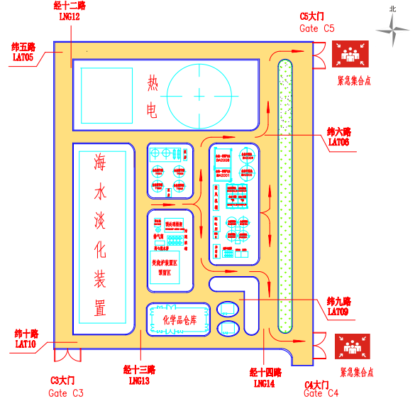

6.4.2 Plan of emergency evacuation route and assembly point for air separation/compression systems and the second circulating water units

空分空压及第二循环水装置应急疏散线路和紧急集结点平面图

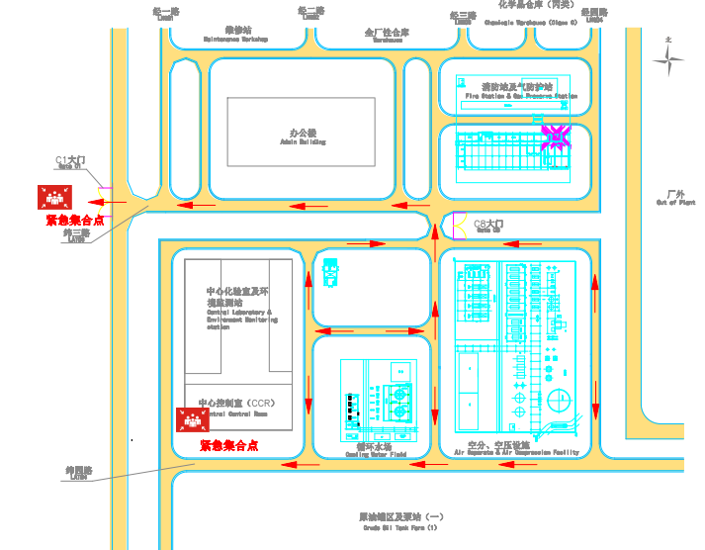

6.4.3 Plan of emergency evacuation route and assembly point for water supply and fire fighting pressure pump station

给水及消防加压泵站紧急疏散线路和紧急集结点平面图

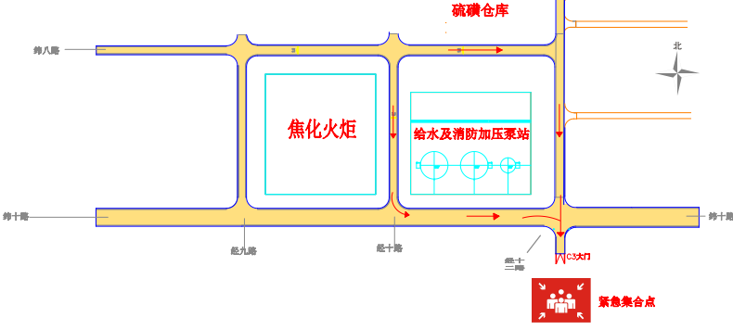

6.4.4 Plan of emergency evacuation route and assembly point for the first circulating water field and the refrigeration station in the unit area

第一循环水场及装置区制冷站紧急疏散线路和紧急集结点平面图

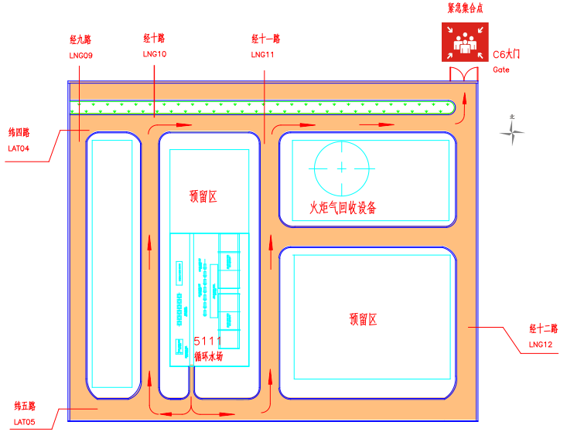

6.4.5 Plan of emergency evacuation route and assembly point for rainwater monitoring pool and accident pool

雨水监控池及事故池紧急疏散线路和紧急集结点平面图

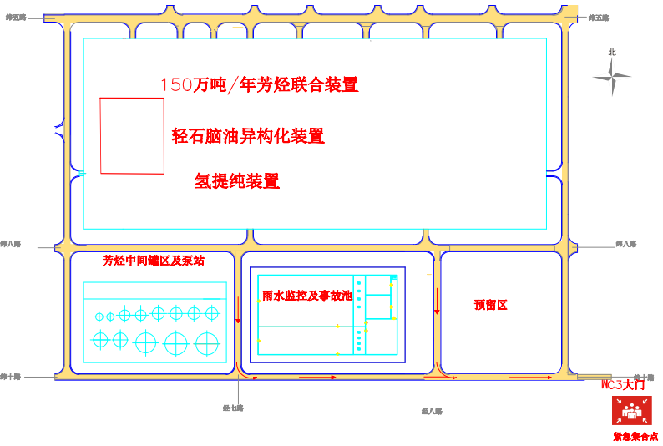

6.5 Unit plan & fire-fighting facilities arrangement plan

装置平面图、消防设施平面布置图

6.5.1 Unit plan & fire-fighting facilities arrangement plan for sewage treatment plant

污水处理厂装置平面图、消防设施平面布置图
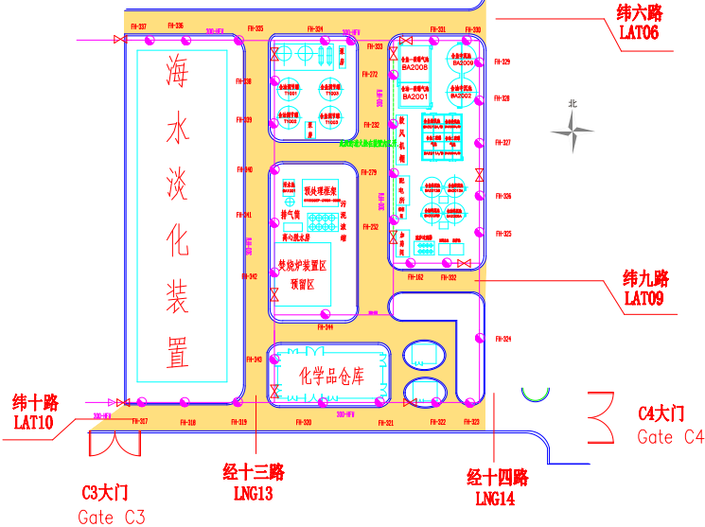

6.5.2 Unit plan & fire-fighting facilities arrangement plan for air separation/compression systems and the first circulating water field

空分空压、第一循环水场装置平面图、消防设施平面布置图
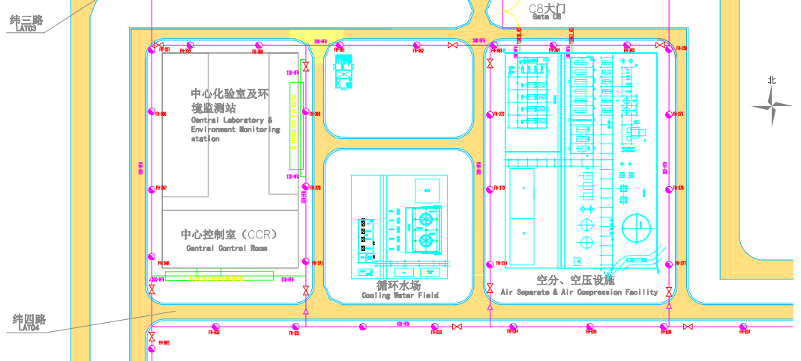

6.5.3 Unit plan & fire-fighting facilities arrangement plan for water supply and fire fighting pressure pump station

给水及消防加压泵站装置平面图、消防设施平面布置图

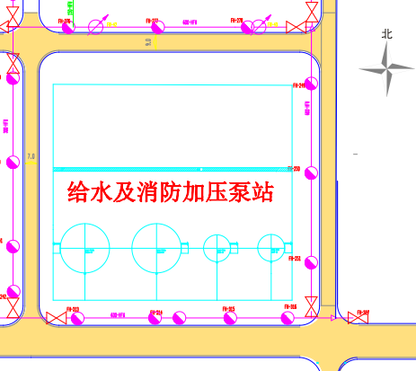

6.5.4 Plan & fire-fighting facilities arrangement plan for rainwater monitoring pool and accident pool

雨水监控池及事故池平面图、消防设施平面布置图
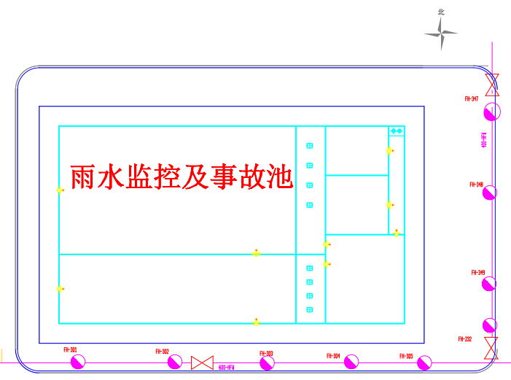

6.5.5 Plan & fire-fighting facilities arrangement plan for the first circulating water field

第一循环水场平面图、消防设施平面布置图
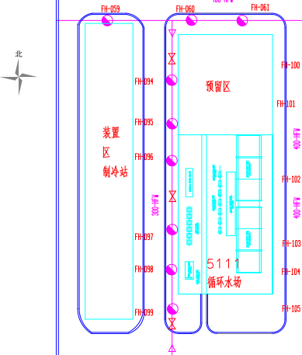

6.5.6 Layout plan of eye washer of unit

装置洗眼器布置平面图

6.5.6.1 Layout plan of eye washer for caustic sludge treatment

碱渣处理洗眼器布置平面图
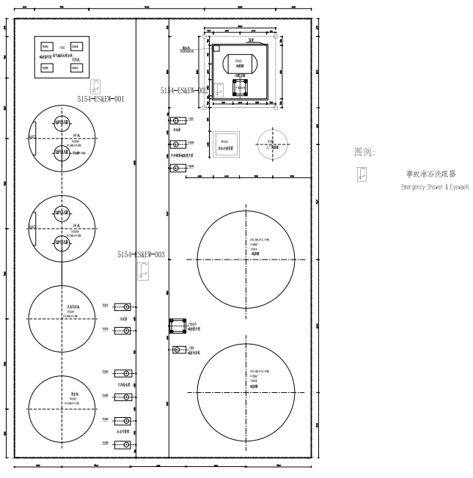

6.5.6.2 Layout plan of eye washer of the circulating water field (I)

循环水场（一）洗眼器布置平面图
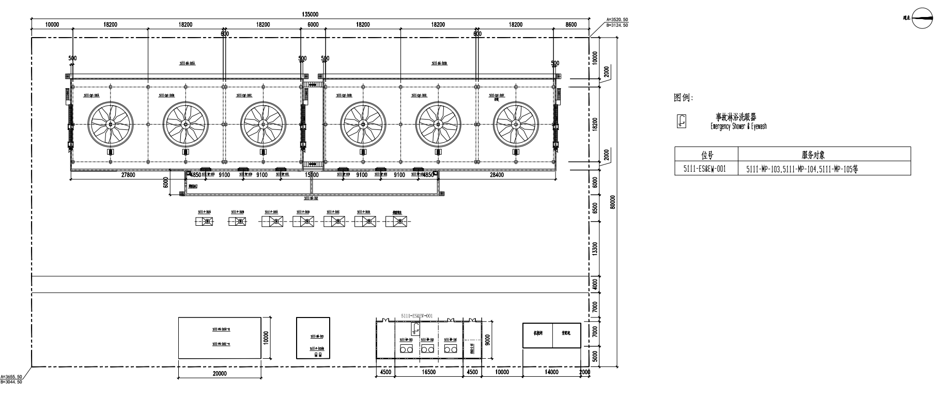

6.5.6.3 Layout plan of eye washer of the circulating water field (II)

循环水场（二）洗眼器布置平面图
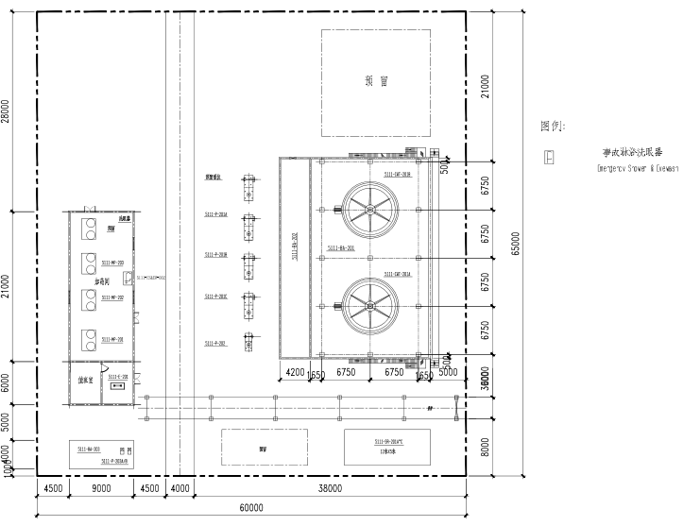

6.5.6.4 Layout plan of eye washer for sewage treatment and reuse

污水处理及污水回用洗眼器布置平面图
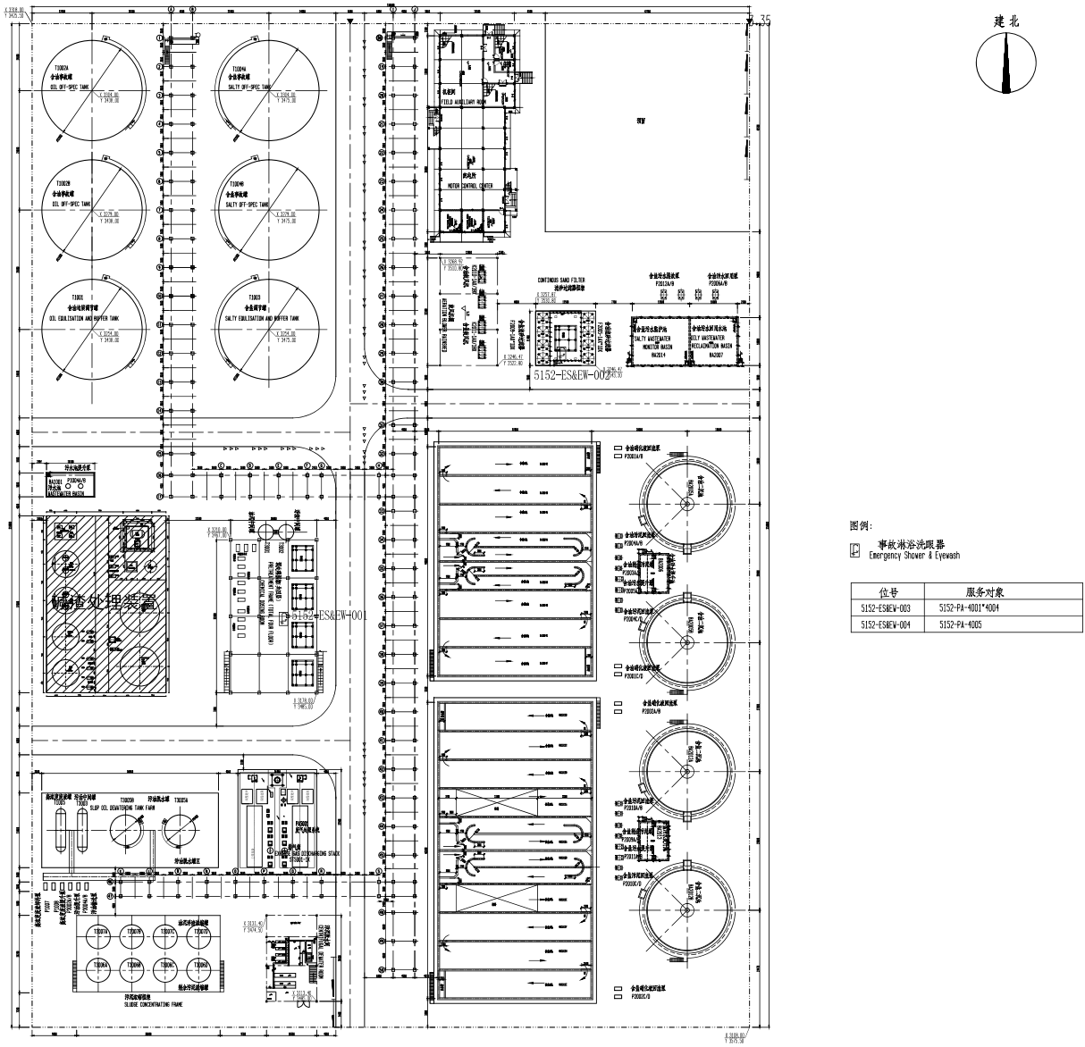

6.6 Layout plan for fixed combustible and toxic gas alarms and manual fire alarms of unit (Atlas can be attached separately)

装置固定式可燃、有毒气体报警仪，火灾手动报警仪平面布置图(图册可分别附加)

6.6.1 Distribution plan of combustible and toxic gas detectors for caustic sludge treatment

碱渣处理可燃、有毒气体检测器分布图
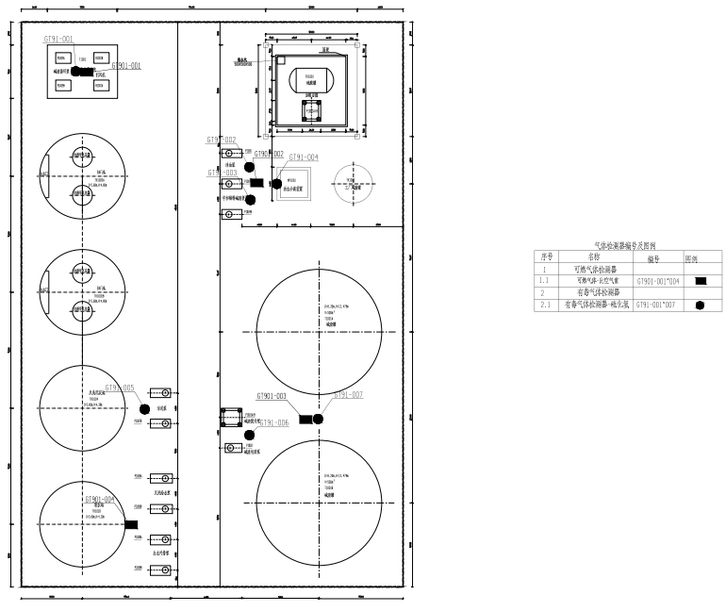

H₂S gas detector
H₂S气体检测器

Combustible gas detector
可燃气检测器

6.6.2 Distribution plan of combustible and toxic gas detectors for sewage treatment and backhaul

污水处理及污水回运可燃、有毒气体检测器分布图

