中控制室管理临时规定
The temporary regulations of CCR
中控室为各部门内操岗位集中的操作区域，为充分管理好中控室各项工作，特制定中控制室当班期间的管理规定，规范岗位人员行为。并纳入交接班检查内容。本规定执行部门为：炼油一部、炼油二部、炼油三部、炼油四部、公用工程部、港储部中控室岗位人员。
The central control room is the centralized operation area for the operation posts within each department. In order to fully manage the work of the central control room, the management regulations in the central control room are specially formulated to regulate the behavior of the staff during the shift.And take the regulations into the shift inspection content. The enforcement department of these provisions include CCR’s staff of No. 1 Refinery Department，No. 2 Refinery Department，No. 3 Refinery Department， No. 4 Refinery Department，Utilities Department，Port and Storage Department.
- 各部门班长安排当班内操的值周轮岗管理工作。
The monitor of each department shall arrange the weekly shift management of the operator on duty.
2.各部门各自负责本岗位DCS操作台面、抽屉、文件摆放柜面、工作椅的卫生及物品摆放、日常维护工作，并进行班班交接。（卫生打扫不包括各联锁操作按钮）
Each department shall be responsible for DCS operating table, drawer , document display cabinet surface and work chair health, daily maintenance . And carry out shift handover.(cleaning area does not include interlock operation buttons)
3.DCS操作台电脑屏幕、对讲机及充电器、台机摆放整齐统一沿标识线摆放整齐，横平竖直。不用的键盘，鼠标垫沿标识线摆放整齐。DCS操作台上不准摆放与工作无关的物品（手机、手套、水杯、安全帽等）。
DCS operating station computer screen, intercom, charger and station machine should be placed neatly and uniformly along the marking line, horizontally and vertically. Unused keyboard, mouse pad along the line placed neatly. Items irrelevant to work (mobile phone, gloves, water cup, helmet, etc.) shall not be placed on the DCS operating table.
4.茶水柜上除了文件和水杯以外不得摆放其他任何物品，尤其是饭菜及安全帽。
Apart from papers and cups, there should be no other items on the tea cabinet, especially food and helmet.
5.严禁在中控室（DCS操作台上）就餐。严禁在中控室内玩手机。
It is strictly forbidden to eat in the central control room (on the DCS table). It is strictly forbidden to play mobile phones in the central control room.
6.工作椅上不准悬挂衣物、巡检包、个人背包等用品。不用的工作椅沿操作台与电脑屏幕对正摆放整齐。操作区域的警戒隔离带要横平竖直。
Clothes, patrol bags, personal backpacks and other supplies are not allowed on the work chair. The unused work chairs are placed neatly along the operation table and the computer screen. The warning barrier of the operating area should be horizontal and vertical.
7.除DCS操作台面由运行部自己负责外，中控室内其他公共区域的卫生由总经理办安排的保洁人员进行打扫及维护。由于中控楼局部房间还处于装修状态，加之施工期间外来劳工较多，常有劳工来中控楼蹭网、乘凉和抽烟，影响操作安全。为加强中控楼的运行管理，各运行部需要安排操作人员对中控楼定期巡检。顺序如下：《炼油一部》→《炼油二部》→《炼油三部》→《炼油四部》→《公用工程部》→《港储部》，原则：每周（每周一轮换，跨月也按周一轮换）轮流执行。
In addition to the DCS operation table, the operation department is responsible for it. The cleaning of other public areas in the central control room is cleaned and maintained by the cleaning staff arranged by the general manager. Because some rooms in the central control room are still in the state of decoration, and there are more migrant workers during the construction period, there are often laborers who come to the central control room to take advantage of the net, enjoy the cold and smoke, which affects the safety of operation.Now in order to strengthen the operation and management of the central control building, each operation department needs to arrange for operators to regularly inspect the central control building.
The order is as follows: No. 1 Refinery Department→No. 2 Refinery Department→No. 3 Refinery Department →No. 4 Refinery Department、→Utilities Department→Port and Storage Department, rules: It is executed weekly (every week, every month, and every month is also rotated on a weekly basis).

8.值日生的职责包括：监督保洁人员操作大厅卫生打扫情况和餐厅、卫生间的垃圾倾倒情况；衣柜、鞋柜内物品摆放的完好性、整洁性；卫生间常流水管理；劝退中控制不请自来的外来人员；中控室外车辆、自行车的摆放是否按线摆放等。
The responsibilities of the daily life include: Supervise the cleaning of the lobby of the cleaning staff and the dumping of garbage in restaurants and bathrooms; The integrity and cleanliness of the items in the closet and the shoe cabinet; the regular water management in the bathroom; and the uninvited foreigners in the retreat; Advise retreat to control uninvited outsiders; Whether the central control outdoor vehicles and bicycles are placed in a line or the like.
9.不穿的衣服、安全帽、手套等全部入柜，不得随意摆放。
All clothes, helmets, gloves, etc. that are not worn are not allowed to be placed in the cabinet.
10.餐盒、微波炉、冰箱内必须干净整洁，不得存有剩饭菜以及其他任何杂物，比如塑料袋和卫生筷。
Lunch boxes, microwave ovens, and refrigerators must be clean and tidy. There must be no leftovers and any other debris, such as plastic bags and sanitary chopsticks.
11.当班值日生有权对外来人员按中控室管理规定提出相应管理要求。
When the class value is born, the right to the outsiders shall be subject to the corresponding management requirements in accordance with the regulations of the central control room.
生产准备部Production preparation department
2019-04-19
19th April,2019

附图说明：
As the picture shows

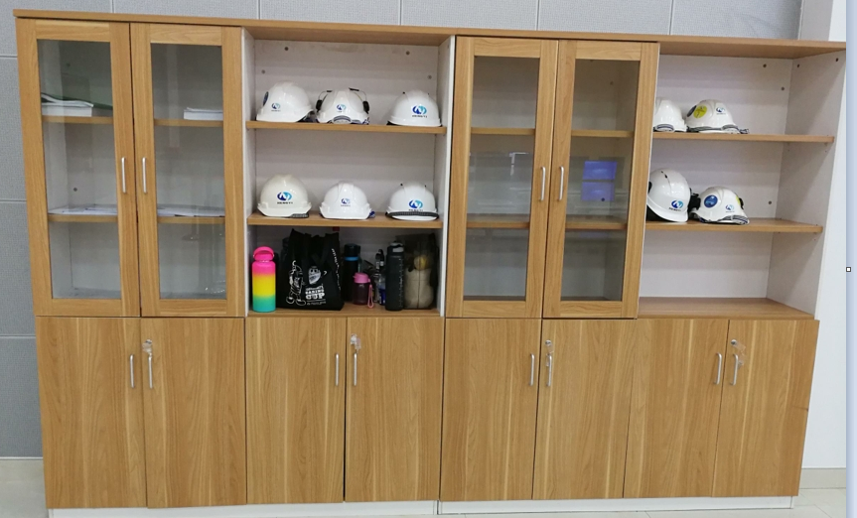
外来人员安全帽存放处，此处不要存放当班人员的安全帽，当班人员安全帽放置在大屏幕右侧的房间内柜子内。There is outside personnel helmet storage, where is not store the helmet on-duty personnel. The on-duty helmet is placed in the cabinet in the room on the right side of the big screen.

存放各种记录和文件
Here is where you can store your various records and files.

存放水杯处
Here is where you can store your various records and files.

存放个人物品（背包）处
Here is where you store your personal belongings (backpack)

