# 单点登录使用说明

# Single sign-on instructions

1、使用系统时候，请断开无线重新连接，以确保可以获取到正确的DNS信息；

When using the system, disconnect the wireless reconnection to ensure that correct DNS information is available.

2、打开浏览器输入<http://brunei.hengyi.com/>，会进入到一下登录界面，输入工号，如1000XXXX，默认密码为Hy123456；

Open the browser and enter http://brunei.hengyi.com/, you will enter the login interface, enter the work number, such as 1000XXXX, the default password is Hy123456.

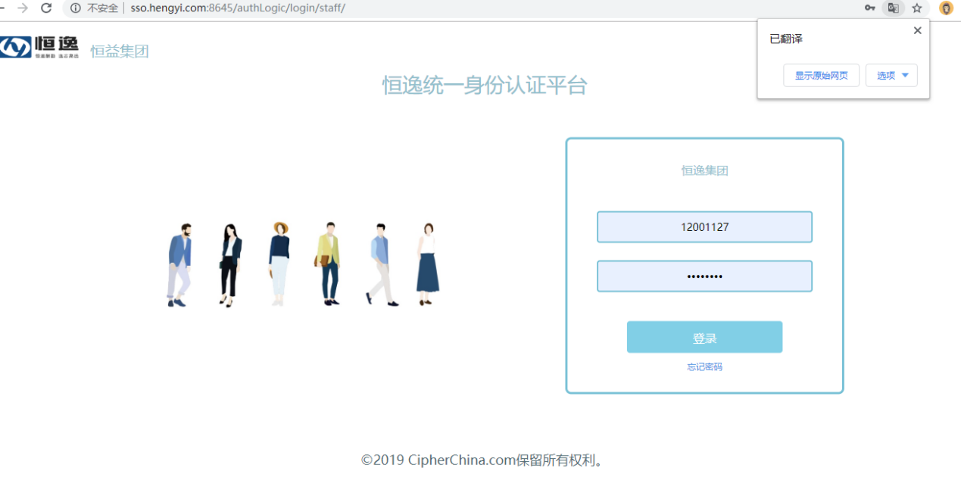

1. 部分非工号邮箱首次登录还需要验证邮箱，邮箱支持pmb.hengyi.com以及hengyi.com后缀，如没有公司邮箱可输入其他邮箱验证，但无法实现邮箱业务的单点登录。

Some non-work number email need to be validated for the first time. email support the suffixes of pmb.hengyi.com and hengyi.com. If there is no company email, other email validation can be entered, but single sign-on of mailbox business can not be realized.

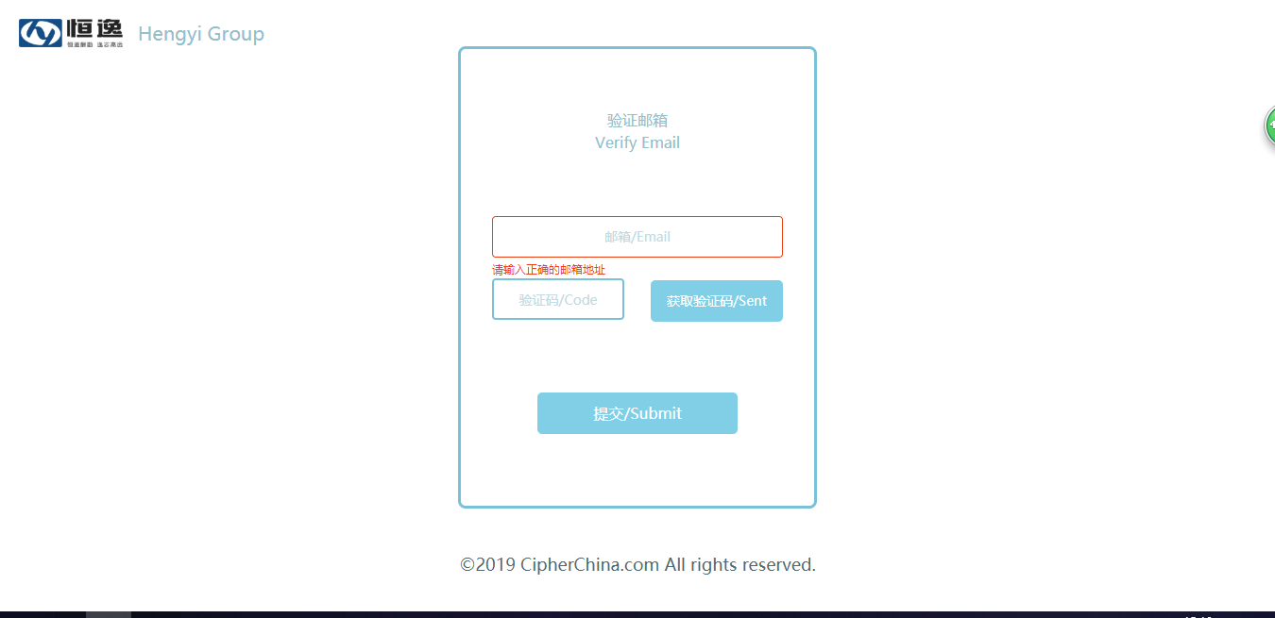

4、进去后点击业务系统下的应用，如OA，点开后会提示绑定账号，绑定成功后下次登录将不再需要提供密码即可直接进入OA。

Go in and click on the application under the business system, such as OA. After clicking it, you will be prompted to bind the account. After the binding is successful, the next login will no longer need to provide a password to enter the OA directly.

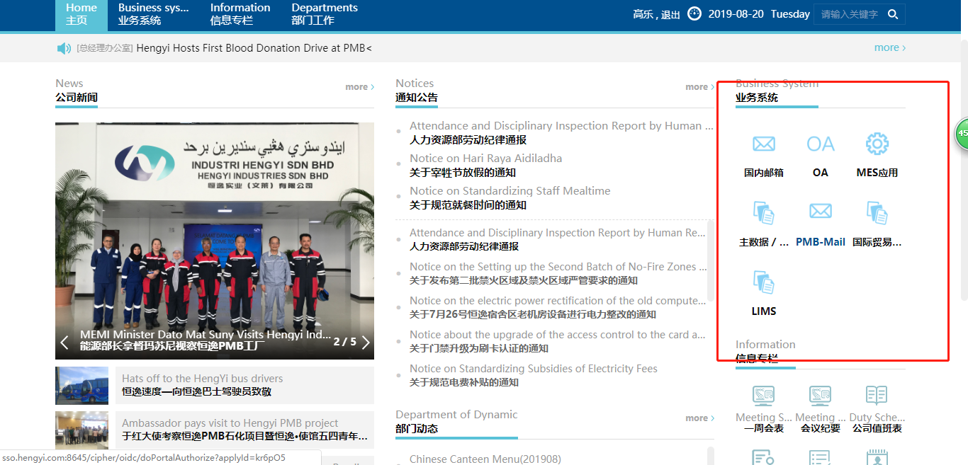

5、系统绑定过程如下：以OA为例，

The system binding process is as follows: Take OA as an example.

1. 点击OA图标，提示以下页面：

Click the OA icon to prompt the following page

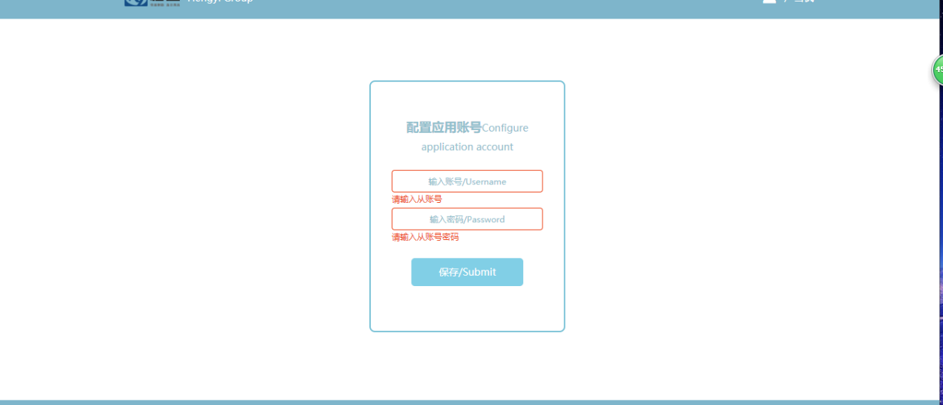

1. 输入OA的账号及OA密码即可绑定完成。

Enter the OA account number and OA password to complete the binding.

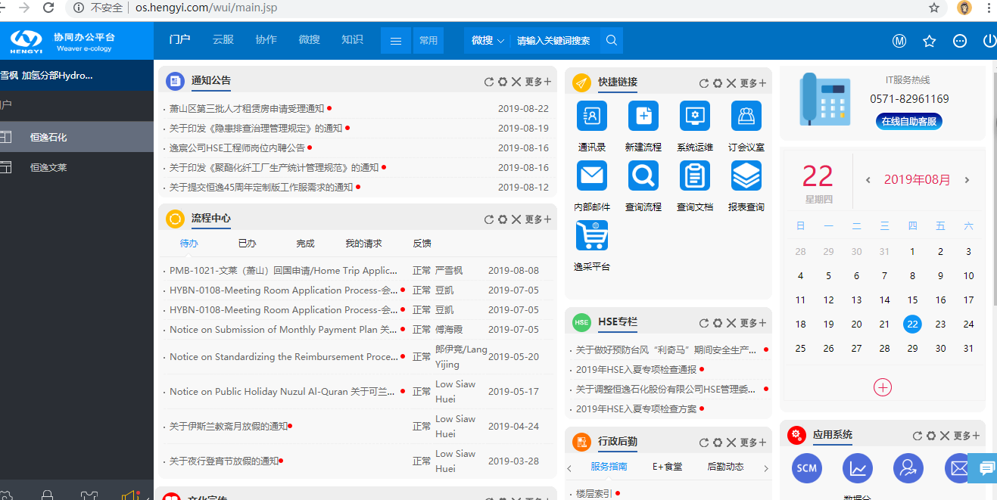

6、网站密码修改参考

website password modification reference

1. 登录到网站首页，点击自己的名字即可进入个人信息；

Log in to the homepage of the website, click on your name to access personal information.

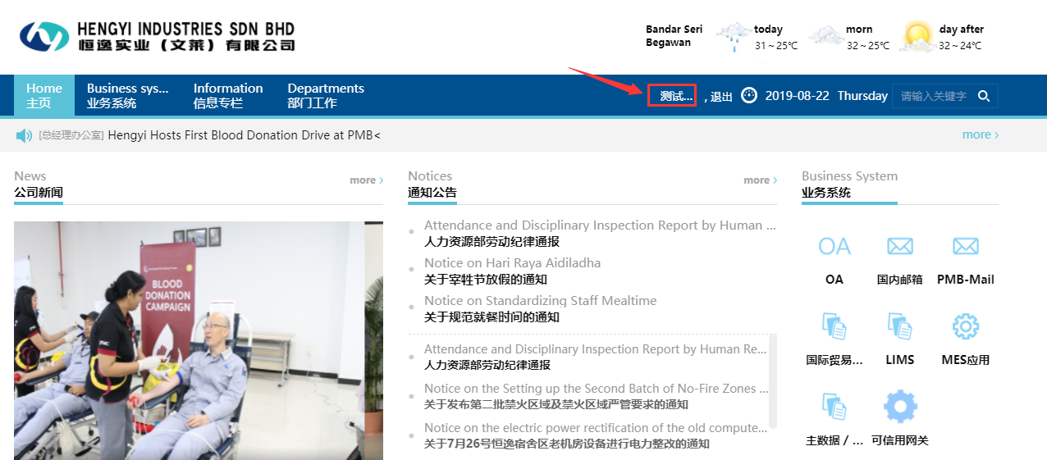

1. 单击姓名后，找到修改密码选项

After clicking on the name, find the option to change password

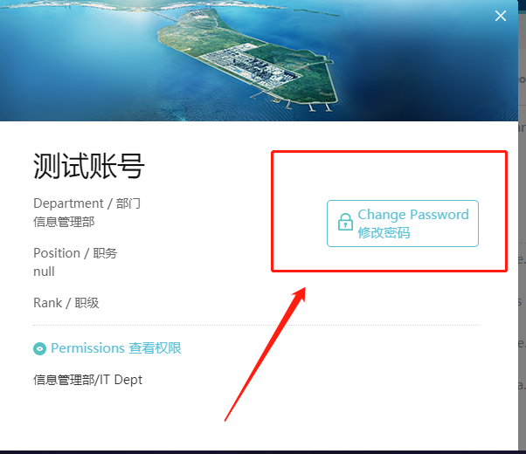

1. 输入新密码即可完后密码修改，新密码必须符合强度要求，至少大小写加字母，如Hengyi123。

Enter the new password to complete the password modification，the new password must meet the strength requirement, at least case plus letter, such as Hengyi123.

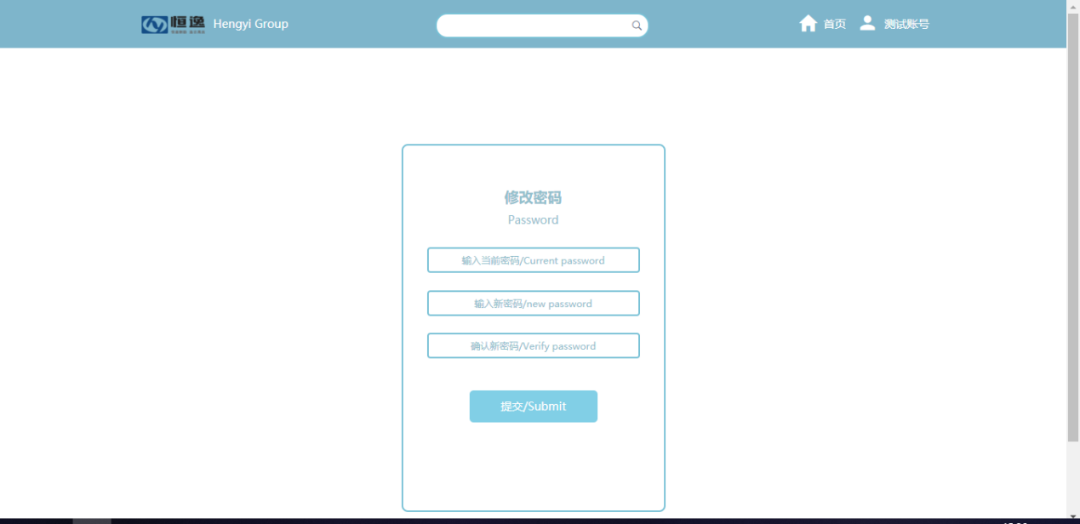

PS：

其他系统绑定过程请参考OA；

Please refer to OA for other system binding processes.

7、绑定其他系统前请先确保自己拥有该系统权限；

Make sure you have the system permissions before binding to other systems.