 | Hengyi Industries Sdn Bhd 恒逸实业（文莱）有限公司
Emergency Drill Record
应急演练记录
 | Record No. |  | HYBN-T6-08-1016- -2018 |  |  |  | Page 3 of 3
使用部门  Department |  | 公用工程  Utilities |  |  | 日期  Date | 2022 年 9 月 30日
演练地点  Location |  | 空分空压中控/现场  Central Control Room/Site |  |  | 时间  Time | 10时 04分
演练内容  Content |  | 空分空压晃电应急演练  Air separation and compression electric shock emergency drill
参加人员  Participants |  | 闫路军、苟旺富、张振、刘瑞铭、韩彦飞、Lee Xin Jeay
观摩人员  Observers |  | 温建成、张云波、邓文涛、米歇尔、闵瑞颖
演练过程记录：
10:04分，副班长苟旺富发现DCS部分运行机组运行信号丢失报警，立即使用对讲机告知现场班长闫路军；班长闫路军现场确认空压机、氮气增压机均已停止，宣布空分装置停车应急预案启动；并让内操人员汇报调度、部门领导；
10:05分，副班长苟旺富安排内主操张振使用仪表气事故罐维持仪表气管网压力，使用2.5MPa氮气补充0.6MPa氮气、0.85MPa氮气管网；安排Lee Xin Jeay维持中压液氮罐压力及中压水浴式汽化器温度；副班长苟旺富则汇报调度、部门领导；（汇报内容：空分装置跳车，请关注氮气管网压力，协调氮气用量、仪表气用量，工厂风外送已中断）；
10:05分，外副操韩彦飞汇报，低压液氮泵已停止运行，备用中压液氮罐出口已打开；外副操刘瑞铭汇报，第二循环水场循环水泵已停止运行；班长闫路军将空压机“紧急停车”按钮按下，且将“加卸载”按钮调至“卸载”位置；安排外副操刘瑞铭对循环水泵进行启动前的检查、确认；安排外副操韩彦飞检查后备系统运行情况及重要阀门的状态；
10:07分，外副操韩彦飞汇报，仪表气事故罐外送阀投用正常、0.6MPa氮气、0.85MPa氮气补气阀门投用正常；并联系电气、仪表配合空分装置恢复；
10:07分，副班长苟旺富对空分装置停车各系统检查，冷箱内各阀门状态正常、分子筛已经暂停、干燥器已暂停；检查完毕后，汇报班长闫路军；（内容：空分装置冷箱已封闭，仪表气压力、各等级氮气压力均正常）；
10:08分，副班长苟旺富联系电调，是否能够启动空分装置，待调度允许后，告知现场进行设备的操作；
10:08分，班长闫路军汇报，预冷系统各液位正常；膨胀机已停止运行，且膨胀机密封气切换至0.85MPa氮气供应；主冷排放阀V00504已关闭；

10:09分，中控启动低压液氮泵并加载，同时，中控相互配合缓慢退出2.5MPa氮气补充0.6MPa氮气阀门；
10:10分，副班长苟旺富联系调度，低压液氮泵已运行正常，氮气管网压力稳定；计划启动循环水泵等设备；
10:10分，外副操刘瑞铭现场启动2台循环水泵，检查循环水压力、流量正常；班长闫路军安排外副操韩彦飞关闭干燥器入口阀门；
10:11分，外副操刘瑞铭凉水塔风机已经启动，溴化锂热水阀已关闭；班长闫路军询问内操各介质用量、运行情况；
10:11分，班长闫路军启动空压机并加载，并安排外副操韩彦飞打开干燥器入口阀门；
10:12分，外副操韩彦飞打开干燥器入口阀，中控内主操张振投用仪表气干燥器，并外送仪表气，退出仪表气事故罐；
10:12分，副班长苟旺富汇报调度、仪表气供应正常，事故罐已退出备用；
10:13分，空分装置开车步骤简化，应急演练停止。
Record of the exercise process:
At 10:04, Deputy Squad Leader Gou Wangfu found out that some of the DCS operating units had lost the operating signal, and immediately used the walkie-talkie to inform the on-site squad leader Yan Lujun; the squad leader Yan Lujun confirmed on the spot that both the air compressor and nitrogen booster had stopped, and announced the start of the emergency plan for the shutdown of the air separation plant. ; And let the internal operators report to the scheduling and department leaders;
At 10:05, deputy squad leader Gou Wangfu arranged for the main operator Zhang Zhen to use the instrument gas accident tank to maintain the pressure of the instrument gas pipe network, and use 2.5MPa nitrogen to supplement the 0.6MPa nitrogen and 0.85MPa nitrogen pipe network; arrange Lee Xin Jeay to maintain the medium pressure liquid nitrogen tank Pressure and temperature of medium-pressure water-bath vaporizer; Deputy squad leader Gou Wangfu will report to scheduling and department leaders; (Report content: Air separation plant trips, please pay attention to nitrogen pipe network pressure, coordinate nitrogen consumption, instrument gas consumption, factory air delivery has been interrupted );
At 10:05, the deputy foreign operator Han Yanfei reported that the low-pressure liquid nitrogen pump had stopped running, and the outlet of the backup medium-pressure liquid nitrogen tank had been opened; the deputy foreign operator Liu Ruiming reported that the circulating water pump of the second circulating water field had stopped running; Press the "emergency stop" button of the press, and adjust the "loading and unloading" button to the "unloading" position; arrange the external assistant Liu Ruiming to check and confirm the circulating water pump before starting; arrange the external assistant Han Yanfei to check the operation of the backup system and the status of important valves;
At 10:07, Deputy Foreign Officer Han Yanfei reported that the outgoing valve of the instrument gas accident tank was in normal operation, and the 0.6MPa nitrogen and 0.85MPa nitrogen supplementary valves were in normal operation; and contact the electrical and instrumentation to cooperate with the air separation unit to restore;
At 10:07, Deputy Squad Leader Gou Wangfu inspected the shutdown systems of the Air Separation Unit. The valves in the cold box are in normal condition, the molecular sieve has been suspended, and the dryer has been suspended; after the inspection, he will report to the monitor Yan Lujun; (Content: Air Separation Unit Cold Box It has been closed, and the instrument gas pressure and nitrogen pressure of all grades are normal);
At 10:08, Deputy Squad Leader Gou Wangfu contacted the ESC to see if the air separation plant could be started. After the scheduling allowed, he would inform the site to operate the equipment;
At 10:08, the squad leader Yan Lujun reported that the liquid levels of the pre-cooling system were normal; the expander had stopped running, and the expander sealing gas was switched to 0.85MPa nitrogen supply; the main cooling discharge valve V00504 had been closed;

At 10:09, the central control started the low-pressure liquid nitrogen pump and loaded it. At the same time, the central control cooperated with each other and slowly exited the 2.5MPa nitrogen to supplement the 0.6MPa nitrogen valve;
At 10:10, the deputy monitor Gou Wangfu contacted the dispatcher, the low-pressure liquid nitrogen pump was operating normally, and the pressure of the nitrogen pipe network was stable; it was planned to start the circulating water pump and other equipment;
At 10:10, the assistant operator Liu Ruiming started 2 circulating water pumps on site to check that the circulating water pressure and flow were normal; the squad leader Yan Lujun arranged for the assistant operator Han Yanfei to close the inlet valve of the dryer;
At 10:11, Liu Ruiming's cooling water tower fan has been started, and the lithium bromide hot water valve has been closed; squad leader Yan Lujun asked the internal operator about the dosage and operation of each medium;
At 10:11, the squad leader Yan Lujun started the air compressor and loaded it, and arranged for the assistant operator Han Yanfei to open the inlet valve of the dryer;
At 10:12, the external assistant operator Han Yanfei opened the inlet valve of the dryer, and the main operator in the central control, Zhang Zhentou, used the instrument gas dryer, sent instrument gas to the outside, and exited the instrument gas accident tank;
At 10:12, Deputy Squad Leader Gou Wangfu reported that the scheduling, instrument gas supply was normal, and the accident tank had been withdrawn for standby;
At 10:13, the start-up steps of the air separation unit were simplified, and the emergency drill was stopped.
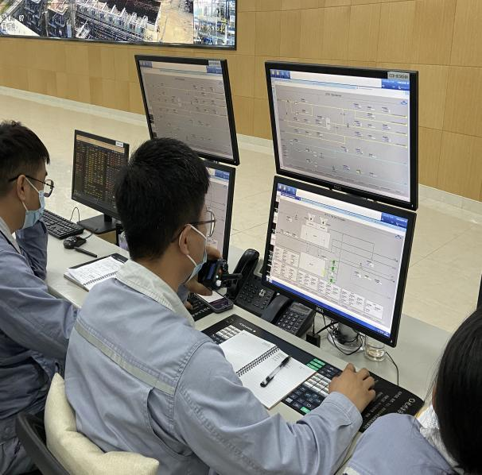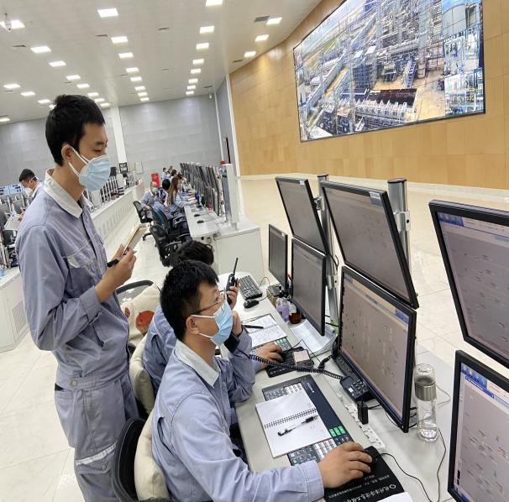
现场确认机组停止后，中控汇报调度及部门领导
After site confirmation, the central control report to the dispatch and department leaders
中控发现设备异常，及时汇报班长
The central control finds that the equipment is abnormal and reports to the squad leader

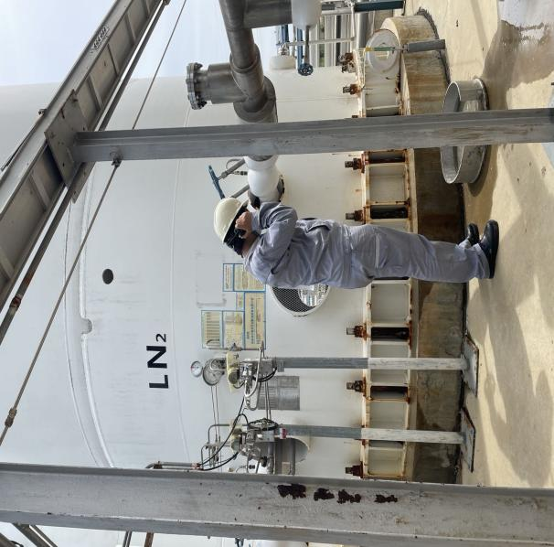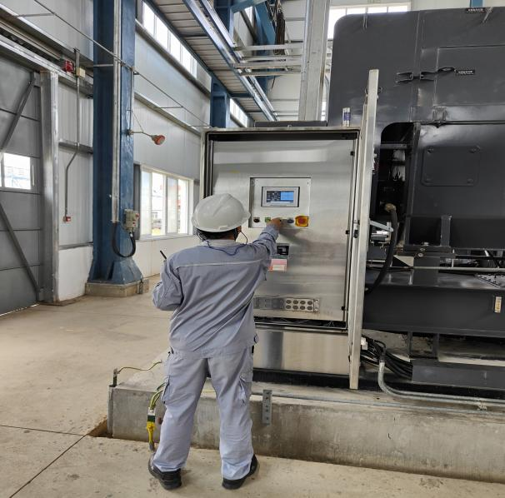

现场模拟打开备用液氮泵出口
On-site simulation to open the outlet of the standby liquid nitrogen pump
现场模拟启动空压机
On-site simulation of starting the air compressor

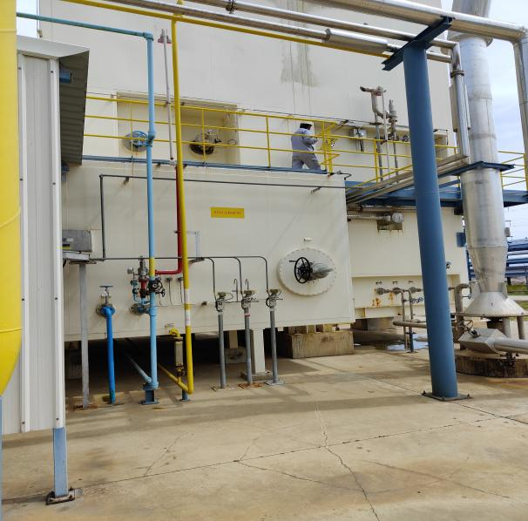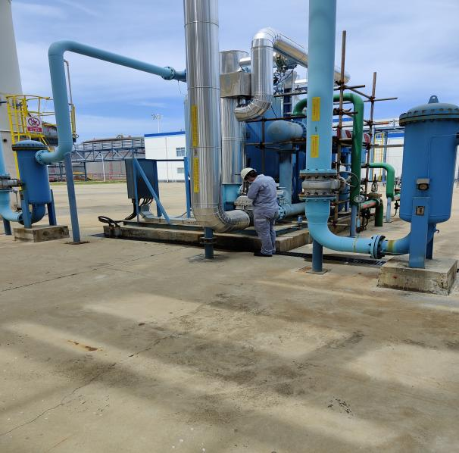
模拟打开干燥器入口阀
Simulate opening of dryer inlet valve
关闭空分装置V00504阀
Close the V00504 valve

演练效果评价：
班组整体演练能够按照“仪表风应急、氮气应急等”的思路进行；演练过程中班组人员分工明确，班员能够按照分工要求完成操作并及时反馈操作信息；班组成员相互提醒、配合，但班组演练中也存在部分问题，希望后续演练中予以整改。
Evaluation of the exercise effect:
The overall drill of the team can be carried out according to the idea of "instrument air emergency, nitrogen emergency, etc."; during the drill, the division of labor among the team members is clear, and the class members can complete the operation according to the requirements of the division of labor and timely feedback the operation information; the team members remind and cooperate with each other, but the team drills There are also some problems, and we hope to rectify them in the follow-up exercise.

签字： 年 月 日
存在的问题 Existing problems |  |  |  | 整改人  Revise Personnel |  |  |  | 整改期限  Date
外送介质外送均需联系调度  The delivery of the delivery medium needs to be contacted for scheduling |  |  |  | 苟旺富 |  |  |  | 2022.10.6
现场模拟真实度不足  Insufficient realism of on-site simulation |  |  |  | 闫路军 |  |  |  | 2022.10.6
关键阀门瞬时开度需日常加强摸索  The instantaneous opening of key valves needs to be explored daily |  |  |  | 苟旺富、张振 |  |  |  | 2022.10.6
后续跟踪落实 Follow-up implementation
整改措施落实：Implementation of corrective measures: |  |  |  | 验证人  Verify Personnel |  |  |  | 日期  Date
加强班组演练频次，下月副班再次演练  Strengthen the frequency of team drills, and the sub-class will drill again next month |  |  |  | 温建成、张云波、邓文涛 |  |  |  | 2022.10.7

