 | Hengyi Industries Sdn Bhd 恒逸实业（文莱）有限公司
Emergency Drill Record
应急演练记录
 | Record No. |  | HYBN-T6-08-1016- -2018 |  |  |  | Page 3 of 3
使用部门  Department |  | 公用工程  Utilities |  |  | 日期  Date | 2022 年 9 月 27日
演练地点  Location |  | 空分空压中控/现场  Central Control Room/Site |  |  | 时间  Time | 14时 47分
演练内容  Content |  | 空分空压晃电应急演练  Air separation and compression electric shock emergency drill
参加人员  Participants |  | 孟新 陈聊 姬生莘 牛志超
观摩人员  Observers |  | 温建成、张云波、邓文涛、米歇尔、闵瑞颖
演练过程记录：
14:47分，中控陈聊发现DCS部分运行机组运行信号丢失报警，且仪表气管网、氮气管网压力降低；立即使用对讲机告知现场班长孟新，并安排内副操牛志超使用仪表气事故罐补充仪表气管网；
14:47分，班长孟新收到中控汇报后，立即启动空分应急预案，安排中控一人负责仪表风管网压力，另一人负责0.6MPa、0.85MPa、2.5MPa氮气管网压力的稳定；安排姬生莘负责第二循环场及后备系统现场确认；班长孟新负责空压机现场确认；
14:48分，内副操牛志超通过对讲机告知现场，PV01001A仪表气事故罐补气阀门已开至3%，请现场确认，工厂风外送阀门已全关；副班长陈聊则将2.5MPa氮气补充0.6MPa氮气、0.85MPa氮气调节阀调至手动，并开至90%、30%，将中压水浴式汽化器汽化器液氮阀门开至40%、中压空温式汽化器设至50%；
14:48分，外主操姬生莘汇报，中压液氮罐B出口外送阀已全开，中压水浴式汽化器运行正常；仪表气事故罐补气阀门已打开；
14:49分，孟新现场确认5台空压机均停止，现场将空压机切至“卸载”位置；确认氮气增压机已停止，将负荷调节旋扭调整至“0%”；
14:49分，副班长陈聊则汇报计划调度部、部门领导；（内容：空分装置5台空压机均跳车，请协调氮气用量、仪表气用量）
14:50分，外主操姬生莘汇报，循环水泵已经停止，现场已将循环水泵出口阀门关闭；班长孟新将膨胀机密封气切换至0.85MPa氮气供应；
14:51分，后备系统已运行稳定，副班长陈聊安排内副操牛志超监控后备系统的运行；陈聊则进行装置停车各系统检查；
14:51分，孟新现场关闭V00504阀门；
14:52分，电力恢复后，中控立即告知现场班长；班长立即安排启动低压液氮泵，并加载；
14:53分，中控启动低压液氮泵后，出口压力异常，立即汇报班长进行现场确认；确认无异常后中控继续加载低压液氮泵，同时，中控相互配合缓慢退出2.5MPa氮气补充0.6MPa氮气阀门；此时，发现仪表气事故罐压力低，立即汇报班长；
14:53分，现场启动循环水泵P201A/B，启动正常后汇报中控；
14:54分，班长联系中控，空压机已具备启动条件，请示调度启动空压机；请示完毕后，启动并加载第1台空压机；安排姬生莘启动凉水塔风机；
14:55分，副班长陈聊中控投用仪表风干燥器，内副操牛志超退出仪表气事故罐并外送工厂风；
14:56分，孟新启动第2台空压机；姬生莘启动凉水塔风机；
14:57分，姬生莘关闭厂前区制冷站溴化锂热水阀门；孟新启动仪表气增压机进行事故罐补充压力；
14:58分，主冷凝液位高，内外操配合进行现场排液；
14:59分，内副操牛志超告知现场仪表气事故罐压力达到3.6MPa，孟新现场停止仪表气增压机；
15:00分，姬生莘启动剩余空压机组；依次启动预冷系统等
15:04分，空分启动过程简化；班长联系化验室分析氮气纯度，合格后外送；
15:05分，副班长陈聊中控缓慢打开HV00403阀，开始外送0.6MPa氮气，副操牛志超缓慢退出后备低压液氮增压、汽化系统；
15:06分，姬生莘现场启动氮气增压机，副操牛志超中控退出中压液氮0.85MPa氮气调节阀；
15:06分，班长孟新安排内操汇报调度及部门领导；副班长陈聊汇报后演练结束。
Record of the exercise process:
At 14:47, Central Control, Chen Liao found that some DCS operating units lost the operation signal and the pressure of the instrument gas pipe network and nitrogen pipe network decreased; immediately used the walkie-talkie to inform the on-site squad leader, Meng Xin, and arranged for the deputy operator, Niu Zhichao to use the instrument gas accident tank to supplement the instrument gas pipe network;
At 14:47, after receiving the report from the central control, Meng Xin, the squad leader, immediately started the air separation emergency plan, and arranged one person from the central control to be responsible for the pressure of the instrument air pipe network, and another person to be responsible for the stability of the nitrogen pipe network pressure of 0.6MPa, 0.85MPa and 2.5MPa. ; Arrange Ji Shengxin to be responsible for the on-site confirmation of the second circulation field and backup system; monitor Meng Xin to be responsible for the on-site confirmation of the air compressor;
At 14:48, Niu Zhichao, the deputy operator, informed the scene through the walkie-talkie that the gas supply valve of the PV01001A instrument gas accident tank has been opened to 3%. Please confirm on the spot that the factory air delivery valve has been fully closed; the deputy squad leader Chen Liao adjusted the 2.5MPa nitroget to supplement 0.6MPa nitrogen, and adjust the 0.85MPa nitrogen control valve to manual, and open it to 90% and 30%, open the liquid nitrogen valve of the medium pressure water bath vaporizer vaporizer to 40%, and set the medium pressure air temperature vaporizer to 50%;
At 14:48, Ji Shengxin, the field operator, reported that the outlet valve of the medium-pressure liquid nitrogen tank B has been fully opened, and the medium-pressure water-bath vaporizer is operating normally; the gas supply valve of the instrument air accident tank has been opened;
At 14:49, Mengxin confirmed on site that all 5 air compressors had stopped, and switched the air compressors to the "unloading" position; confirmed that the nitrogen booster had stopped, and adjusted the load adjustment knob to "0%";
At 14:49, Deputy Squad Leader Chen Liao reported to the planning and dispatching department and department leaders; (Content: All 5 air compressors in the air separation plant jumped, please coordinate the nitrogen consumption and instrument gas consumption)
At 14:50, Ji Shengxin, the foreign master, reported that the circulating water pump had stopped, and the outlet valve of the circulating water pump had been closed at the scene; the squad leader Meng Xin switched the expander sealing gas to 0.85MPa nitrogen supply;
At 14:51, the backup system was running stably. Deputy squad leader Chen Liao arranged for the deputy operator Niu Zhichao to monitor the operation of the backup system; Chen Liao checked the installation and shut down systems;
At 14:51, Mengxin closed the V00504 valve on site;
At 14:52, After the power was restored, the central control immediately informed the on-site squad leader; the squad leader immediately arranged to start the low-pressure liquid nitrogen pump and load it;
At 14:53, After the central control started the low-pressure liquid nitrogen pump, the outlet pressure was abnormal, and immediately reported to the squad leader for on-site confirmation; after confirming that there was no abnormality, the central control continued to load the low-pressure liquid nitrogen pump, and at the same time, the central control cooperated with each other and slowly withdraws the 2.5MPa nitrogen to supplement the 0.6MPa nitrogen valve; at this time, it is found that the pressure of the instrument gas accident tank is low, and immediately report to the squad leader;
At 14:53, the circulating water pump P201A/B was started on site and reported to the central control after it started normally;
At 14:54, the squad leader contacted the central control, the air compressor was ready to start, and asked for scheduling to start the air compressor; after the request was completed, the first air compressor was started and loaded; Ji Shengxin was arranged to start the cooling water tower fan;
At 14:55, the deputy squad leader Chen Liao put the instrument air dryer into use, and the deputy operator Niu Zhichao withdraws the instrument air accident tank and sent the plant air out;
At 14:56, Meng Xin started the second air compressor; Ji Shengxin started the cooling tower fan;
At 14:57, Ji Shengxin closed the lithium bromide hot water valve of the refrigeration station in the front of the factory; Meng Xin started the instrument air booster to supplement the pressure of the accident tank;
At 14:58, the main condensate level is high, and the internal and external operations are coordinated to carry out on-site drainage;
At 14:59, the deputy operator Niu Zhichao informed the on-site instrument air accident tank pressure reached 3.6MPa, and Mengxin stopped the instrument air booster on site;
At 15:00, Ji Shengxin started the remaining air compressor units; then, started the pre-cooling system, etc.
At 15:04, the air separation start-up process was simplified; the squad leader contacted the laboratory to analyze the nitrogen purity, and delivered it after passing the test;
At 15:05, Deputy Squad Leader Chen Liao Zhongkong slowly opened the HV00403 valve and began to deliver 0.6MPa nitrogen. Deputy Operator Niu Zhichao slowly withdraws the backup low-pressure liquid nitrogen pressurization and vaporization system;
At 15:06, Ji Shengxin started the nitrogen booster on site, and the deputy operator Niu Zhichao central control exited the medium pressure liquid nitrogen 0.85MPa nitrogen regulating valve;
At 15:06, the squad leader Meng Xin arranged the internal drills to report on the scheduling and department leaders; the drill ended after the deputy squad leader Chen Liao reported.
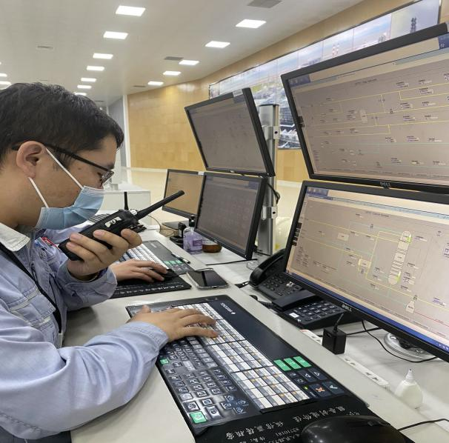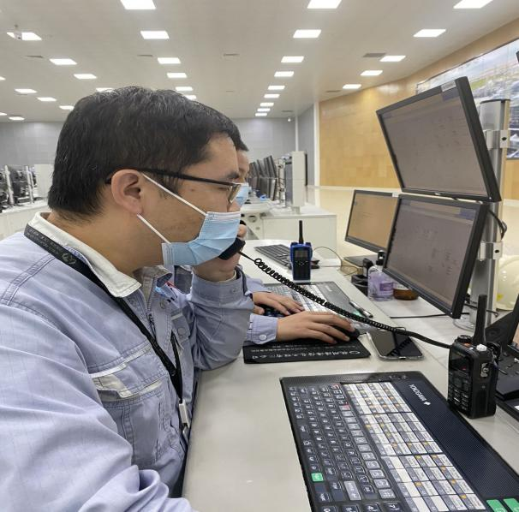
现场确认机组停止后，中控汇报调度及部门领导
After site confirmation of operation, the central control report to the dispatch and department leaders
中控发现设备异常，及时汇报班长
The central control finds that the equipment is abnormal and reports to the squad leader in time

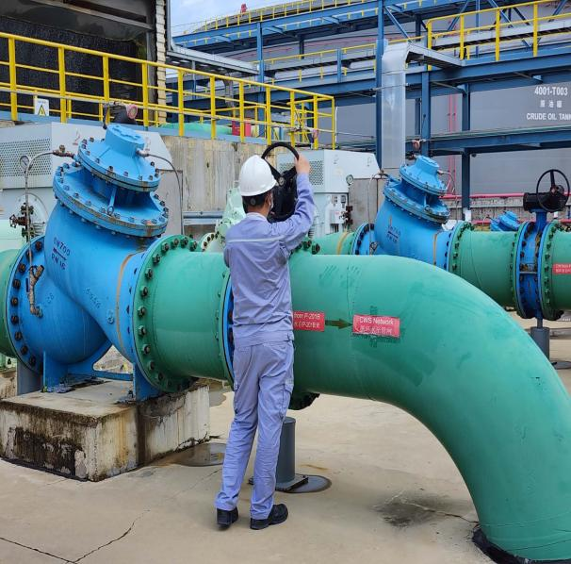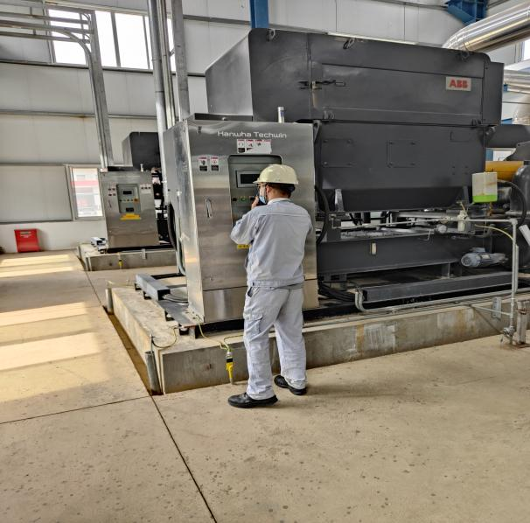
现场模拟启动循环水泵
On-site simulation to start the circulating water pump
现场模拟启动空压机
On-site simulation of starting the air compressor

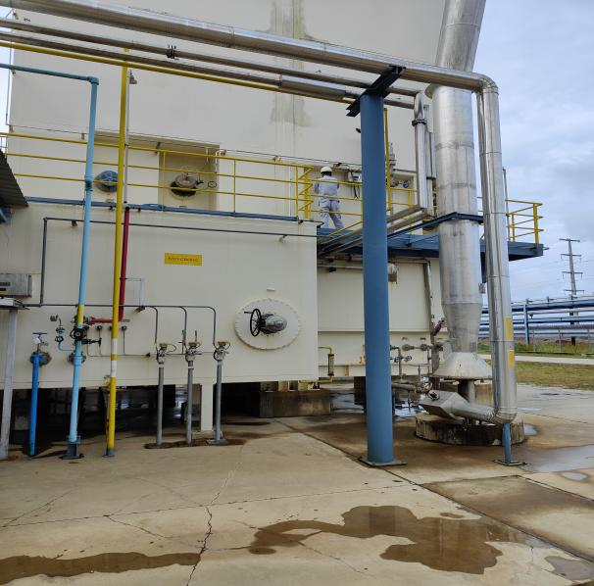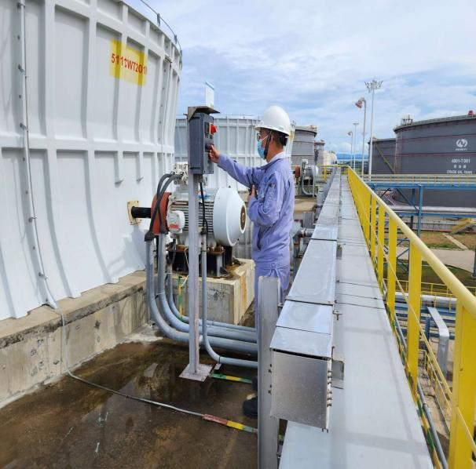
启动凉水塔风机
Start the cooling tower fan
关闭空分装置V00504阀
Close the V00504 valve

演练效果评价：
班组整体演练能够按照“仪表风应急、氮气应急等”的思路进行；演练过程中班组人员分工明确，班员能够按照分工要求完成操作并及时反馈操作信息；班组成员相互提醒、配合，但班组演练中也存在部分问题，希望后续演练中予以整改。
Evaluation of the exercise effect:
The overall drill of the team can be carried out according to the idea of "instrument air emergency, nitrogen emergency, etc."; During the drill, the division of task among the team members is clear, and the team members can complete the operation according to the requirements of the division of labor and timely feedback the operation information; the team members remind and cooperate with each other. However, there are also some problems in the team drills, and we hope to rectify them in the follow-up drill.

签字： 年 月 日
存在的问题 Existing problems |  |  |  | 整改人  Revise Personnel |  |  |  | 整改期限  Date
外送介质中断/外送均需联系调度  If the delivery of medium is interrupted/delivered, please contact the dispatcher |  |  |  | 陈聊 |  |  |  | 2022.10.3
班组演练过程中较紧张，需加强班组演练频次  The team is relatively nervous during the drill, and the frequency of team drills needs to be strengthened |  |  |  | 孟新 |  |  |  | 2022.10.3
空分装置停车后，现场检查不足，需班组加强  After the air separation plant was stopped, the on-site inspection was insufficient, and the team needed to be strengthened |  |  |  | 孟新 |  |  |  | 2022.10.3
班长对重要/关键的数据未做了解  The monitor does not understand important/critical data |  |  |  | 孟新 |  |  |  | 2022.10.3
后续跟踪落实 Follow-up implementation
整改措施落实：Implementation of corrective measures: |  |  |  | 验证人  Verify Personnel |  |  |  | 日期  Date
加强班组演练频次，下月副班再次演练  Strengthen the frequency of team drills, and the sub-class will drill again next month |  |  |  | 温建成、张云波、邓文涛 |  |  |  | 2022.10.4

