 | Hengyi Industries Sdn Bhd 恒逸实业（文莱）有限公司
Emergency Drill Record
应急演练记录
 | Record No. |  | HYBN-T6-08-1016- -2018 |  |  |  | Page 3 of 3
使用部门  Department |  | 公用工程  Utilities |  |  | 日期  Date | 2022 年 9 月 29日
演练地点  Location |  | 空分空压中控/现场  Central Control Room/Site |  |  | 时间  Time | 16时 00分
演练内容  Content |  | 空分空压晃电应急演练  Air separation and compression electric shock emergency drill
参加人员  Participants |  | 张文俊、高烁、李凯强、周乐乐
观摩人员  Observers |  | 温建成、张云波、邓文涛、米歇尔、闵瑞颖
演练过程记录：
16:00分，副班长高烁汇报当班班长张文俊，中控DCS发现大量报警，疑似装置跳车，请现场确认；同时，将仪表气事故罐补气阀门开至30%，关闭工厂风阀门；将2.5MPa氮气补充0.6MPa氮气、0.85MPa氮气调节阀调至手动，并开至70%、30%，将中压水浴式汽化器汽化器液氮阀门开至40%、中压空温式汽化器设至50%，水浴式汽化器蒸汽阀门设至100%，安排周乐乐关注并调整中压液氮汽化器及中压液氮罐；
16:01分，班长张文俊安排外主操李凯强打开备用中压液氮罐出口阀；并安排中控汇报调度及部门领导；
16:01分，外主操李凯强汇报，备用中压液氮罐出口外送阀已全开；
16:01分，副班长高烁安排周乐乐汇报调度、部门领导；（内容：空分装置晃电停车，0.6MPa、0.85MPa、2.5MPa氮气暂由中压氮气供应，仪表气由仪表气事故罐供应，工厂风退出，请协调氮气用量、仪表气用量）；
16:02分，副班长高烁进行空分内部各系统停车后检查，此时冷箱已封闭、分子筛已暂停、各电加热器停止、干燥器暂停、各类泵均停止、水冷塔液位正常，并安排周乐乐关注并调整0.6MPa、0.85MPa氮气管网压力；
16:02分，外主操李凯强汇报，中压水浴式汽化器、空温式汽化器运行正常；并已将膨胀机密封气切换至0.85MPa氮气供应；
16:03分，副班长高烁检查空分装置各系统后，向班长张文俊汇报中控运行情况；（内容：后备运行正常，仪表气由事故罐外供，分子筛暂停、干燥器暂停）；
16:03分，电力恢复后，中控立即告知现场班长；并告知班长，已启动低压液氮泵，并加载；缓慢退出2.5MPa氮气补充0.6MPa氮气阀门
16:03分，班长张文俊汇报，循环水泵出口已经关闭，等待送电；并已通知电气、仪表至现场配合开车；
16:04分，副班长高烁汇报班长，后备中、低压液氮增压、气化系统供应正常，仪表气由事故罐供应，让其尽快启动空压机；
16:05分，班长张文俊汇报，循环水泵已启动并运行正常，凉水塔风机已启动并运行正常；外主操李凯强汇报，空压机已启动2台并已加载；
16:05分，副班长高烁汇报班长，仪表气外供正常，事故罐已退出备用；同时，安排周乐乐汇报调度；（内容：空压机启动正常，已正常外供仪表气，现要投用工厂风）；
16:06分，外主操李凯强汇报，厂前区制冷站热水阀门已经关闭；
16:06分，副班长高烁汇报班长，工厂风已正常外送；
16:07分，空分装置开车步骤简化，应急演练停止。
Record of the exercise process:
At 16:00, deputy squad leader Gao Shuo reported to the squad leader Zhang Wenjun that the central control DCS found a large number of alarms, and the suspected device jumped, please confirm on the spot; at the same time, open the gas supply valve of the instrument gas accident tank to 30%, and close the plant air valve; Add 2.5MPa nitrogen to 0.6MPa nitrogen, adjust the 0.85MPa nitrogen control valve to manual, and open it to 70% and 30%, open the liquid nitrogen valve of the medium pressure water bath vaporizer vaporizer to 40%, and set the medium pressure air temperature vaporizer to 50%, the steam valve of the water-bath vaporizer is set to 100%. Zhou Lele is arranged to pay attention and adjust the medium-pressure liquid nitrogen vaporizer and medium-pressure liquid nitrogen tank;
At 16:01, the squad leader, Zhang Wenjun, arranged the foreign leader, Li Kaiqiang, to open the outlet valve of the backup medium-pressure liquid nitrogen tank; and arranged for the central control to report to the dispatch and department leaders;
At 16:01, Li Kaiqiang, the field operator, reported that the outlet valve of the backup medium-pressure liquid nitrogen tank was fully opened;
At 16:01, Deputy Squad Leader Gao Shuo arranged for Zhou Lele to report to the scheduling and department leaders; (Content: Air separation plant was shut down, 0.6MPa, 0.85MPa, 2.5MPa nitrogen was temporarily supplied by the medium pressure nitrogen, and instrument gas was supplied by instrument gas accident tank supply, the plant air is withdrawn, please use the nitrogen and instrument gas consumption wisely);
At 16:02, Deputy Squad Leader Gao Shuo checked after the shutdown of each system in the air separation. At this time, the cold box was sealed, the molecular sieve was suspended, the electric heaters were stopped, the dryer was suspended, all kinds of pumps were stopped, and the liquid level of the water cooling tower was normal. Arrange Zhou Lele to pay attention to and adjust the 0.6MPa, 0.85MPa nitrogen pipe network pressure;
At 16:02, Li Kaiqiang, the field operator, reported that the medium-pressure water-bath vaporizer and the air-temperature vaporizer were operating normally; and the expander sealing gas had been switched to 0.85MPa nitrogen supply;
At 16:03, Deputy Squad Leader Gao Shuo reported the operation of the central control to Squad Leader Zhang Wenjun after checking each system of the air separation plant; (Content: The backup operation is normal, the instrument gas is supplied from the accident tank, the molecular sieve is suspended, and the dryer is suspended);
At 16:03, after the power was restored, the central control immediately informed the on-site squad leader; and informed the squad leader that the low-pressure liquid nitrogen pump had been started and loaded; slowly exited the 2.5MPa nitrogen gas to supplement the 0.6MPa nitrogen valve
At 16:03, the squad leader Zhang Wenjun reported that the outlet of the circulating water pump had been closed, waiting for power to be sent; and the electric and instrumentation had been notified to the scene to cooperate with the operation;
At 16:04, deputy squad leader Gao Shuo reported to the squad leader that the backup medium and low pressure liquid nitrogen pressurization and gasification systems were supplied normally, and the instrument gas was supplied from the accident tank, so that it could start the air compressor as soon as possible;
At 16:05, the squad leader Zhang Wenjun reported that the circulating water pump has been started and is running normally, and the cooling water tower fan has been started and running normally; the field operator Li Kaiqiang reported that 2 air compressors have been started and loaded;
At 16:05, Deputy Squad Leader Gao Shuo reported to Squad Leader that the external supply of instrument gas was normal, and the accident tank had been withdrawn from standby; at the same time, Zhou Lele was arranged to report the scheduling; (Content: The air compressor started normally, and the external instrument gas has been supplied normally, and now it is time to put it in with factory style);
At 16:06, the field operator master Li Kaiqiang reported that the hot water valve of the refrigeration station in the front area of the factory had been closed;
At 16:06, Deputy Squad Leader Gao Shuo reported to Squad Leader that the plant air has been delivered normally;
At 16:07, the driving steps of the air separation unit were simplified, and the emergency drill was stopped.
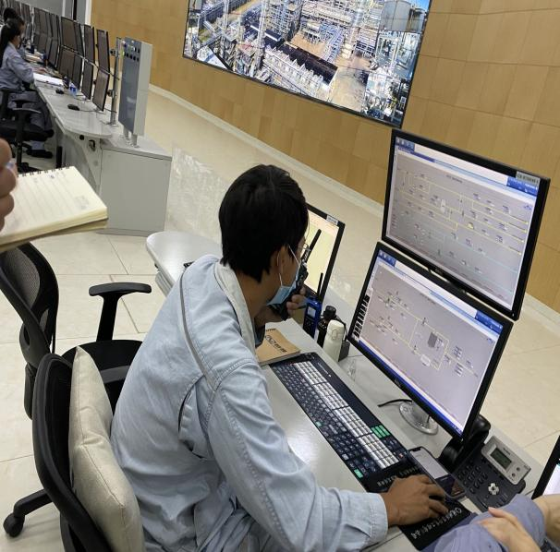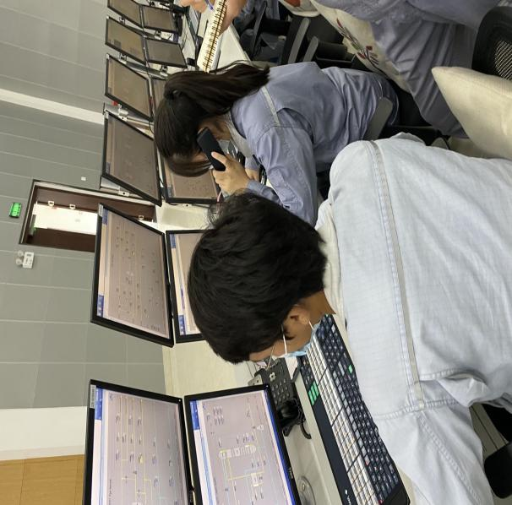
中控发现设备异常，及时汇报班长
The central control finds that the equipment is abnormal and reports to the squad leader
汇报调度及部门领导
Report the scheduling and department leaders

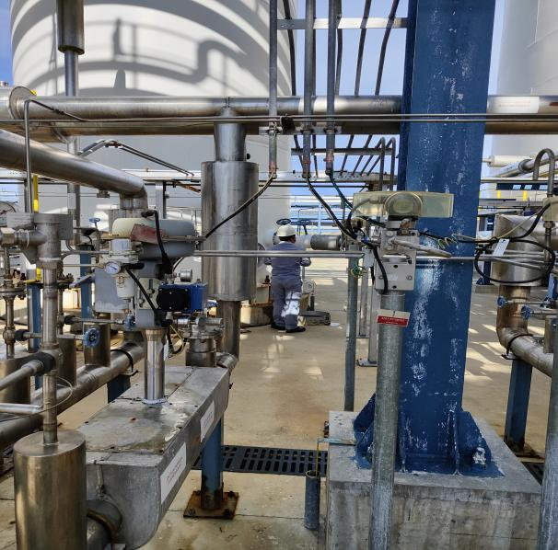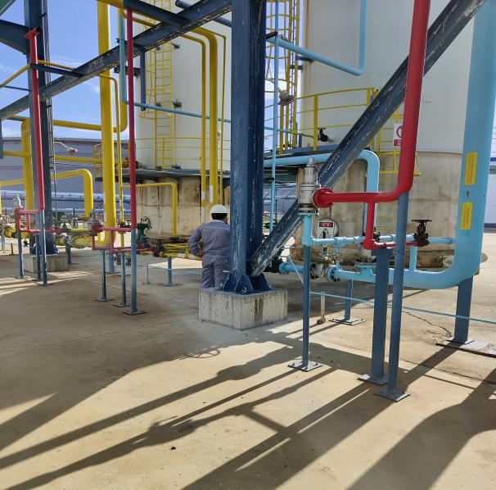
打开备用中压液氮罐阀门
Open the valve of the backup medium pressure liquid nitrogen tank
检查后备系统各阀门状态
Check the status of each valve in the backup system

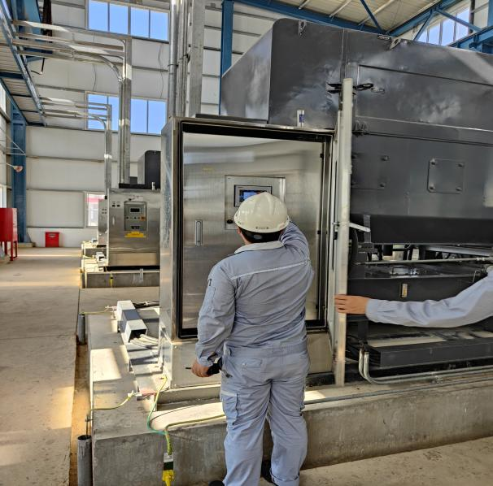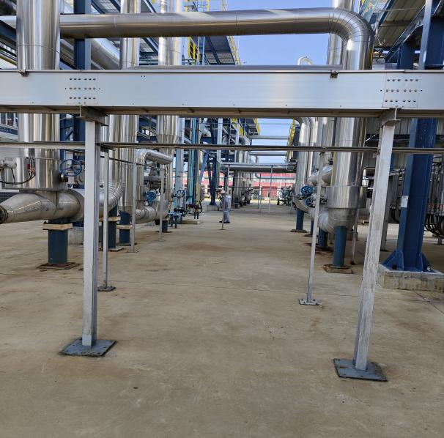
启动空压机
Start the air compressor
检查空分装置停车后的状态
Check the status of the air separation plant

演练效果评价：
班组整体演练能够按照“仪表风应急、氮气应急等”的思路进行；演练过程中班长应急把控不足，且未对停止的设备进行现场确认后的信息共享，现场演练跑位不足；。
Evaluation of the exercise effect:
The overall drill of the team can be carried out according to the idea of "instrument air emergency, nitrogen emergency, etc."; during the drill, the team leader's emergency control was insufficient, and the information sharing after on-site confirmation of the stopped equipment was not carried out, and the on-site drill was insufficient;

签字： 年 月 日
存在的问题 Existing problems |  |  |  | 整改人  Revise Personnel |  |  |  | 整改期限  Date
应急整体把控需加强  Overall emergency control needs to be strengthened |  |  |  | 张文俊 |  |  |  | 2022.10.5
班组信息共享不足  Insufficient sharing of team information |  |  |  | 张文俊 |  |  |  | 2022.10.5
班长对重要/关键的数据未做了解  The monitor does not understand important/critical data |  |  |  | 张文俊 |  |  |  | 2022.10.5
现场模拟真实度不足  Insufficient realism of on-site simulation |  |  |  | 张文俊、李凯强 |  |  |  | 2022.10.5
后续跟踪落实 Follow-up implementation
整改措施落实：Implementation of corrective measures: |  |  |  | 验证人  Verify Personnel |  |  |  | 日期  Date
加强班组演练频次，下月副班再次演练  Strengthen the frequency of team drills, and the sub-class will drill again next month |  |  |  | 温建成、张云波、邓文涛 |  |  |  | 2022.10.6

