 | Hengyi Industries Sdn Bhd 恒逸实业（文莱）有限公司
Emergency Drill Record
应急演练记录
 | Record No. |  | HYBN-T6-08-1016- -2018 |  |  |  | Page 3 of 3
使用部门  Department |  | 公用工程  Utilities |  |  | 日期  Date | 2022 年 9 月 28日
演练地点  Location |  | 空分空压中控/现场  Central Control Room/Site |  |  | 时间  Time | 16时 04分
演练内容  Content |  | 空分空压晃电应急演练  Air separation and compression electric shock emergency drill
参加人员  Participants |  | 赵宇、武明、周强、刘振辉、杨广君、Izzah、Noris
观摩人员  Observers |  | 温建成、张云波、邓文涛、米歇尔、闵瑞颖
演练过程记录：
16:04分，内主操武明汇报当班班长赵宇，CCR出现晃电现场，运行的空压机、膨胀机运行信号均已经丢失；
16:04分，班长赵宇收到中控汇报后，立即启动空分应急预案，安排中控维持仪表气、氮气管网压力稳定；
16:05分，内主操武明手动控制0.6MPa氮气、0.85MPa氮气管网的稳定；安排内副操刘振辉维持仪表气管网、安排内副操Izzah维持中压汽化器稳定；内副操武明汇报计划调度部，部门领导；（内容：空分装置出现晃电现象，已启动装置应急预案，如蒸汽正常供应，可供氮气10000Nm³/h，如蒸汽供应异常，则氮气最大供应5000Nm³/h，请协调仪表气、氮气用量）；
16:05分，安排外主操周强至后备系统，打开压液氮罐B出口外送阀，并检查中压汽化器运行情况及阀门开度，仪表气事故罐压力；安排外副操杨广君检查空压机、氮气压缩机、循环水泵等的运行情况；
16:05分，外副操杨广君汇报，空压机均已停止，膨胀机已停止，循环水泵等均已停止；
16:06分，班长赵宇联系中控外副操Izzah，让其联系Noris检查第二循环水场循环水泵、凉水塔风机运行情况；
16:06分，外主操周强汇报，中压液氮罐B出口外送阀已全开，已将胀机密封气切换至0.85MPa氮气供应；
16:06分，内主操武明联系外主操周强，启动空压机辅助油泵及膨胀机辅助油泵；班长赵宇联系内副操刘振辉汇报调度，并让其协调用量；
16:07分，内副操刘振辉联系外主操周强打开仪表气事故罐调节阀旁路阀；
16:07分，内主操武明进行空分内部各系统停车后检查，此时冷箱已封闭、干燥器已暂停、分子筛已暂停、各电加热器已停止；检查时发现主冷液位高，联系班长赵宇进行排液操作；
16:08分，电力恢复后，中控立即告知现场班长，班长赵宇安排外副操杨广君至第二循环水场启动循环水泵；
16:08分，内主操武明联系外主操周强，关闭V00504阀门；
16:10分，内主操武明启动并低压液氮泵，缓慢退出2.5MPa氮气补充0.6MPa氮气阀门，并汇报班长赵宇，后备系统稳定运行；
16:10分，外副操杨广君启动循环水泵P201A/B，正常后汇报中控；
16:11分，外副操杨广君启动凉水塔风机，正常后汇报中控；外主操周强汇报，低压液氮泵运行正常；班长联系中控，空压机已具备启动条件，请示调度启动空压机；请示完毕后，启动并加载第1台空压机；
16:12分，内主操武明汇报班长赵宇，仪表气外供正常，仪表气事故罐已退出；
16:13分，空分装置开车步骤简化，应急演练停止。
Record of the exercise process:
At 16:04, Wu Ming, the head coach, reported to Zhao Yu, the squad leader on duty, that the CCR appeared on the scene of unstable electricity, and the signals of the operating air compressor and expander had been lost;
At 16:04, after receiving the report from the central control, squad leader Zhao Yu immediately started the air separation emergency plan, and arranged for the central control to maintain stable pressure of the instrument gas and nitrogen gas pipe network;
At 16:05, Wu Ming, the central control room main operator, manually controlled the stability of the 0.6MPa nitrogen and 0.85MPa nitrogen pipe networks; the central control room assistant operator,Liu Zhenhui, was arranged to maintain the instrument gas pipe network, and the central control room assistant operator,Izzah, was arranged to maintain the stability of the medium pressure vaporizer; the inner control room assistant,Wu Ming, reported the plan to Dispatching department’s leader; (Content: The air separation unit has an electric shock phenomenon, and the emergency plan of the unit has been activated. If the steam supply is normal, the nitrogen supply can be 10000Nm3/h. If the steam supply is abnormal, the maximum nitrogen supply is 5000Nm3/h, please coordinate the dosage of instrument gas and nitrogen gas consumption);
At 16:05, arranged the external master,Zhou Qiang,to the backup system, open the external delivery valve of the B outlet of the liquid nitrogen tank, and check the operation of the medium pressure vaporizer, the valve opening, and the pressure of the instrument gas accident tank; arrange the external assistant, Yang Guangjun, to check the operation of the air compressors, nitrogen compressors, circulating water pumps, etc.;
At 16:05, Yang Guangjun, the deputy foreign operator, reported that the air compressors had stopped, the expanders had stopped, and the circulating water pumps had all stopped;
At 16:06, the squad leader Zhao Yu contacted Izzah, the central control room assistant operator, and asked her to contact Noris to check the operation of the circulating water pump and cooling tower fan in the second circulating water field;
At 16:06, the foreign leader Zhou Qiang reported that the outlet valve of the medium pressure liquid nitrogen tank B has been fully opened, and the sealing gas of the expander has been switched to 0.85MPa nitrogen supply;
At 16:06, Wu Ming, the central control main operator, contacted Zhou Qiang, the main field operator, to start the auxiliary oil pump of the air compressor and the auxiliary oil pump of the expander; the squad leader Zhao Yu contacted Liu Zhenhui, the deputy central control operator, to report the scheduling and let him coordinate the dosage;
At 16:07, the deputy operator Liu Zhenhui contacted the main operator Zhou Qiang to open the bypass valve of the regulating valve of the instrument gas accident tank;
At 16:07, Wu Ming, the chief instructor, inspected the internal systems of the air separation system after. At this time, the cold box was sealed, the dryer was suspended, the molecular sieve was suspended, and the electric heaters were stopped; during the inspection, it was found that the main cooling liquid level was high , so contact the squad leader Zhao Yu for the drainage operation;
At 16:08, after the power was restored, the central control immediately informed the on-site squad leader, and the squad leader Zhao Yu arranged for Yang Guangjun, the deputy operator, to go to the second circulating water field to start the circulating water pump;
At 16:08, the main central room operator, Wu Ming, contacted the field main operator, Zhou Qiang to close the V00504 valve;
At 16:10, the main central room operator, Wu Ming, started the low-pressure liquid nitrogen pump, slowly exited the 2.5MPa nitrogen gas to complement the 0.6MPa nitrogen valve, and reported to the squad leader Zhao Yu that the backup system was running stably;
At 16:10, Yang Guangjun, the deputy foreign operator, started the circulating water pump P201A/B, and reported to the central control after it was normal;
At 16:11, Yang Guangjun, the deputy operator, started the cooling tower fan, and reported to the central control after it was normal; Zhou Qiang, the chief operator, reported that the low-pressure liquid nitrogen pump was running normally; the squad leader contacted the central control, and the air compressor was ready to start. Request the scheduling to start the air compressor; after that, start and load the first air compressor;
At 16:12, Wu Ming reported to the squad leader Zhao Yu that the external supply of instrument gas was normal, and the instrument gas accident tank had been withdrawn;
At 16:13, the start-up steps of the air separation unit were simplified, and the emergency drill was stopped.
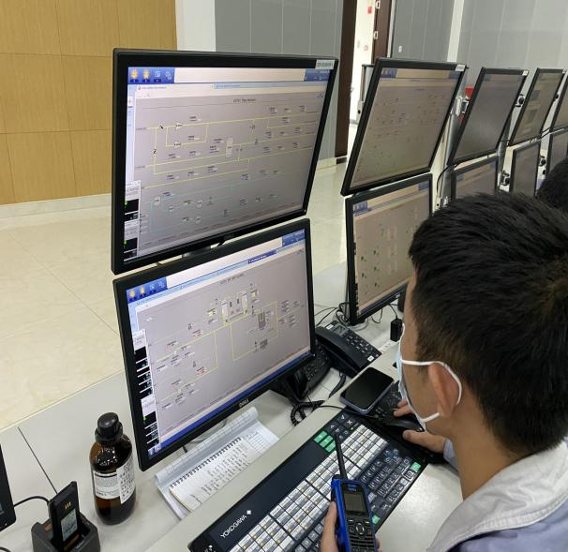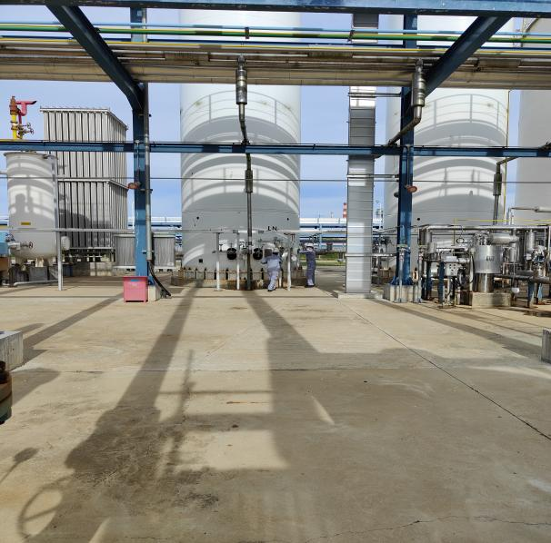
中控发现设备异常，及时汇报班长
The central control finds that the equipment is abnormal and reports to the squad leader in time.
现场确认膨胀机的运行状态
Site confirmation of expander operation

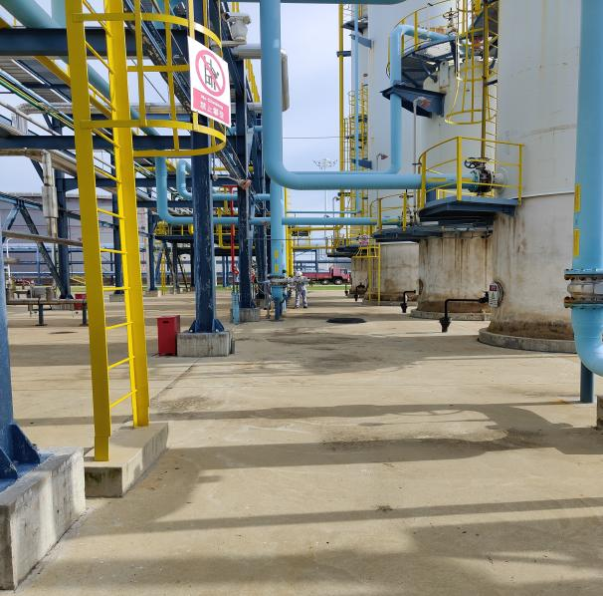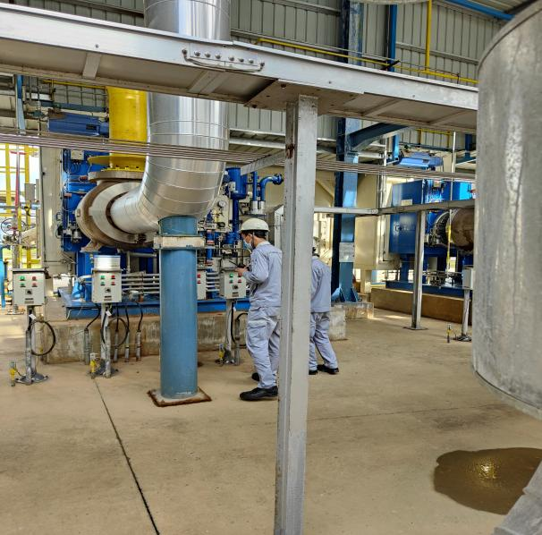
现场检查后备系统阀门状态
Site inspection of backup system valve
现场投用备用液氮罐
On-site use of backup liquid nitrogen tanks

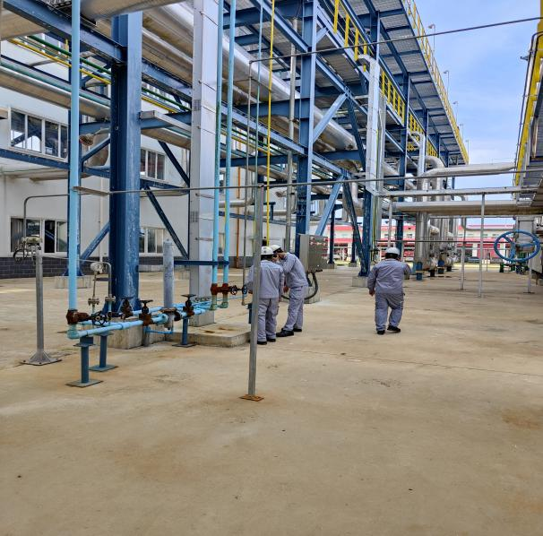
切换膨胀机密封气
Switching of the expander seal gas

演练效果评价：
班组整体演练能够按照“仪表风应急、氮气应急等”的思路进行；演练过程中班组人员分工不明确，班员间反馈操作信息不及时；整体班组应急操作还需细化并加强班组间的演练。
Evaluation of the exercise effect:
The overall drill of the team can be carried out according to the idea of "instrument air emergency, nitrogen emergency, etc."; during the drill, the division of labor among team members is not clear, and the feedback operation information among class members is not timely; the overall team emergency operation needs to be refined and strengthened.
签字： 年 月 日
存在的问题 Existing problems |  |  |  | 整改人  Revise Personnel |  |  |  | 整改期限  Date
人员分工不明确  The division of task is not clear |  |  |  | 赵宇 |  |  |  | 2022.10.4
班组演练时沟通较少，人员间操作信息不及时  There is less communication during team drills, and the operation information between personnel is not timely |  |  |  | 赵宇 |  |  |  | 2022.10.4
空分装置停车后，现场检查不足，需班组加强  After the air separation plant was stopped, the on-site inspection was insufficient, and the team needed to be strengthened |  |  |  | 赵宇 |  |  |  | 2022.10.4
班长对重要/关键的数据未做了解  The monitor does not understand the important/critical data |  |  |  | 赵宇 |  |  |  | 2022.10.4
现场模拟真实度不足  Insufficient realism of on-site simulation |  |  |  | 赵宇、周强、杨广君 |  |  |  | 2022.10.4
后续跟踪落实 Follow-up implementation
整改措施落实：Implementation of corrective measures: |  |  |  | 验证人  Verify Personnel |  |  |  | 日期  Date
加强班组演练频次，下月副班再次演练  Strengthen the frequency of team drills, and the sub-class will drill again next month |  |  |  | 温建成、张云波、  邓文涛 |  |  |  | 2022.10.5

