 | Hengyi Industries Sdn Bhd 恒逸实业（文莱）有限公司
Emergency Drill Record
应急演练记录
 | Record No. |  | HYBN-T6-08-1016- -2018 |  |  |  | Page 3 of 3
使用部门  Department |  | 公用工程  Utilities |  |  | 日期  Date | 2022 年 10 月 6日
演练地点  Location |  | 空分空压中控/现场  Central Control Room/Site |  |  | 时间  Time | 16时 19分
演练内容  Content |  | 空分空压氮气中断应急演练  Air separation air compressor nitrogen interruption emergency drill
参加人员  Participants |  | 赵宇 武明 刘振辉 周强 杨广军 Noris
观摩人员  Observers |  | 温建成、张云波、邓文涛
演练过程记录：
16:19分，中控武明发现DCS显示0.6MPa氮气管网压力及流量下降，同时空分氮气放空阀FIQ00402缓慢开大；立即使用对讲机告知现场班长赵宇，并安排内副操刘振辉使用中压液氮汽化后供应低压氮气管网；
16:19分，班长赵宇收到中控汇报后，立即启动空分外供氮气中断应急预案，安排中控一人负责汇报调度，另一人负责0.6MPa、0.85MPa、2.5MPa氮气管网压力的稳定（同时缓慢加载低压液氮泵外供）；安排周强第一时间至低压后备汽化器前排气，保证低压后备正常外供氮气；班长赵宇赶往现场检查及查找原因；
16:20分，内主操武明将2.5MPa氮气补充0.6MPa氮气阀门调至手动，并开至50%、30%，将中压水浴式汽化器汽化器液氮阀门开至40%、中压空温式汽化器设至50%；内副操刘振辉通过对讲机告知现场，低压后备系统已正常供应氮气，中压后备缓慢退出供应，氮气管网压力保持稳定；
16:22分，外主操周强汇报，检查现场后备系统正常供应氮气且未发现有氮气泄漏；
16:24分，周强现场检查至空分氮气送出阀HIC00403时发现阀门处于全关状态；Noris至二层平台FIQ00402阀门处检查确认放空阀开度；
16:25分，周强现场打开空分氮气送出阀HIC00403旁通供气，赵宇要求中控做好氮气管网及后备系统工况调整；
16:26分，周强、杨广军关闭HIC00403前后截止阀，联系仪控人员至现场检查处理故障阀门；
16:29分，HIC00403阀门故障处理完毕，联系中控调试正常后阀门手动开至42%；
16:30分，打开HIC00403前后截止阀，缓慢关闭HIC00403旁通；
16:31分，班长赵宇通知中控退出后备系统，改空分供应氮气；
16:32分，班长赵宇安排内操汇报调度及部门领导；班长宣布演练结束。
Record of the exercise process:
At 16:19, Zhongkong Wu Ming found that the DCS showed that the pressure and flow of the 0.6MPa nitrogen pipe network dropped, and the air separation nitrogen vent valve FIQ00402 was slowly opened; immediately used the walkie-talkie to inform the on-site squad leader Zhao Yu, and arranged the deputy operator Liu Zhenhui to use the medium pressure Supply low-pressure nitrogen pipe network after liquid nitrogen vaporization;
At 16:19, after receiving the report from the central control, the squad leader Zhao Yu immediately started the emergency plan for the interruption of nitrogen supply outside the air separation, and arranged one person from the central control to be responsible for reporting and scheduling, and another person responsible for the pressure of the 0.6MPa, 0.85MPa, 2.5MPa nitrogen pipe network. Stable (while slowly loading the low-pressure liquid nitrogen pump for external supply); arrange Zhou Qiang to exhaust in front of the low-pressure backup vaporizer at the first time to ensure the normal supply of nitrogen from the low-pressure backup; the squad leader Zhao Yu rushed to the site to check and find out the reason;
At 16:20, Wu Ming, the main operator, adjusted the 2.5MPa nitrogen to supplement 0.6MPa nitrogen valve to manual, and opened it to 50% and 30%, and opened the liquid nitrogen valve of the medium pressure water bath vaporizer vaporizer to 40%, and the medium pressure air temperature. The vaporizer was set to 50%; the deputy operator, Liu Zhenhui, informed the scene through the walkie-talkie that the low-pressure backup system had been supplying nitrogen normally, the medium-pressure backup was slowly withdrawing from the supply, and the pressure of the nitrogen pipe network remained stable;
At 16:22, the field operator Zhou Qiang reported that the on-site backup system was supplying nitrogen normally and no nitrogen leakage was found;
At 16:24, Zhou Qiang inspected the air separation nitrogen delivery valve HIC00403 and found that the valve was fully closed; Noris went to the second floor platform FIQ00402 valve to check and confirm the opening of the vent valve;
At 16:25, Zhou Qiang opened the air separation nitrogen delivery valve HIC00403 to bypass the gas supply on site. Zhao Yu asked the central control to adjust the working conditions of the nitrogen pipe network and backup system;
At 16:26, Zhou Qiang and Yang Guangjun closed the front and rear stop valves of HIC00403, and contacted the instrument and control personnel to check and deal with the faulty valve on site;
At 16:29, the HIC00403 valve fault was processed, contact the central control and the valve was manually opened to 42% after the debugging was normal;
At 16:30, open the front and rear stop valves of HIC00403, and slowly close the bypass of HIC00403;
At 16:31, the squad leader Zhao Yu informed the central control to withdraw from the backup system and change the air separation to supply nitrogen;
At 16:32, the squad leader Zhao Yu arranged for internal drills to report to the dispatch and department leaders; the squad leader announced the end of the drill.
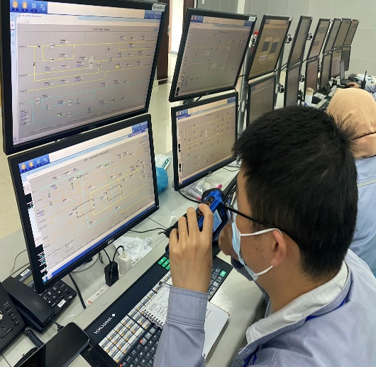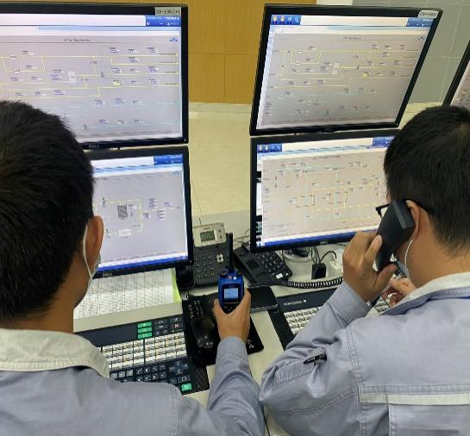
现场确认阀门故障后，中控汇报调度及部门领导
After the valve failure is confirmed on site, the central control reports to the dispatch and department leaders
中控发现系统氮气外供压力、流量异常，及时汇报班长
The central control found that the nitrogen supply pressure and flow rate of the system were abnormal and reported to the squad leader in time

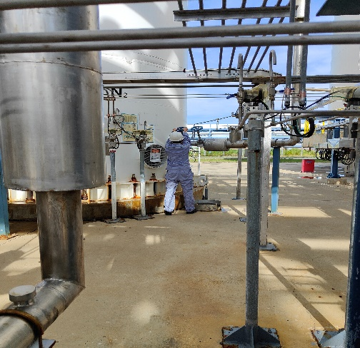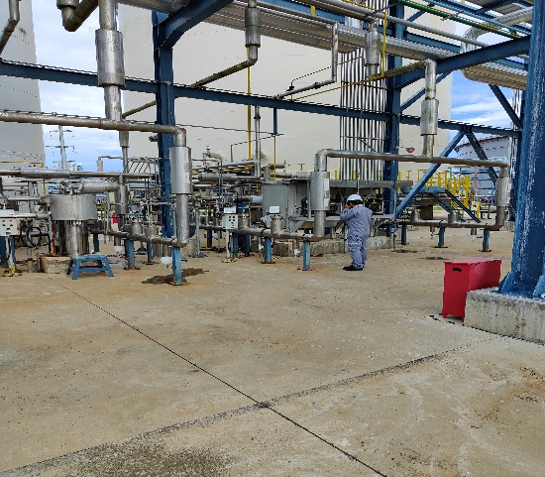
现场外操检查后备低压液氮泵运行情况
Field operation to check the operation of the backup low-pressure liquid nitrogen pump
现场外操模拟打开中压液氮罐出口外供氮气
The on-site operation simulates opening the outlet of the medium-pressure liquid nitrogen tank to supply nitrogen

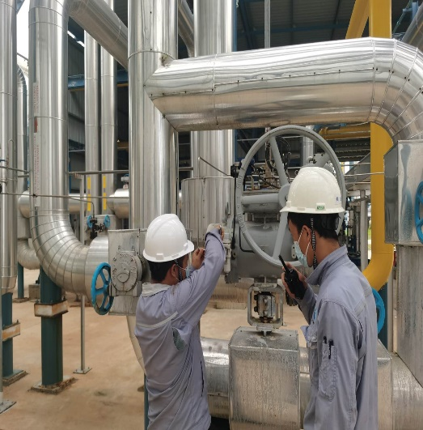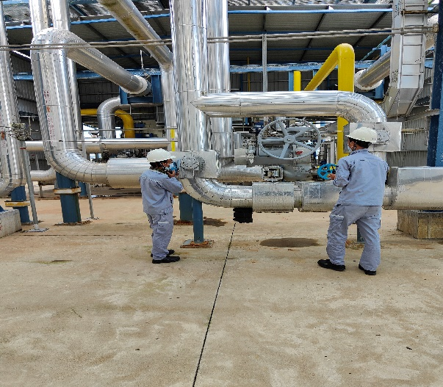
现场检查发现问题阀门并联系仪控处理
On-site inspection finds problem valves and contact instrument control for processing
现场关闭问题阀门前后截止阀
On-site closing of the problem valves before and after shut-off valves

演练效果评价：
班组演练按照“氮气中断后先用后备系统补充管网然后查找问题，处理问题后投用”的思路进行；演练过程中班组人员分工明确，班员能够按照分工要求完成操作并及时反馈操作信息；班组成员相互提醒、配合，但班组演练中也存在部分问题，希望后续演练中予以整改。
Evaluation of the exercise effect:
The team drill is carried out according to the idea of "after the nitrogen is interrupted, first use the backup system to supplement the pipeline network, then find the problem, and then put it into use after solving the problem"; during the drill, the team members have a clear division of task, and the team members can complete the operation according to the requirements of the task division and timely feedback the operation information; The team members reminded and cooperated with each other, but there were also some problems in the team drills. I hope that they will be rectified in the follow-up drills.
签字： 年 月 日
存在的问题 Existing problems |  |  |  | 整改人  Revise Personnel |  |  |  | 整改期限  Date
班组演练过程比较紧张  The team practice process is relatively tense |  |  |  | 赵宇 |  |  |  | 2022.10.11
现场外操检查确认后未及时通过对讲机反馈至中控  After the on-site inspection and confirmation, the feedback to the central control through the walkie-talkie was not timely. |  |  |  | 赵宇 |  |  |  | 2022.10.11
演习过程时间太短，模拟真实度不够  The exercise process is too short, and the simulation is not realistic enough |  |  |  | 赵宇 |  |  |  | 2022.10.11
后续跟踪落实 Follow-up implementation
整改措施落实：Implementation of corrective measures: |  |  |  | 验证人  Verify Personnel |  |  |  | 日期  Date
加强班组演练频次，下月副班再次演练  Strengthen the frequency of team drills, and the sub-class will drill again next month |  |  |  | 温建成、张云波、邓文涛 |  |  |  | 2022.10.11

